IMPLEMENTATION REPORT – CYCLICAL PROGRAM REVIEW
DUE DATE FOR IMPLEMENTATION REPORT: May 1, 2026

Degree Programs Being Reviewed | BA Indigenous Studies  BA/BSc Indigenous Environmental Studies and Sciences  PhD Indigenous Studies
Year of Review | 2023-2024
Date of Site Visit | 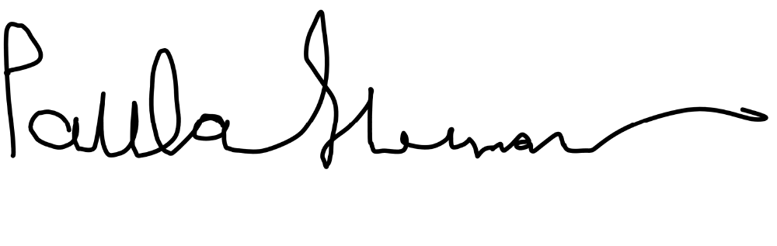  April 10 – 11, 2024
Signature of Director
Date | May 6, 2026
Signature of Dean | Kathryn Norlock
Date | May 21, 2026
Signature of Graduate Dean |   Craig Brunetti
Date | June 8, 2026

Recommendations to be Addressed
Recommendation | Proposed Follow-Up | Specific Timeline | Follow-Up Taken

BA Indigenous Studies
Recommendation 1  That additional funds and support be provided for the BA INDG program for the delivery of Indigenous Knowledge (IK) and Indigenous language content and programming. | The Implementation Plan will indicate whether the budget proposal was approved, and what types of support have been put in place to provide for the delivery of IK and Indigenous language content and programing in the BA INDG. | In place for Sept 2025 | The IK budget provided from the university to CWS was reduced for the 2025-2026 academic year from  $75,000 to $67,500 as a result of budget cuts.  The amount for this academic year (2026-2027) remains $67,500).
Recommendation 2  That teaching groups be established to help lead and facilitate ICR first year courses. | No follow-up is required.  Teaching groups have been created. |  | We are meeting with the dean and VP Academic this summer to discuss the ICR courses and have formed a university wide ICR committee to guide the future evolution of the ICR teams.

BA/BSc Indigenous Environmental Studies and Sciences
Recommendation 3  That IESS review the types of interaction students have with Elders and explore how Elders are incorporated into the program components. | IESS faculty are leading a Teaching Fellowship project that will examine the role and engagement of Elders and IK holders in courses and student engagement.  The Implementation Report will report on findings of this Project and indicate any revisions they have made to courses to further incorporate the valuable teachings of Elders and IK holders. | Jan 2026 | IESS: The Teaching Fellowship project is in process.  - An Alumni Survey on program strengths and needs is drafted and will be carried out this year.  - A program review of course syllabi, pedagogical approaches, role and place of IK, course pathways through the program, gaps and strengths is underway and will be completed this AY. It will then be used to identify curriculum adaptations and needs moving forward.  - An employers' roundtable is planned to be held this AY to solicit feedback from the work environment into which many of our students enter after graduation. It will focus on the identification of critical skills needed upon graduation to further inform curriculum adaptation moving forward.  - The CWSIS is currently discussing better approaches to coordinating Elders and traditional teachers' visits to CWSIS classes to try to optimize use of resources and student access to IK.

BA Indigenous Studies and BA/BSc Indigenous Environmental Studies and Sciences
Recommendation 4  That more land-based content and courses be created to deepen community relationships, Indigenous pedagogy and the experience of students. | IESS faculty are leading a Teaching Fellowship project that will review land-based content and courses and their role in student learning and experiences.  The Implementation Plan will report on findings of the Project and indicate whether any changes have been made to the offering of land-based content and/or courses. | In place for 2025-26 academic year | BA INDG: We have one new half course on Anishinaabe Law (INDG 3430H) that will have land-based components. It has not been possible to expand land-based course offerings in the program beyond that because of capacity of existing facility as well as the school lacking enough faculty with an expertise in IK to offer more courses of this nature. As well, one of the faculty members who teach in this area has been on sabbatical for the 2025-2026 academic year.  For an update on the Teaching Fellowship project, see recommendation 3.

PhD Indigenous Studies
Recommendation 5  That the time to completion for PhD Students be clarified. | The Implementation Report should report on any action that has been taken to address time to completion, including whether a mentor coach has been put in place. | In place for Sept 2025 | The nature of the Core Comprehensive Written Exam has been changed to follow an editorial process where students work with the same question, receive feedback and then have a period to do revisions. This allows them to learn important revision and editorial skills necessary for their dissertations and will not have to wait 6 months to take a new exam. We believe this will lessen times to completion for most students.  We submitted a proposal for the mentor coach and have had some discussions with the Dean and Provost, but because of the budget cuts this was not possible to consider at this time.
Recommendation 6  That supervision for PhD students be more equitably distributed. | The Implementation Report should provide an update on the process for assigning supervisors, noting that the Dean has indicated this should take place at the time of admission and co-supervision is a possibility. | Jan 2026 | This has not been achieved as we are in a transition phase in the CWS with faculty who are set to retire within two years and are not taking on new students and new faculty who are in their probationary phase and cannot supervise at this time. In the meantime, we have stepped up co-supervision to try and alleviate some of the pressure on tenured faculty who have too many graduate students.  We are also working on a policy to provide workload adjustment to faculty who supervise through an incentive program where faculty who have a student complete can earn points toward a course release. This is ultimately dependent though on  support from the Dean’s Office to provide stipends for replacements for  affected courses.
Recommendation 7  That a course release be assigned to the position responsible for community and practicum placements to allow ongoing contact with students and their sponsors, ensuring progress and advising as necessary. | No follow-up is required. This has been implemented.

Relevant to all Degree Programs
Recommendation 8  That the Programs conduct anonymous surveys for students on an annual basis for purposes of program review and initiating change. | The Implementation Report should provide an update on student surveys. | To be implemented by end of 2025-26  Academic year | To be sent out to students in June.
Recommendation 9  That the Programs establish a process to track alumni employment and help promote the Programs. | The School is encouraged to work with Alumni Engagement Services.  The Implementation Report should provide an update on this initiative. | Update to be provided | This has been discussed by the directors and the AAA, and she will be working on this over the summer months.

General Recommendations
Recommendation 10  That more permanent faculty be hired to grow the Programs, and specifically three (3) full-time faculty are required in the BA INDG program to support the delivery of ICR requirements. | This recommendation extends beyond the intended scope of the program review, which is to evaluate the quality of the degree program.  The School is encouraged to discuss faculty hires with their Dean(s) as part of the annual academic planning process, specifically the delivery of ICR requirements.
Recommendation 11  That a Canada Research Chair (Tier II) position be considered for the Chanie Wenjack School. | This recommendation extends beyond the intended scope of the program review, which is to evaluate the quality of the degree program.  The School is encouraged to pursue this recommendation through the appropriate channels.
Recommendation 12  That the School be encouraged to hire a two-spirit Elder for its Elder in-Residence Program. | This recommendation extends beyond the intended scope of the program review, which is to evaluate the quality of the degree program.  However, the Program is encouraged to pursue this initiative and the value it would bring to the School and its students.
Recommendation 13  That supports and additional mentorship be provided to junior faculty to achieve tenure and promotion. | This recommendation extends beyond the intended scope of the program review, which is to evaluate the quality of the degree program.  The School is encouraged to discuss this recommendation with their dean.
Recommendation 14  That the School conduct an overall assessment of space requirements for their Programs. | The Implementation Report should provide an update on space requirements. | To be completed by April 2026 | Space is an ongoing issue for the CWS. The PhD Program has four cohorts of students (first year through fourth year) but only three offices. Capacity of these offices is four students per office for a total of 12 students.  We also need faculty office space for new faculty positions that are expected to be coming in the next 1-2 years.
Recommendation 15  That thoughts be given to commemoration surrounding the contributions of Indian residential school survivors in the community. | This recommendation extends beyond the intended scope of the program review, which is to evaluate the quality of the degree program.  The Program had identified this recommendation as a larger, university-wide undertaking.
Recommendation 16  That the responsibility for reviewing ethics proposals related to Indigeneity be distributed beyond faculty in the PhD program and the Chanie Wenjack School. | This recommendation pertains to faculty university service.
Recommendation 17  That the Chanie Wenjack School and the University develop an Indigenous Identity verification policy led by Elders, Knowledge Keepers, and leaders as partners. | This recommendation extends beyond the intended scope of the program review, which is to evaluate the quality of the degree program.  The development of this policy is currently underway.
Recommendation 18  That senior administration, deans, and associate deans take action to ensure that units across the university develop actionable plans for Indigenization within their programs to take pressure off Indigenous graduate faculty and teaching assistants within the PhD program. | This recommendation extends beyond the intended scope of the program review, which is to evaluate the quality of the degree program.
Recommendation 19  That the University provide respectful compensation for Knowledge Holders and Elders working with students. | The Program notes that the fee schedule was updated in September 2024.
Recommendation 20  That further University-wide fundraising supports be made, co-led by the university, to support growing initiatives at the Chanie Wenjack School. | This recommendation extends beyond the intended scope of the program review, which is to evaluate the quality of the degree program.  The School is encouraged to continue working with the Development Office.
Recommendation 21  That the relationship between the Chanie Wenjack School and First Peoples House of Learning be addressed. | This recommendation extends beyond the intended scope of the program review, which is to evaluate the quality of the degree program.
Recommendation 22  That the School create an Indigenous Research Centre. | This recommendation extends beyond the intended scope of the program review, which is to evaluate the quality of the degree program.  The School is encouraged to work with discuss this with the Office of Research & Innovation.

