
IMPLEMENTATION REPORT – CYCLICAL PROGRAM REVIEW
DUE DATE FOR IMPLEMENTATION REPORT: May 1, 2024

Degree Programs Reviewed | MA Cultural Studies PhD Cultural Studies
Academic Year – Program was Reviewed | 2022-2023
Date of Site Visit | 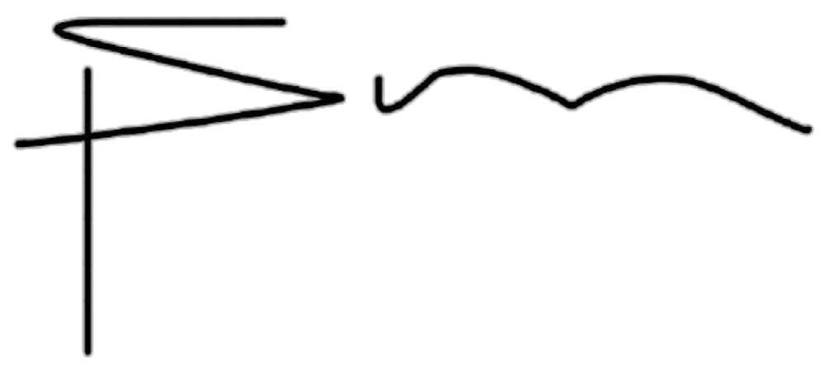  November 24-25, 2022
Signature of Chair and/or Director
Signature of Dean | 
Date | October 10, 2024

Recommendations to be Addressed
Recommendation | Proposed Follow-Up | Timeline | Follow-up Taken
Recommendation 1 That the Programs pursue more avenues for cross-listing of courses, collaboration and joint appointments with other programs, specifically, but not exclusively in the area of Indigenous. | The Program should seek out opportunities for collaboration and course cross-listings.  The Implementation Report will outline any new collaborations and cross- listed courses. | Ongoing; update to be provided by May 1, 2024. | The program has introduced a new requirement for PhD students in their second year: a .5 elective.  The grad program also routinely looks at course offerings in adjacent programs for potential cross-listing.
Recommendation 4 That the Programs, in partnership with Graduate Studies, develop a long-term plan for supporting research-creation and media arts in terms of facilities, space, faculty complement, community partnerships, and | Standards for evaluation and community partnerships should be reviewed by the Program Committee through the lens of providing support for research-creation and media arts.  The Implementation Report will outline outcomes to support research creation and media arts. Specifically  talk about: | Ongoing; update to be provided by May 1, 2024. | 1) The program has developed guidelines for student projects that engage in research-creation. These guidelines are now available through our website. 2) In October 2023, students and faculty affiliated with the program participated in a day-long hybrid conference devoted to the future of research-creation with a focus on evaluation criteria. 3) The graduate program will be involved  in the infrastructure projects that

standards for evaluation. | - Areas of development  - Partnerships and collaborative opportunities |  | are currently underway at Traill College, which include building a dedicated photochemical processing lab, studio and exhibition spaces.
Recommendation 5 That the Programs place strong emphasis on the cultivation and support of partnerships with community organizations, and that students at both the MA and PhD levels be encouraged to engage in public-facing scholarship as part of their degree programs. | The Program should investigate ways to promote public-facing scholarship within the degree programs. Further emphasis on cultivating community partnerships is encouraged.  The Implementation Report will identify any new development and support of partnerships, as well as how they have been incorporated into the degree program. | Ongoing; update to be provided by May 1, 2024. | This year, the program will introduce an internship stream in the MA, and we will also revisit our draft guidelines for incorporating community-based research.  Regarding the latter, we are in contact with the Trent Community Research Centre (TCRC).
Recommendation 7 That the Program explores greater incentives and more direct, program-specific support for student applications for Tri- Council funding. | The School of Graduate Studies provides extensive supports for students applying for tri-council funding and other scholarships. The Program should work on ensuring that all qualified students apply for these funding opportunities.  The Implementation Report will outline:  - New supports introduced  - Student applications and grant success | Update to be provided by May 1, 2024. | Professional development is incorporated in our core courses at the MA and PhD level. These include CUST 5000Y, CUST 6110Y,  and CUST 6200Y. In addition, members of our program have offered informal sessions to prepare for Tri-Council grants.
Recommendation 9 That students be supported to explore opportunities for professional development at both the MA and PhD levels, and that professional development goals and activities be included in degree requirements. | The Program Committee will consider incorporating professional development opportunities into degree requirements for CUST 5000,  CUST 6100 and CUST 6200.  The Implementation Report will identify: | Update to be provide by May 1, 2024  Changes to be in place for Sept 2024. | Professional development has for years been included in our core courses. This year there was increased discussion of conference applications in CUST 5000Y, 6110Y, and 6200Y. In addition, the program is currently working on developing a permanent Student Professional Expenses Fund (SPEF), to help those who participate in conferences and other

 | - any curriculum changes to specific courses  - any changes to program degree requirements |  | professional meetings. The director and AAA have partnered with the awards office and with payroll to optimize the delivery of SPEF.
Recommendation 10 That the Programs develop a greater range of Graduate Research Assistant opportunities to provide experience in collaborative research and skill-specific professionalization, and that these positions be paid in addition to the standard funding package. | Faculty are encouraged to explore funding opportunities that may be available from external sources such as Tri-Council awards or research grants.  The Implementation Report will identify any progress in securing funding. | Update to be provided by May 1, 2024. | These opportunities are currently provided by the CRC in Media and Environment, who routinely hires students in the capacity of RAs. In addition, the grad program manages an international, peer- reviewed and open-access journal (Media Theory), which has hired and continues to hire students as Editorial Assistants. We encourage our faculty to develop more opportunities in the future.
Recommendation 11 That the Programs develop formal, program-specific guidelines on MA and PhD supervision and examination including clearly defined responsibilities (for both students and faculty), procedures for changes to the supervisory committee, and directions to institutional channels for support, complaints, and appeals. | The program is encouraged to consider program-specific guidelines.  The Implementation Report will outline results of discussion. | Update to be provided by May 1, 2024. | The graduate program adheres to the supervision and examination guidelines provided by the Faculty of Graduate Studies. In addition, we have developed our own guidelines, which are both readily available online and subject to modification, as required.
MA Program Specific
Recommendation 12 That the required MA course CUST 5000 include ‘framing’ assignments and questions to allow students to respond to the included Salons in terms of approach, methodology, and professional development. | The Program will review and consider if any changes to curriculum need to be made.  The Implementation Report will indicate any curriculum changes. | Decision by May 1, 2024. | We have considered this recommendation but do not think it is productive at this time.

PhD Program Specific
Recommendation 14 That Graduate Studies fund a full-day retreat for CUST faculty members and students to discuss the curriculum, overall objectives of the PhD program in light of changed conditions of graduate study, as well as changes to the theory and practice of Cultural Studies that have occurred since the Program’s inception. | The Program is encouraged to hold a Retreat to review and reflect on those aspects of the Program identified in the External Reviewers’ Report.  The Implementation Report will highlight discussions of the retreat, and outline resulting changes to the Program and curriculum. | To be discussed at Retreat – Summer 2023. | We held a retreat in Spring 2023 and Spring 2024, and will continue in 2025 and for years to come.  These meetings have been productive for setting the agenda for the following year, which is reflected in the current report.
Recommendation 15a That the Program review curriculum of CUST 6100. | The Program will review CUST 6100 at their retreat.  The Implementation Report will indicate any curriculum changes to CUST 6100. | To be discussed at Retreat – Summer 2023. | CUST 6100 has been considerably overhauled in the context of suggestions that grew out of the review. Changes include longer writing assignments over weekly assignments. The new approach was implemented in the fall of 2024.
Recommendation 16 That the Program support the creation of a student-generated reading list to accompany the required readings for the first comprehensive examination, and suggest that the comprehensive examination could, with the supervisor’s agreement, include a selection of texts from this list as well as the 6100 required readings. | The Program is encouraged to consider a reading list.  The Implementation Report will provide an update on the reading list. | Update to be provided by May 1, 2024. | This was implemented following the suggestions of an ad hoc committee to revamp CUST 6100Y (see 15a of this report). A student-generated reading list is now included in the evaluation  scheme of this course. These texts may also be included in the comprehensive  examination.
Recommendation 18 That CUST 6110 should ideally include ‘framing’ assignments and questions to allow students to respond to the weekly Salons in terms of approach, methodology, and professional development. | The Program will review and consider if any changes to curriculum need to be made.  The Implementation Report will indicate any curriculum changes. | Decision by May 1, 2024. | CUST 6110Y was revamped in 2023 in accordance with this recommendation.

Recommendation 19 That one of the final assignments for CUST 6200 should be a course syllabus. | The Program will consider whether the course will include the creation of a syllabus. They may also want to consult with CTL about potential professional development opportunities for syllabus creation.  The Implementation Report will provide an update. | Decision by May 1, 2024.  Changes to be implemented by Sept 2024. | The Program notes that CUST 6200 does include syllabus development as part of the course.
Recommendation 20 That some of the required PhD courses be taught by Faculty other than the Graduate Program Director so that students have the opportunity to work with a broader range of faculty members over their degree programs. | The Program will discuss staffing needs with their Dean(s). | Update to be provided by May 1, 2024. | The program has managed their staffing needs; currently, CUST 6110 is no longer taught by the director, and the first year PhD electives are taught by a wide variety of faculty.
Recommendation 21 That the Program develop and publish a clear set of guidelines regarding the three- project dissertation model. | The Program is encouraged to finalize their guidelines and make them available to students.  The Implementation Report will report on progress. | Update to be provided by May 1, 2024. | The 3-project dissertation model will be retained as an option alongside a conventional dissertation model. The program guidelines will be rewritten to reflect this change before the incoming cohort in 2025.
Recommendation 23 That the Program standardize access to undergraduate courses for those students opting to meet the PhD language requirement through this process. | The Program will provide information on undergraduate courses that meet the PhD language requirements. | Update to be provided by May 1, 2024. | In fall 2024, the program voted to remove the language requirement. The program  noted that the majority of its students do not need to learn new languages to pursue their  research.

