IMPLEMENTATION REPORT – CYCLICAL PROGRAM REVIEW

DUE DATE FOR IMPLEMENTATION REPORT: December 1, 2024

Degree Programs Reviewed | BBA – Bachelor of Business Administration  BA/BSc Joint Major Honours
Academic Year – Program was Reviewed | 2022-2023
Date of Site Visit | March 27-28, 2023
Signature of Chair and/or Director | 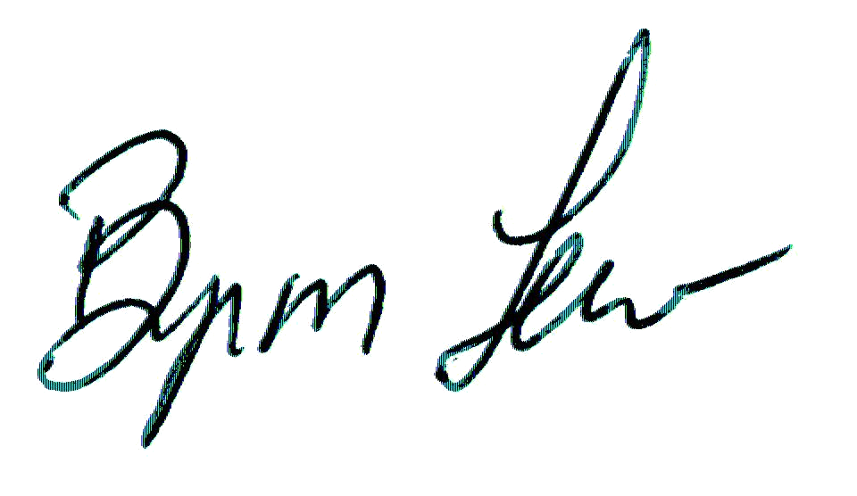  Byron Lew
Signature of Dean | Mark Skinner  
Date | December 16, 2024
Signature of Dean | Wenying Feng  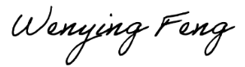
Date | 12/17/2024

Recommendations to be Addressed
Recommendation | Proposed  Follow-Up | Timeline | Follow-up Taken
Recommendation 1  That the Program develop a process for systematic curriculum review and revision. | The Implementation Report will provide details on the formalized process for the review and revision of curriculum albeit, in practice, the School does appear to be reviewing curriculum on a regular basis, but perhaps not consistently. | To be put in place for the 2024-25 academic year | The School has introduced a process to formalize curriculum review through their Curriculum Committee. Curriculum review will now be a standing item on the Curriculum Committee. Specialization coordinators will submit reports on recommended changes to current curriculum. Core courses that are not part of Specializations will be the responsibility of the Curriculum Committee Chair to review, gather input from Curriculum Committee members and Program Committee members, and propose revisions as needed.  The School has successfully modified the core fourth-year course requirements under this process. Degree requirements are now more flexible, and students may select two courses from a list rather than the prescribed two courses.
Recommendation 2  That the Program develop a strategic plan which clarifies their focus and utilizes value proposition as a basis for decision-making. | A strategic plan is critical to the School of Business to address enrolment growth.  The Implementation Report will provide details on the School’s strategic plan, clarity on the value propositions of the program, and how Durham’s programming may become more distinct. | To be completed by December 2024 | The Program Committee has struck a subcommittee to develop the School’s strategic plan with a focus on our value proposition. The Committee met in October, and will work on it through the fall term, with the intention of delivering results to the Program Committee.  In consideration of Durham and the emerging identity of the program, structural differences will be taken into account. The School would like to promote a subset of their specializations in Durham, and reconsider whether they can offer all, but there are competing interests involved in this decision, including the support of postgraduate certificates. As part of the strategic plan, the Subcommittee will assess Durham’s programming for the coming years, and consider the timing of any new faculty hires.
Recommendation 3  That the Program consider assigning core courses in first and second year to fulltime faculty members. | The School should undergo an extensive review of its curriculum that would consider the streamlining of programming and alignment with current strengths of the program and full-time faculty.  The Implementation Report will provide a summary of the curriculum review and program streamlining. | To be in place for next academic year  Ongoing | The School has considered this recommendation, taking into account the TUFA CA and the expertise of faculty to support courses in their specialization.  This approach has worked well for ADMN-1000, 1221, 2010, 2100, 2220, 2230 and 2510.  For example, in Peterborough a full-time faculty member has been assigned to deliver ADMN 1000H for three years. Other commitments include full-time faculty members instructing ADMN 1221H, 2220H, 2510H and most sections of ADMN 2100H, 2230H, as well as an LTA delivering ADMN 2010H. These changes raise the proportion of first- and second-year core courses taught by fulltime faculty.  For Durham, this points to a larger issue related to Recommendation 2 above. How can the School run the entire program, complete with all the specializations, in Durham with a much small faculty complement? The proportion of core first- and second-year courses taught by fulltime faculty is likely to be lower in Durham than in Peterborough for the foreseeable future based on faculty resources.  With only two permanent faculty and LTAs supporting courses in the undergraduate, post-graduate certificates, and Master of Management programs, the School simply does not have the capacity to cover a higher proportion.  Durham is expecting to hire new tenure-track positions, and it is anticipated that the new hires will teach the first year accounting course, as well as ADMN 1000H, 2010H and possibly 2510.
Recommendation 4  That the School of Business be established as an independent decanal unit. | This recommendation falls outside the scope of this review which is to review the quality of the BBA. No follow-up is required.  The School is encouraged to discuss this recommendation with Senior Administration.
Recommendation 5  That the Program identify and enhance support for students on both the Peterborough and Durham campuses. | CPRC acknowledges that the School has already begun to look at these issues.  The Implementation Report will provide an update on student supports in Durham and Peterborough, identifying any new supports or changes to existing supports. | Ongoing; update to be provided for December 2024 | The School distributes a weekly newsletter to students on both campuses that provides more than news; it outlines academic deadlines and provides information on opportunities for students, both internal and external. Information is circulated through Instagram and offer in-person information sessions.  Additional steps the School has taken include:  1. A dedicated AAA in Durham.  2. Increased support from the RO, Trent International, and academic advising in Durham  3. Reorganization of admin support in Peterborough:  - New position, Post-graduate Certificate and Placement Liaison to handle PGCs in Peterborough.  - New position: internships and co-ops coordinator to assist with the coordination of the two EL programs for us on both campuses.  - With the new positions, the Department Coordinator will be more available to focus on responsibilities including student academic advising, as well as timetabling and other admin duties.
Recommendation 6  That the Program strengthen communication channels with students, specifically with respect to:  - experiential learning opportunities, and  - providing students with an opportunity to bring forward issues and concerns. | CPRC notes that the School has been working on providing information on experiential learning opportunities. The School should continue to explore methods of distributing the weekly newsletter, and supports for the re-establishment of the Student Association.  The Implementation Report will include an update on any additional communication strategies put in place (e.g., townhall), and any forums put in place to address student issues. | Ongoing; update to be provided for December 2024 | The School has addressed this concern through the restructuring of our administrative support, as outlined for Recommendation 5.  Additional communication strategies have been put in place and include:  The School has also established a number of key communication strategies to inform students:  - Experiential Learning  - Instagram posts  - Weekly newsletters, that includes information on internships and placements, orientation events, and study abroad  - Emails to promote experiential learning opportunities  - Visits to first and second year ADMN classes to promote experiential learning and course planning  - Distribution of information to third year course instructors; instructors post information on their course Blackboard  - Promotion of accounting internships in third year courses  - Information sessions  - Promotion of study abroad in first and second year courses  (2) The ability for students to bring forward concerns is being addressed by the School’s DEIB Committee. The Committee has surveyed students and is currently engaged in developing recommendations.

