 | Class of  Chemicals | Recommended Storage Method and Additional Concerns |  | Common Chemical Examples | Common Incompatibles.  (Always Consult MSDS)
 | Flammable  Liquids | An approved flammable storage cabinet  *Remember: peroxide-forming chemicals must be dated upon delivery and opening (consult Peroxide  Forming-Chemical storage) |  | Ethanol, Methanol, Acetone, Xylene, Toluene, and peroxide formers like *Diethyl Ether and  *Tetrahydrofuran | Oxidizers, reactives, acids, bases
 | Toxics | In a ventilated, dry, cool area in a chemically resistant secondary container |  | Chloroform, Cyanides, Heavy Metal Compounds (e.g.  Cadmium, Mercury) | Flammable liquids, acids, bases, reactive, oxidizers please consult Risk Management for assistance
 | Corrosive  Acids- Inorganic | Store in corrosives cabinet (marked ACID), or on protected shelving and in secondary containment  *Do NOT store acids on metal shelving |  | Hydrochloric Acid, Sulfuric Acid, Phosphoric acid, Chromic Acid, Nitric Acid*  *Nitric acid is a strong oxidizing agent and should be stored by itself with secondary containment | Flammable liquids, flammable solids, bases and oxidizers, organic acids, cyanides, sulfides
 | Corrosive  Acids- Organic | Store in corrosives cabinet, on protected shelving, secondary containment away from inorganic acids  *Do NOT store acids on metal shelving |  | Acetic Acid, Trichloroacetic Acid, Formic Acid | Flammable liquids, flammable solids, bases and oxidizers, inorganic acids, cyanides, sulfides
 | Corrosive-  Bases- Inorganic | Store in corrosives cabinet, or on protected shelving away from acids |  | Ammonium Hydroxide, Potassium Hydroxide,  Sodium Hydroxide | Flammable liquids, acids, oxidizers, organic bases
 | Corrosive  Bases-Organic | Store in corrosive cabinet, and separated from acids and inorganic bases |  | Hydroxylamine, Tetramethylethylamine  Diamine, Triethylamine | Acids, oxidizers, hypochlorites, inorganic bases
 | Flammable  Solids | Cool dry area away from oxidizers and corrosives |  | Carbon, Charcoal, Paraformaldehyde | Acids, bases, oxidizers
 | Oxidizers | Store in secondary containment with non- combustibles or inorganic material |  | Perchlorates, Permanganates, Nitrates | Flammables, combustibles and organic materials
 | Water Reactive | Store in a cool dry location. Protect from fire sprinkler system and sources of water. Label area for water-reactive storage |  | Sodium, Lithium, and Potassium Metals, Sodium  Borohydride | Aqueous solutions, oxidizers,  water sources. Please consult Risk Management, and  SDS for specific information
 | Explosives | Store in a secure location away from other chemicals, store in areas away from shock or friction |  | Trinitrophenol, Diazoisobutylnitrile | Consult the SDS and Risk Management.
 | General Stock  Chemicals | Storage on laboratory benches, or shelves with like chemicals |  | Sodium bicarbonate, Agar, Salt buffer | See chemical-specific SDS
A Combatable Organic bases  B Combatable Pyrophoric & water reactive  C Combatable Inorganic Bases  D Combatable organic Acids  E Combatable Oxidizers including Peroxides  F Combatable Inorganic acids not including Oxidizers or Combustibles  G Not Intrinsically Reactive or Flammable or Combustible  J Poison Compressed Gas  K Compatible Explosives or other Highly Unstable material  L Non-reactive Flammables and Combustibles including Solvents  X Incompatible with all other Storage Groups  Storage Groups J, K and X needs consultation with OH&S  Consult SDS for specific storage requirements |  |  | 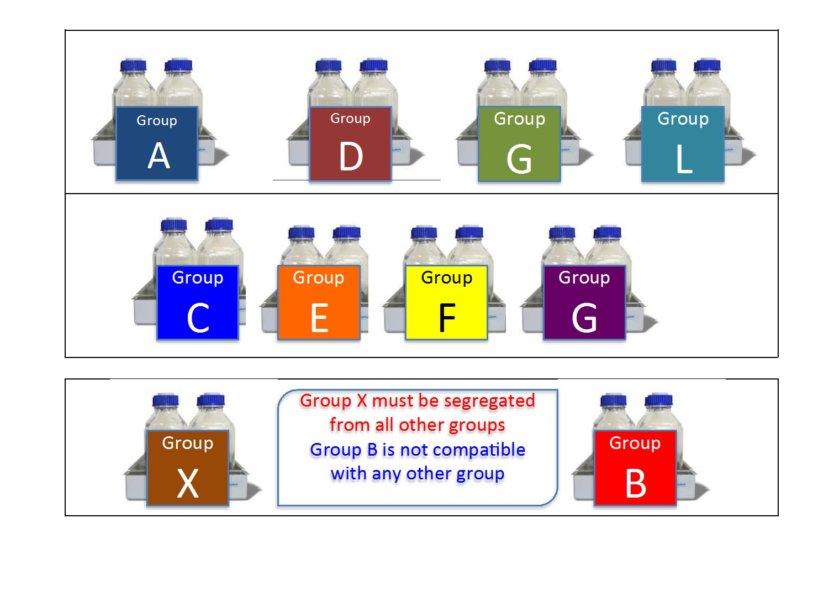
If space does not allow storage groups to be kept in separate cabinets, the above scheme can be used with extra care taken to provide uncrowded and carefully monitored conditions.
Prudent Practices in the Laboratory: Handling and Management of Chemical Hazards: Updated Version

