Trent University 2016
Trent University X-Ray Safety Program Manual

This page left blank intentionally

X-ray Safety Program Manual

Table of Contents
- ADMINISTRATION and RESPONSIBILITY ........................................................................................................... 6
  - Introduction ................................................................................................................................ 6
    - What this Program Covers ...................................................................................................... 6
    - What this Program Does Not Cover ........................................................................................ 6
    - Program Overview .................................................................................................................. 6
  - Legislation and Guidance Documents ......................................................................................... 7
  - X-ray Safety Policy ....................................................................................................................... 7
  - Scope ........................................................................................................................................... 8
  - Authority and Responsibility ....................................................................................................... 8
  - Radiation Safety Officer .............................................................................................................. 8
  - Authorized Users ........................................................................................................................ 8
  - Permit Holders ............................................................................................................................ 8
  - Communication .......................................................................................................................... 9
  - Program Performance................................................................................................................. 9
- SETTING UP AN X-RAY LABORATORY ............................................................................................................... 9
  - Critical PRE PURCHASE requirements – Also applies to donated devices .................................. 9
  - Types of X-ray Devices ............................................................................................................... 10
    - Analytical X-ray machine ....................................................................................................... 10
    - X-ray Source ........................................................................................................................... 11
  - Design and Approval of Rooms .................................................................................................. 13
  - Installation of X-ray Device ......................................................................................................... 13
  - Warning Signs and Labels ........................................................................................................... 14
- TRAINING REQUIREMENTS............................................................................................................................ 15
- STANDARD OPERATING PROCEDURES .......................................................................................................... 15
  - Use ........................................................................................................................................... 15
  - Storage ..................................................................................................................................... 16
  - Decommissioning ..................................................................................................................... 16
- PROTECTIVE MEASURES ................................................................................................................................ 16
  - Common Causes of Accidents................................................................................................... 16
  - General Precautions ......................................................................... ....................................... 17
  - ALARA Principle ........................................................................................................................ 17
- OCCUPATIONAL EXPOSURE MONITORING .................................................................................................... 17
  - X-ray Workers ........................................................................................................................... 17
  - Dose Limits ............................................................................................................................... 17
  - Personal Dosimetry and Exposure Reports .............................................................................. 18
- LEAK TESTING OF X-RAY EQUIPMENT ............................................................................................................ 18
- SECURITY ........................................................................................................................................................ 18
- EMERGENCY PROCEDURES ............................................................................................................................ 19
- GLOSSARY ...................................................................................................................................................... 20

LIST OF FIGURES

Figure 1: Photograph of X-ray Diffraction (XRD) Device with Enclosure ............................................................ 10
Figure 2: Photograph of X-ray Fluorescence (XRF) Device with Enclosure ......................................................... 11
Figure 3: Photograph of Portable X-ray Fluorescence (XRF) Device…………………………………………………………………..11
Figure 4: Photograph of a transmission electron microscope with diagram and a diagram of a scanning electron
microscope (bottom picture) .................................................................................................................................12
Figure 5: Examples of Warning Label & Light on Energized X-ray Machine ......................................... .............. 14
Figure 6: Safety Tips to Prevent Overexposure .................................................................................................... 17

LIST OF TABLES

Table 1: Radiation Exposure - Annual Limits (based on O. Reg. 861) ........................................................................ 18

1 | ADMINISTRATION AND RESPONSIBILITY
1.1 | INTRODUCTION
There are several types of X-ray devices and sources used in teaching and research at Trent University. The X-ray safety program is part of the overall radiation safety program at Trent University.
The X-ray safety program manual was developed to assist university personnel in meeting all applicable legal requirements for X-ray emitting devices in non-medical equipment. It is designed to provide information for students, staff and faculty to safely work with X-rays by following radiation protection principles and internal safety procedures. Users of X-ray emitting devices have a responsibility to protect themselves and other persons from the hazards arising from the use of these devices.

1.1.1 WHAT THIS PROGRAM COVERS
This program is limited to:
- Devices that produce X-rays through artificial means (e.g. electrical generation via an X-ray tube)
- Any part of a device that emits X-rays, whether or not the device is designed specifically to produce X-rays (e.g. electron microscopes)

1.1.2 WHAT THIS PROGRAM DOES NOT COVER
This program does not address the registration, operating and safety requirements of:
- Devices that contain radioactive materials
- Devices used on living persons (medical devices)
The use of X-rays for medical purposes (use on living humans) is strictly forbidden at Trent University. Any work that includes medical X-rays must be done at a recognized hospital or medical clinic.
Please refer to the Trent University Radiation Safety Program Manual for all work relating to radioactive materials and devices (http://www.trentu.ca/scienceservices/safety/radiation)
1.1.3

PROGRAM OVERVIEW
Following is a summary of safety and regulatory issues that must be addressed by X-ray device permit holders and users during the life cycle of an X-ray device. The life cycle is broken down into 3 sections.
- The installation phase, which consists of:
  - Purchase/acquisition planning
  - Registration
  - Installation
  - Acceptance of the device
  - Training
  - Dosimetry enrolment
  - Record keeping
- The day-to-day or ongoing phase of operation, which consists of:
  - Authorization
  - Worker safety
  - Incident and accident reporting
  - Device Safety, Regulatory Compliance and Quality Control
  - Inspections/Audits (internal and government)
  - Special Practices and Procedures
- The end-of-life phase, which consists of:
  - Decommissioning and removal of X-ray device
  - Notification of the appropriate government branch when an X-ray device is replaced, stored or removed
The Science Facilities Office and RSO provides information and support during all phases of X-ray device ownership.
Please visit our website (www.trentu.ca/scienceservices/safety/radiation) and look under X-ray Safety Program for resources that will help in day-to-day X-ray safety matters.
1.2 | LEGISLATION AND GUIDANCE DOCUMENTS
The Federal and Provincial Governments control the installation and use of radiation emitting devices. They do so through a number of Acts and Regulations.
How an X-ray device is regulated depends on a number of factors. In particular, it depends on:
- How the device will be used (e.g. medical vs. non-medical applications)
- How the X-rays are produced (natural vs. artificial generation), and
- The peak energy of the radiation emitted by the device.
The federal government regulates all X-ray emitting devices through the Radiation Emitting Devices Act.
The primary regulation in Ontario for non-medical X-rays is Ontario Regulation 861, which is enforced by the Ontario Ministry of Labour. X-ray emitting devices are generally not regulated by the Canadian Nuclear Safety Commission. In addition, industry standards such as Health Canada Safety Codes are incorporated into Trent University’s X-ray safety program.
1.3 | X-RAY SAFETY POLICY
The University shall establish an X-ray Safety Program for X-ray emitting devices in accordance with Ontario’s Occupational Health and Safety Act and the Radiation Emitting Devices Act, as well as other applicable regulations and regulatory documents. All occupational exposures to ionizing radiation shall be limited in accordance with the ALARA principle (As Low As is Reasonably Achievable) and within legislated prescribed dose limits. Trent University’s X-ray Safety Program is designed to keep exposures ALARA through training and implementation of standard operating procedures and protocols to control the use, storage and disposal of X-ray emitting devices.

1.4 | SCOPE
This program applies to all faculty, staff and students working with X-ray generating devices for non-medical uses. The program is intended for teaching and research work only.
The Ontario Occupational Health and Safety Act regulate all aspects of X-ray safety for non-medical use. X-ray devices and sources are also regulated federally through the Radiation Emitting Devices regulation, under the Radiation Emitting Devices Act (C.R.C, c. 1370). The X-ray Safety Program for X-ray devices outlines the regulatory requirements in observance with associated legislation.
1.5 | AUTHORITY AND RESPONSIBILITY
Responsibility for controlling all activities related to X-ray safety in research at Trent University rests with the designated “supervisor” of the X-ray emitting device. According Ontario Reg. 861 of the OHS Act, the “employer shall designate a person for each X- ray source who is competent because of knowledge, training, or experience in the use and operation of X-ray sources and in radiation safety practices, to exercise direction over the safe use and operation of the X-ray source”.
The RSO has authority to implement the X-ray safety program encompassing the University. The X-ray safety program includes protocols and procedures for purchasing of X-ray devices, usage, monitoring, storage and disposal. Collectively, the Science Safety Advisory Committee (SSAC) advises the administration and the Radiation Safety Officer on X-ray safety matters in general and on the effectiveness of radiation protection programs within the university in particular. In addition to the requirements outlined in the manual, the SSAC may develop additional policies as required.

1.6 | RADIATION SAFETY OFFICER
The position of Radiation Safety Officer receives its authority from the Vice President Research and the Dean (Science). The Radiation Safety Officer is responsible for coordinating all activities related to X-ray safety, and for making recommendations to the Vice Presidents, through the VP Research and Dean (Science), regarding the control of all activities related to X-ray safety.
1.7 | AUTHORIZED USERS
Authorized users are those individuals who have been trained in the safe handling of X-ray devices and have been authorized by the Radiation Safety Officer.
Each individual who uses X-ray devices is responsible for complying with the requirements outlined in the Ontario Regulation 861 under the Occupational Health and Safety Act of Ontario, as well as with any additional requirements prescribed in legislation and internal procedures contained in the X-ray Safety Program.
1.8 | PERMIT HOLDERS
A permit holder is an authorized user who is a faculty member or technical staff in charge of a specific xray device and who will be registered with the Ontario Ministry of Labour as the person who exercises (or will exercise) direction over the safe use and operation of the X-ray source.
Each permit holder is responsible for:
- Allowing only authorized persons to enter rooms that are specified as restricted areas for reason of X-ray protection.
- Following the standard operating procedures (SOP) as prescribed by the X-ray Safety Program. Section 4 outlines the Standard Operating Procedures in the X-ray safety Program.
- Supervising students using the X-ray sources and instructing them in safe and responsible procedures for using these devices or machinery.
- Ensuring that personnel wear appropriate personal radiation monitors, if required.
- Maintaining an up to date X-ray Permit with the RSO.
- Coordinating all acquisitions and disposal of X-ray devices with the Radiation Safety Officer.
- Ensuring X-ray device is operating properly prior to use.
- Reporting to the Radiation Safety Officer any incidents involving suspected exposures to ionizing radiation exceeding permissible standards, tampering, unauthorized access, unauthorized use or theft of the device.

1.9 | COMMUNICATION
The Radiation Safety Policy and Program will be communicated to all permit holders of X-ray devices and relevant administrative support units in consultation with departmental chairs/academic directors and Deans.
1.10 PROGRAM PERFORMANCE
 | The policy and program will be reviewed annually and updated whenever necessary.
2 | SETTING UP AN X-RAY LABORATORY
2.1 | CRITICAL PRE PURCHASE REQUIREMENTS – ALSO APPLIES TO DONATED DEVICES
➢ | All X-ray devices must be certified for use in Canada. Contact the RSO to verify if your device has been certified in Canada and/or apply for certification in Canada. This must be completed PRIOR to device arriving in Canada.  o X-ray devices are regulated in Canada under the Radiation Emitting Devices Act (REDA). The Consumer and Clinical Radiation Protection Bureau (CCRPB) of Health Canada is the regulatory agency that administers the REDA and certifies X-ray devices for use in Canada.
➢ | The location where the device is intended to be used must be approved by the Ontario Ministry of Labour PRIOR to installation of the device. Contact the RSO who will prepare and submit all required application documents for approval to the Ontario Ministry of Labour.
➢ | All X-ray devices must be CSA or Ontario Hydro approved.
2.2 | TYPES OF X-RAY DEVICES
2.2.1

ANALYTICAL X-RAY MACHINE
An Analytical X-ray machine is an electrically powered device with a primary purpose of producing X-rays. Analytical X-ray instruments produce X-rays for the purpose of analyzing materials or structures such as X-ray diffractometers (XRD) (see Figure 2) or X-ray fluoroscopic devices. Typically these units are enclosed and have built-in shielding. Radiography devices use X-rays to inspect parts for mechanical defects such as in the aerospace industry, pipe welds, to look for flaws or hidden cracks. They are not intended for use in any medical applications or exposure of humans or animals.
X-ray diffraction (XRD) is commonly used in chemical analysis, biochemistry and other types of similar research. A narrow beam of X-rays is sent through the material being studied and scattered according to the details of the atomic arrangement. Thus, the arrangements of atoms in solids can be determined by studying the beam scatter patterns.
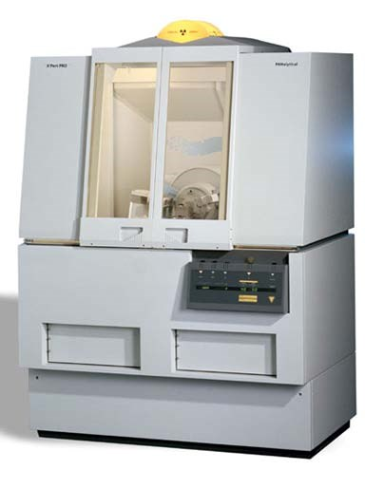

FIGURE 1: PHOTOGRAPH OF X-RAY DIFFRACTION (XRD) DEVICE WITH ENCLOSURE

X-ray fluorescence (XRF) machines (see Figure 3) are used to observe the fluorescent emissions of X-ray and UV as the atoms in a sample are bombarded by X-rays. The structure of the material being studied can be determined by examining the absorption spectrum.
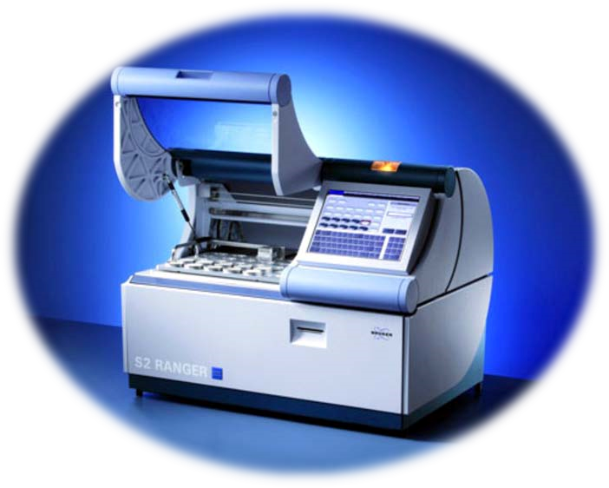

FIGURE 2: PHOTOGRAPH OF X-RAY FLUORESCENCE (XRF) DEVICE WITH ENCLOSURE

FIGURE 3: PHOTOGRAPH OF PORTABLE X-RAY FLUORESCENCE (XRF) DEVICE

2.2.2

X-RAY SOURCE
An X-ray Source means any part of a device that emits X-rays, whether or not the device is an X-ray machine. The primary use of the device may not be the production of X-rays such as in the case of electron microscopes (Figure 8). X-rays are produced by electron microscopes when the primary electron beam or back scattered electrons strike metal parts of the microscope. The shielding provided by the metal casing of the microscope and leaded glass on the viewing ports is usually sufficient to ensure that radiation exposure to personnel is kept to a minimum. A radiation survey should be performed at any time the microscope is moved, the operating levels (such as voltage, etc) are set higher than normal or if the shielding has been removed.
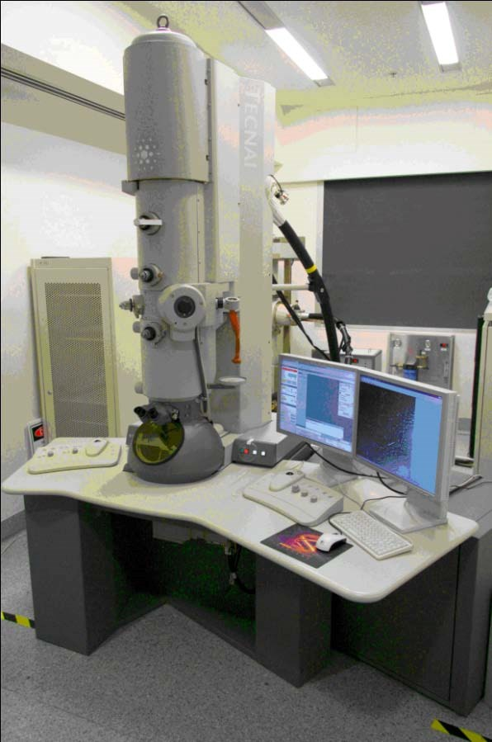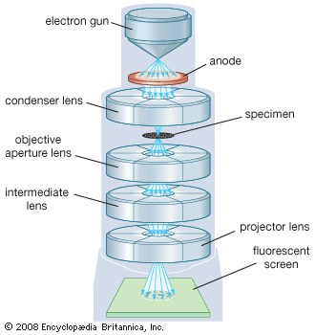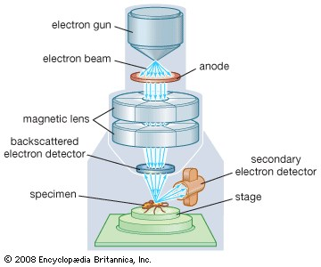

TRANSMISSION
SCANNING

FIGURE 4: PHOTOGRAPH OF A TRANSMISSION ELECTRON MICROSCOPE WITH DIAGRAM AND A DIAGRAM OF A SCANNING ELECTRON MICROSCOPE (BOTTOM PICTURE)

2.3 | DESIGN AND APPROVAL OF ROOMS
Contact the Radiation Safety Officer for the design and approval of rooms where an X-ray device is to be installed. This must be done before the project cost is being quoted, since lead shielding and its installation is extremely expensive. Contractors also need significant advance notice of shielding requirements since lead doors and windows may take several weeks to be manufactured and shipped.
Note that cabinet X-ray devices are self-shielded and generally do not require special shielding provisions although they still must undergo the registration process. Canadian, American and other foreign regulations may differ on what is accepted as being a cabinet X-ray device, therefore early consultation with the Radiation Safety Officer is advised when purchasing cabinet systems to avoid regulatory entanglements and unforeseen costs.
The MOL requires the following documentation:
- The application (MOL Forms 2a and 2b) • Shielding specification, e.g.
  - Cabinet units: Proof of compliance with self-shielding requirements.
  - All other devices: Calculations supporting the safety of shielding provisions for the device.
- Scale drawing (must be no less than 1:100 scale) of the room planned to hold the X-ray device(s) and an indication of occupancy and use of the surrounding areas.
Every area where a mobile X-ray device might be used must be registered with the MOL, even for a one time exposure.
The registration process by the MOL for simple devices may take between 2 - 4 weeks. Complex devices may take several weeks. This assumes that the device is already certified for use in Canada. The RSO will notify the permit holder of the X-ray device as soon as approval has been granted by the MOL. Once the approval has been given, the X-ray device may be installed.
2.4 | INSTALLATION OF X-RAY DEVICE
When receiving any X-ray device:
- Acceptance testing of newly installed device must be done before its first use. This testing :
  - Ensures that installed device meets manufacturer, regulatory and facility requirements
  - Ensures that all safety accessories are installed to plan
  - Ensures a copy of the technical and safety acceptance tests are kept on file for MOL review

- A radiation survey of the new X-ray device shall be carried out before it is put into operation. Contact the Radiation Safety Officer to arrange for this survey.
- The permit holder must complete an X-ray Permit application with the RSO. This serves as a current inventory and tracking system for all X-ray devices at Ryerson University.

2.5 | WARNING SIGNS AND LABELS
Rooms where an X-ray device is used or stored must be signed. X-ray devices must be marked with a sign that has a warning symbol and the words “X-ray ON” as shown in Figure 9.

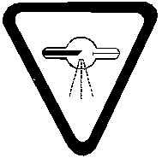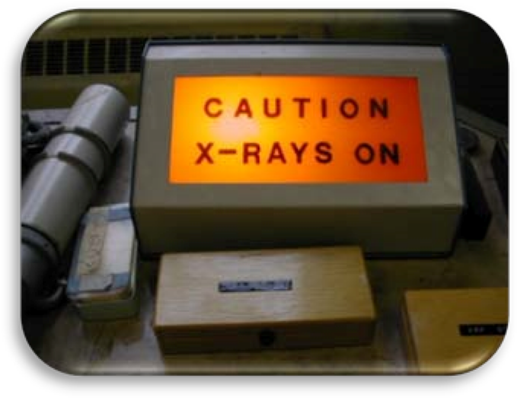
CAUTION X-RAY RADIATION

FIGURE 5: EXAMPLES OF WARNING LABEL & LIGHT ON ENERGIZED X-RAY MACHINE

- Entrances to areas containing X-ray devices must have a sign that has a warning symbol and the words “Caution X-ray Radiation”:

CAUTION – X-RAY RADIATION

- Contact the Radiation Safety Officer for posting of warning signs.

3 | TRAINING REQUIREMENTS
All permit holders and authorized users must participate in a training program. This includes the Radiation Safety course Part 1. and system-specific training provided by the manufacturer and later by the permit holder to all future authorized users. In addition, permit holders for portable XRF devices require XRF-NDT certified training or XRF Level 2 certified training if they will be training authorized users. Contact the RSO for details

Trent University X-ray Safety Training
Prior to installation and use of any X-ray device, all permit holders and authorized users of the xray device must have completed the general radiation safety Part 1. training offered by the RSO, the quiz on X-ray safety and the Science Safety Program Core principles module . Once the Radiation safety training has been successfully completed, authorized users will be added to the X-ray Permit. This will constitute authorization by the RSO.

System-Specific Training (a.k.a. Manufacturer’s Training)
Unless the principal investigator (permit holder) is the designer of the X-ray system, training on the use of the X-ray system (device and all associated controls) must be provided by a qualified person from the manufacturer of the X-ray system. This training is usually provided during the installation process. If obtaining a used X-ray system from someone other than the manufacturer, a qualified person must be identified to provide system-specific training.
- System-specific training must be documented and records of this training must be kept as long as the X-ray device remains in the permit holder’s possession.
- Update training is required after any modifications to the X-ray system and it must also be documented and records kept.
- The permit holder is responsible for providing system-specific training to all users of the X-ray system.
4 | STANDARD OPERATING PROCEDURES
4.1 | USE

General requirements
a) Device will be used under the guidance and supervision of an authorized user.
➢ Students and persons with no previous experience with X-ray devices shall work under the direct supervision of an authorized user until they have successfully completed all required training to become an authorized user.
- The area in which this device is used shall be marked with signs to indicate that X-rays may be present.
- Warning labels shall be affixed to all devices (see section 2.5)
- Device shall be operated in such a way that the user does not expose any part of his or her body to the direct beam and in such a way that no other person may be accidentally exposed.
- Warning lights shall be provided which will light when the X-ray tube is energized.
- No repairs or adjustments shall be made when the tube is energized or during the time any safety cover is removed.
- Interlock or other safety devices shall not be deliberately defeated or bypassed.

Additional requirements for “open beam design” devices
- Protection of personnel in the area surrounding an X-ray device should be achieved by effectively absorbing the scattered, leakage radiation or residual beam as close as possible to the site of scatter or to the device.
- The useful beam shall be directed toward an unoccupied area or towards a wall containing adequate shielding, as per Ontario Ministry of Labour approved room design.
- The beam should be adjusted so that it covers only the minimum area necessary for the nature of the work being undertaken.
- When beam alignment is carried out, the user’s working position shall be approximately at right angles to the direction of the beam.
A template for system-specific standard operating procedures is available on our under the X-ray Safety Program)
4.2 | STORAGE
If the X-ray device is no longer in use but remains in the possession of the permit holder at Trent University, the X-ray Permit must be updated to indicate this change in status. The X-ray Permit serves as a current inventory of X-ray devices at the University, whether the device is in use or in storage.
4.3 | DECOMMISSIONING
Contact the Radiation Safety Officer for the disposal of all X-ray devices. Disposal arrangements must be made through the Radiation Safety Officer prior to disposal.
Some parts of the X-ray device, such as the X-ray tube and/or transformer oil, may contain beryllium or PCBs and must be disposed of as hazardous waste. The RSO must also contact the MOL to de-register the X-ray device and confirm that it was disposed of properly.
5 | PROTECTIVE MEASURES
5.1 | COMMON CAUSES OF ACCIDENTS
Preventing accidents and over-exposure requires the proper use of protective measures.
Overexposure to X-rays can result from either direct exposure to the primary beam or indirect exposure from leakage or scattering. The major causes of accidents with X-ray devices include improper training, improper system or device configuration (e.g., unused beam ports not covered), handling or adjusting of samples or other equipment when the machine is energized.

FIGURE 6: SAFETY TIPS TO PREVENT OVEREXPOSURE
SAFETY TIPS TO PREVENT OVEREXPOSURE

- Know location of primary and diffracted beams at all times
- Do not put body parts into beam path
- Inspect shielding
- No maintenance work when beam is energized
- Monthly safety checks
- Survey unit when moved or beam realigned

5.2 | GENERAL PRECAUTIONS
Wherever possible, exposure shall be reduced by using appropriate shielding, increasing the distance from the source and reducing the amount of time spent working with the source.
5.3 | ALARA PRINCIPLE
As outlined in the X-ray Safety Policy (section 1.3), it is the policy of the University to maintain all occupational exposures to X-rays in accordance with the ALARA principle. ALARA is an acronym for As Low As is Reasonably Achievable. This takes into account the regulatory dose limits, as well as all social and economic factors when determining the lowest permissible level of exposure.
6 | OCCUPATIONAL EXPOSURE MONITORING
All occupational exposures to X-ray devices shall be limited in accordance with Ontario Ministry of Labour legislation and the ALARA principle (see Section 5.3).
6.1 | X-RAY WORKERS
Under the Ontario Occupational Health and Safety Act, Ontario Regulation 861 (X-ray Safety), an “X-ray Worker” means any person who in the course of their work, business or occupation, is likely to receive a dose of ionizing radiation in excess of the annual dose for a Member of the General Public specified in Table 1. Each person who, in the opinion of the Radiation Safety Officer, may be exposed to external or internal radiation from sources (except prescribed medical treatment) in excess of the limits for Members of the General Public, listed in Table 1, will be classified as an X-ray Worker. An X-ray Worker Acknowledgement Form can be downloaded from our website (www.ryerson.ca/ehss under the X-ray Safety Program).
Any pregnant X-ray Worker must inform the Radiation Safety Officer in writing as soon as she is aware of her condition. The dose rate to a pregnant X-ray Worker may not exceed 5 mSv to the abdomen during her pregnancy.
6.2 | DOSE LIMITS
The exposure from sources of ionizing radiation shall normally be controlled in such a way as to provide assurance that no individual or user shall receive an absorbed dose in excess of the limits listed in Table 1.

 | Table 1: Radiation Exposure - Annual Limits (based on O. Reg. 861)
ANNUAL LIMITS |  | Member of the General Public | X-ray Worker*
Part Of Body Irradiated |  | Annual (mSv) | Annual (mSv)
Whole Body or Trunk of Body |  | 5 | 50
Partial or non-uniform irradiation of body |  | 5 | 50
Lens of eye |  | 50 | 150
Skin |  | 50 | 500
Individual organ or tissue other than lens of eye or skin |  | 50 | 500
- Every reasonable precaution will be taken in the circumstances to ensure that the mean dose equivalent received by the abdomen of a pregnant X-ray Worker does not exceed five milliSieverts during the pregnancy

6.3 | PERSONAL DOSIMETRY AND EXPOSURE REPORTS
All persons requiring personal dosimetry must register with the Radiation Safety Officer All records of dosimetry are reviewed and retained by the Radiation Safety Officer and a copy of each report is available to permit holders of X-ray devices by contacting the RSO.
Those who do not reach the investigation limits will not be contacted by the RSO. Anybody who wishes to know their TLD readings can contact the Radiation Safety Officer to obtain their specific results at any time. All users, whether they are considered general public or X-ray workers, have their TLD results sent to the National Dose Registry for lifetime dose records. Therefore, lifetime dose records can be obtained through Health Canada’s National Dose Registry (http://www.hcsc.gc.ca/ewh-semt/occup-travail/radiation/regist/index-eng.php ).
7 | LEAK TESTING OF X-RAY EQUIPMENT
For all X-ray devices, an annual leak test is required. In addition, a radiation survey for a new or modified X-ray installation shall be carried out before it is put into operation. The dose rate must not exceed 5 µGy per hour at 5 cm from any accessible external surface. Contact the Radiation Safety Officer to arrange for a leak test.
8 | SECURITY
- Only Authorized Users may have access to X-ray devices which must be secured at all times from unauthorized personnel.
- Energized X-ray devices must be attended at all times. Non-energized devices must be secured by locking the door which allows access to the X-ray device when not attended.
- Any suspicion of unauthorized use, tampering or theft of an X-ray device must be reported immediately to the Radiation Safety Officer at extension 7061 or Trent Campus Security by dialling 1333.
9 | EMERGENCY PROCEDURES
- Remove all occupants from area and, only if safe to do so, de-energize device by turning off power supply before leaving.
- Prevent further access to area by closing and locking doors.
- Call the Radiation Safety Officer immediately or Campus Security after hours or if no answer from RSO (do not leave a message; you must speak to someone immediately).
All radiation incidents (excessive exposure, damage to or loss of device, etc.) must be reported immediately to the Radiation Safety Officer. After hours or when no answer, contact Security by dialing 1333 from any Trent Campus phone.

10. GLOSSARY

µGy | Micro Gray. A measure of absorbed dose.
Absorbed Dose | The amount of energy (radiation) absorbed in a unit of mass of material.
ALARA | Acronym for As Low As Reasonably Achievable. The ALARA principle states that exposures must be kept as low as possible, taking into account all social and economic factors.
Authorized User | A person trained in the safe use of X-ray devices and authorized by the Radiation Safety Officer.
Direct Supervision | Direct supervision means that the person supervising is in the same room, guiding the person in their work and available to intervene at any moment, if necessary.
Dose | Amount of radiation exposure. Can be used to refer to absorbed dose, equivalent dose or effective dose, depending on the context.
Dose Equivalent | Also referred to as Equivalent Dose, it is radiation dose that takes into effect the damage potential of the specific type of radiation. It is the product of absorbed dose and a radiation quality factor.
Dose Rate | A value of dose that is dependent on time and is expressed as a function of dose per unit time, i.e.  Gray per hour (Gy/h) or Sievert per hour (Sv/h).
Dosimeter | A device that performs dosimetry.
Dosimetry | A method of measuring radiation dose.
Effective Dose | Radiation dose that takes into account the tissue sensitivity, as well as the damage potential of the radiation type. It is the product of equivalent dose and a tissue weighting factor.
Equivalent Dose | See Dose Equivalent.
Gray | The SI unit for absorbed dose (Gy).
Ionizing Radiation | Radiation with sufficient energy to physically remove electrons from neutral atoms to create ions.
MOL | Ministry Of Labour (Ontario)
mSv | milli Sievert. A measure of equivalent/effective dose.
Permit Holder | A faculty member or technical support staff, with appropriate training and experience in the safe handling of X-ray devices and authorized by the Radiation Safety Officer. Will be registered as the person responsible for safe use of X-ray device with the Ontario Ministry of Labour.
Personal Dosimetry | Using dosimeters to measure radiation dose to an individual. Dosimeters are usually worn at chest or waist levels to record whole body exposure. They can also be worn on the fingers, wrists and on eyewear to measure extremity and eye dose.
RSO | Radiation Safety Officer
Sievert | SI unit for equivalent and effective dose (Sv).
TLD | Acronym for Thermoluminescent Dosimeter. This is a particular type of dosimeter which uses lithium fluoride (LiF) crystals to determine radiation exposure. Energy from the radiation is deposited in the LiF crystals, which is then released as light upon heating of the crystals. The amount of light is proportional to the energy that was deposited by the radiation in the crystals.
User | A person who operates an X-ray emitting device. This can be any faculty, staff, or student and if not authorized, it must be performed under the direct supervision of an authorized user.
X-ray | A type of ionizing radiation (maximum energy greater than 5 KeV) that are produced from machines rather than particles emitted from radioactive materials. X-rays, as the name implies, are not comprised of physical particles like alpha or beta radiation but are made up of individual packets of energy called photons or  electromagnetic waves. Unlike gamma rays which are emitted from the nucleus of the atom, X-rays are emitted from the electron shells of the atom. This can happen naturally through some radioactive decay processes or be artificially produced by bombarding a target material with high energy electrons.
X-ray Device | Includes all physical parts of a machine associated with the production and use of X-rays.

X-ray Machine | An electrically powered device with a primary purpose of producing X-rays to analyze materials (Analytical X-ray machine), examine building structures (Industrial X-ray machine) or humans and animals (Medical X-ray machine).
X-ray Source | Any part of a device, in whole or in part, that emits X-rays whether or not the device is an X-ray machine. The primary use of the device may not be the production of X-rays. Examples include electron microscopes.
X-ray System | Includes all X-ray devices and the software used to control them.
X-ray Worker | Any person who in the course of their work, business or occupation, is likely to receive a dose of ionizing radiation in excess of the annual dose to a member of the general public, as defined in Ontario Regulation 861.

