(adapted from Columbia University)
NMR and Strong Superconducting Magnets
NMR instruments use large superconducting magnets that are housed in a cryostat containing liquid helium and liquid nitrogen.
Magnetic Field Hazards
Magnets will exert large attractive forces on equipment or other magnetic objects when brought close. The force may become large enough to move the equipment uncontrollably towards the NMR magnet. Small pieces of metallic subjects (wrenches, screwdrivers...) may become projectiles. Large equipment (gas cylinders) can cause bodies or limbs to become trapped between the equipment and the magnet. Keep in mind the following:
The closer to the magnet, the larger the force.
The larger the mass, the larger the force.
Remember: Superconducting magnets are ALWAYS on.

Rules:
- Do bring any metallic object within 10 feet of any magnet. Assume all metallic objects are ferrormagnetic and will be attracted to the magnets, unless verified by NMR staff.
- Do NOT bring compressed gas cylinders into the NMR laboratories without NMR personnel supervision.
- NEVER put any object into the magnet, except the NMR tube and holder.
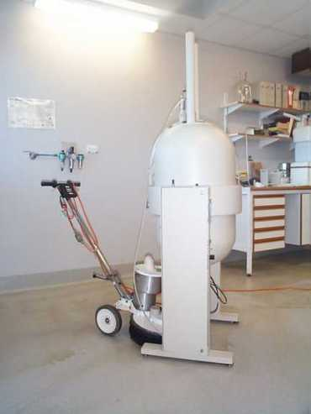
Figure 1. What can happen when metal gets too close to the magnet.
Medical Implants
The operation of electronic,electrical or mechanical medical implants, such as cardiac pacemakers, biostimulators, and neurostimulators may be affected or even stopped in the presence of either static or changing magnetic fields. Medical implants such as aneurysm clips, surgical clips or protheses may contain ferromagnetic materials and therefore would be subjected to strong attractive forces near the magnet. This could result in injury or death. Additionally, in the vicinity of rapidly changing fields (pulsed gradient fields), eddy currents may be induced in the implant resulting in heat generation.

Rules:
- Persons with these types of implants MUST remain outside the NMR laboratories until more extensive safety training is provided.

Cryogen Hazards
Cryogens such as liquid nitrogen (LN2) and liquid helium that are present in the magnet cryostat and portable dewars may pose several dangers, including asphyxiation, frostbite and chemical explosions. A) When a magnet quenches, or suddenly becomes non-superconducting, large amounts of liquid cryogens are quickly vaporized. Here is a video of a magnet quenching. Due to their large expansion ratios (nitrogen 695:1, helium 760:1), these gases can quickly displace all the oxygen in the NMR room and cause asphyxiation. Effects from oxygen deficiency become noticeable at levels below ~18% and sudden death may occur at ~6% oxygen content by volume. B) Direct contact with cryogenic substances in liquid or vapor form can produce “cold burns” on the skin similar to conventional burns. The temperature of liquid helium is -269 C and of liquid nitrogen is -196 C. C) Cryogenic fluids with a boiling point below that of liquid oxygen are able to condense oxygen from the atmosphere. Repeated replenishment of the system can thereby cause oxygen to accumulate. Violent reactions, e.g. rapid combustion or explosion, may occur if the materials, which make contact with the oxygen, are combustible.

Rules:
- If you observe a sudden exhaust of gas from a magnet (and NMR staff are not performing a cryogen fill) or if the oxygen sensor alarm sounds, EXIT the NMR laboratory IMMEDIATELY.
- NMR staff periodically must replenish the magnet’s cryogens. During a fill, keep away from the gaseous exhaust from the magnet as frostbite burns may result.
- When handling cryogens, wear gloves, googles, and closed toe shoes.

