Indigenous Environmental Studies/Sciences

Annual Report
September 2015 – April 2016
Abstract
This report provides an overview of the program including biographies of the faculty and staff, course descriptions and highlights from the program events throughout the year.

Contact Information
For information regarding this report or the program, please visit the IESS website or contact us at ies@trentu.ca or contact one of our faculty/staff:
Dan Roronhiakewen Longboat, BA (Trent), MES, PhD (York)
Program Director, Associate Professor
Phone: (705) 748-1011 ext. 7844
E-mail: dlongboat@trentu.ca
Office: GCS 302
Chris Furgal, BSc (UWO), MSc, PhD (U of Waterloo)
Associate Professor
Phone: (705) 748-1011 ext. 7953
E-mail: chrisfurgal@trentu.ca
Office: GCS 303
Dorothy Howard, BSc (McGill), MSc (Trent)
Scientific Support
Phone: (705) 748-1011 ext. 7426
E-mail: dhoward@trentu.ca
Office: ESC C201.1
Note: Requests for alternative accessible formats or supports can be sent to access@trentu.ca.

Table of Contents
Indigenous Environmental Studies/Sciences 0
Annual Report 0
Contact Information 1
Table of Contents 2
Greetings from the Director 4
Faculty and Staff Biographies 5
Faculty and Staff 5
Teaching Assistants 7
Program Staff 10
First Peoples House of Learning (FPHL) 10
Course Descriptions and Highlights 11
Foundations in Indigenous Environmental Studies and Sciences: 1001H 12
Introduction to Indigenous Environmental Studies: INDG – ERST 2601Y 13
Issues in Indigenous Environmental Studies: ERST–INDG 3631Y 13
International Issues in Indigenous Environmental Studies: ERST–INDG 3632Y 13
Introduction to Indigenous Food Systems: INDG – ERST 3634H – 14
Sustainable Indigenous Communities: INDG – ERST 4730Y 14
Advanced Topics in Indigenous Peoples’ Health and the Environment: INDG – ERSC/ERST – NURS 4740Y 14
Environmental Assessment Techniques for Indigenous Communities: ERSC –INDG 2150H 15
Indigenous Peoples Health and the Environment: ERSC / ERST- INDG 3730Y 15
Practicum Field Placements: INDG 3860Y 16
Reading Course: ERSC/ERST – INDG 3900Y, 3901H, 3902H 16
Thesis: ERSC/ERST – INDG 4020D 16
Program Growth 17
Figure 1. Total number of students in IESS core courses from 2000-2015 17
Table 1. IESS declared majors and graduating students 2011-2015 18
Table 2. Core Course Enrollment. 18
IESS Event Calendar 2015-2016 19
Igniting the Sacred Power of Creation: IESS Conference 19
Trent Temagami Colloquium – September 24^{h}-27th, 2015 20
Annual Welcome Event and Corn Lying Workshop- October 8th 2015 21
TIESS (Trent Indigenous Environmental Studies/Science) General Meeting Thursday January 21st, 2016 21
End of Semester Feast- Celebrating the corn harvest of 2015 22
Northern Studies Colloquium – Thursday March 12^{th,} 2016 22
Career Day with MNRF and other Guests– Thursday March 26th, 2016 22
Sacred Water Circle – May 6th-8th 2016 23
Resource & Tutoring Centre 24
TRACKS (Trent Aboriginal Cultural Knowledge and Science) Youth Program 25
Student & Alumni Achievements, Awards & Happenings 28
Alumni Profile 28
Student Survey Highlights 30
Q:“What attracted you to the IES program? Or what made you choose IES as a major.” 30
Looking Ahead… The Future of Indigenous Environmental Studies/Sciences 32
Funders, Supporters and Partners 33

Greetings from the Director
Shé:kon Sewakwé:kon,
Greetings everyone,
As the Director of the Indigenous Environmental Studies/Sciences program, I send you warm greetings and I’m very pleased to present you with the IESS Annual Report for 2015-2016.
We’ve had an active year with lots of new and exciting things happening in our program. As you may have noticed, we have updated our program name to incorporate the scientific aspects of our program and to reflect both the Bachelor of Science in Indigenous Environmental Science and the Bachelor of Arts in Indigenous Environmental Studies. I am also pleased to have introduced the new IESS course, under our own course code IESS 1001: “Foundations of Indigenous Environmental Studies/Sciences,” which was a great success. I am very pleased introduce this course as it provides students with the basis of Indigenous Environmental Knowledge and complements IESS courses of all levels.
This spring we held our first IESS Conference Re-igniting the Sacred Power of Creation: Essential Knowledges for Transformative Action, which brought many Knowledge Holders, teachers and participants from all over the world. This conference was the first of its kind and highlighted the work being done by Indigenous Nations and their partners to protect the natural world and also created dialogue with participants to map out next steps for the field of Indigenous Environmental Studies/ Sciences at Trent, across Turtle Island and around the world.
The students and faculty of the IESS program have initiated many new opportunities and expanded on past initiatives that have offered students new and exciting ways to be involved in the IESS program. These initiatives include the founding of a new student group called TIESS, the creation of new events and the development of new partnerships. The numbers of students in IESS courses are the highest we’ve seen.
This past year, we have had a number of events inviting guest speakers who have inspired our students in a number of ways. We continue to grow and learn through the nature of our program. We’re glad to be able to share this report that outlines everything we have accomplished in the past year. At this time, I would like to thank each and every one of the students, faculty members, teaching assistants, administrators, and supporters in our program. Your hard work and commitment to building IESS is greatly appreciated and we wouldn’t be here without you!
Skennenhatye
— Dan Roronhiakewen Longboat

Faculty and Staff Biographies

Faculty and Staff
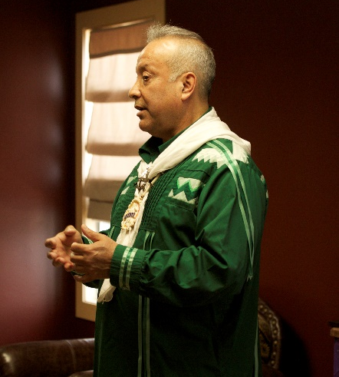

Dan Longboat, PhD – Program Director & Associate Professor
Dr. Dan Longboat Roronhiakewen (He Clears the Sky) is Mohawk from the Six Nations Territory on the Grand River. He is Director of the Indigenous Environmental Studies/Sciences Program at Trent. Dan is known for his Haudenosaunee cultural knowledge and has taught Haudenosaunee culture at Trent in addition to his developmental work and teaching in Indigenous Environmental Studies. He was also the first Director of Studies of the Indigenous Studies Ph.D. program. Dan completed his Ph.D. in Environmental Studies at York University and continues to lecture and teach across the country on Indigenous environmental issues, education and Indigenous knowledge.
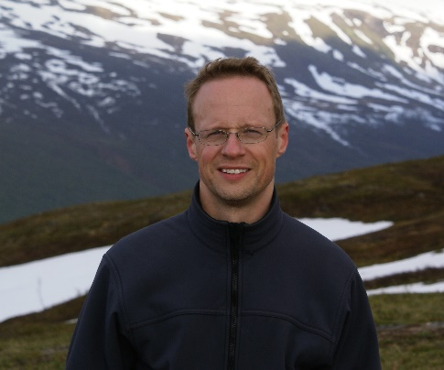

Chris Furgal, PhD – Associate Professor
Chris Furgal is an Associate Professor in the Indigenous Environmental Studies Program at Trent University in Peterborough, Ontario. He is cross-appointed to the Departments of Indigenous Studies and Environmental Resource Studies and Sciences and is Director of the Health, Environment and Indigenous Communities Research Group and co-Director of the Nasivvik Centre for Inuit health and changing environments. His teaching and research interests are in the areas of Indigenous environmental health and science-Indigenous knowledge interaction. He has been working with Arctic Inuit communities and organizations on issues of environmental health for over 20 years. He was on sabbatical from July 1, 2014 to June 30, 2015 and was therefore not teaching this year.
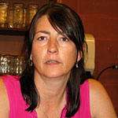

Dorothy Howard, MSc – Scientific Support
Dorothy is involved in supporting all IESS courses. She provides lab and scientific support, as well as the coordination of events and advises academic planning for IESS students. Her environmental interests include the chemistry of aquatic environments and potable groundwater supplies. Her main passion in life is animal rights. Dorothy is currently working on her Ph.D. at Trent University.
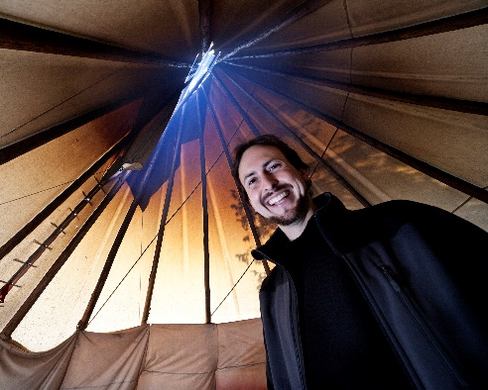

James Wilkes – Instructor
James Wilkes is a cultural ecologist, educator, and photographer who is dedicated to social and environmental justice, Indigenous and Canadian rights, land protection and biodiversity, as well as decolonization, re-humanization and knowledge revitalization. His educational and experiential background is rooted in diverse understandings of the environment, coupled with interests in politics, science, spirituality and knowledge system interaction. James is an instructor in the Indigenous Environmental Studies Program at Trent University, as well as a course instructor in the Ecosystem Management and Ecological Restoration Programs at Fleming College.

Teaching Assistants

Kristeen McTavish – Teaching Assistant
Kristeen is a current graduate student in the Sustainability Studies program at Trent University in Peterborough, Ontario. This year, she was the teaching assistant (TA) for the Indigenous Peoples Health and the Environment course. Previously, Kristeen held the position of the Nasivvik Centre coordinator, and has worked on various environmental health projects in Inuit communities within the HEIC (Health, Environment and Indigenous Communities) Research Group over the past 5 years. Her current research interests include food security, community decision making around complex public health issues and youth health and engagement of youth in health research. In her spare time, you are likely to find her outside practicing with her bow, or with her camera.
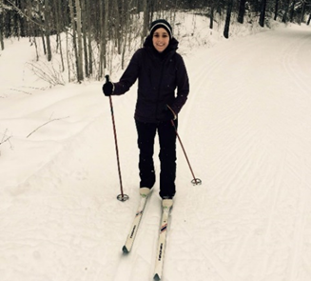

Tessa Nasca – Teaching Assistant
Tessa Nasca is a Teaching Assistant for Sustainable Indigenous Communities, a fourth-year IESS course. Tessa is also a student in the MA Sustainability Studies Program, and a recent graduate from the IESS program. She is grateful for the opportunity to TA alongside Dan Longboat, and is continually learning from the students in the course. Tessa has strong research interests linked to transportation, urban planning and sustainability.

Carly Armstrong – Teaching Assistant & Resource Centre
Carly has worked with Indigenous Nations and organizations in the environment sector as an educator, communicator, researcher, project coordinator and activist for over a decade. Her Master’s research explored teaching troubling and complex environmental issues and generated guiding principles for environmental education that aims to empower and give hope to learners.
As a doctoral student in Indigenous Studies, Carly is broadening her understanding of Indigenous Knowledges, perspectives and approaches to cross-cultural collaboration and applying this to the development of educational curriculum and professional development training that will engage learners in understanding how to go about respectful engagement in cross-cultural work that brings together multiple knowledge systems toward addressing environmental issues. In her spare time she loves to garden and spend time outside with friends and family hiking, paddling and swimming.
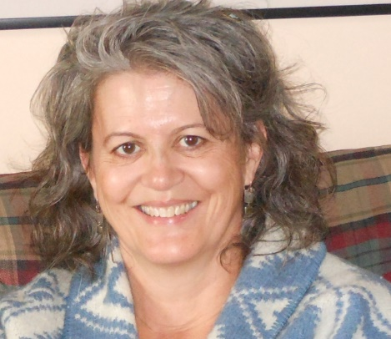

Barbara Wall Potter – Teaching Assistant & Resource Centre Staff
Barbara, Bodwewadmii Anishinaabekwe is Citizen Band Potawatomi of Shawnee, Oklahoma. She is a Professional Engineer with over ten years of experience in consulting engineering and nearly twelve years of experience in teaching algebra and earth, environmental and physical science. Her approach in teaching middle school students is on utilizing Indigenous pedagogies. Her Ph.D. research will focus on uncovering and restoring Bodwewadmii women’s Indigenous Knowledge and traditional responsibilities surrounding water.
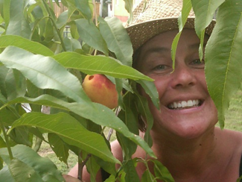

Paula Anderson – Teaching Assistant
Paula Anderson is the teaching assistant for INDG/ERST 3634H (the Introduction to Indigenous Food Systems) course in the IESS Program and is an instructor in Trent’s Sustainable Agriculture and Food Systems Program. She is an organic vegetable grower, community food-system developer, avid seed saver, urban maple tree tapper and manomiin (wild rice) harvester. She has an MSc in sustainable systems design, with focus on sustainable agriculture and permaculture and is presently working on her PhD in Indigenous Studies. Her focus is on the bio-cultural revitalization of the manomiin-based food system in the Kawartha Lakes Region as a strategy for restoring Indigenous Food Sovereignty.

Lindsay Thackery
Lindsay completed her undergrad at Trent in the Environmental Science and Studies program, and was able to take a number of IESS courses as a part of her degree. These were some of her favourite courses at Trent, and she is glad to be able to remain a part of the program as a TA.
Lindsay has just completed her first year in the M.A. of Sustainability Studies Program, and is completing a thesis under the supervision of Dr. Chris Furgal. Her project uses the Arctic region of Nunavik as a case study to examine the association between identified policy challenges in food and food-related policy, and the high prevalence of household food insecurity in the region.

Program Staff

Emily King
Emily is entering into her fourth year of IESS. She is always looking to expand her IESS experience through various opportunities. Emily is the event coordinator for the IESS program. She always looks forward to engaging the IESS community through organizing various events throughout the year. Emily is a Metis student who has her goals set on perusing a career in law and policy. In her spare time Emily enjoys exploring Ontario by canoeing and hiking.

First Peoples House of Learning (FPHL)
IESS is pleased to have a strong working relationship with the First Peoples House of Learning (FPHL). FPHL provides innovative support programming for Indigenous students to both Peterborough and the Oshawa campus. It provides numerous weekly and monthly Traditional teachings, Pine Tree lectures and cultural events for student learning. In addition FPHL provides counselling and cultural advisor service, academic supports, peer mentoring and tutoring, workshops and Peer ambassadors. We urge all IESS students to connect with and become involved with FPHL.
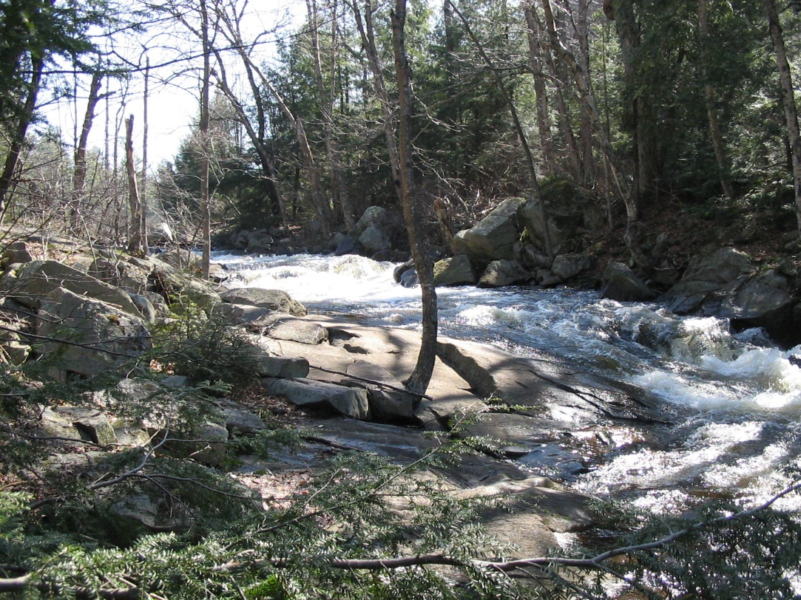

Course Descriptions and Highlights
Indigenous Environmental Studies and Sciences offers a variety of courses for students interested in bringing together Indigenous and Western science to address complex environmental issues. Students interested in exploring these issues are recommended to take the introduction course to IESS (INDG-ERST-2601Y), taught by Prof. Dan Longboat.
Although here we only discuss the IESS core courses, students are able to take a wide range of courses that are cross-listed with other programs, or from an enriched interdisciplinary educational offering such as Indigenous Studies, Environmental Science/Studies, International Development Studies, Sustainable Agriculture and Food Systems, Biology and Business in order to complete a degree in IESS.
We have provided descriptions of all the core courses in IESS, and given an overview of some of the key highlights from each of the courses this year, including notable guest speakers and events. For more detailed information on IESS courses please see our website.
Course Title | Course Code | Instructor
Foundations in Indigenous Environmental Studies and Sciences | IESS-1001H | Dan Longboat
Introduction to Indigenous Environmental Studies | INDG – ERST 2601Y | Dan Longboat
Environmental Assessment Techniques for Indigenous Communities | ERSC –INDG 2150H | Eric Sager
Issues in Indigenous Environmental Studies | ERST–INDG 3631H | James Wilkes
Global Issues in Indigenous Environmental Studies | ERST–INDG 3632H | James Wilkes
Introduction to Indigenous Food Systems | INDG – ERST 3634H | Dan Longboat
Indigenous Peoples Health and the Environment† | ERSC/ERST- INDG 3730Y | Chris Furgal
IESS Practicum Field Placements | INDG 3860Y | Faculty
IESS Reading Course | INDG 3900Y, 3901H, 3902H | Faculty
Thesis | ERSC/ERST – INDG 4020D | Faculty
Sustainable Indigenous Communities | INDG – ERST 4730Y | Dan Longboat
Critical Investigations in Indigenous Peoples’ Health and the Environment† | INDG – ERSC/ERST – NURS 4740Y | Chris Furgal

Foundations in Indigenous Environmental Studies and Sciences: 1001H
Course Instructor: Dan Longboat
Teaching Assistant: Danielle Harris

Description:
This course provides essential foundational learning for students in Indigenous Environmental Studies and Sciences while providing benefits to students enrolled in Indigenous Studies and Environmental Resource Studies and Science courses. Students gain a solid grounding in material that will be built upon in later years of study, including research methods, writing and referencing, and oral learning and effective communication. The course is designed to provide students with basic grounding and competency in academic approaches used in IESS: methods and theories and in particular the awareness of and respect for different knowledge paradigms. Within the course students develop their understanding of the importance of reflection and self-awareness, familiarity with nature-as-teacher, integrative and collaborative approaches to learning, critical and analytical thinking, research approaches and protocols, scientific methods, political and policy awareness, community-oriented research and applications of these approaches.

Introduction to Indigenous Environmental Studies: INDG – ERST 2601Y
Course Instructor: Dan Longboat
Teaching Assistant(s): Carly Armstrong and Bill Moss

Description:
Explores Indigenous worldviews, environmental philosophies, and cultural values through exposure to the perspectives of Indigenous Elders, community people, political leaders, academics, activists, and scholars. Students will be introduced to Indigenous knowledge as it pertains to the natural environment.

Highlights:
As always, INDG/ERST 2601 was an extremely popular course, with our highest enrolment to date at just over 70 students in the course. The students were introduced to Haudenosaunee Knowledge Foundations and beliefs about the environment and were visited by many fantastic guest lecturers in both lectures and seminars to provide grounding in Anishinaabeg philosophies, practices and beliefs as well as Indigenous Knowledge from around the world. Seminar activities included trips to the tipi, water ceremony, classes outside on the teaching rocks, in-depth discussions and dialogue. For the second year running we had a series of student-facilitated seminar, which provided a great diversity of activities and approaches to learning.

Issues in Indigenous Environmental Studies: ERST–INDG 3631Y
Course Instructor: James Wilkes

Description:
Examines a wide range of contemporary environmental issues, conflicts and solutions in the context of Indigenous peoples and territories. Studies will examine issues at local, provincial, and national levels, highlighting the multi-dimensional perspectives of Indigenous peoples in North America.

International Issues in Indigenous Environmental Studies: ERST–INDG 3632Y
Course Instructor: James Wilkes

Description:
Explores the international dimensions of Indigenous Environmental Studies (IES) and examines a wide range of contemporary environmental issues, conflicts, and solutions in the context of Indigenous peoples and territories throughout the Americas and worldwide.

Introduction to Indigenous Food Systems: INDG – ERST 3634H –
Course Instructor: Dan Longboat
Teaching Assistant: Paula Anderson

Description:
Provided students with the opportunity for self-directed research that examined the food systems of Indigenous peoples. Students were enabled to explore a wide range of historical and contemporary food systems, practices and issues that impacted Indigenous communities and their connections to the ecosystems that support them.

Sustainable Indigenous Communities: INDG – ERST 4730Y
Course Instructor: Dan Longboat
Teaching Assistant(s): Tessa Nasca

Description:
A research colloquium course that gave students an opportunity to examine concepts of sustainability, select their own research area, and develop a model for a “sustainable” community. Provided insight into Indigenous understandings and environmental impacts, and encouraged a multidisciplinary approach to resolving issues.

Advanced Topics in Indigenous Peoples’ Health and the Environment: INDG – ERSC/ERST – NURS 4740Y
Course Instructor: Chris Furgal

Description:
A critical examination of historical and contemporary issues in Indigenous peoples’ health with a particular emphasis on the relation to land and other dynamic environments as a determinant of health status. Provided a basic foundation in understanding the key determinants of health for Indigenous peoples in Canada and around the world.

Environmental Assessment Techniques for Indigenous Communities: ERSC –INDG 2150H
(not offered in 2015-2016)

Description:
This two week residential field course is designed to provide students with appropriate western scientific theory and basic scientific skills to address environmental assessment and natural resource issues frequently encountered on Indigenous lands and Treaty areas.

Indigenous Peoples Health and the Environment: ERSC / ERST- INDG 3730Y
Course Instructor: Chris Furgal
Teaching Assistant: Lindsay Thackery

Description:
Provides an introduction to the multidisciplinary field of environmental health and its application to understanding health among Indigenous peoples. Students gain an understanding of the concepts, theories, and methods used in environmental health, and apply this knowledge to the investigation of the changing health status of Indigenous populations. This course may be taken as a science credit by successfully undertaking an appropriate technical assignment.

Highlights
This course provides students with an introduction to the multidisciplinary field of environmental health, and its relationship to understanding health and changing health status among Indigenous peoples. It consists of one weekly two-hour lecture followed immediately by a one-hour seminar. During the lecture, students are taught basic concepts, theories and methods used in environmental health, and during seminars they apply this knowledge to investigate the role of environment in the changing health status of Indigenous populations around the world.
During the winter semester, students conduct a mock environmental health management and communication group assignment over a number of weeks. They are given a hypothetical situation of a First Nations community approaching them with specific environmental health concern. They must investigate and manage the issue using the skills obtained in the course. This is an immersive and intensive assignment meant to give students experience with community environmental health management.
A number of guest speakers also visit this class throughout the year. During the 2015/2016 academic year, students were lucky to learn from Elder Bea Shawanda, who taught about community development and cultural enrichment, Pat Etherington Sr. and Frances Whiskeychan, who taught about healing and reconciliation, and Joe Pitawanakwat, who taught about traditional plants and medicines.
As this is a comprehensive course exploring knowledge from various disciplines, it is open to students from a variety of academic backgrounds, including Environmental science/studies, Indigenous studies, and Nursing. Students may choose to complete this full-year as a science or a studies credit, with different assignment requirements depending on which option is chosen.

Practicum Field Placements: INDG 3860Y

Description:
An opportunity for students to apply learning in a field setting, reflecting student interests and the availability of agencies willing to take students. Learning about development and culture was dialectical, through experience (action) and reflection on experience. It was formal and informal, and at many levels (personal, interpersonal and community).

Reading Course: ERSC/ERST – INDG 3900Y, 3901H, 3902H

Description:
Intended for third-year majors and for second-year students who wish to carry out independent research on a specific topic outside the scope of currently offered courses. Reading courses, supervised by a faculty member, allow students to learn more about a topic they are passionate about and perhaps have not been exposed to previously. Details must be arranged with the Chair of the Department before the end of the preceding academic year. Student reading courses in IESS typically cover topics such as land claims, resource management, Indigenous plants and medicines, climate change, Indigenous health and well-being, and community sustainability.

Thesis: ERSC/ERST – INDG 4020D

Description:
This is a double credit research course in which students produce a thesis at the year end. An in-depth study in library or field-oriented research supervised by a Research Project Committee, for which a double fee is charged. Details must be arranged with the Chair of the Department before the end of the preceding academic year. In many cases students enrolled in the course use their undergraduate thesis as a foundation for their advanced study at the Masters Degree level.
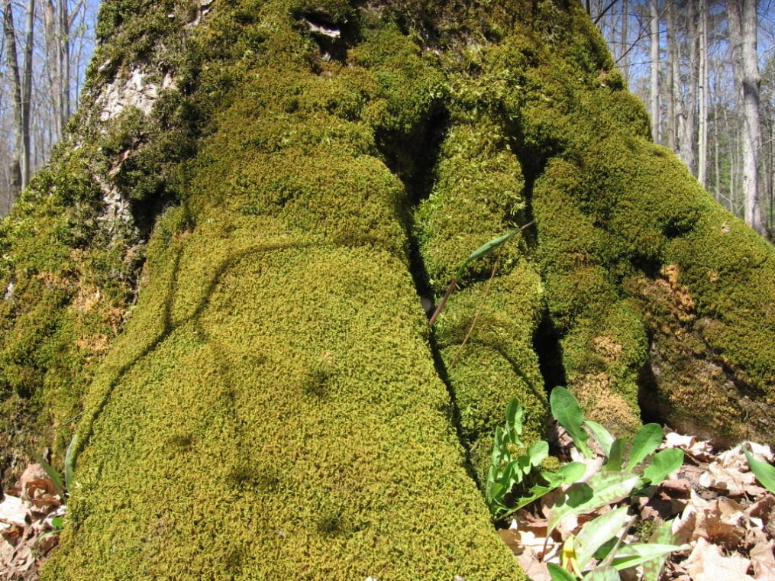

Program Growth

Figure 1. Total number of students in IESS core courses from 2000-2015

Table 1. IESS declared majors and graduating students 2011-2015
Year | IESS Majors | Diploma | Graduated
2011-12 | 18 | N/A | 7
2012-13 | 24 | N/A | 5
2013-14 | 29 | plus 2 IESP | 11
2014-15 | 29 | plus 3 IESP | 5
2015-16 | 27 | plus 2 IESP | 12

Table 2. Core Course Enrollment.
IESS Core Course # | 2011-12 | 2012-13 | 2013-2014 | 2014-2015 | 2015-2016 | Total | Average
INDG/ERST2601Y | 52 | 49 | 51 | 57 | 73 | 209 | 56
INDG/ERST3630Y | 10 | 12 | 17 | 26 | 25 | 65 | 18
INDG/ERST3634H | 30 | 54 | 45 | 65 | 70 | 194 | 53
INDG/ERST/SC3730Y | 16 | 11 | 24 | N/A | 14 | 51 | 16
INDG/ERST4630H | 11 | 14 | N/A | N/A | N/A | 25 | 13
INDG/ERST4730Y | 26 | 19 | 30 | 21 | 26 | 96 | 24
IESS 1001H | N/A | N/A | N/A | N/A | 20
4200/4600/4740 | 13 | 7 | 13 | 18 | 2 | 51 | 11
TOTAL | 158 | 166 | 180 | 187 | 230 | 691 | 184
Note INDG/ERST3630Y became two half courses (3631H,3632H) this academic year.
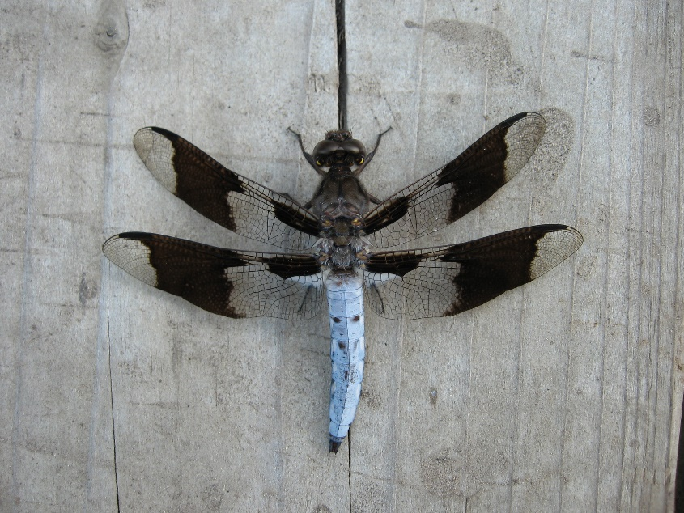

IESS Event Calendar 2015-2016

Igniting the Sacred Power of Creation: IESS Conference
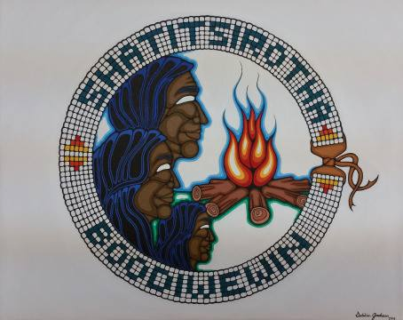
In recognizing the social and spiritual roots of the current global environmental crisis, we gathered to engage people with original teachings as medicine for restoring our sacred relationships with life, land, air and water. The conference goal was to create pathways for transformative action by honouring our diverse roles and shared responsibilities through knowledge collaboration across disciplines and traditions. The conference empowered participants by rebalancing principles, values, and revitalizing practices for the continuation and strengthening all Life.
This conference, the first of its kind in North America, focused on bringing together Indigenous teachings and Traditional Knowledge with a specific focus on addressing complex environmental challenges. Conference participants engaged in keynote addresses, workshops, panel discussions, plenary sessions and break out action groups to learn from Indigenous Knowledge Holders and develop plans for addressing environmental issues. Re-igniting the Sacred Power of Creation brought together Indigenous and non-Indigenous thinkers in the environment sector, Youth and Elders to create a unique dynamic not often experienced at academic conferences.
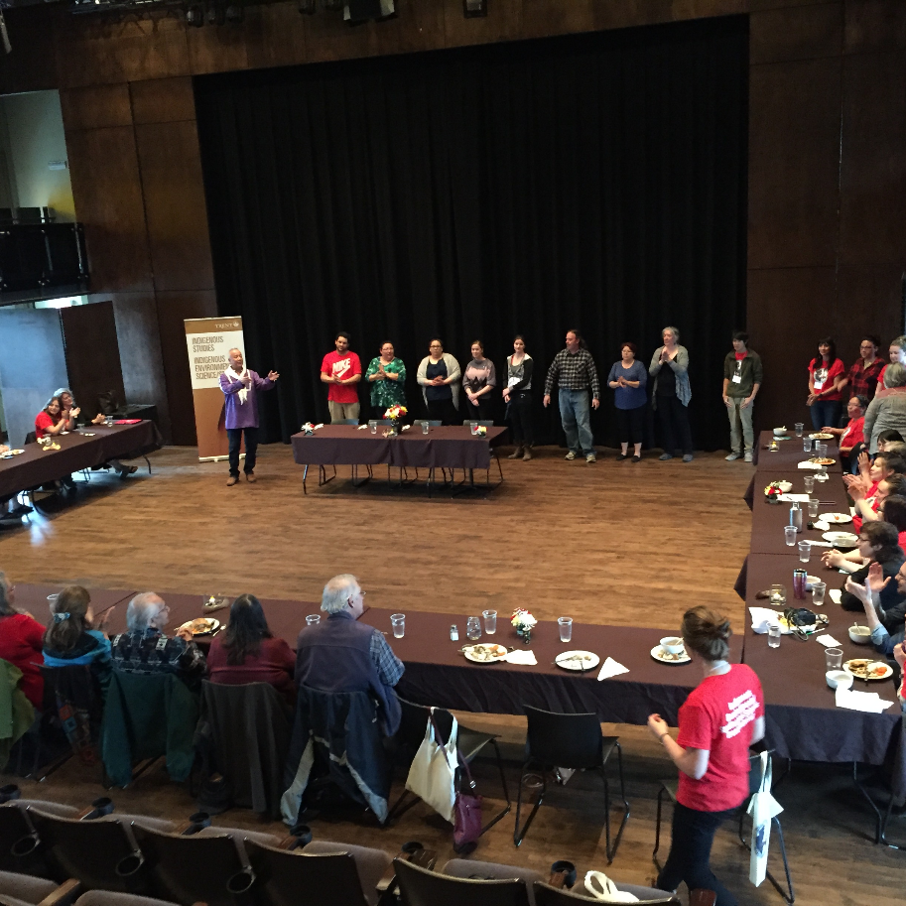
Our keynote speakers included Manulani Aluli-Meyer, Robin Wall Kimmerer, Tommy Porter and Vandana Shiva. We also had many other honoured guests including Sylvia Plain, Diane Longboat, Edna Manitowabi, Deb McGregor and Norma General.
The IESS community was extremely busy this year not only preparing for the first IESS conference but also with other events. Each year IESS hosts different events that encourage students, faculty and guests to gather and learn together. It is not uncommon to see these events accompanied by food as the IESS community rarely meets without some sort of food nearby be it catered or pot luck style. This year IESS introduced a few new events and built on some traditional events as well.

Trent Temagami Colloquium – September 24^{h}-27th, 2015
Every fall since 1973 a group of students and faculty, along with a mélange of alumni and community members, have traveled to Temagami to discuss and examine the human experience of the Land, particularly through the lenses of Indigenous, Canadian and environmental issues.
This year the colloquium took place on the weekend of September 24th- 27th. Some of the activities included day hikes, canoeing, and a special Screening of Six Miles Deep, and discussion with filmmaker Sara Roque.

Annual Welcome Event and Corn Lying Workshop- October 8th 2015
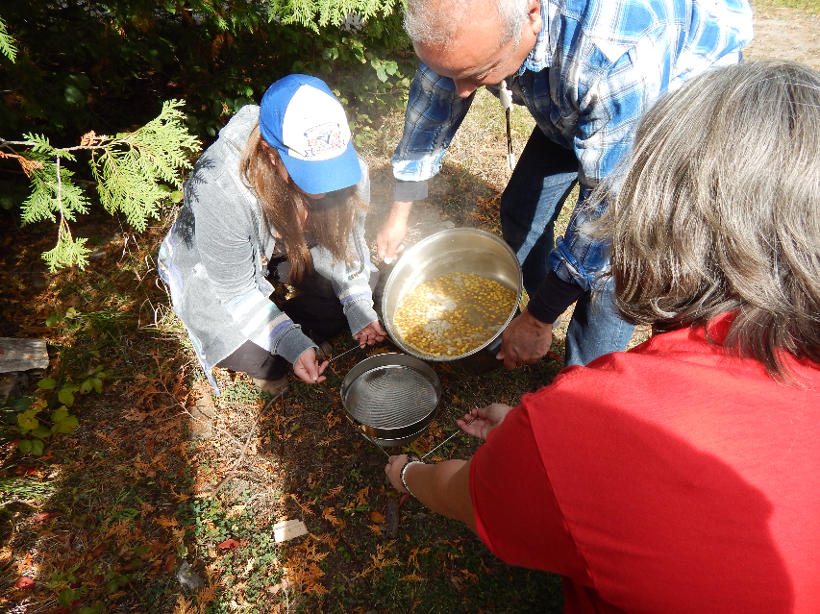
This year’s annual welcome event was partnered with the Corn Lying workshop. This event brought over 50 students out to learn about teachings and practices of Corn Lying from and Indigenous ways of corn preservation from Terrlynn Brant. The corn lying workshop took place in the afternoon with the feast following. This annual event is held to encourage new IESS students to meet with other students, staff and faculty as well as other community members. This event is a very popular event and is always accompanied by delicious food. This year Gary Williams catered the event and incorporated corn within the dishes. This event was one of the most attended events of the year.

TIESS (Trent Indigenous Environmental Studies/Science) General Meeting Thursday January 21st, 2016
The TIESS Meeting was held so the program director, Dan Longboat could talk to all students that are involved in TIESS as well as to plan upcoming events in the New Year. Students and helpers gathered to discuss potential upcoming events that included the career day event. The students also discussed the student group organization and roles.
Dan Longboat thanked the students for leading the student group and offered words of encouragement for the upcoming year. Dan is keen on giving students the opportunity for jobs and career development once they graduate, especially with the unique degree they have earned so he is very encouraging of the career day event held annually and was excited TIESS decided to head the event along with the program, this year. This event was held with the addition of a potluck style meal for the participants to enjoy.

End of Semester Feast- Celebrating the corn harvest of 2015
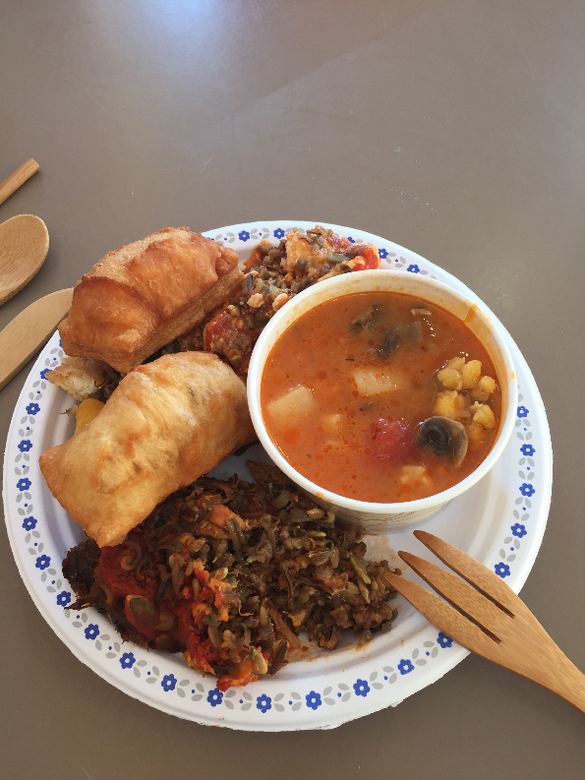
This event was for all IESS students, faculty and staff. Many people attended the event, with everyone enjoying the food. Dan Longboat spoke briefly at the beginning thanking everyone for a wonderful semester. Following this, guests spoke in small groups with each other and IESS faculty. It was a wonderful get-together where all students could interact and enjoy some excellent food before leaving for the holidays.
This year we followed the theme of corn and enjoyed dishes with corn from the harvest earlier in the fall. Gary Williams who brought a delicious array of food for everyone to enjoy catered the event.

Northern Studies Colloquium – Thursday March 12^{th,} 2016
IESS was happy to support the Trent Northern Studies Colloquium again this year. The colloquium is run by a volunteer committee of students to showcase northern research being conducted by undergraduate and graduate students at Trent and to exchange ideas regarding their involvement in, and the future, of research in the North.

Career Day with MNRF and other Guests– Thursday March 26th, 2016
This year was the third year for the IESS career day event. A group of students came out to hear from a variety of speakers including government and environmental organizations to discuss careers within the IESS realm. Similar to last year, there was a great focus on resume and cover letter writing through the Tent career centre, which gave students useful tips on how to succeed in the job application process.
Speakers:
- Joe Pitawanakwat,
- Mary Goldsmith – Trent Career Centre
- Jackie Oulette– Strategic and Indigenous Policy Branch MNRF
- Heathyr Francis – TRACKS

Sacred Water Circle – May 6th-8th 2016
IESS and TRACKS (Trent Aboriginal Cultural Knowledge and Science, youth program) provide support for the Sacred Water Circle – a not-for-profit initiative that has brought together Indigenous and non- Indigenous people to work together for the benefit of water. The initiative leads with spirituality- but also recognizes the necessity of working with science and policy to promote positive change in how we live with water.
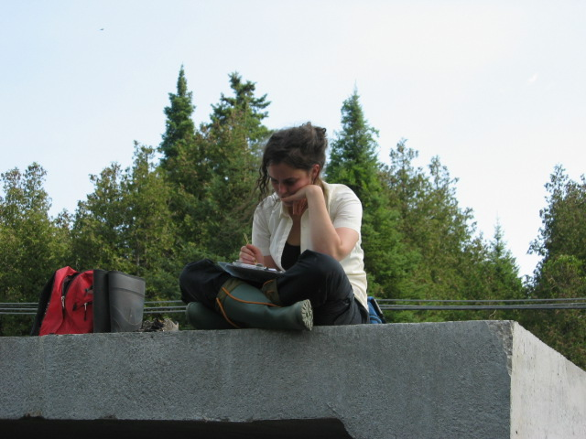

Resource & Tutoring Centre
Resource & Tutoring Centre The IESS Resource Centre, open six hours per week on a drop-in basis, serves students enrolled in IESS courses by providing IESS-specific resources and tutoring. Resources included DVDs, journals, textbooks, field guides, and books. Tutoring and access to resources is also available by appointment. Graduate students involved in IESS-related research staff the Centre, located in the Kawartha World Issues Center. The Centre’s unique resources are not available from the University Library and include a growing collection of primary source Haudenosaunee, Anishinaabe, and Inuit Indigenous Knowledge books; Indigenous research methodologies texts; healing and health related sources; and sources focused on environmental issues impacting Indigenous communities in Canada, and throughout Turtle Island and the world. This year (2015-16) the centre was used by a diversity of students, reporting nearly 60 visits in total. Students visited the centre to seek out and borrow useful resources, to get help on material and assignments for their courses, for tutoring in related courses, and to get advice on courses and programs.

TRACKS (Trent Aboriginal Cultural Knowledge and Science) Youth Program
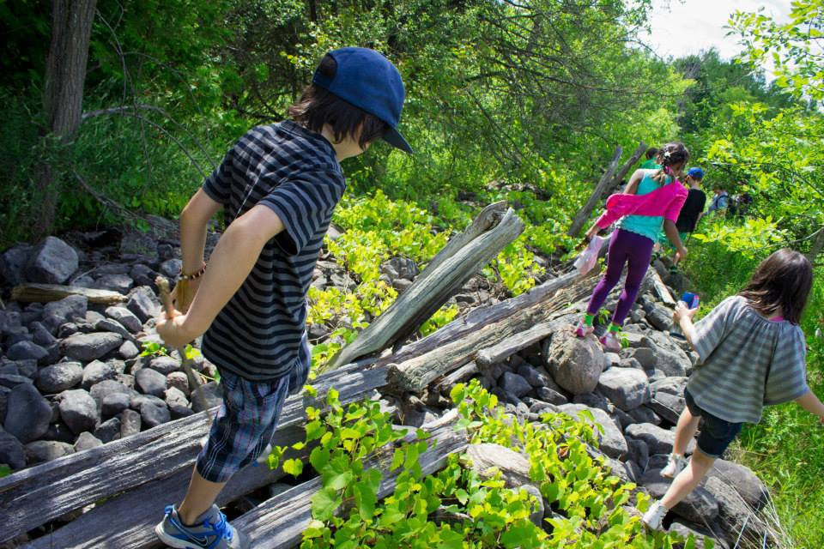
By Robyn Smith, Program Coordinator
TRACKS is a youth outreach program run in partnership with Indigenous Environmental Studies/Sciences and the Kawartha World Issues Centre. We deliver science programming with an Indigenous-and-environmental approach, working closely with our First Nation partner communities, Trent University and affiliated groups, and local school boards. We partner with a number of community-based organizations including the Canadian Canoe Museum, Farms at Work, Peterborough Green UP, Kawartha Turtle Trauma Centre, Camp Kawartha, Nogojiwanong Friendship Centre, and more!
2015/16 marked our busiest and most eventful year yet. We celebrated the end of our 2015 camp season with the exciting news that we’d been named one of five winners, and the only Canadian program, in the inaugural UL Innovation in Education Awards, administered by the North American Association of Environmental Educators (NAAEE). As well as a $25,000 prize, we’ve benefited immensely from the connections we’ve made to others in the program including a winners’ summit at UL headquarters in Chicago and quarterly check-ins with the other programs. In March, TRACKS hosted a team of NAAEE and UL representatives who attended and filmed our March Break programming, which will be included in a professional video featuring the five winning programs.
This award was not only an honour for our program but also an important recognition of a growing acknowledgement of the importance of Indigenous perspectives within scientific conversation. Inspired by this, we were off to a great start as school started in September and we ramped up our volunteer recruitment efforts.
2015/2016 saw TRACKS focusing on Trent relationships, particularly with students. We attended a number of outreach events at the beginning of the school year and implemented a volunteer recruitment strategy involving events, classroom visits and extensive promotion. We hosted several volunteer orientation sessions and a well-attended plant medicinal workshop with Joe Pitawanakwat, a knowledge-holder from Manitoulin Island.
In April, in response to huge demand for workshops including a huge influx of high school request, we hired a fantastic team of occasional staff members. Four of these are IESS students (Keara Long, Sylvie Dasne, Alyssa Sgro and Emily King) and one from Indigenous Studies (Sherri-Anne Medema). Joe Pitawanakwat and Brendan Campbell, another IESS student, also joined us for several workshops. We were pleased with the high level of knowledge and expertise within our group, particularly within the sciences, and the high number of Indigenous youth bringing teachings from different Nations.
TRACKS continues to expand our teacher education program including through a third year as a partner in the TEACH Outside the Box program, where we supported four student teachers in placement opportunities with us and led a workshop for other teacher candidates. We also hosted two full-day training sessions with teachers in the Peterborough Victoria Northumberland Clarington Central District School Board, and once again presented at the Science Teachers’ Association of Ontario and the Ontario Association of Physics Teachers’ annual conferences.
After delivering 185 workshops that reached a total of 4500 kids in three different school boards as well as a variety of community organizations, we were off to another exciting summer season! This year we delivered camps in Hiawatha, Scugog, Curve Lake and Georgina Island First Nations, as well as three camps here at Trent University and two one-day field trips to the Petroglyphs and to the Unimin mine.
This busy season was made possible thanks to our fantastic summer team, comprised of Instructional Lead Heathyr Francis (B.Ed, B.Sc), Summer Camp Office Coordinator Sarah Day (Algonquin), completing her first year in Biology, Kevin Cardoso, entering his fourth year in Forensics, and Zachary James (Oneida), a returning staff member entering his first year at Trent in Computer Sciences.
Dawn Martin, who’s in the concurrent education program here at Trent and from Six Nations, was another staff member who worked to deliver educational programming as well as coordinate our Flint Corn Project, an educational Three Sisters garden project in partnership with Farms at Work. The garden hosted a number of volunteers as well as workshops with children and youth.
On top of managing a busy season of children’s and youth programming, the TRACKS team had some extra helpers to mentor this summer, as we embarked on the first stages of a Youth Leadership pilot to provide leadership and volunteer opportunities to six youth, former campers ages 14-16, looking to extend their TRACKS experiences. We hope to obtain funding to expand this program.
Through a partnership with PVNCCDSB, we offered two co-op credits and paid employment to four high school students considered socially, financially or educationally at-risk. This was a great learning opportunity for them as well as a huge benefit to our programming, and helped us explore what mentorship means at TRACKS.
As we wrap up our summer season we’re excited to be a part of the back-to-school festivities at Trent, where we will continue offering workshops and volunteer opportunities to students and staff, including as part of the TEACH Outside the Box program and the School of Education’s new Indigenous education initiatives.
Stay tuned for more updates as we continue to learn and grow! Find us on Facebook or visit the TRACKS website.
TRACKS 2016 at-a-glance:
Type | # Delivered | # of children | # of youth  18-25 | # of adults over 25
Workshops | 185 | 4500 | 85 | 310
Outreach | 13 | 1660 | 390 | 962
Camp | 7 | 125 | 5 | 10
Educators’ Training | 7 | N/A | 42 | 81

Student & Alumni Achievements, Awards & Happenings
- IESS Graduating Student Award – for B.A. in IESS. 2015-2016 D’Arcy Hutton
- IESS Graduating Student Award – for B.Sc. in IESS. 2015-2016 Alexandra Small
- IESS Award of Excellence (for graduating students or alumni)

Alumni Profile

Zoë Mager
Since graduating from Indigenous Environmental Studies with a Bachelor of Arts with honors, Zoë has worked on contracts with Kawartha Land Trust as a Program and Volunteer Coordinator, and with Alderville First Nation Black Oak Savanna as an Interpretive Garden Coordinator.
Zoë is now in the process of completing her Masters of Urban and Regional Planning through the Faculty of Environmental Studies at York University. Her graduate work focuses on how planners and municipalities can uphold treaty and constitutional responsibilities, to participate in meaningful consultation process with Indigenous communities as per the Duty to Consult and Accommodate.
She volunteers as the Education Group Coordinator with Shared Path Consultation Initiative, a collective of Indigenous and non-Indigenous planners, consultation staff, archaeologists, lawyers, academics, professionals and students who "work collaboratively to illuminate the intersection of Aboriginal & Treaty rights, and Indigenous interests, within the urban and regional planning process"
She:kon/Warm Greetings.

Hattie Edwards
My name is Hattie Edwards, I am a wolf clan member of the Mohawk Nation of Akwesasne and
I am a recent graduate from the Indigenous Environmental Science/Studies Program. I originally
chose Trent University for the IESS Diploma Program because it allowed me to transition from
high school to university as an Indigenous student without all the necessary university requirements. Furthermore, it provided me with the opportunity to earn credits towards a bachelor’s degree in IESS, once I completed the diploma program. After two years, I fell in love with the IESS program because of the teachings, skills, and traditional knowledge I was learning.
It aligned with who I am as an Haudenosaunee woman, my beliefs and way of life, providing me
the knowledge and skills to promote change in my community.
Overall, the IESS Bachelors program changed my life for the best! I became a part a community which helped me to better my life, rebuild my spirit and mind. I was given the tools necessary to begin creating a lifestyle that I am proud of. I learned about the importance to live and work for the power of creation. More importantly, I found my sense of responsibility as a woman which is to create life, and sustain life for future generations. I graduated from the IESS program knowing that life is sacred, and we are all on borrowed time, so we must walk gently on Mother Earth to ensure that life will continue.
I am currently working for a not-for- profit organization called Green Communities Canada and the Sacred Water Circle as the Youth for Water Program coordinator. This program has provided me with an opportunity to work directly with Indigenous youth who are interested in becoming environmental leaders in their communities within the Kawartha region. I am grateful for this position as it allows me to apply the teachings, skills and knowledge I have acquired from IESS.
Working as the Youth for Water program coordinator I am able to see a brighter future for myself and furthering my career in water sustainability, water policy and Indigenous Peoples. This position has helped me to find my passion in the environmental field and has pushed me to further my education. I intend on obtaining a master’s degree in sustainability studies focusing on water or agriculture. I intend on continuing on this journey to do meaningful work in promoting positive change in the society and the environment.
For me, life is a gift and every day is an opportunity to create positive relationships that will promote change. I honestly do not know where life will take me but I intend on following my heart because it has brought me many blessings in the last 27 years, and I believe it will continue to do so. Thank you for allowing me to share a part of my story and what I learned from the IESS program at Trent University.
Hattie Edwards

Student Survey Highlights
Student Comments Taken From the Annual Survey

Q:“What attracted you to the IES program? Or what made you choose IES as a major.”
A: Dan Longboat’s enthusiasm, love, and passion for the program, the courses, our Mother Earth, and the students.
A: The combination of two areas of study that have always interested me the most. Yet I was never able to find a way to connect both without having to do joint major or choose which to be my major and which to be my minor.
A: I listened to a teaching by Dan Longboat, and he explained what the IES program was and what it hoped to accomplish. I realised that the IES program reflects many of my feelings, and that it would teach me what I need to learn to be able to help the environment.
A: My personal interest in the environment and my culture
A: It seemed to align with my values, and promised to push me in different ways. As an individual who has always had an affinity for the environment, and not having a lot of knowledge about my Indigenous background or the knowledge of Indigenous peoples it seemed to be a good fit.
A: Environmental issues are rooted in Indigenous issues, and vice versa
A: I visited my partner at Trent last year and met with graduating students of the IES program. When we got talking about my goals and the work I have been doing since being out of College, I was unanimously told to study IES at Trent and that it would be a good place for me... After a lot of thought, I decided to go for it because I really appreciate Indigenous perspectives and teachings about the environment and have always felt like I understood their ways of interacting with nature more than the way other Canadians do it.
A: Dan Longboat is the short answer. Learning about Indigenous worldviews opened my eyes to how we should all be relating to each other and the earth
A: The IES program speaks to my own traditional ways, ways that were wiped out and made taboo by western education. It fits my need to get my science degree while reviving my spirituality. This is a perfect fit for me.
A: It aligned with all my values as a human being and what I consider to be our purpose and obligation on earth and Turtle Island. Which is restoring and giving back to Mother Earth who gives us so much and supporting the knowledge of Indigenous peoples as they know the route to this the best.
A: I love both Indigenous studies and Environmental studies and was so happy Trent had a program that included those two subjects.
A: I believe that indigenous knowledge is necessary for environmental stewardship, and environmental preservation is necessary for the health of Indigenous peoples. I think we need to unpack colonialism to deal with inequality and exploitation.
A: I was drawn to the style of teaching/learning and the course offerings. I also felt like it was an exciting, empowering course of study into how to come up with respectful, holistic solutions to Indigenous and/or environmental issues.
A: Being interested in both Indigenous and environmental science courses. Wanting to help make a difference in the world.
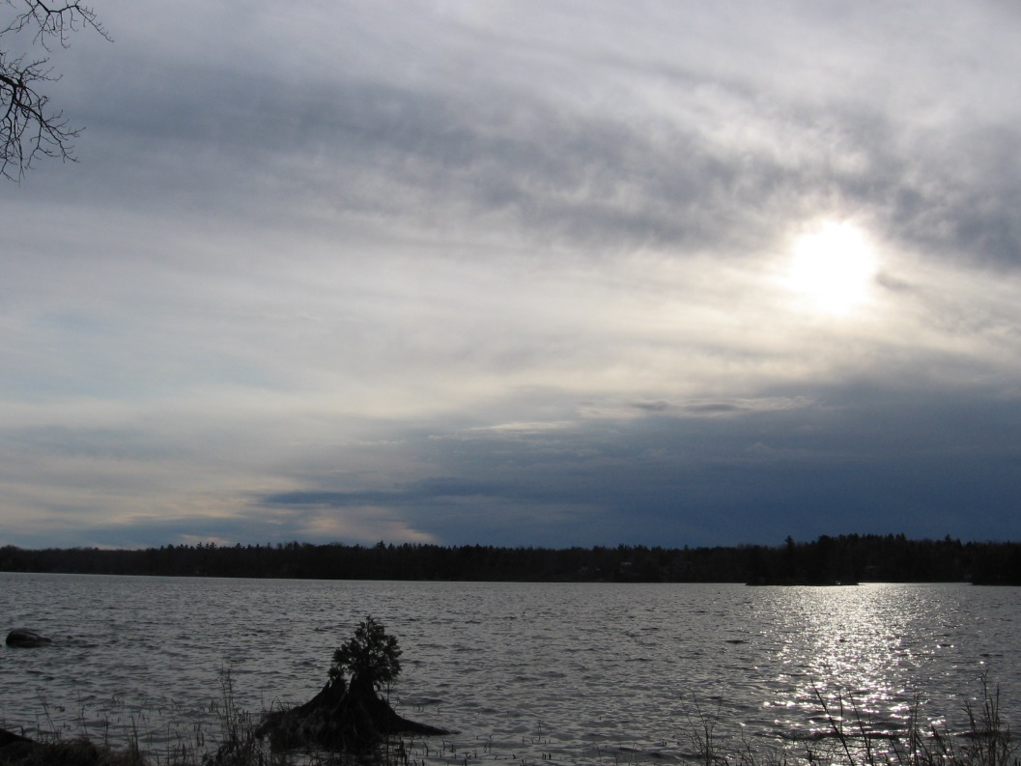

Looking Ahead… The Future of Indigenous Environmental Studies/Sciences
Another very successful year is behind us, and as always, we are very excited about the future of IESS and what is coming next.
In the 2016-2017 academic year, we will be offering “Foundations of Indigenous Environmental Studies/Sciences” for a second time, this year during the fall term. This is a unique course that examines the role of Indigenous Environmental Knowledge systems and Western sciences and how they can work together. The purpose of this course is to provide students with a basis of Indigenous Environmental Knowledge and Scientific Knowledge and theory in order to help develop integrative thinking skills, and to help create innovative solutions to common environmental problems and issues. This course sets a foundation for upper year courses in IESS and is recommended to first year students, although it is open to students at any stage in their IESS journey.
We will continue to build partnerships across the environment sector and host innovative events at Trent. For example, in the fall of 2016 IESS is working with Plenty Canada, Walpole Island Land Trust, and Ontario Nature to host a 2-day event at the university focussing on Conservation Offsets. We will be bringing First Nations from across the province as well as representatives from government, industry and the not-for-profit sector to create space for knowledge sharing and relationship-building. There are a limited number of spaces for students to attend and volunteer in this exciting event.
This is just one example of the many exciting initiatives we are working on for the upcoming year. We will be hosting our annual Welcome Event in the early Fall, so stay tuned to your email and social media for details on that event. We always appreciate the opportunities that these informal events offer us to get to know each other over a delicious traditional meal and we hope to see you at our events!
As the director, I am excited about the continued growth of the IESS program and to see the ongoing successes of our students and graduates in developing their careers in this growing and exciting field of study.
Thank you for taking the time to read this report and for your continued support for IESS. I wish you all the best in this upcoming academic year.
Niá:wen,
Dan Roronhiakewen Longboat

Funders, Supporters and Partners
We would like to acknowledge and send our sincere gratitude to all the individuals and organizations who have been involved in making IES a success, through partnerships and financial support. Thank you!
