Indigenous Environmental Studies/Sciences Annual Report
2016-2017

Contact Information
For information regarding this report or the program, please visit the IESS website or contact us at ies@trentu.ca or contact one of our faculty/staff:
Dan Roronhiakewen Longboat, BA (Trent), MES, PhD (York)
Program Director, Associate Professor
Phone: (705) 748-1011 ext. 7844
E-mail: dlongboat@trentu.ca
Office: GCS 302
Chris Furgal, BSc (UWO), MSc, PhD (U of Waterloo)
Associate Professor
Phone: (705) 748-1011 ext. 7953
E-mail: chrisfurgal@trentu.ca
Office: GCS 303
Dorothy Howard, BSc (McGill), MSc (Trent)
Scientific Support
Phone: (705) 748-1011 ext. 7426
E-mail: dhoward@trentu.ca
Office: ESC C201.1
Note: Requests for alternative accessible formats or supports can be sent to access@trentu.ca.

Table of Contents
Indigenous Environmental Studies/Sciences Annual Report 0
Contact Information 1
Table of Contents 2
Greetings from the Director 4
Indigenous Environmental Studies and Sciences 6
Trent University 6
Faculty and Staff Biographies 7
Faculty and Staff 7
Teaching Assistants 9
Program Staff 14
TRACKS Staff 15
First Peoples House of Learning (FPHL) 15
Course Description and Highlights 16
Foundations of Indigenous Environmental Studies and Science: IESS 1001H 17
Introduction to Indigenous Environmental Studies: IESS 2601Y 17
Issues in Indigenous Environmental Studies: IESS 3631H 19
Issues in Indigenous Environmental Studies: IESS 3632H 19
Introduction to Indigenous Food Systems: IESS 3634H 20
Indigenous Peoples Health and the Environment: IESS 3730Y 21
Sustainable Indigenous Communities: IESS 4730Y 22
Advanced Topics in Indigenous Peoples’ Health and the Environment: IESS 4740Y 23
Practicum Field Placements: INDG 3860Y 24
Reading Course: ERSC/ERST – INDG 3900Y, 3901H, 3902H 24
Thesis: ERSC/ERST – INDG 4020D 24
Program Growth 26
IESS Program - Event Calendar 2016-2017 27
Trent Temagami Colloquium – September 22nd-25th, 2016 27
Annual Welcome Event – Wednesday, October 12th, 2016 28
Winter Feast – Thursday, December 8th, 2016 29
Northern Studies Colloquium – Tuesday, April 4th, 2017 29
Career Day – Wednesday, March 8th, 2017 30
Resource & Tutoring Centre 30
TRACKS: Trent Aboriginal Cultural Knowledge and Sciences Youth Program 31
Student Achievements and Award 35
IESS Graduating Student Award Bachelor of Arts, Honours in IESS 35
IESS Graduating Student Award Bachelor of Science, Honours in IESS 35
Student Survey Highlights 36
Profile of Students Enrolled in IESS Courses Last Year 36
Survey Responses 37
Looking Ahead… The Future of Indigenous Environmental Studies/Sciences 38
Funders, Supporters and Partners 39

Greetings from the Director
Shé:kon Sewakwé:kon Greetings everyone,
It’s a privilege to be able to provide the Indigenous Environmental Studies/Sciences Annual Report for the 2016-2017 academic year. We have had another very active year with many different events hosted that provided different experiences for students. This year we graduated over a dozen students. I am also happy to report that, while many have chosen to major in IESS as a Bachelor of Arts degree, we have seen a significant increase in the number choosing to major in IESS as a Bachelor of Science degree. Students that have the opportunity to build a stronger background within the sciences creates momentum within the job market, providing recognition for students having a multiplicity of skillsets when they graduate.
We have been able to host a number of interesting events throughout the year. Our welcome feast in October embraced new students into the program and facilitated the opportunity to develop mentorship relationships with upper year students. This event is an opportunity for students to create a stronger cohort that help and support one another.
We have had an increase in the number of guest speakers this year, including David De Launay who came from the Ministry of Northern Development and Mines as the Deputy Minister and had an excellent lecture with our students, Joe Pitawanakwat provided lectures around traditional medicines and foods, and Dorian Richie spoke to students about engagement with communities.
We also hosted Larry McDermott and Mi’kmaw elder Albert Marshall from Cape Breton, Nova Scotia to lecture to the students, as well as a number of other interesting lecturers and speakers.
Our IESS Resource Room and Tutoring Centre has continued to support our students and provide opportunities for students to connect, work together and help each other. This year we are looking forward the Bata Library renovations that will include a designated IESS student research space. It will include an office, a meeting room, and a work space available to students in the fall of 2018. This will also be the new location of the IESS Resource and Tutoring Centre. We look forward to this all-encompassing space to generate even more collaborative work and community between students and faculty. We will also have a lounge spot for students to gather to discuss and engage with each other and guests.
We are very happy to provide the 2016/17 report that culminates the different activities, projects and initiatives we have undertaken throughout the year. This report celebrates the achievement of the program and, more specifically, our students. We also wish to recognize our teaching faculty and teachings assistants for their help and dedication. The collection of these reports show the gradual movement forward of our emerging discipline of IESS.
I am very happy again to provide this to you and at the same time to look at the road ahead, so thank you for reading.
– Dan Roronhiakewen Longboat

Indigenous Environmental Studies and Sciences

Trent University
Indigenous Environmental Science/Studies at Trent University is an innovative and multidisciplinary program. It brings together principles of both Indigenous knowledge and Western science through courses offered in the Indigenous Studies Program and through the Trent School of the Environment as well as unique courses within the program. Instruction, integrating these approaches, will provide students with the necessary knowledge and skills, including both critical and integrative thinking abilities, to begin to address the complex environmental problems facing Indigenous communities, governments, business, industry, research, and society in general.
Students may complete a B.A. in Indigenous Environmental Studies or a B.Sc. in Indigenous Environmental Science. The program also offers a Diploma in Indigenous Environmental Studies/Science which is intended for students of Indigenous ancestry who may be interested in specific education opportunities or a pathway to a university degree. In addition to the program requirements listed for each respective option, students must also satisfy the University degree requirements.

Indigenous Environmental Studies/ Sciences offers a variety of courses for students interested in bringing together Indigenous and Western science to address complex environmental issues. The foundation upon which the program is based recognizes both the strengths and limitations of any single perspective, and seeks to develop interactive and integrative thinking to address environmental, health, and social issues. Learning and problem solving are focused on benefiting both Indigenous and non-Indigenous communities.

Faculty and Staff Biographies

Faculty and Staff
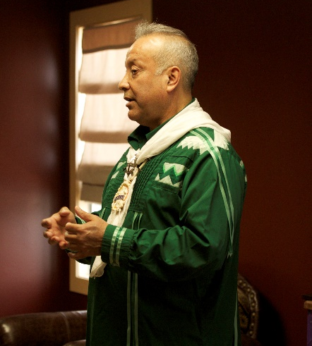

Dan Longboat, PhD – Program Director & Associate Professor
Dr. Dan Longboat Roronhiakewen (He Clears the Sky) is a Mohawk of the Haudnosaunee (the Six Nations) from the Grand River Territory. He is the founding Director of the Indigenous Environmental Studies/Sciences Program at Trent. Dan embeds cultural knowledge into his developmental work and teaching in Indigenous Environmental Studies/Science. He was also the first Director of Studies of the Indigenous Studies Ph.D. program. Dan completed his undergraduate in Indigenous studies, with an interest in psychology, at Trent and both his Masters and Ph.D. in Environmental Studies at York University. He lectures and teaches across the country on Indigenous environmental issues, cultural education and Indigenous environmental knowledge.
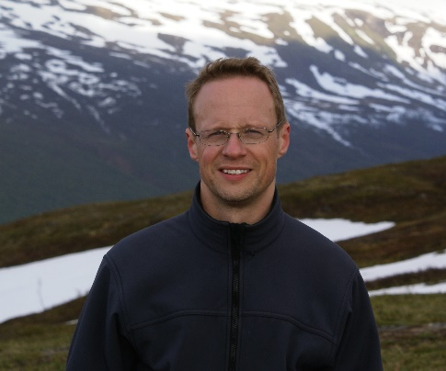

Chris Furgal, PhD – Associate Professor
Chris Furgal is an Associate Professor in the Indigenous Environmental Studies/Science Program at Trent University in Peterborough, Ontario. He is cross-appointed to the Departments of Indigenous Studies and Environmental Resource Studies and Sciences and is Director of the Health, Environment and Indigenous Communities Research Group and co-Director of the Nasivvik Centre for Inuit health and changing environments. His teaching and research interests are in the areas of Indigenous environmental health and Science-Indigenous knowledge interaction. He has been working with Arctic Inuit communities and organizations on issues of environmental health for over 20 years.
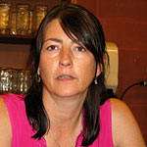

Dorothy Howard, MSc
Dorothy is involved in supporting all IESS courses. She provides lab and scientific support, as well as the coordination of events and advises academic planning for IESS students. Her environmental interests include the chemistry of aquatic environments and potable groundwater supplies. Her main passion in life is animal rights. Dorothy is currently working on her Ph.D. at Trent University.
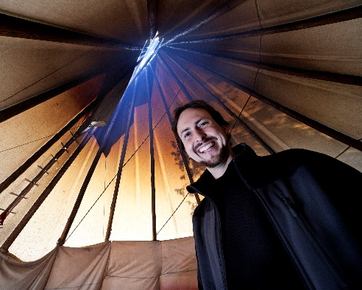

James Wilkes – Instructor
James Wilkes is a cultural ecologist and educator who is dedicated to social and environmental justice, Indigenous and Canadian rights, land protection and biodiversity, as well as decolonization, re-humanization and knowledge revitalization. His educational and experiential background is rooted in diverse understandings of the environment, coupled with interests in Indigenous law, science, spirituality and knowledge system interaction. James is an instructor in the Indigenous Environmental Studies Program at Trent University, as well as currently undertaking his PhD in Environmental Studies at Queen’s University.

Teaching Assistants
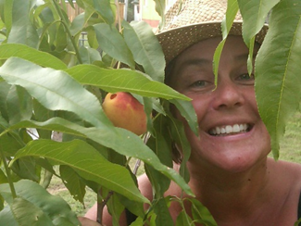

Paula Anderson – Teaching Assistant
Paula Anderson is the teaching assistant for INDG/ERST 3634H (the Introduction to Indigenous Food Systems) course in the IESS Program and is an instructor in Trent’s Sustainable Agriculture and Food Systems Program. She is an organic vegetable grower, community food-system developer, avid seed saver, urban maple tree tapper and manomiin (wild rice) harvester. She has an MSc in sustainable systems design, with focus on sustainable agriculture and permaculture and is presently working on her PhD in Indigenous Studies. Her focus is on the bio-cultural revitalization of the manomiin-based food system in the Kawartha Lakes Region as a strategy for restoring Indigenous Food Sovereignty.

Carly Armstrong – Teaching Assistant & Resource Centre Staff
Carly has worked with Indigenous Nations and organizations in the environment sector as an educator, communicator, researcher, project coordinator and activist for over a decade. Her Master’s research explored teaching troubling and complex environmental issues and generated guiding principles for environmental education that aims to empower and give hope to learners.
As a doctoral candidate in Indigenous Studies, Carly is broadening her understanding of Indigenous Knowledges, perspectives and approaches to cross-cultural collaboration and applying this to the development of educational curriculum and professional development training. The goal of this curriculum development is to engage learners in understanding how to go about respectful engagement in cross-cultural work that brings together multiple knowledge systems toward addressing environmental issues.
Recently, Carly is thrilled to have taken on a new role as the Director of Education and Training at the National Aboriginal Lands Managers Association. As the Director, she is applying what she has learned over the years to deliver education and training with Indigenous Lands Managers across the country.
In her spare time, Carly loves to garden and spend time outside with friends and family hiking, paddling and swimming.
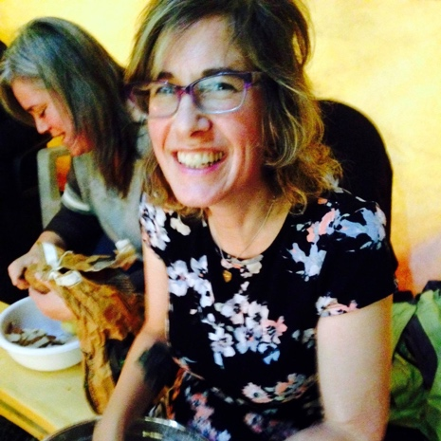

Gillian Austin – Teaching Assistant
Gillian was a TA for Introduction to Indigenous Environmental Studies in 2016/17. From 2013-2016, she was a TA for Research Methods for Indigenous Studies, as well as a course instructor for a similar course in the Indigenous Studies Program at the University of Toronto in 2015/16. Gillian is a Ph.D Candidate in the Trent Indigenous Studies program. For her dissertation work, she is exploring what practices support Indigenous Knowledge holders’ autonomy in relation to their knowledge systems, in postsecondary education and research. The goal of this is to nurture Indigenous autonomy and governance over Indigenous Knowledge systems. The focus of her work is at Trent and in the Atlantic region.
Gillian is a Scottish, Irish and British settler, born in Anishinaabeg homelands. She has lived on Haida Gwaii (the Queen Charlotte Islands) and in Mi’kma’ki (Nova Scotia specifically). She is a singer-songwriter who plays piano, guitar and banjo, a Reiki practitioner and a Kripalu yoga instructor.
Gillian has a Master of Environmental Studies from York University. Her thesis was a story-writing project in which she explored the relationships between Anishinaabeg peoples and her ancestors, as well as came to learn some Anishinaabeg perspectives on land, culture, language and story. Gillian has worked for more than 10 years for Indigenous and environmental organizations in the non-profit sector. Prior to attending Trent, she was the research coordinator for the Atlantic Aboriginal Economic Development Integrated Research Program (AAEDIRP) for the Atlantic Policy Congress of First Nations Chiefs (APCFNC) from 2007-2012. Through the APCFNC, she worked alongside Elders as part of two-year collaborative research project with 23 Mi’kmaw, Wolastoqey, (Maliseet) Innu and Inuit Elders.

Nikki Auten – Teaching Assistant
Nikki Auten (Tayohseron:tye) is Kanyen’keha:ka (Mohawk), turtle clan and a mother of three. She is currently a Master of Arts candidate in the Sustainability Studies program at Trent University. She also received her Honours Bachelor in Indigenous Studies at Trent and received her teacher’s certificate through the Aboriginal Teacher’s Education Program at Queen’s. She is currently working as a TA in the Introduction to Indigenous Environment Studies course (IESS2601Y).
Nikki has been actively involved in her home community, Tyendinaga Mohawk Territory, coordinating a youth Rites of Passage group for the past three years. She has recently become involved with the Haudenosaunee Seedkeepers Society. She is also involved in the Peterborough community with the Flint Corn Project working to revive seeds from the early 90s and educate people about the planting and seed saving practices of the Rotinonhson:ni people, as well as about the processes and the uses of corn.

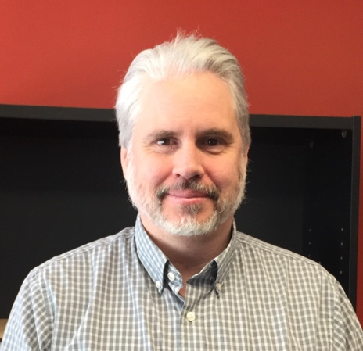

Bill Moes – Teaching Assistant
William (Bill) Moes has a degree in Native, which is now Indigenous, Studies at Trent University (97-01) and went on to complete a Masters in Environmental Studies at York University. One of his supervisors was Dan Longboat, who had also taught him in his undergraduate degree. Bill was born in Nova Scotia and grew up in Toronto. He has been studying traditional skills since 1987, which began at Tom Brown’s Tracking Nature, and Wilderness Survival School. Bill met his wife, Elizabeth, at Trackers school and his son is a recent graduate here at Trent. He is undertaking his second Masters in Sustainability Studies with Dan Longboat and is working on creating a new IESS summer field course that teaches traditional skills.
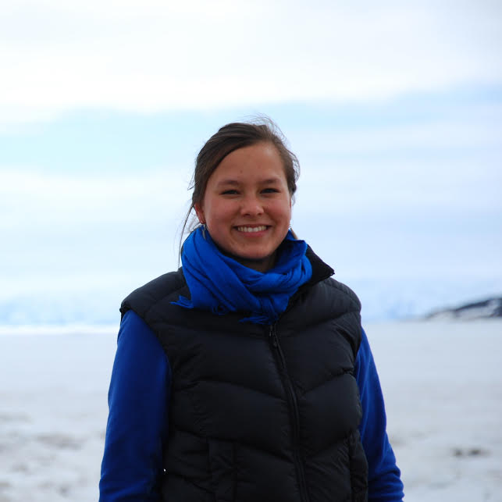

Shirin Nuesslein – Teaching Assistant
Shirin Nuesslein is a MA student in the Sustainability Studies program at Trent University. She is also a Teaching Assistant for IESS 3730 ‘Indigenous Peoples, Health and the Environment’, a tutor for the IESS Resource Centre, and a Research Assistant for the Health, Environment and Indigenous Communities Research Group.
Supervised by IESS Program Co-Director Dr. Chris Furgal, her thesis explores factors that influence health vulnerabilities in Indigenous populations. Specifically, she looks at the key determinants in the social environment influencing household food security status of at-risk groups within the Inuit population of Northern Canada. Findings will provide a more nuanced understanding of the vulnerabilities to food insecurity experienced within the Inuit population and the social conditions required to promote food security, and ultimately health, for all Inuit including the most at-risk groups within an already vulnerable population.
She has a BA in Environmental and International Development Studies from Trent University, and enjoys working at the intersection of society and the environment in an Indigenous context.
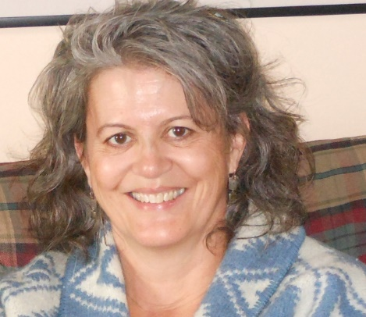

Barbara Wall Potter – Teaching Assistant & Resource Centre Staff
Barbara, Bodwewadmii Anishinaabekwe is Citizen Band Potawatomi of Shawnee, Oklahoma. She is a Professional Engineer with over ten years of experience in consulting engineering and nearly twelve years of experience in teaching algebra and earth, environmental and physical science. Her approach in teaching middle school students is on utilizing Indigenous pedagogies. Her Ph.D. research will focus on uncovering and restoring Bodwewadmii women’s Indigenous Knowledge and traditional responsibilities surrounding water.

Mehran Monsef – Teaching Assistant
(No info).

Jane Gray – Teaching Assistant
(No info).

Coral Voss – Teaching Assistant
(No info).

Program Staff

Emily King
Emily is graduating from IESS this year. She is always looking to expand her IESS experience through various opportunities. Emily is the event coordinator for the IESS program. She always looks forward to engaging the IESS community through organizing various events throughout the year. Emily is a Metis student who has her goals set on perusing a career in law and policy, and is headed to law school next year. In her spare time Emily enjoys exploring Ontario by canoeing and hiking.
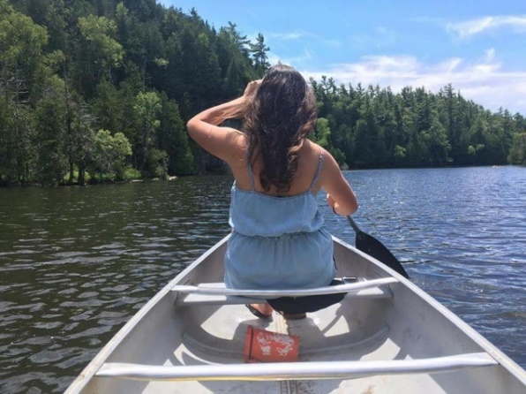

Brianna Barnhart – Research Assistant
Brianna is entering her fourth year of IESS. She is looking forward to the research project she will be doing this summer with Dirk Wallschlaeger, who will also be her honours thesis supervisor. She is interested in chemistry and intends to integrate it with the knowledge gained from IESS classes. Through the knowledge that IESS has provided her, Brianna has gained a passionate interest in Indigenous and environmental justice. When relaxing, she enjoys reading, drawing, and spending time outdoors.

Alyssa Sgro
A special Thanks to Alyssa for helping to complete this report. Alyssa is an IESS graduate, a research assistant with Professor Chris Furgal and the recipient of the IESS Graduating Award Bachelor of Science, Honours 2017.

TRACKS Staff
TRACKS is comprised of a dedicated team of Indigenous and non-Indigenous individuals from a variety of background. The team members are undergraduate students from IESS, Indigenous Studies and the Sciences; Masters' and PhD students, educators, environmental technicians, community workers, and activists. This year we also hosted seven youth leaders (paid high school staff) to learn and teach alongside our senior staff and instructors.
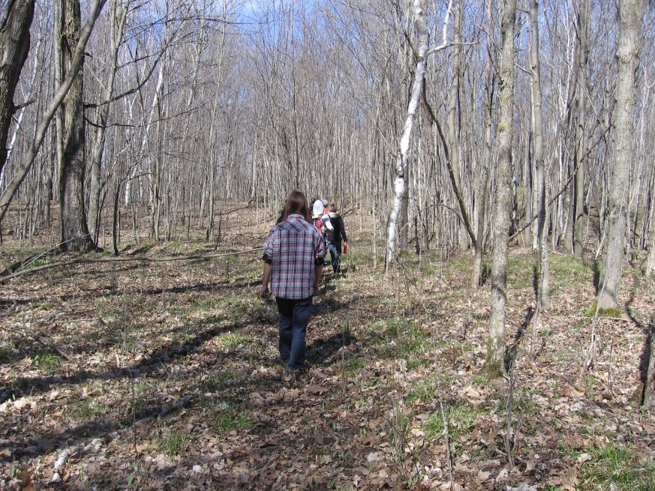

First Peoples House of Learning (FPHL)
IESS is pleased to have a strong working relationship with the First Peoples House of Learning (FPHL). FPHL provides innovative support programming for Indigenous students to both Peterborough and the Oshawa campus. It provides numerous weekly and monthly Traditional Teachings, Pine Tree lectures and cultural events for student learning. In addition, FPHL provides counseling and cultural advisor service, academic supports, peer mentoring and tutoring, workshops and Peer ambassadors. We urge all IESS students to connect and become involved with FPHL.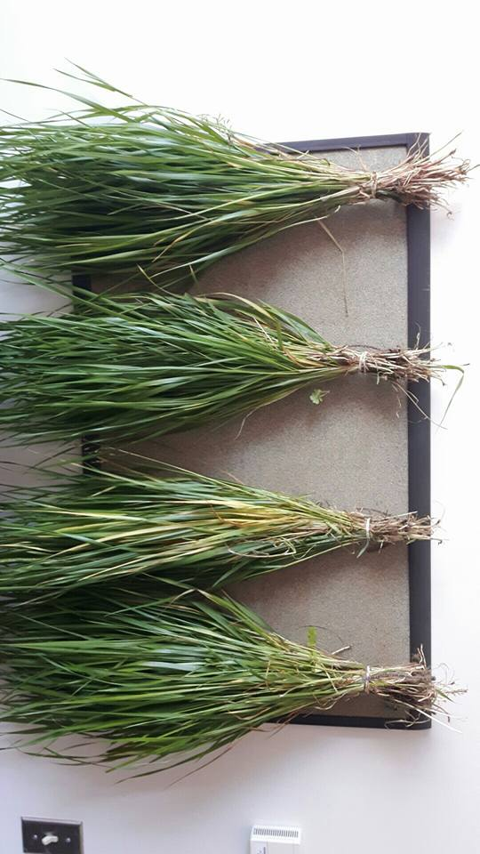

Course Description and Highlights
Indigenous Environmental Studies/Sciences offers a variety of courses for students interested in bringing together Indigenous and Western science to address complex environmental issues. Students interested in exploring these issues are recommended to take the new Foundations in Indigenous Environmental Studies and Science course IESS 1001H, taught by Professor Dan Longboat.
IESS core courses are discussed here, however students can take a wide range of courses that are cross-listed with other programs, or from an enriched interdisciplinary educational offering of subjects. Faculties including Indigenous Studies, Environmental Resource and Studies/Science program, International Development Studies, Sustainable Agriculture and Food Systems, Biology, Chemistry, and Business can contribute to the completion of an IESS degree.
Below are descriptions of all core IESS courses, including an overview of some of the key highlights from each. Descriptions contain notable guest speakers and events that enhanced the interdisciplinary and experiential learning experience that students received. For more detailed information on IESS courses please see our website.
Course Title | Course Code | Instructor
Foundations in Indigenous Environmental Studies and Sciences | IESS-1001H | Dan Longboat
Introduction to Indigenous Environmental Studies | IESS 2601Y | Dan Longboat
Issues in Indigenous Environmental Studies | IESS 3631H | James Wilkes
Global Issues in Indigenous Environmental Studies | IESS 3632H | James Wilkes
Introduction to Indigenous Food Systems | IESS 3634H | Dan Longboat
Indigenous Peoples Health and the Environment | IESS 3730Y | Chris Furgal
IESS Practicum Field Placements | INDG 3860Y | Faculty
IESS Reading Course | INDG 3900Y, 3901H, 3902H | Faculty
Thesis | ERSC/ERST – INDG 4020D | Faculty
Sustainable Indigenous Communities | IESS 4730Y | Dan Longboat
Critical Investigations in Indigenous Peoples’ Health and the Environment | IESS 4740Y | Chris Furgal

Foundations of Indigenous Environmental Studies and Science: IESS 1001H
Course Instructor: Dan Longboat
Teaching Assistant(s): Mehran Monsef and William Moes
Course Enrollment: 54 students

Description:
Introduces students to the foundational approaches, philosophies, values and methods used in Indigenous Environmental Studies. Teaching methods include lectures, written resource materials, classroom discussions, and experiential learning.

Highlight
Guest speakers include Brigitte Evering, Carly Armstrong, Eric Sager and Diane Hill.

Introduction to Indigenous Environmental Studies: IESS 2601Y
Course Instructor: Dan Longboat
Teaching Assistant(s): Carly Armstrong, Gillian Austin and Nikki Auten
Course Enrollment: 73 students

Description:
This course explored Indigenous world views, environmental philosophies, and values through exposure to the perspectives of Indigenous Elders, community people, political leaders, academics, activists and scholars. Students were introduced to Indigenous Knowledge as it pertains to the environment with guest speakers who focused on knowledge system interactions.

Highlights
With the highest enrolment yet, this year’s course was a stellar blending of Haudenosaunee environmental philosophy, as embodied within the Creation Story, Cycle of Ceremonies, the Peacemaker’s journey and the Teachings of Handsome Lake, along with an exploration of western environmental sciences and the beliefs, values, and practices embedded in western knowledge systems.
Using a weekly lecture and seminar format, including time in the tipi and on the land, students’ learning focused on the concepts of relationship with the land and beings of Creation, reciprocity, respect, responsibility, and restoration. Guest lecturers enriched and complimented the teachings of course instructor Dr. Dan Longboat, such as Anishinaabe Elders Rick Beaver and Edna Manitowabi, Dene Elder George McKenzie and Dr. Sekagya of Uganda, a practitioner and teacher of traditional medicine. Rick Beaver, Alderville First Nation, spoke passionately about our relationship with and responsibility to the land. Edna Manitowabi told her personal story of returning to mno bemaadiziiwin, the Anishinaabe way of living, through learning her peoples’ teaching and medicines. George McKenzie echoed Rick’s words, shared a moving prayer song, spoke of water issues in the North and introduced the concept of “Strong Like Two,” a coming together of Indigenous and western ways of knowing. An exciting finale to the course was led by IESS student Caleb Musgrave from Hiawatha First Nation and the Brothers of Bushcraft who provide seminars on traditional skills for IESS Students.
The course Teaching Assistants (TAs) also contributed to student learning by sharing lectures from their personal experiences and backgrounds. TA Carly Armstrong shared her understanding of Indigenous environmental issues impacting communities in Ontario and throughout Canada in her presentation on “The Contemporary Contexts of IES”.
This year, all students in the course created a digital story of their personal learning journey, had the opportunity to facilitate a seminar in small groups and honed their active listening skills by attending Traditional Teachings through the First Peoples House of Learning. Lively discussions in lecture and seminar added to student learning and understanding of the nuances of cross-cultural collaboration in environmental contexts.

Issues in Indigenous Environmental Studies: IESS 3631H
Course Instructor: James Wilkes
Course Enrollment: 38 students

Description:
The class atmosphere encourages active participation in lively discussions surrounding contemporary Indigenous environmental issues. This course provided students the opportunity to examine a wide range of contemporary environmental issues, conflicts and solutions in the context of Indigenous Peoples and territories. Studies examined issues at local, provincial and national levels. The course highlighted the perspectives of Indigenous scholars, Elders, Knowledge Holders, and activists, to address particular issues in Indigenous Environmental Studies.
Through individual research projects and group led seminars students are engaged in current, relevant and meaningful research with a focus on taking action. Students were offered opportunities to understand the ways in which Indigenous and Western Knowledge systems address environmental concepts, concerns and solutions. The course began by deepening students’ understanding of the context of environmental issues within Indigenous territories by discussing colonization, resistance, decolonization, Indigenous Knowledge, and renewal. Throughout the term, attention was drawn to various issues confronting communities including land dispossession, resource extraction and industrial contamination, to name just a few. Indigenous ways of understanding these issues were explored, including Indigenous worldviews, governance, participation, mobilization, restoration and revitalization.
This year, guest speaker Doran Ritchie (Saugeen Ojibway Nation) shared his experience working as a land use planning coordinator for his nation, and he discussed the opportunities and barriers of the ‘duty to consult.’ Barbara Wall (Citizen Potawatomi Nation) shared her experience from her PhD research, with a focus on the Catholic Church’s Papal bulls in the history of North American colonization, as well as her Bodwewadmii Anishinaabekwe understanding of women’s water teachings and responsibilities.

Issues in Indigenous Environmental Studies: IESS 3632H
Course Instructor: James Wilkes
Course Enrollment: 31 students

Description:
In the winter term, we turned our attention to international issues, with a focus on rights protection throughout the Americas. These issues included war, globalization and corporatization, water privatization, biopuracy, ongoing land dispossession, and neo-colonialism. These issues were studied through various multimedia, including book chapters, documentaries, photographs, perspective papers, and guest presentations. Gues speakers included Marcelino Entzin Lopez from Chiapas Mexico, a Mayan Tseltal social anthropologist, who spoke about the Zapatista liberation movement. Guests often share firsthand knowledge with the students and provide personal and experiential accounts of ongoing issues.
Further to the topics discussed in class, students were encouraged to research an Indigenous environmental issue beyond Canada, since North America was already the focus of last semester’s 3631 course. Students continued to develop their own individual learning in preparation for a final essay and student led-seminars, based on their chosen research topic. These seminars are helpful to keep students on track for their final essays and to inform the class on a broad range of issues throughout the world. Despite the heavy topics and the weight of so many global issues discussed during the semester, students leave the class on a positive note and with a responsibility to get involved. This year for our final gathering, we enjoyed a potluck feast to share thoughts and reflections on lessons learned. Overall, 3632 is a course that provides knowledge and insights from multiple worldviews, and brings together students from many different disciplines, to engage in environmental and social justice issues around the world.

Introduction to Indigenous Food Systems: IESS 3634H
Course Instructor: Dan Longboat
Teaching Assistant(s): Paula Anderson and Anne Sylvie Dasné
Course Enrollment: 92 students

Description:
Provided students with the opportunity for self-directed research that examined the food systems of Indigenous peoples. Students were enabled to explore a wide range of historical and contemporary food systems, practices and issues that impacted Indigenous communities and their connections to the ecosystems that support them.

Highlights
Once again this year our Introduction to Indigenous Food Systems course was a huge success, as the most popular of all IESS courses. With an ever growing class – this year 92 students – we still managed to introduce students to Indigenous food systems in quite engaging ways, including a wide range of guest speakers and hands on workshops. Dan Longboat helped students re-consider their understanding of our relationship with food through the telling of the Haudenosaunee Creation Origins and Traditional Teachings.
Elder Doug Williams came in and spoke to his experiences with the Machi Sagiig Nishinaabeg food system that is based on the seasonal round. James Whetung joined us to share his knowledge about revitalizing the manomiin (wild rice)-based food system in this region. Gary Williams visited to share with the class how to prepare wild rice and regional fish dishes in the kitchen. During Kim Lamothe’s visit, she spoke to the students about the health challenges First Nation Communities are having in relation to their changing food system. Finally, Suzanne Brant came in to share her knowledge about food as medicine.
All the while students were researching the origins, culture, ecology, and health aspects of a specific food from their own cultural tradition. Their research culminated in an amazing final feast to celebrate the foods, held in the Great Hall. Where students prepared and shared the food they researched with their classmates and special guests. The course was awesome and the food was delicious!
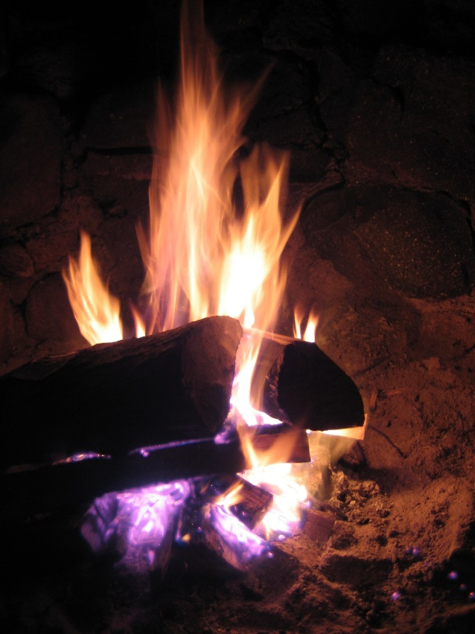

Indigenous Peoples Health and the Environment: IESS 3730Y
Course Instructor: Chris Furgal
Teaching Assistant: Shirin Nuesslein
Course Enrolment: 22 students

Description:
The course critically examines historical and contemporary issues in Indigenous Peoples' health with a particular emphasis on the relation to land and other dynamic environments as a determinant of health status. The course provides the development of a foundation in understanding the key determinants of health for Indigenous Peoples in Canada and around the world. Broadens perspectives of Indigenous Peoples health and the environment further through the incorporation of guest speakers.

Highlights
This course provides students with an introduction to the multidisciplinary field of environmental health, and its relationship to understanding health and changing health status among Indigenous peoples. It consists of one weekly two-hour lecture followed immediately by a one-hour seminar. During the lecture, students are taught basic concepts, theories and methods used in environmental health, and during seminars they apply this knowledge to investigate the role of environment in the changing health status of Indigenous populations around the world.
During the winter semester, students conduct a mock environmental health management and communication group assignment over several weeks. They are given a hypothetical situation of a First Nations community approaching them with specific environmental health concern. They must investigate and manage the issue using the skills obtained in the course. This is an immersive and intensive assignment meant to give students experience with community environmental health management.
Many guest speakers also visit this class throughout the year. During the 2016/2017 academic year, students were lucky to learn from Victor McCoy, who taught about, Dylan Miner, who taught about, and Joe Pitawanakwat, who taught about traditional plants and medicines.
As this is a comprehensive course exploring knowledge from various disciplines, it is open to students from a variety of academic backgrounds, including Environmental science/studies, Indigenous studies, and Nursing. Students may choose to complete this full-year as a science or a studies credit, with different assignment requirements depending on which option is chosen.

Sustainable Indigenous Communities: IESS 4730Y
Course Instructor: Dan Longboat
Teaching Assistant(s): Jane Gray
Course Enrollment: 29 students

Description:
A research colloquium course that gave students an opportunity to examine concepts of sustainability, select their own research area, and develop a model for a “sustainable” community. The course delivers insight into Indigenous understandings and environmental impacts, and encouraged a multidisciplinary approach to resolving issues.

Highlights
This is a challenging, but highly rewarding course of study. Students learned from guest speakers, films, elders, class presentations and group sharing. Every year students are inspired to learn, create and develop innovative ways to understand community sustainability, what does it mean and how do we do it. Students provided a major research paper and presentation to the class that contributed to this overall model of a “sustainable community”. Many students have used this work as a basis for career development or on to graduate school. This year, six students were accepted at the graduate level.

Advanced Topics in Indigenous Peoples’ Health and the Environment: IESS 4740Y
Course Instructor: Chris Furgal
Teaching Assistant(s): Shirin Nuesslein
Course Enrolment: 14 students

Description:
A critical examination of historical and contemporary issues in Indigenous peoples’ health with a particular emphasis on the relation to land and other dynamic environments as a determinant of health status. Provided a basic foundation in understanding the key determinants of health for Indigenous peoples in Canada and around the world.

Highlights
This course is designed to allow students to independently explore contemporary topics of importance to Indigenous peoples around the globe and their health. Once again this year, the small number of students in the course allowed the class to engage in interesting and thought provoking discussions during the seminar style lectures. These discussions were enriched by the various disciplines that the course’s students came from: Environmental Science, Indigenous Studies, Nursing and Biology.
Students were guided and supported through an independent research process where they studied a variety of interesting topics such as contaminants in traditional foods and the associated health risks, barriers to health care access for Indigenous women, Indigenous culturally based approaches to substance abuse treatment programs for youth, and the influence of endocrine disrupting contaminants on sex-ratios in Indigenous communities. Through the course, students learned about a variety of contemporary issues facing Indigenous communities from their peers, and how to engage and critically discuss these issues with students of diverse academic backgrounds. Students have expressed that the course helped them develop their time management and planning skills and taught them how to apply these to a step-wise research process. Students appreciated the opportunity to look at one topic in an in-depth way, and to learn how to undertake a thorough research process, tailor it to their working styles, and produce a comprehensive research paper.

Practicum Field Placements: INDG 3860Y

Description:
An opportunity for students to apply learning in a field setting, reflecting student interests and the availability of agencies willing to take students. Learning about development and culture was dialectical, through experience (action) and reflection on experience. It was formal and informal, and at many levels (personal, interpersonal and community).

Reading Course: ERSC/ERST – INDG 3900Y, 3901H, 3902H

Description:
Intended for third-year majors and for second-year students who wish to carry out independent research on a specific topic outside the scope of currently offered courses. Reading courses, supervised by a faculty member, allow students to learn more about a topic they are passionate about and perhaps have not been exposed to previously. Details must be arranged with the Chair of the Department before the end of the preceding academic year. Student reading courses in IESS typically cover topics such as land claims, resource management, Indigenous plants and medicines, climate change, Indigenous health and well-being, and community sustainability.

Thesis: ERSC/ERST – INDG 4020D

Description:
This is a double credit research course in which students produce a thesis at the year end. An in-depth study in library or field-oriented research supervised by a Research Project Committee, for which a double fee is charged. Details must be arranged with the Chair of the Department before the end of the preceding academic year. In many cases students enrolled in the course use their undergraduate thesis as a foundation for their advanced study at the Master’s Degree level.
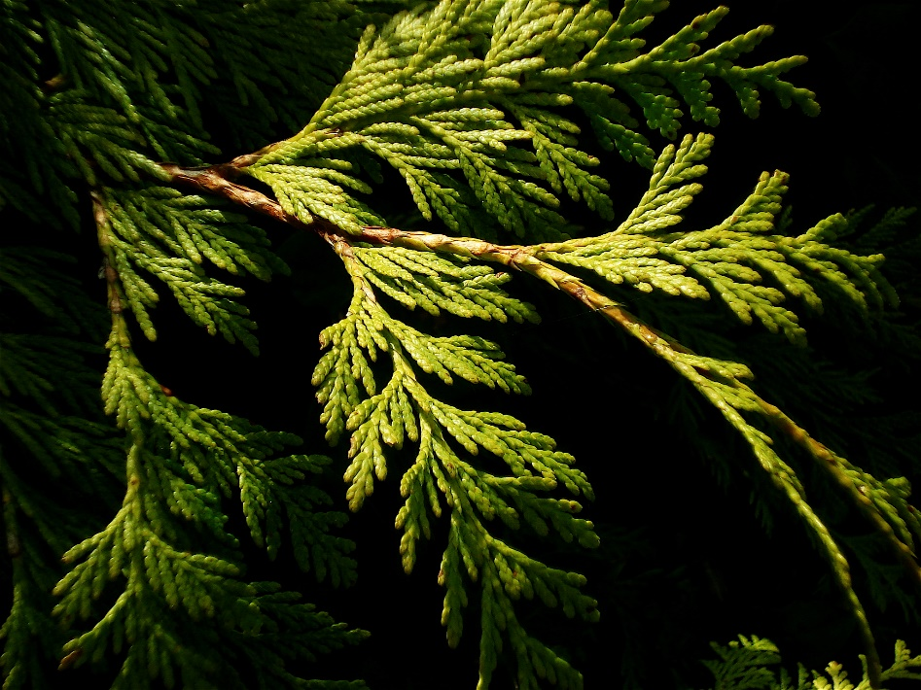

Program Growth
Each year, enrolment in our program courses continues to grow. This year, we had 332 students enrolled in IESS courses. With a total of 37 students majoring in IESS and 2 in the IESS Diploma Program.

Figure 1 Course enrolment per year
The Indigenous Environmental Studies and Sciences program grows its family every year. We look forward to this continued increase in majors and students in our classes as the program components themselves expands.

IESS Program - Event Calendar 2016-2017
Photo: Alyssa Sgro
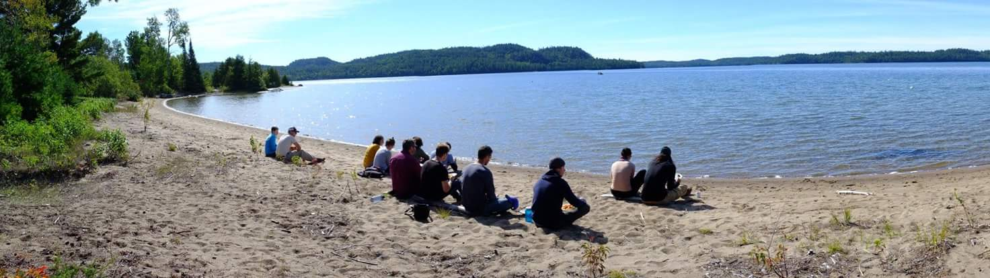
Throughout the year, the IESS program hosts and supports many events to encourage student learning and community-building. This involves hosting guest speakers from different universities, agencies or communities and panel discussions – but it is most common to see the IESS student community coming together for a feast. Many of our events centre around food and coming together to share a meal, whether through a pot-luck or catered events, food is always available and all are always welcome. At these events there are a multitude of opportunities to learn and share with each other.

Trent Temagami Colloquium – September 22nd-25th, 2016
IESS is proud to support the Trent Temagami Colloquium at Camp Wanapitei in Temagami, Ontario – an annual event that seeks to examine and experience our understanding of the land, with a focus on the study of Canadian, environmental, and Indigenous issues. This unique event celebrates interdisciplinary, experiential learning and provides a unique opportunity for IESS students to learn about the Temagami region.
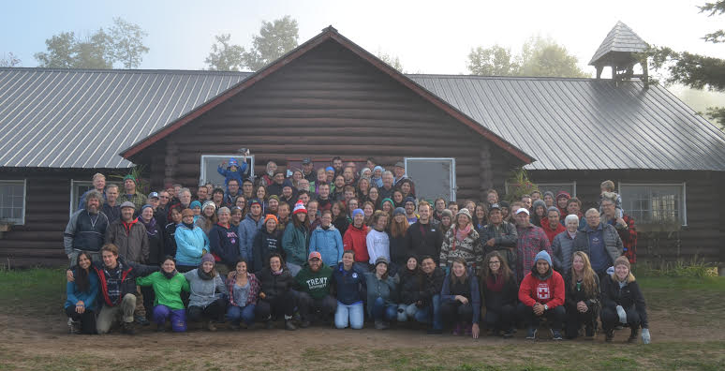
This September marked the 44th year of the annual colloquium, which bring together Trent faculty, staff, alumni and students, as well as scholars from Ottawa. Daily activities included hiking, canoeing, scholarly presentations and student discussion. This year, Teme Augama Anishnabai Elder Alex Matthias, former Chief Gary Potts and musician/storyteller Wayne Potts shared their knowledge and words with the gathering.

Annual Welcome Event – Wednesday, October 12th, 2016
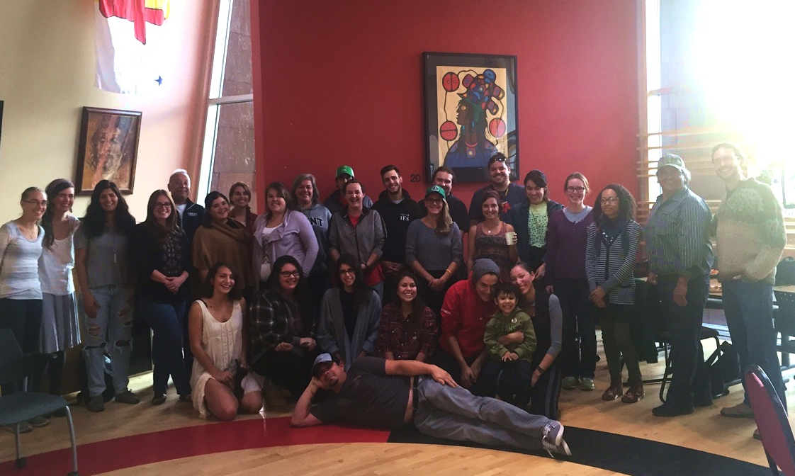
The IESS Welcome Event was an event to welcome all IESS students to the program and a new year. At this event both students and faculty members talked about their experiences in and with the program. Most IESS faculty members attended and spoke briefly about their experiences with the program. Some IESS students spoke about their experiences in the program and how it has been of great benefit to them in helping them become engaged learners and agents for positive change.
The IESS Welcome Event featured a dinner catered by Gary Williams that included: wild rice pilaf, chilli, fried bannock, three sisters’ soup, wild rice pudding, and cedar tea. The meal was enjoyed by all. Guests participated in informal discussions during and after the meal. All guests were very helpful and graciously assisted with clean-up once the event was finished.

Winter Feast – Thursday, December 8th, 2016
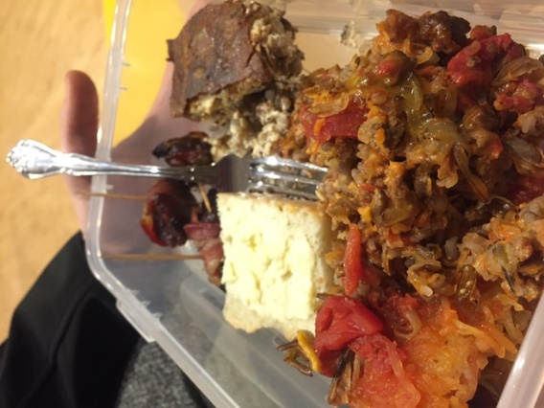
The IESS Feast was held as a last get together before the holidays. Gary Williams prepared an assortment of delicious foods for the event including, wild rice pudding, fry bread, and wild rice and squash based dishes.
This event was for all IESS students, faculty and staff. Many people attended the event, with everyone enjoying the food. Dan Longboat spoke briefly at the beginning thanking everyone for a wonderful semester. It was a delightful get-together where all students could interact and enjoy some excellent food before leaving for the holidays. The event was ended with kind words of encouragement to rest up over the holidays in preparation for the next semester by various professors and teaching assistants.

Northern Studies Colloquium – Tuesday, April 4th, 2017
IESS was happy to support the Trent Northern Studies Colloquium again this year. The colloquium is run by a volunteer committee of students to showcase northern research being conducted by undergraduate and graduate students at Trent and to exchange ideas regarding their involvement in and the future of research in the North. This event is about Trent University students presenting their research and ideas, and providing a forum for students form all disciplines to share and learn from each other. All are welcome to the free annual event, from students, and faculty to community members and family/friends.
This year’s keynote speaker, Dr. Anne Keenleyside, shared her work in central and eastern Nunavut as a bioarchaeologist. Her talk, which was titled: Archaeology of the Franklin Expedition: Evidence from the Skeletal Remains.

Career Day – Wednesday, March 8th, 2017
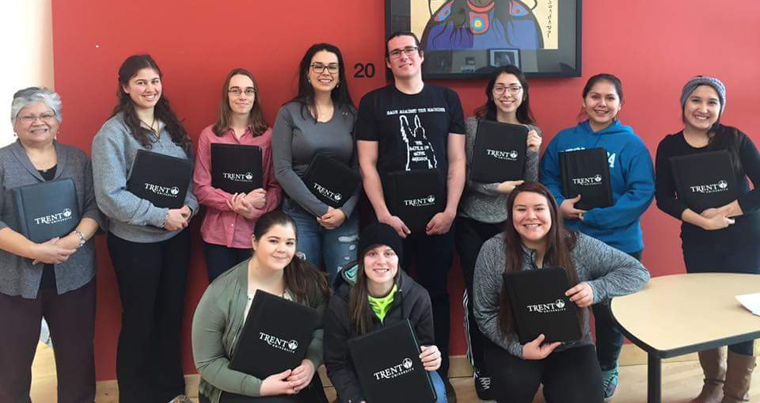
This year we held the third career day run by the IESS program – and it was a big success. A variety of speakers came to the event to share their experience searching for jobs and what employment is like in the Indigenous and/or environmental fields. We had visitors from around the Peterborough area from various organizations share their expertise. We had a great turnout! Gary Williams also came in to cater the event with amazing food.
This year the event was featured in the Career Readiness Series, which included three workshops leading up to the main event on March 8th. Workshops included resume building skills, interview skills, and LinkedIn 101.

Resource & Tutoring Centre
The IESS Resource Centre, open six hours per week on a drop-in basis, serves students enrolled in IESS courses by providing IESS-specific resources and tutoring. Resources included DVDs, journals, textbooks, field guides, and books. Tutoring and access to resources is also available by appointment. Graduate students involved in IESS-related research staff the Centre, located in the Kawartha World Issues Center (ESB B101).
The Centre’s unique resources are not available from the University Library and include a growing collection of primary source Haudenosaunee, Anishinaabe, and Inuit Indigenous Knowledge books; Indigenous research methodologies texts; healing and health related sources; and sources focused on environmental issues impacting Indigenous communities in Canada, and throughout Turtle Island and the world.
This year (2016-17) the centre was used by a diversity of students. Students visited the centre to seek out and borrow useful resources, to get help on material and assignments for their courses, and to get advice on courses and programs.

Figure 2: Percentages of types of visits during 2016-17 academic year.

TRACKS: Trent Aboriginal Cultural Knowledge and Sciences Youth Program
Photo: TRACKS
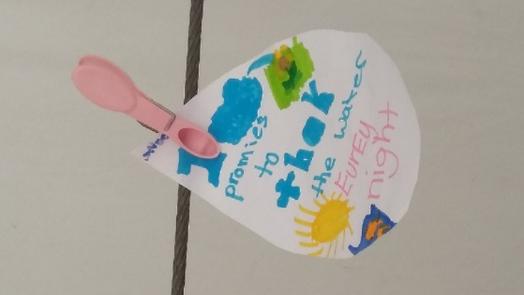
TRACKS Youth Program operates in partnership with Indigenous Environmental Studies/Sciences at Trent and the Kawartha World Issues Centre. Based on the theories and principles of IESS, one area where TRACKS seeks to make a difference is by promoting the values of relationship-building, knowledge interactions and respect for different perspectives, among youth from grade school to high school. Our hope is that the teachings of the IESS program will reach farther as we encourage children to consider different perspectives in their learning with environmental sciences and Indigenous knowledges by taking what we call an Indigenous-and-environmental approach to science education.
Through school workshops, summer camp programs, outreach activities and an after-school science club, TRACKS seeks to engage Indigenous and non-Indigenous youth in math and science, and to promote Indigenous knowledge and other ways of knowing as equally rigorous forms of science. We aim to help Indigenous youth to both develop an appreciation and respect for Indigenous Knowledge and to get excited about science, whether it's in the lab and the classroom or the fields, forests and tipi, and strive to show youth that we are all scientists.
Photo: TRACKS
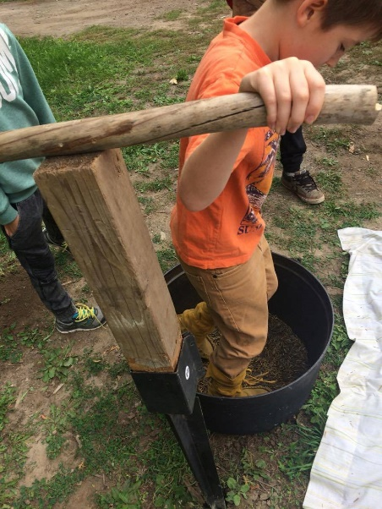
In 2016, TRACKS reached over 7,000 youth and launched 2017 with some exciting funding announcements and new projects. This academic year we enjoyed some special highlights: our participation in the Community Flint Corn Project allowed students and community members to engage with teachings and science behind a traditional Haudenosaunee Three-Sisters Garden, we delivered PA Day and March Break programming at Trent and in communities with some very special guests, and we sent three of our staff members to the North American Association of Environmental Educators' annual conference, where they not only shared a plane with David Suzuki but also got to enjoy a lengthy private meeting with him, thanks to TRACKS' status as a UL Innovation in Education winner.
One of our most exciting 2016/2017 highlights, was the formal launch of our Oshkwazin Youth Leadership project, engaging youth ages 14-18 in leadership and work opportunities. Oshkwazin allows youth to be mentored by our older staff and guests, while at the same time sharing their own skills with younger participants. Some of these leaders have been with us since campers and are now having the chance to pass on what they have learned, to others. We are exceedingly grateful to the Ontario Trillium Foundation for its Seed funding to help us launch this project, and to the OTF's Youth Opportunities Fund for generous four-year funding that will allow us to help this program grow.
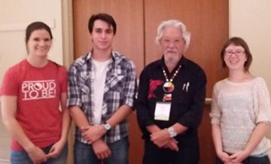
TRACKS is always on the lookout for new partnerships and opportunities, and are always looking for guests, occasional instructors and volunteers with relevant background. Get in touch if you want to participate in our programs!
info@trackscamp.ca/705 748 1011, ex 6381
Miigwech/Niá:wen/Thank you!
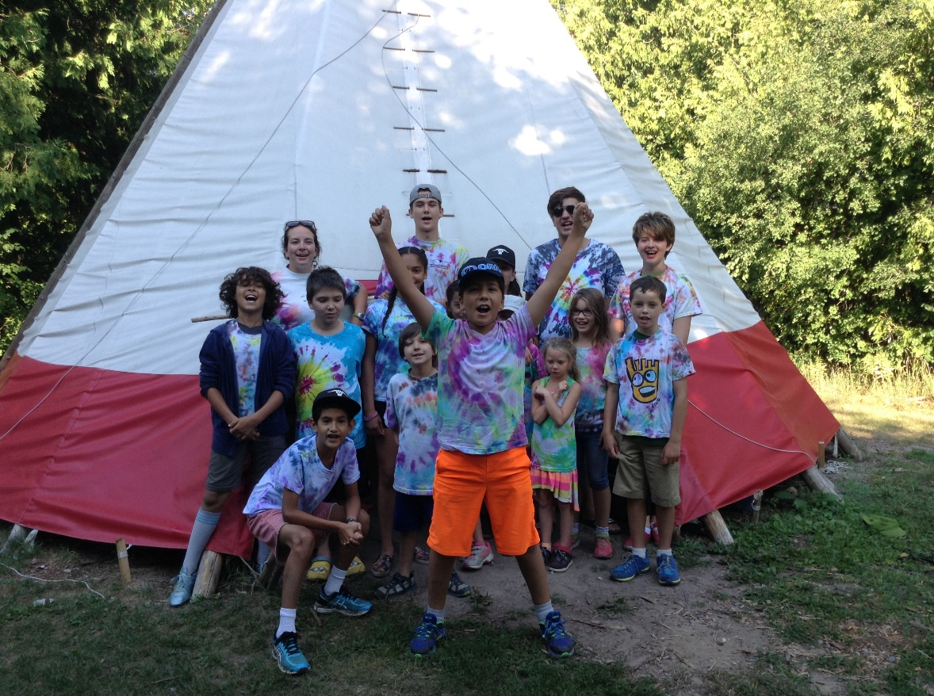
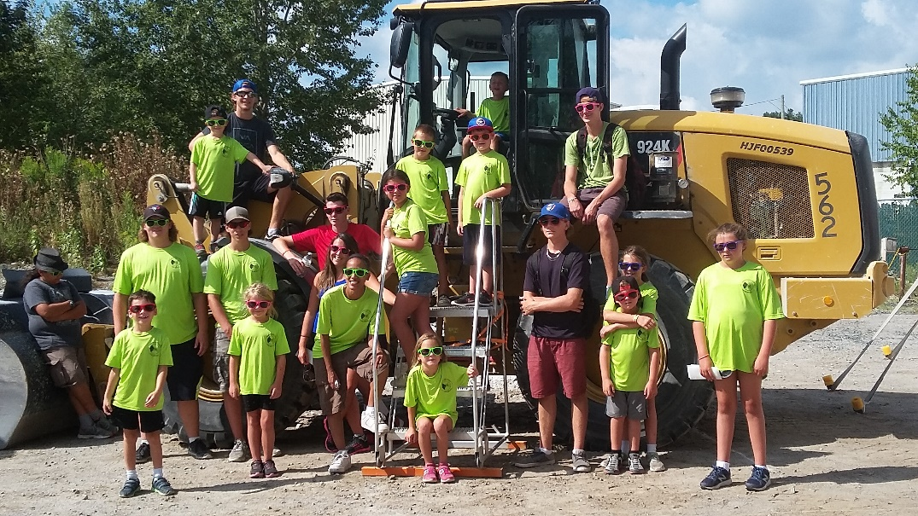

Student Achievements and Award

IESS Graduating Student Award Bachelor of Arts, Honours in IESS
Emily Vanderwey

IESS Graduating Student Award Bachelor of Science, Honours in IESS
Alyssa Sgro

Student Survey Highlights
Each year we ask students enrolled in our classes to respond to a program-wide survey. We collect a variety of demographic and academic-related information. We do this to obtain feedback so we can improve our courses and program to fit the needs of our students. Provided below is a summary of the survey highlights from the previous year.

Profile of Students Enrolled in IESS Courses Last Year
Category | Data
Age Group: | 18 – 21 = 57%  22– 25 = 28%  26 – 29 = 6%  30 – 39 = 5%  40 – 49 = 2%  50 + = 2%
Gender: | Female = 76%  Male = 19%  Transgender/Two-Spirit = 3%  No Response = 2%
Identify as | Indigenous = 24%  Non-Indigenous = 75%  No Response = 1%
Already held a post-secondary degree/diploma: | No = 77%  Yes = 23%  - of these from College = 69%  of these from University = 21%
Previous experience working with: | Local / provincial / federal government environmental department / agency: 27%  Local / provincial / federal government Aboriginal department / agency: 9%  Environmental organization (NGO): 15%  Indigenous organization (NGO): 18%  Environmental Consulting Business: 3%

Survey Responses
What attracted you to the IESS program? Or what made you choose IESS as a major?
- “I decided to change my major to IES because I wanted to love what I was learning about and I wanted to be able to have a meaningful degree. As an Indigenous person I can see how important it is to have an education and to be able to work for and with our people. IES has opened my eyes and has helped me become a better person.”
- “It integrates learning about and benefiting people and the earth into one program and approaches the issues holistically. It isn’t about helping the unfortunate or imposing solutions, but about being a better person, respecting other, and living a good life.”
- “The collaboration of two topics of interest. The potential to make a difference.”
- “IES would apply to any other marginalized communities experiencing similar social, cultural, and environmental issues.”
- “This major represented the area of greatest interest for me, and I relate to the content on many levels. I was eager to grow my knowledge of all things Indigenous.”
- “Being Anishnabe, having a connection to the environment is key. Being able to pursue the study of the natural world in tandem with my original teachings and ways was a no brainer.”
I would like to use the knowledge that I am learning in this program to…
- “Educate people on how they can better Indigenous Peoples and their land”
- “Ensure fair, prior and informed consent for any resource extraction agreements”
- “Educate others and work towards restoring the environment”
In what ways have IESS courses influenced or changed you?
- “IES has helped me stay on the path I'm on”
- “It met all my needs and desires for learning and personal growth”
- “IES has been a fundamental piece to my healing”

Looking Ahead… The Future of Indigenous Environmental Studies/Sciences
Plans for the future of IESS come in a number of different areas. Beginning with the changes to the Bata Library, which will provide a designated space for IESS student research, tutoring, and collaboration. Internship and coop opportunities with industry, government, First Nations, and communities are high on our list, to enable students to begin to do some of the work needed.
We are working to expanding recruitment to incorporate more community engagement and students from urban and rural indigenous populations. As well as growing the influx of non-Indigenous students, to add to the value of their careers through the vital components of Indigenous Knowledge and reality with respect to aboriginal and treaty rights. Increasing the student population overall will help support the growing career market in a range of different areas that look at natural resource development, research, developing/enhancing community capacity, and working with industry, business, and government. IESS also wishes to raise opportunities in the education field to teach secondary, elementary and post-secondary levels.
We are also very pleased and honoured to announce that an anonymous donor has generously provided $25,000 to support student awards for our graduates for the upcoming years.
We are excited to see the future ahead the opportunities for our students, and at the same time looking forward to seeing continued success of the program and asking for support from those interested in helping this discipline of Indigenous Environmental Studies/Sciences. With the unique nature of the IESS program growth has been rapid. Future growth is anticipated in undergraduate and graduate studies, and students will be offered opportunities to expand their studies into 5 key areas of knowledge:
- Traditional Foods and Medicines
- Water and Indigenous Peoples
- Resource Management and Restoration
- Environmental Rights, Responsibilities and Realities
- Traditional Living Skills & Community Engaged Learning and Research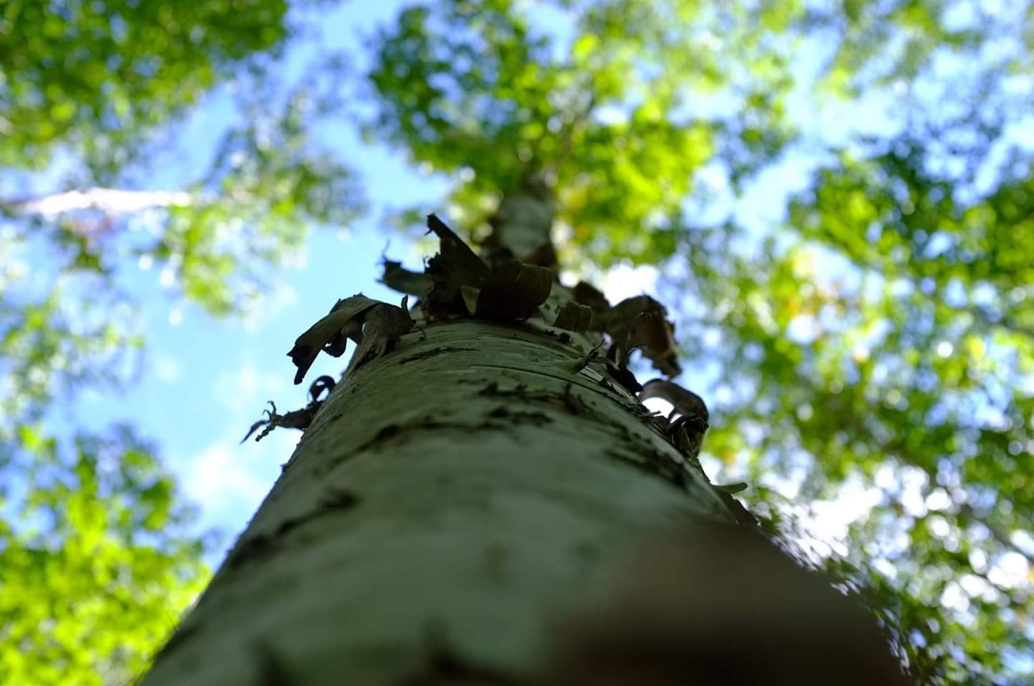

Funders, Supporters and Partners
We would like to acknowledge and send our sincere gratitude to all the individuals and organizations who have been involved in making IESS a success, through partnerships and financial support. Thank you! 