Worker Definition Under OHSA (Bill 18)
In 2014 the definition of a “worker” was broadened in the Occupational Health and Safety Act (OHSA) to include:
A person who performs work or supplies services for no monetary compensation
under a program approved by a post-secondary institution.

This definition is likely to result in expanded obligations for Trent University as an employer in the following situations:
- Unpaid undergrad students who participate in research on campus
- Graduate students whose research is also used by a Principal Investigator or part of a larger research project in the lab
- Students enrolled in an approved program at Trent, participating in unpaid placement at Trent
The new definition has also resulted in expanded employer duties for placement employers who host Trent students during unpaid practicum placements.

The Risks
Trent has legislated obligation to provide supervision, information, instruction and take every precaution reasonable in the circumstances for protection of students who perform work or provide a service to Trent for no monetary compensation. Faculty and Staff who have authority over or direct an unpaid student’s work will be considered supervisors by the MOL: 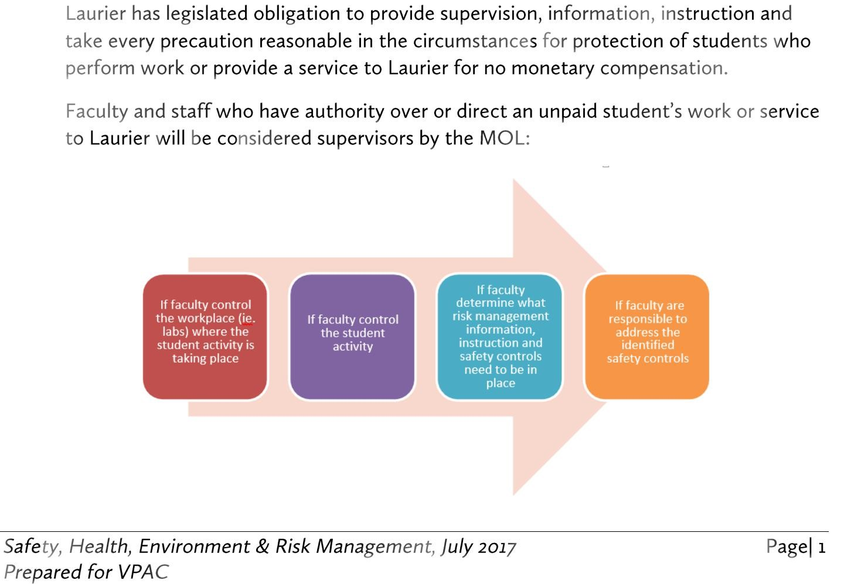

Alternative text:
[If faculty control the workplace (ie. Labs) where the student activity is taking place -> If faculty control the student activity -> If faculty determine what risk management information, instruction and safety controls need to be in place -> If faculty are responsible to address the identified safety controls.]
Trent’s control of work in a placement employer’s workplace during an unpaid student placement invites potential liability for the duties of an employer.
Faculty or staff members who control work in an outside placement employer’s workplace may be considered supervisors by the MOL when they:
- Determine the tasks to be done by a particular placement student
- Direct and monitor how work is performed on an ongoing basis
- Decide and schedule hour of work
- Deal directly with placement students’ occupational health and safety concerns

Mitigating the Risks

For Trent:
Appoint competent supervision (has the knowledge, training and experience to organize work, and is familiar with the OHSA and has knowledge of any potential or actual danger in our workplace) for students performing unpaid work or supplying a service.
- Provide information, instruction and supervision to protect the health and safety of the student
- Provide equipment, materials and protective devices as prescribed and ensure they are used by the students
- Take every precaution reasonable in the circumstances for the protection of the unpaid student
- Ensure faculty and staff who coordinate unpaid student placements understand the increased liability risk for Trent and themselves when controlling work in a placement employer’s workplace

For Faculty and Staff (who have authority over or direct an unpaid student’s work or service):
- Ensure faculty and staff are provided with appropriate supervisory training
- Provide information and instruction to protect the health and safety of the student
- Ensure equipment, materials and protective devices as prescribed are used by the students
- Take every precaution reasonable in the circumstances for the protection of the unpaid student
Scenario | Worker Status Arguable | Analysis
High School placement students performing placement at Trent | Yes | The high school student is a worker in the placement employer location, in this case the University. As such they need to receive health and safety training and supervision similar to a regular worker in our workplace.
Take Our Kids to Work Day (TOKTWD) | No | Grade 9 students participating in TOKTW program are visitors or guests at a workplace. They are observers and are not performing work or supplying services in a work experience program authorized by a school board.  FAQ: Definition of Worker in the OHSA
Students who participate in research in a community based setting, towards their thesis | Yes | Unpaid students may be working under the direction of a faculty member, participating in a research project, visiting community based settings. This research would also be used towards their thesis.  This is technically not an unpaid placement even though the students may be learning in an external community based setting.  However, students are arguably “workers” as it falls under part three of the definition of worker as they are performing work or supplying services to their university.  FAQ: Definition of Worker in the OHSA
Unpaid undergraduate student doing research for a university faculty member | Yes | The unpaid undergraduate student would be a worker under the OHSA if the research being carried out is part of a program approved by the university.  The student would not be considered a worker if the research was carried out, for example, on a voluntary basis to assist the faculty member, or as part of an optional course and not under a program approved by the university.
Graduate Students who conduct research in a university facility | Yes | These students are compensated, but it is not typically processed as pay. They are doing research in pursuit of their degree, which is approved by the university.  Whether or not a graduate student receiving a stipend is a worker under the OHSA would be an objective assessment made on a case by case basis. A MOL inspector would make the determination based on the facts as s/he finds them in the work place.  The research the student conducts in pursuit of their degree could also be used by a Principal Investigator (PI) or they could be researching as part of a larger research project in the lab. In these situations, the university is not typically considered a placement employer. However, these students are likely workers as they are performing work or supplying services under an approved program.
Students who participate in research on campus | Yes | The unpaid students may be working under the direction of a faculty member, participating in a research project that takes place on a university campus. The location in which the students are working does not dictate their status. They are arguably “workers” while conducting research on campus and at an outside workplace under part three of the definition of worker.
Unpaid students enrolled in a non-credit, non-graded research practicum course that would not attract a course fee and would be volunteering in labs or other areas over the summer and during the term | Yes | These students would be workers under s.1(5) of the OHSA as they are receiving training from an employer, but who, under the ESA, are not an employee for the purposes of the Act because the conditions set out in subsection 1(2) if the ESA have been met.
Students enrolled in an approved program at Trent, participating in an unpaid placement at Trent (Trent as the placement employer) | No | These students would be considered to be workers of Trent as they are performing work or supplying services under an approved program for no monetary compensation.
Volunteers | No | Volunteers are not covered by this new definition of worker.

