

Foodservice Advisory Committee
October 3, 2024

Meeting Notes

Attendance: Mark Murdoch, Food Services; Jocelyn Williams, TUFA; Jillienne Simone-Burns, Student Housing; Michael Eamon, Traill College; James Onusko, Champlain College; Kim Stevens, CUPE3205; Jessica Brooks, Chef Joseph, Chritine Thomas, Chartwells; Vickie Albrecht, Durham GTA; Aimee Blyth, Seasoned Spoon.

- Terms of Reference
  - Review and edits – revisions attached with one item waiting for confirmation from TDSA, will send to CASSC when completed
  - Role of the Committee and Participants – see attached
- Role of Sub-Committees
  - Membership
  - Meetings
- Review of Meeting Notes of July 25
  - No items to follow up
- Sub-committee reports
- Operations and Marketing
  - See Meeting Notes of September 24
    - Proposed hours for Thanksgiving and Reading Week - attached
    - Harvest Lunch – Oct 9, Pay what you can – see attached
- Sustainability and Fair Trade
  - See meeting notes of September 24
    - There was a question about adding information about eating well to the O-week program. Mark will investigate.
- Budget
  - See meeting notes of September 24
    - There was an question about why there is no advertising budget at the Durham GTA campus. Items like this are all just rolled into the Symons Camus budget as this is where the work takes place and most of the expenses relate to printing done in Peterborough.
- Catering – no meeting yet
- All-You-Care-To-Eat Dining Plan Working Group
  - See Meeting Notes of September 24
- Additional Working Group Reports
  - Dining room redevelopment group – meeting notes of August 27 attached.
- General Discussion and Q & A
- Next meeting – November 7 and 28, 9:00 – 10:30, by TEAMS


Trent Food Services Advisory Committee
Terms of Reference – September, 2024

Membership:
Executive Director, Food, Conferences and Campus Payment Services (Chair)
A designate of: TCSA, TDSA, TGSA, TUFA
Student Representative from each College Cabinet (5 total)
Student Representative from Durham GTA College Residence Council
Student Representative from Trent International
Trent Market Garden
Trent Vegetable Garden
Trent International Staff member
First People House of Learning representative
Sustainability Committee representative
Trent Director of Student Housing or Designate
Trent Director of Conference Services
Chartwells General Manager
Chartwells CUPE staff member
Ceilie Pub Manager
Seasoned Spoon Manager
Starbucks Manager
A College Principal
A staff representative from Durham GTA

Meetings:
Monthly during the fall and winter semesters, summer as required. Meetings are open to the entire community. Minutes will be posted online.

Mandate:
- To provide feedback and recommendations regarding the Trent Food Services operations
- To identify specific food needs of individuals and the community, and to ensure they are being met
- To review financial, sustainability, wellness, education and community outreach key performance indicators
- To review dining plan structures and cost for the following year
- To determine short-term and long-term food service goals and advise on planning and future directions
- To communicate with the broader Trent community about food services issues and operations
- To identify partnerships and initiatives to educate and support the Trent, Kawartha and Durham region communities, including educating students about food issues
- To assist all campus foodservice providers in developing a top-tier food service operation that is a national model for quality and sustainability

Decision Making
The committee is advisory in nature and will normally make decisions on a consensus basis. Typically, the only item that will be voted on will be the approval of the annual budget for Trent University Food Services and the related fees for Dining Plans for the following year. Only the representative from each of the College Cabinets and Durham GTA Residence Council and a student elected or appointed to represent residents from the Durham GTA Campus will participate in this vote. If there is a tie, the representative from the TCSA will cast the deciding vote.

Sub Committees
Sub committees and working groups, both regular and ad hoc may be established to address specific matters, for example:
- Operations and Marketing
- Sustainability and Fair Trade
- Budget
- Catering
- Ad hoc and Special Working Groups

Role of Sub Committees
Operations and Marketing
The role of this sub-committee is to identify the operational elements of the foodservice program that can be changed or corrected in very short time frames to create an immediate impact for customers, with a specific focus on residents. For example, the committee may recommend improvements to signage as an immediate item. The renovation of a foodservice facility would not be considered by this sub-committee

Sustainability and Fair Trade
The role of this group is to plan and execute small and targeted activities, in the two weeks to one month time frame, that create immediate changes in sustainable behavior, with a goal of establishing longer term habits in on-campus consumers.

Budget
The committee will advise the Executive Director, Food, Conferences and Campus Payment Services in the development of the annual operating budget for the University department. This budget is limited to Trent Foodservice and does not consider the budget of Chartwells or other on-campus foodservice providers. The group will make a recommendation to the Food Services Advisory Committee regarding the budget and related dining plan fess for Trent University Foodservice for the next fiscal year (May – April). The recommendation to FSAC, if approved, is forwarded to CASSC for information and then the Board of Governors for final approval.

Catering
The Catering Working Group is a subcommittee of the Food Services Advisory Committee that meets to discuss items that are unique to the users of catering services.

Ad hoc and Special Working Group
Ad hoc and special working groups may be established from time to time.

Food Service Advisory Committee
Thursday July 25, 2024

MEETING NOTES

Attendance: Mark Murdoch, Food Services; Christine Thomas, Chartwells; Kim Stevens, Corine Bolton, CUPE 3205; Michael Eamon, Traill College; Lori Johnston, Conferences; Shauna Carlow, Housing; Shelley Strain, Sustainability Office, Ainsley MacPherson, Jazmine Raine, TGSA

- Review of Meeting Notes of June 19
  - Fair trade recertification pending
  - Food Guide Friendly recognition completed for the Seasoned Spoon. We will use the learning points to improve operations at all locations.
  - Bata Bean Just Walk Out in progress for a fall opening
  - All-You-Care-To-Eat dining – financial model to convert four dining halls was not viable. An ad hoc working group to explore a two dining hall solution will start in the fall
- Dining Room Redevelopment Group
    - No meeting
- New Business:
  - Chartwells will be implementing a new AI based waste management system for back of house, Waste Not 2.0, that will help reduce pre-consumer waste.
  - Trent is looking to be a zero-waste campus by 2028. The alignment of several programs will support that initiative.
  - By 2028 will be reporting on our “Scope 3” emissions which will include food waste, packaging, compost, etc.
  - O-week operating hours – attached (these are not the same as those included in the agenda)
  - New wrist bands for O-week meals
  - Fall Operating Hours
    - The DNA Pod will reopen this fall, after a four-year closure.
  - 3-Star Green Restaurant Certification received for LEC and Durham GTA
  - White Buffalo Coffee has been added to the Gzowski Dining Hall and the DNA Pod.
- General Discussion and Q&A
  - The Sustainability Office is developing a few “sustainability spotlights”, brief write ups of sustainability initiatives on campus
  - Chartwells is working to develop a Level 2 Allergen Aware kitchen and service point at LEC, with a primary focus on gluten free items
  - Chartwells will transition to made from scratch baking in the fall
- Next meetings: Late September - TBD, by TEAMS

Trent University Foodservices
Food Services Advisory Committee
Operations and Marketing Working Group
September 24, 2024

MEETING NOTES

Attendance: Mark Murdoch, Food Services; Aimee Blyth, Seasoned Spoon; Christine Thomas, Jessica Brooks, Chartwells; Shauna Carlow, Student Housing.

- Role of the committee

Operations and Marketing

The role of this sub-committee is to identify the operational elements of the foodservice program that can be changed or corrected in very short time frames to create an immediate impact for customers, with a specific focus on residents. For example, the committee may recommend improvements to signage as an immediate item. The renovation of a foodservice facility would not be considered by this sub-committee.

- Review meeting notes from FSAC July 25
  - No items to follow up were identified
- Harvest Lunch, October 9, Great Hall, 11:30 until 2:00, pay what you can, supported by campus Food Service partners. Proceeds to TCSA One Stop Chop Food Pantry
- DNA POD has reopened after a four-year COVID closure. We will monitor sales to assess long term viability. So far it is doing better than expected.
- White Buffalo Café update. In addition to the coffee kiosk in the Gzowski atrium, White Buffalo Coffee is being served in the Gzowski Dining Hall and the DNA POD. April Munnings, an owner of White Buffalo Coffee and a resident of Curve Lake, will be spending some time on campus as an ambassador of the brand and supporting indigenous students on campus.
- Bata Bean Amazon Just Walk Out update. The location will close the Thursday before Thanksgiving, for two weeks, to allow final installation and calibration of the system. A soft opening is planned for October 28 and the Grand Opening for November 4.
- BOOST update. New BOOST terminals are being installed to provide a more consistent customer experience. When locations are short staffed, BOOST locations are closed first to [provide more support to in-person service. BOOST will be installed at Traill.
- Thanksgiving operating hours - attached
- Reading week operating hours - attached
- Other business
  - This year The Trend at Traill College is being operated by Chartwells. With support from the Symons campus, a broader menu is being offered. Response from users has been positive and sales are sufficient to support operating costs.
- Next meeting November 5 and 26, 9:00 – 10:30 by TEAMS



Foodservice Advisory Committee
Sustainability and Fair-Trade Working Group
Tuesday September 24, 2024

MEETING NOTES

Attendance: Mark Murdoch, Food Services; Shelley Strain, Sustainability Office; Aimee Blyth, Seasoned Spoon; Christine Thomas, Jessica Brooks, Chartwells; Ainsley MacPherson, Gzowski College.

- Role of the working group

The role of this group is to plan and execute small and targeted activities, in the two week to one month time frame, that create immediate changes in sustainable behavior, with a goal of establishing longer term habits in on campus consumers.

- Review of FSAC Meeting Notes of July 25, 2024
- Current commitment:
- Review of prior Strategies and Initiatives

- Participation in eco-tray program – see below
  - We are already hitting participation in eco-tray and china plate usage that significantly exceeds last year, now at 75%. Great news.
- Paper Cup usage – see below
- Renewal of Fair-Trade certification – completed
- Renewal of Gzowski, Lady Eaton and Durham Green Restaurant 3-star certification - completed
- Food Guide Friendly program at The Seasoned Spoon – congratulations to Aimee and The Seasoned Spoon team
- What does our goal of being a “Waste Free” campus by 2028 look like and how might it impact food service operations?
- Shelley Strain from the Sustainability Office provided a high level look at the strategies that will help Trent achieve a “Zero-Waste” target by 2028. A zero-waste campus will need to divert 90% of waste to alternate streams, like composting or recycling. Shelley noted that over the past five years our per capita waste has decreased 20%. Our current diversion rate is about 80%.
- A copy of the most recent report of the Sustainability Office can be found at :

https://www.trentu.ca/sustainabilityoffice/sites/trentu.ca.sustainabilityoffice/files/documents/Trent_Sustainability%2BEnergy_Plan_REPORT_FINAL_NOV2023.pdf

- Slides from Shelley’s presentation are attached.

- Does anyone want to lead an Organic Campus Certification program, requires four students? – tabled for the next meeting
- General discussion and Q and A
  - Aimee attended and presented at a conference for groups that grow food on campus. Trent has a great story to tell.
  - Christine spoke about Waste Not 2.0, an AI supported tool that identifies the type and value of food waste and, over time, provides data to support decision making to reduce food over production and waste.
  - Shelley will connect Jessica with a student who can use social media to better tell the Food Services sustainability stories.
  - Christne will provide Shelley with data from the Winnow system to be included in Trent’s submission to the University Impact Rating.
- Next meetings– November 5 and 26, 10:30 – 12:00 by TEAMS



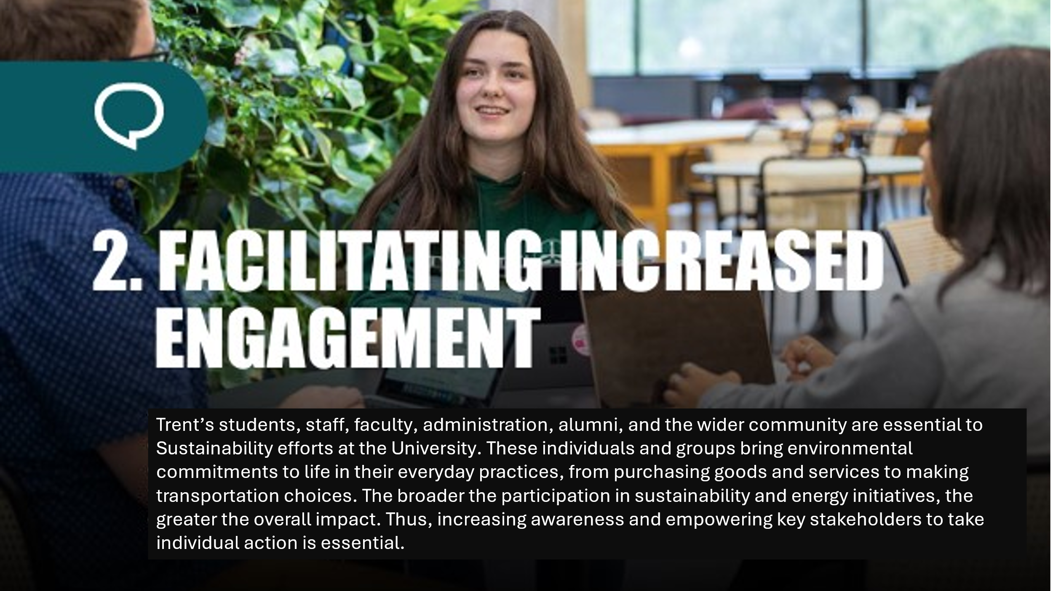

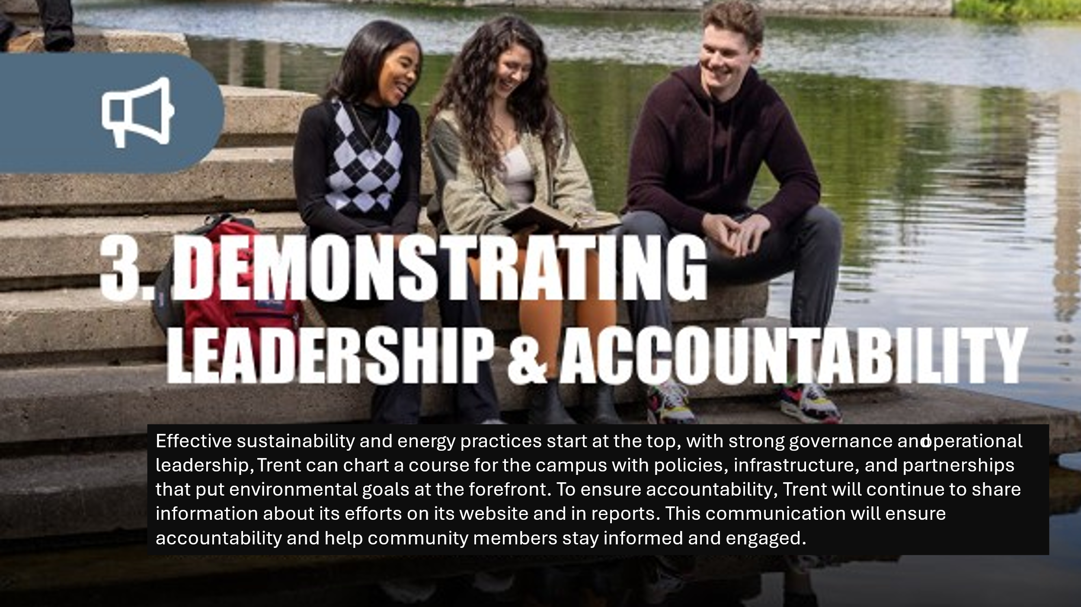



Foodservice Advisory Committee
Budget Working Group
September 24, 2024

MEETING NOTES

Attendance: Mark Murdoch, Food Services; Heather Klyn-Hesselink, TGSA.

- Roll of this working group:

The committee will advise the Executive Director, Food, Conferences and Campus Payment Services in the development of the annual operating budget for the University department. This budget is limited to Trent Foodservice and does not consider the budget of Chartwells or other on-campus foodservice providers. The group will make a recommendation to the Food Services Advisory Committee regarding the budget and related dining plan fess for Trent University Foodservice for the next fiscal year (May – April). The recommendation to FSAC, if approved, is forwarded to CASSC for information and then the Board of Governors for final approval.

- Budget drivers:
  - Escalating food cost – inflation has slowed, running around 2%
  - Wage costs- pending negotiation of Collective Agreement with Chartwells and CUPE 3205
  - Projects – Tim Hortons and Subway
  - Preliminary 2024-2025 Budget
  - New budget schedule
  - Priorities
  - Discuss Dining Plan rates for 2025 - 2026
- Other business
  - Consolidation of all Food Service Operations
  - Durham cost as a result of room closures
- General Discussion and Q & A
  - Can we look at a 5-day and 7-day dining plan model? Yes.
  - Is the redevelopment cost for Tim Hortons functional or just cosmetic? A little bit of both. Some of the equipment is at the end of its useful life and needs to be replaced. We do not to remain compliant with the current operating standards. Some money will just go toward to paint and the current colour scheme.
- Next meetings – November 5 and 26, 1:30 by TEAMS

- The key messages related to the development of the Trent University Foodservices Budget:
  - Trent Foodservices is a not-for-profit ancillary operation of the University. Over time, the department should “breakeven” once it has covered the costs of all operations, overhead and an appropriately level of accrual for future investments or projects.
  - We attempt to keep retail prices at or below the national average, based on an annual survey conducted by the Canadian College and University Food Service Association.
  - Trent students greatly value the ability to “carry forward” any unused dining plan balances at the end of the year.
  - Student value the tax exempt status of the dining plans.
  - The design of dining plans should be simple and easy to understand.
  - A comparison of several dining plans at Canadian schools has been provided below. Trent is at the very low end of the scale.
  - Additional operating hours costs residents. For example, adding Gzowski on weekends would cost each resident about $100.

- Major budget drivers in future years
  - Capital replacement. Within the budget we need to begin to set aside capital reserves for known future projects. For example, the redevelopment of Tim Hortons in 2025 will cost about $500,000. We had been setting aside funds each year, but these reserves were wiped out by operating losses during COVID. We have developed a small reserve, approx. $650k, but this is far short of the anticipated needs over the next two or three years.
  - A lower-than-normal recruitment level has resulted in about 200 empty beds system wide. This will result in an operating loss of about $250k this year, reducing our available reserve.
  - Inflation. While inflation has cooled to about 2%, wage and food cost increases will continue to put pressure on the total costs of operation.
  - US dollar. Most food commodities are traded in US dollars. If the Canadian dollar weakens the effective cost of food increases, compounding any inflationary affect.
  - The US election is likely to have economic impacts that will not be fully understood until the spring.

- Current Dining Plan Rates:

a. Basic plans:
Plan | Traditional | Suite
Cost | $5,650 | $3,800
Overhead | $ 824 | $ 524
O-Week Meals | $ 276 | $ 276
Value | $4,550 | $3,000

- Special Plans:
Plan: | Traill | Traill College Annex
Cost | $5,650 | $5,650
Overhead | $ 824 | $ 824
O-Week Meals | $ 276 | $ 276
Value (see above) | $4,550 | $4,550
3- Meals per week |  | $1,845
Trent Cash | $1,000
Declining Balance | $3,550 | $2,705

- Tax Exemption. To be tax exempt a Dining Plan must meet a number of criteria established by the Canadian Revenue Agency. One of these requires that the plan provides for meals over the duration of the plan (30 weeks for two semesters) and a minimum of 10 meals per week at the “average” cost of a meal on campus.

For Trent the math is; 30 weeks X 10 meals X $10.00 = $3,000.

Given inflationary pressures the average cost of a meal will need to increase next year, likely close to $10.33, moving the suite style declining balance plan value to about $3,099, plus overhead and O-week meals.

- In support of improved governance, the University has accelerating the budget cycle by about one month. This will provide for a greater opportunity to explore impacts to the University Operating Budget. Sadly, it means we also need to work quicker on getting a new budget and related dining plan rates in place for the next fiscal year. The work of this committee needs to be completed by late November.
*Discreet dining plan rates are not available for all Canadian schools as
many schools include the cost of the dining plan within a total cost for
room and board.

Preliminary Unadjusted Budget Food Services 2024-2025
The budget is broken down into several bundles:
- Revenue
- Wage and Benefits
- Transfers to vendors for services
- Operating expenses
- University Overhead
- Utilities
- Principal and Interest Repayment

Dining Plan Components

The total Dining Plan Fee is made up of two components, the overhead and the declining balance portion.
- The cost for O-week “free” meals will increase by 1.9%

- Proposed 2025-2026 Overhead for a Traditional Dining Plan:
Should we use the rate for each campus or a blended rate across all rooms? Blend the difference over three years? – Use blended.
The overhead fee that was collected ($1,100) fell short of actual costs at a net negative impact of about $145k. This amount is recovered from other income sources, vending commissions, product rebates.

- The declining balance portion of the dining plan needs to increase by an amount sufficient to cover inflation in the three broad categories of expenses:
Item: | % of total | Increase | Weighted Increase
Food Cost | 40% | 2% | 0.8%
Labour Cost | 40% | 4% | 1.6%
Other Expenses | 20% | 2% | 0.4%
Total |  |  | 2.8%

The value of the Declining Balance portion of a dining plan will need to increase by 2.8% to maintain the same purchasing power.
- We have a lot of work to do on the costs included in the Overhead fee (where will utilities land for example) and on the declining balance value, given inflation.



FOOD SERVICES ADVISORY COMMITTEE
ALL-YOU-CARE-TO-EAT DINING PLAN
EXPLORATION WORKING GROUP
SEPTEMBER 24, 2024

MEETING NOTES

Attendance: Mark Murdoch, Food Services;

- Role of this ad-hoc working group
  - Explore the attributes of all-you-care-to-eat-dining that are important to Trent residents.
  - Formulate a plan for conversion to AYCTE dining.
- Meeting schedule
  - November 5 and 26, 3:00 – 4:30
  - Additional meetings may be required
- Campus tours
  - Tours of a few campuses are anticipated to allow members of the group to see the different operating styles firsthand and assess which attributes are most important to Trent students. Current proposed dates are Monday November 11 or Tuesday November 12.
- Why this and why now?
  - To address food insecurity for residents.
  - With the opening of Gidigaa Migizi College and the relocated Otonabee College in the fall of 2028, both of which will operate under an AYCTE dining plan, approximately two-thirds of our traditional rooms on the Symons Campus will have AYCTE dining. It is prudent to explore how we create flexibility in our campus wide dining program, offering residents choices in where they dine. For example, if other buildings do not also become AYCTE dining facilities, students of the new building will be limited to dining only in that building and residents of the other Colleges will be largely excluded from using the new facility.
  - AYCTE dining is more environmentally sustainable and eliminates the use of single use packages and beverage containers.
- Residences that are included, traditional rooms in:
  - Champlain College
  - Gzowski College
  - Lady Eaton College
  - Otonabee College in both the current and future location
  - Traill College Annex (possibly)
- Residences that are excluded, and would remain on a declining balance model:
  - All suite style rooms in the four Symons Campus College buildings
  - Water Street Annexes
  - Traill College
  - Durham GTA
- Two approaches to All-You-Care-To-Eat dining:
  - Board Plan. A student selects a dining plan model of the number of meals per week, for example 10, 14 or 19 meals per week. The resident can visit a dining hall that number of times per week and during each visit enjoy a buffet style of service for foods and beverages.
  - All Inclusive Dining. A student selects how many days of the week they want to use the dining room, typically 5 or 7 days. The resident can visit the dining room as frequently as they want.
- Flexibility and Community Access:
  - Add flexibility to either model through “flex cash” and/or meal exchanges.
  - The AYCTE facilities are accessible to the entire campus community as guests who are not residents covered under the AYCTE dining plan to visit the dining hall and pay a flat rate for a single visit or they can purchase a block of “tickets.”
- Grandfather returning students.
  - There is sufficient time and flexibility in the system to allow any resident who previously lived in a traditional room with a declining balance program to continue to do so.

Dining Room Redevelopment Group
August 27, 2024
Great Hall

Attendees: James Onusko, Champlain College; Lori Johnston, Conferences; Sara Pearce, Facilities Management; Jillienne Simone-Burns, Housing; Donna Doherty, Philanthropy; Shannon Brockbank, Facilities Management.

Operational Details Discussion
- 23 are now refurbished or brand new; another 10 or 11 in storage also
- New storage is being utilized; can be used for excess tables as we have more than is needed for regular dining/study hall
- May also be used for excess chairs when that is needed
- Previously, it does not appear to have been discussed, but some discussion around how the corner cabinetry could be renovated (possibly in a style similar to the new storage areas)
- New moveable waste/recycling bins are available now; 1 has been newly built
- Some discussion around floor refinishing; Shannon/Chris will get some quotes
- This would need to be a summer project (it has been 12-years-plus since done the last time)
- Some discussion around the door replacement – in the budget sheet, it is in the FM column for responsibilities at an est. 50K; Sara to inquire with Katherine on that
- Not planning to return the ‘red furniture’ it is damaged/not clean and does not fit with the aesthetic of the rest of the room as we continue to do these updates

- Upcoming Events
  - Major events are associated mainly with Cathy Bruce and a couple of events in mid and late September (including installation luncheon)
  - May also serve as the main site for the actual new Presidential installation as a rain back-up plan

- Budget Update w/ Potential Tasks
  - Table cost was roughly 55K
  - Need to do a reconciliation of the 35 account for this; no one certain of who updates this – Sara and James to discuss further
  - James does not currently “see” this account
  - Sara to find out from Christ about wood refinishing; cold air return maintenance/painting; paint at height – when completed?
  - We need to better understand the budget as it stands today – Sara and James to work on that

- Philanthropy Update
- Donna has launched a broader Champlain Renewal that builds on Doug Kirk’s gift
- Sherry is working on larger gifts (with potential donor(s)
- Have had someone interested in covering costs of tables which would allow other funds to be freed up for further DH improvements
- Opportunities with chairs as that decision is made
- Ideally, chair selection will be finalized in the next month or 2, with completion and installation by Jan 2025

- Chair selection criteria
  - Sara circulated a new set of chairs – looking to build on the recommendation that they be inspired by original “church chair” which was in the GH
  - Michael Eamon had sent in a note that he favoured the Champlain Chair
  - Consensus was that the Darlin Chair and Memphis chairs were 2 of the preferred
  - Can get a custom build from Naked Furniture
  - Want to stay with ladder back idea
  - Stackable would be nice – why we would consider the Memphis chair
  - While not first choice, upholstery okay; but also want a Memphis chair quote without upholstery
  - Looking for rounded corners and rounded legs
  - Both the Darlin and the Memphis would be within preliminary budget which had chairs at $150K

- All Other Business
  - Will seek some further clarification on Project Management of all of this; not entirely clear from previous Minutes
  - James will seek some clarification of that

- Next Meeting Date
  - Not set but agreed we should meet in October and continue to communicate otherwise

