

Foodservice Advisory Committee
October 9, 2024, 2023

MEETING NOTES

Attendance: Mark Murdoch, Food Services; Rylin Wormington, Otonabee; Sarah Ovens, Lady Eaton; TCSA; James Onusko, Colleges; Aimee Blyth, Seasoned Spoon.

- Terms of Reference
  - Review and edits - attached
  - Role of the Committee and Participants - attached
- Role of Sub-Committees - attached
  - Membership
  - Meetings
- Review of Meeting Notes of August 14
  - No items for follow up
- Sub-committee reports
- Operations and Marketing
  - See Meeting Notes of September 30
    - Proposed hours for Thanksgiving and Reading Week
  - Harvest Lunch - $1,916.85 raised for the TCSA One Stop Chop Food Pantry program. Approx. 190 guests served.
- Sustainability and Fair Trade
  - See meeting notes of September 30
- Budget
  - See meeting notes of September 30
    - We are anticipating larger the normal increases in the dining plan fees for next year.
- Catering
  - No report
  - New per diem rates memo - attached
- All-You-Care-To-Eat Working Group
  - See meeting notes of September 30
  - Campus tours planned for Tuesday November 18. Details to follow.
- Additional Working Group Reports
  - Dining room redevelopment group – Met October 8, 2025. Notes to follow. Next meeting prior to end of term.
  - Can we look at possible other layouts to the OC dining room to improve flow and seating utilization. Mark will seek assistance from Facilities Management.

- General Discussion and Q & A
  - Construction of the extension to the Gzowski College dining room is progressing much slower than planned. Work is expected to be completed by mid or late November.
  - The introduction of Mobile Order and Self-Order kiosks for Tim Hortons has moved about 40% of sales to these platforms. This has resulted in shorter lines for ordering and longer lines for the pickup area. This affects how we may chose to layout the furniture differently going forward.
  - There has been a change in how Tim Hortons interprets the tax-exempt status of items purchased at Tim Hortons. Some items cannot currently be purchased on a tax-exempt basis. We are working with all the parties to resolve the issue.
  - What is going on at Traill College? With the closure of the undergrad residence at Traill College this year, it was not feasible to continue to operate The Trend, as the operation has a significant operating loss. In The Trend two vending machines provide snack, beverages, sandwiches, salads, entrees and coffee. The kitchen has been maintained and can be reactivated very quickly if the recruitment numbers improve and ewe reopen the undergrad residences.
- Next meeting – November 6 AND December 4, 9:00 – 10:30, by TEAMS


Trent Food Services Advisory Committee
Terms of Reference – September 2025

Membership:
Executive Director, Food, Conferences and Campus Payment Services (Chair)
A designate of: TCSA, TDSA, TGSA, TUFA
Student Representative from each College Cabinet (5 total)
Student Representative from Durham GTA College Residence Council
Student Representative from Trent International
Trent Market Garden
Trent Vegetable Garden
Trent International Staff member
First People House of Learning representative
Sustainability Committee representative
Trent Director of Student Housing or Designate
Trent Director of Conference Services
Chartwells General Manager
Chartwells CUPE staff member
Ceilie Pub Manager
Seasoned Spoon Manager
Starbucks Manager
A College Principal
A staff representative from Durham GTA

Meetings:
Monthly during the fall and winter semesters, summer as required. Meetings are open to the entire community. Minutes will be posted online.

Mandate:
- To provide feedback and recommendations regarding the Trent Food Services operations
- To identify specific food needs of individuals and the community, and to ensure they are being met
- To review financial, sustainability, wellness, education and community outreach key performance indicators
- To review dining plan structures and cost for the following year
- To determine short-term and long-term food service goals and advise on planning and future directions
- To communicate with the broader Trent community about food services issues and operations
- To identify partnerships and initiatives to educate and support the Trent and Kawartha region communities, including educating students about food issues
- To assist all campus foodservice providers in developing a top-tier food service operation that is a national model for quality and sustainability

Decision Making
The committee is advisory in nature and will normally make decisions on a consensus basis. Typically, the only item that will be voted on will be the approval of the annual budget for Trent University Food Services and the related fees for Dining Plans for the following year. Only the representative from each of the College Cabinets and a student elected or appointed to represent residents from the Durham GTA Campus will participate in this vote. If there is a tie, the representative from the TCSA will cast the deciding vote.

Sub Committees
Sub committees and working groups, both regular and ad hoc may be established to address specific matters, for example:
- Operations and Marketing
- Sustainability and Fair Trade
- Budget
- Catering
- All-You-Care-To-Eat - add
- Ad hoc and Special Working Groups

Role of Sub Committees

Operations and Marketing

The role of this sub-committee is to identify the operational elements of the foodservice program that can be changed or corrected in very short time frames to create an immediate impact for customers, with a specific focus on residents. For example, the committee may recommend improvements to signage as an immediate item. The renovation of a foodservice facility would not be considered by this sub-committee

Sustainability and Fair Trade

The role of this group is to plan and execute small and targeted activities, in the two week to one month time frame, that create immediate changes in sustainable behavior, with a goal of establishing longer term habits in on-campus consumers.

Budget

The committee will advise the Executive Director, Food, Conferences and Campus Payment Services in the development of the annual operating budget for the University department. This budget is limited to Trent Foodservice and does not consider the budget of Chartwells or other on-campus foodservice providers. The group will make a recommendation to the Food Services Advisory Committee regarding the budget and related dining plan fess for Trent University Foodservice for the next fiscal year (May – April). The recommendation to FSAC, if approved, is forwarded to CASSC for information and then the Board of Governors for final approval.

Catering

The Catering Working Group is a subcommittee of the Food Services Advisory Committee that meets to discuss items that are unique to the users of catering services.

All-You-Care-To-Eat Working Group

Working with campus stakeholders, the working group will explore how to best execute the transition to AYCTE ding for the fall of 2028.

Ad hoc and Special Working Group

Ad hoc and special working groups may be established from time to time.

Foodservice Advisory Committee
August 14, 2025

MEETING NOTES

Attendance: Mark Murdoch, Food Services; Wenita Kirkby, Shauna Carlow, Marlee Lunshof, Student Housing; Anthony Coulter, TDSA; Cassandra Kun, Christine Thomas, Chartwells; Kassandra Glasbergen, The Ceilie; Rylin Wormington, Kiara McKinley, Otonabee College Cabinet; Lori Johmston, Conference Services; Jen Richardson, Chris Nelan, Sarah Gallen, Durham GTA; Corine Bolton, Kim Stevens, CUPE 3205; James Onusko, Champlain College; Michael Eamon, Traill College; Emily Poole, Sustainability Office; Heather Klyn-Hesselink, TGSA.

- Review of Meeting Notes of June 18
  - No items identified for follow up.
- Sub-committee reports
- Operations and Marketing
  - See meeting notes of June 18
    - Update on Bata Bean for fall – operational, staffed to support program enrolment, debit payment.
    - Will offer Subway Express sandwiches
- Sustainability and Fair Trade
  - See meeting notes of June 18
    - Waste diversion plan for 2025/26 year – 6 paid student positions to provide peer to peer training on waste diversion
- Catering
  - No meeting
    - Update re Chartwells catering users’ session – dialogue about enhancing the on-campus catering program, service levels and pain points. New menu book coming soon.
    - Events will be provided a QR code to provide event specific feedback
    - New internal catering rates – being explored. Info attached.
- AYCTE WG
  - See meeting notes of June 18
    - We will be moving forward with a far more modest redevelopment of Gzowski servery. No impact to dining room.
- Budget Working Group
  - No meeting
    - With declining enrolment and more empty rooms, our budget is becoming VERY precarious.
    - For example, the $40,000 capital repayment that was previously spread over 200 rooms is now spread over only 100 rooms (57 occupied), increasing the cost per room to $400. We may need to de couple the Peterborough and Durham GTA dining plan rates.

- Dining Room Redevelopment Group
  - New chairs are installed. They look great.
  - Seven tables being sent out to be refinished in the same colour as all the others.
  - Cleaning and painting at height has been completed.
  - Refinishing of woodwork – in progress.
  - Next items – doors, floors and AV
- Construction updates
  - Gzowski – work has fall far behind schedule. Targeted completion in late September.
  - Tim Hortons – on track for completion. Training for new system in late August. We will have the Tim mobile app and self-order kiosk in operation for the fall. These systems will not accept TrentU card for payment.
- Fall Operating Hours – attached.
  - The Trend at Traill College will not operate this year as there are no undergrad residents.
  - Enhanced vending program with snacks, cold beverages, coffee, tea, sandwiches, salads, entrees.
- O-week hours
  - No service on Saturday August 30 – except for scheduled catering
  - “Free” meals begin Sunday August 31, breakfast, with an early start to accommodate leaders and dons. Meals continue through lunch on Wednesday. Food truck festival Wednesday evening.
- General Discussion and Q & A
  - What will happen if construction work at Gzowski is delayed further? A plan is in place that keeps the servery and dining room open for regular operations.
  - Can the new Tim Hortons design support the regular business, plus mobile order, plus self-order? There are more staff at Tim Hortons and the new work flow promises to increase throughput.
- Next meeting – schedule attached

FOOD SERVICES ADVISORY COMMITTEE
MEETING SCHEDULE
SEPTEMBER 2025 THROUGH APRIL 2026

Tuesday September 30, November 4, December 2, January 27, February 24, March 24
9:00 – 10:30 Operations and Marketing
10:30 – 12:00 Sustainability and Fair Trade
1:30 – 3:00 Budget Working Group (extra meeting November 18)
3:00 – 4:30 All-You-Care-To-Eat Working Group

Thursday October 9, November 6, December 4, January 29, February 26, March 26
9:00 – 10:30 Food Services Advisory Committee

The copy of the memo provided below has been redacted as it no longer reflects the current practice. A new version is provided below.
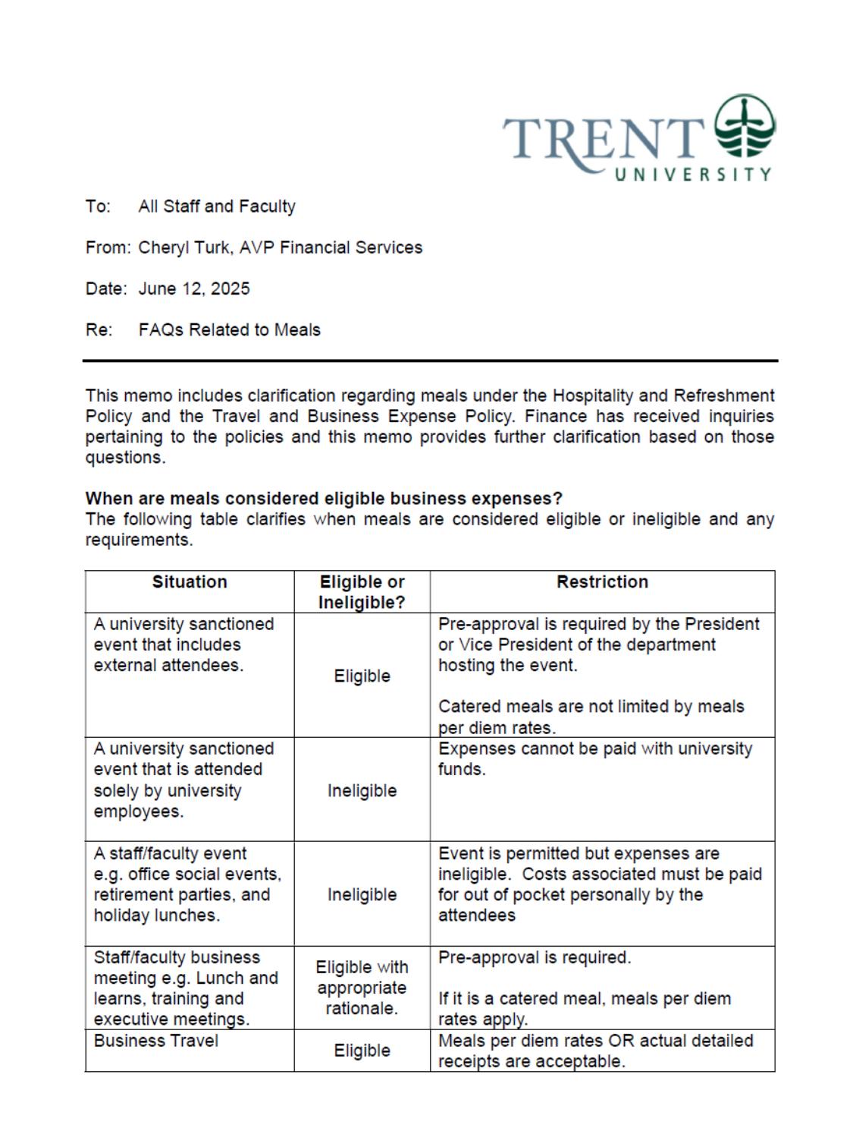
Pages 2 and 3 intentionally deleted as these were no longer accurate.

Trent University Foodservices
Food Services Advisory Committee
Operations and Marketing Working Group
September 30, 2025

MEETING NOTES

Attendance: Mark Murdoch, Food Services; Christine Thomas, Chartwells; Corine Bolton, CUPE 3205; Serena Hong, Gzowski College; Michael Eamon, College Principals.

- Role of the committee

The role of this sub-committee is to identify the operational elements of the foodservice program that can be changed or corrected in very short time frames to create an immediate impact for customers, with a specific focus on residents. For example, the committee may recommend improvements to signage as an immediate item. The renovation of a foodservice facility would not be considered by this sub-committee.

- Harvest Lunch, October 8, Great Hall, pay what you can, supported by campus Food Service partners.
- Punch-a-Lunch update – program data not available yet as today is the last day of the month.
  - One Punch Lunch – new program providing a single punch
- Tim Hortons update
  - Construction – project is 99% complete, producing the desired outcomes.
  - Utilization of Mobile Order and Self-Serve kiosks – revenue is up 47% over the same period last year, with mobile order and self-order kiosks accounting for 40% of revenue. The lines to order are shorter as more customers leverage the new technologies.
- Gzowski Dining Hall update – should be complete by end of October.
- Bata Bean Amazon Just Walk Out update – technology is improving. Customer adoption is increasing. 200% plus lift in revenue. Sold 50 Subway pre-made sandwiches yesterday.
- BOOST update – a marketing and activation campaign was carried out in early September. Trent continues to perform very well in this area.
- Thanksgiving operating hours - attached
- Reading week operating hours - attached
- Other business
- Next meeting November 4 and December 2, 9:00 – 10:30 by TEAMS



Foodservice Advisory Committee
Sustainability and Fair-Trade Working Group
Tuesday September 30, 2025

MEETING NOTES

Attendance: Mark Murdoch, Food Services; Shelley Strain, Sustainability Office; Christine Thomas, Cassandra Kun, Chartwells; Corine Bolton, Kim Stevens, CUPE 3205; Kyra Myderwyk, TCSA; Najah Wardat, TGSA..

- Role of the working group

The role of this group is to plan and execute small and targeted activities, in the two week to one month time frame, that create immediate changes in sustainable behavior, with a goal of establishing longer term habits in on campus consumers.

- Current commitment:
- Review of prior Strategies and Initiatives – so many of our initiatives have become completely embedded within our food service operations that we no longer think about them.
- Participation in eco-tray program and travel mug utilization – oops. Good data is not available. We will work to resolve that data collection.
- Renewal of Fair-Trade certification completed
  - There was a discussion about moving away from Fair Trade to beyond fair trade, through direct purchase of coffee. This would permit Trent to offer a broader range of coffees and better align our coffee offering with an educational component. This is just something that is being contemplated. No concrete action at this time.
  - In response to commentary about the preponderance of Starbucks and Tim Hortons on campus, there was a suggestion to offer iced coffee in the dining halls. The idea has been sent to Chartwells for consideration.
- Update on Food Guide Friendly recognition at The Seasoned Spoon – completed.
- Renewal of Gzowski, Lady Eaton and Durham Green Restaurant 3-star certification
- What does our goal of being a “Waste Free” campus by 2028 look like and how might it impact food service operations?
  - We can achieve our goal with only small tweaks to our current behaviours. The conversion to AYCTE dining will eliminate most waste and packaging from the food service program.
- Deployment of Zero Waste Ambassadors.
  - Food Services has funded $10,000 for “Zero Waste Ambassadors”. Six have been hired in Peterborough and one in Durham.
  - In September they worked 194 hours helping educate students on the proper sorting methodology.
  - They will begin the education program for our “Zero Waste Challenge” shortly.
  - In January the Province will implement a common waste and recyclables sorting program. Additional training resources will be required to support this change.
- General discussion and Q and A
  - There was a question about training specific for international students, many of whom have a different experience for waste management than is common in Ontario. The Sustainability Office likes to connect these opportunities with another event. For example, if Trent International is hosting an event, that includes food, they can provide support to educate participants in proper sorting techniques.
- Pictures from some recent tabling and education events are attached below.
- Next meetings– November 4 and December 2, 10:30 – 12:00 by TEAMS
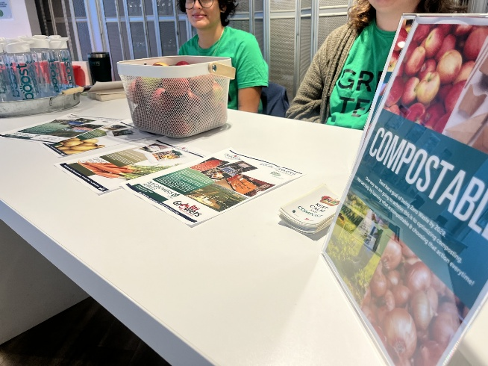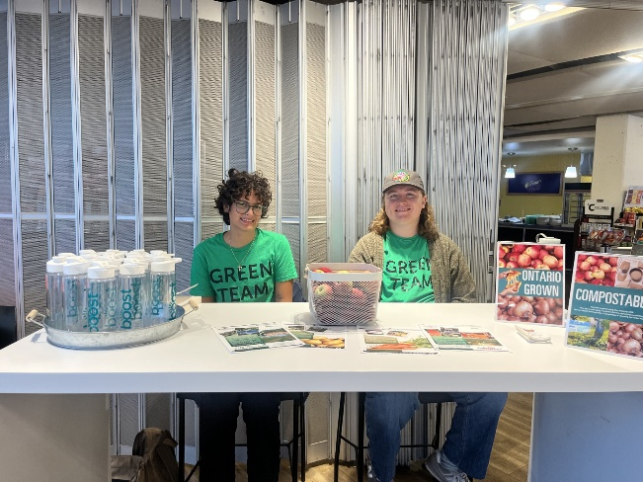



Foodservice Advisory Committee
Budget Working Group
September 30, 2025

MEETING NOTES

Attendance: Mark Murdoch, Food Services; Anthny Coulter, TDSA.

- Role of this working group:

The committee will advise the Executive Director, Food, Conferences and Campus Payment Services in the development of the annual operating budget for the University department. This budget is limited to Trent Foodservice and does not consider the budget of Chartwells or other on-campus foodservice providers. The group will make a recommendation to the Food Services Advisory Committee regarding the budget and related dining plan fess for Trent University Foodservice for the next fiscal year (May – April). The recommendation to FSAC, if approved, is forwarded to CASSC for information and then the Board of Governors for final approval.

- This year, we intend to develop a framework for the redevelopment of the Food Service budget and the establishment of dining plan rates for the next three years as we:
  - transition to All-You-Care-To-Eat dining and the operation of the new dining facility under a relationship with the building owner/partner.
  - Contemplate adding two weeks to the dining schedule, over the winter holiday period
  - Decouple the AYCTE dining plan from the declining balance dining plan
  - Develop a budget model that accounts for fewer beds in Durham and has the location be self supporting, likely resulting in a higher admin fee

- Budget drivers:
  - Escalating food cost – inflation has slowed; however food inflation is running at a rate much higher than general inflation, running around 4%
  - Wage costs- the wages that were established through the latest collective bargaining process were not fully captured in the budget last year. The wage increase, over three years, totals about 18%.
  - Projects
    - Partial redevelopment of Gzowski servery and kitchen, estimated at about $500,000
    - Total redevelopment of LEC in the summer of 2026, estimated at $3,500,000
    - The cost to finance these two projects is estimated at about $425,000 per year.
  - Preliminary 2025-2026 Budget
  - Priorities
  - Discuss Dining Plan rates for 2026 – 2027, 2027-2028, 2028-2029
- Other business
  - Escalating costs per bed as rooms are closed or repurposed
- General Discussion and Q & A
- Next meetings – November 4 and December 2, 1:30 by TEAMS

- The key messages related to the development of the Trent University Foodservices Budget:
  - Trent Foodservices is a not for profit ancillary operation of the University. Over time, the department should “breakeven” once it has covered the costs of all operations, overhead, capital investments and an appropriate level of accrual for future investments or projects.
  - We attempt to keep retail prices at or below the national average, based on an annual survey conducted by the Canadian College and University Food Service Association.
  - Trent students greatly value the ability to “carry forward” any unused dining plan balances at the end of the year.
  - Student value the tax exempt status of the dining plans.
  - The design of dining plans should be simple and easy to understand.
  - A comparison of several dining plans at Canadian schools has been provided below. Trent is at the very low end of the scale.
  - Additional operating hours costs residents. For example, adding Gzowski on weekends would cost each resident about $100.

- Major budget drivers in future years
  - Capital replacement. Within the budget we need to begin to set aside capital reserves for known future projects. For example, the redevelopment of Gzowski in 2026 will cost about $500,000, LEC about $3.5 million.
  - A lower-than-normal recruitment level and the conversion of some beds to upper year/grad rooms, without an assigned dining plan, has resulted in about 400 empty beds system wide. Durham GTA has been reduced to 100 beds,
  - Inflation. While inflation has cooled to about 2%, wage and food cost increases have run much higher and will continue to put pressure on the total costs of operation.
  - US dollar and tariffs. Most food commodities are traded in US dollars. If the Canadian dollar weakens the effective cost of food increases, compounding any inflationary affect.

- Current Dining Plan Rates:

  - Basic plans:

Plan | Traditional | Suite
Cost | $6,050 | $4,150
Overhead | $ 963 | $ 663
O-Week Meals | $ 287 | $ 287
Value | $4,800 | $3,200

- Tax Exemption. To be tax exempt a Dining Plan must meet a number of criteria established by the Canadian Revenue Agency. One of these requires that the plan provides for meals over the duration of the plan (30 weeks for two semesters) and a minimum of 10 meals per week at the “average” cost of a meal on campus.

For Trent the math is; 30 weeks X 10 meals X $10.77 = $3,177

Given inflationary pressures the average cost of a meal will need to increase next year, likely close to $11.04, moving the suite style declining balance plan value to about $3,312, plus overhead and O-week meals.

- Dining plan rates for several Canadian schools for the 2025/2026 (current) year are provided below. Rates for the 2026/2027 are not yet known. Trent remains at the very bottom. The “average” dining plan fee for Canadian schools was $6,738.00.
*Discreet dining plan rates are not available for all Canadian schools as
many schools include the cost of the dining plan within a total cost for
room and board.

Preliminary Unadjusted Budget Food Services 2025-2026
The budget is broken down into several bundles:
- Revenue
- Wage and Benefits
- Transfers to vendors for services
- Operating expenses
- University Overhead
- Utilities
- Principal and Interest Repayment

Dining Plan Components

The total Dining Plan Fee is made up of two components, the overhead and the declining balance portion.
- The cost for O-week “free” meals will not increase for 2026-2027.

- Overhead for a Traditional Dining Plan:

Should we use the rate for each campus or a blended rate across all rooms? Adjust the difference over three years?
There will be a considerable increase in the total Food Service overhead, on a per resident basis, as the number of beds declines and costs continue to increase.
- The declining balance portion of the dining plan needs to increase by an amount sufficient to cover inflation in the three broad categories of expenses:
Item: | % of total | Increase | Weighted Increase
Food Cost | 40% | 4% | 1.6%
Labour Cost | 40% | 6% | 2.4%
Other Expenses | 20% | 3% | 0.6%
Total |  |  | 4.6%

The value of the Declining Balance portion of a dining plan will need to increase by 4.6% to maintain the same purchasing power. The minimum amount for traditional rooms will be $5,020 and suite style rooms $3,350.
We have a lot of work to do on the costs included in the Overhead fee (where will utilities land for example) and on the declining balance value, given inflation.
- Proposed dining plan fees for 2026/2027.
Traditional Style Plans
 | Current | Proposed | Change
Declining Balance | $4,800 | $5,020 | 4.6%
Overhead | $1,250 | $1,550 | 24%
Total | $6,050 | $6,570 | 8.6%

Suite Style Plans

 | Current | Proposed | Change
Declining Balance | $3,200 | $3,350 | 4.7%
Overhead | $950 | $1,250 | 31.6%
Total | $4,150 | $4,600 | 10.8%



FOOD SERVICES ADVISORY COMMITTEE
ALL-YOU-CARE-TO-EAT DINING PLAN
EXPLORATION WORKING GROUP
SEPTEMBER 30, 2025

MEETING NOTES

Attendance: Mark Murdoch, Food Services; Aimee Blyth, Seasoned Spoon; James Onusko, Champlain College;

- Role of this ad-hoc working group
  - Explore the attributes of all-you-care-to-eat-dining that are important to Trent residents.
  - Formulate a plan for conversion to AYCTE dining.
  - The rates for AYCTE dining plans will be set by the Budget Working Group.
- Meeting schedule
  - November 4 and December 2, 3:00 – 4:30
  - Additional meetings may be required.
- Campus tours
  - Tours of a few campuses are anticipated to allow members of the group to see the different operating styles firsthand and assess which attributes are most important to Trent students. Current proposed date is Tuesday November 18. Details to follow.
- Why this and why now?
  - To address food insecurity for residents.
  - With the opening of Gidigaa Migizi College and the relocated Otonabee College in the fall of 2028, both of which will operate under an AYCTE dining plan, approximately two-thirds of our traditional rooms on the Symons Campus will have AYCTE dining. It is prudent to explore how we create flexibility in our campus wide dining program, offering residents choices in where they dine. For example, if other buildings do not also become AYCTE dining facilities, students of the new building will be limited to dining only in that building and residents of the other Colleges will be largely excluded from using the new facility.
  - AYCTE dining is more environmentally sustainable and eliminates the use of single use packages and beverage containers.
- Residences that are included, traditional rooms in:
  - Champlain College
  - Gzowski College
  - Lady Eaton College
  - Otonabee College in both the current and future location
- Residences that are excluded, and would remain on a declining balance model:
  - All suite style rooms in the four Symons Campus College buildings
  - Water Street Annexes
  - Traill College
  - Durham GTA
- All Inclusive All-You-Care-To-Eat dining:
  - All Inclusive Dining. A student selects how many days of the week they want to use the dining room, typically 5 or 7 days. The resident can visit the dining room as frequently as they want.
  - Add flexibility to either model through “flex cash” and/or meal exchanges.
  - The AYCTE facilities are accessible to the entire campus community as guests who are not residents covered under the AYCTE dining plan to visit the dining hall and pay a flat rate for a single visit or they can purchase a block of “tickets.”
- Grandfather returning students.
  - There is sufficient time and flexibility in the system to allow any resident who previously lived in a traditional room with a declining balance program to continue to do so.
- Access to the dining rooms will be maintained during off-peak hours
  - Moveable partitions or barriers that define the space during different day parts.
- Proposed layout of Gzowski College. – not available
- Proposed Layout of Lady Eaton College – not available
- Proposed layout of Gidigaa Migizi College - attached

Proposed layout of Gidigaa Migizi College Dining Room, Servery and Kitchen

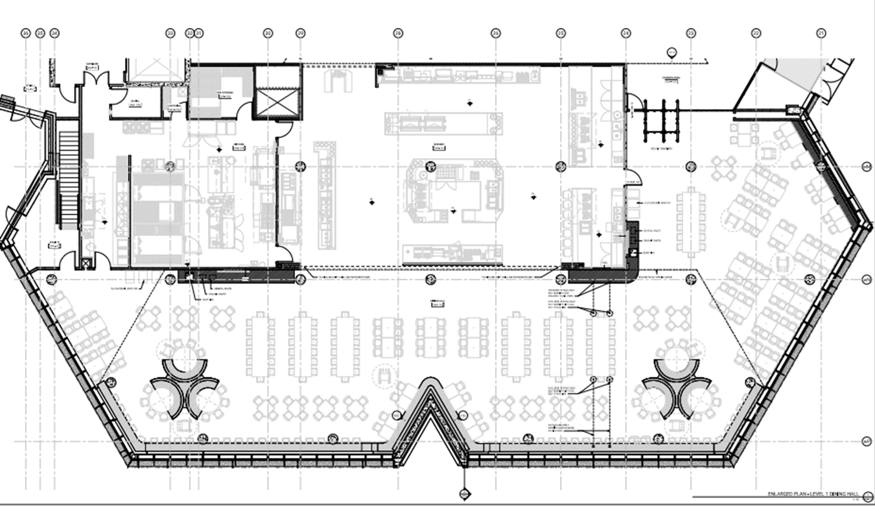

Dining Room Redevelopment Group Minutes
October 8, 9-10 am
Great Hall

Present: James Onusko, Sara Pearce, Michael Eamon, Shannon Brockbank, Mark Murdoch, Christine Freeman-Roth, Chris D’Innocenzo

Regrets: Lori Johnston, Donna Doherty

- Operational Details Discussion
- Chairs delivered in late spring
- Floor refinishing overview
- Shannon has a process that would use a pad for “stripping” the wax
- Likely wouldn’t be done until SU ‘26
- Need to check with Lori on SU ’26 events
- Could possibly do ½ the floor and then partition other half and then reverse process to completion
- Should be considerably less than the $30K that is currently allocated
- Roof news – no news to report
- Storage closets at North End – Heritage/logistical discussion took place in late summer
- Likely to move ahead with both storage closets; NE corner first
- Ideally we would pursue symmetry here
    - Sara will pursue to see how the electrical panel and closet can be navigated in the NW corner of the room
- Corner cabinetry – will be Oak plywood with a grey top (colours will mirror the tables and chairs)
- Refinished remaining tables – completed

- Budget Update w/ Potential Tasks/Costing
- Sara provides updates here – excellent itemization
- Request for an ‘in kind’ column to designate work completed but not billed to the account – F/M doing this on a few lines (painting for eg.)
- Some further updates to be made as some lines have changed – some of the woodwork will be higher $ value for cabinetry
- Also now planning to split the current ‘tied’ display cases and move one to the SW corner of the room as both are now on the SE corner
- Call to move the ‘tacky’ bulletin boards and reposition them in the hallway and facing the cafeteria (Sara & James to confirm spot)

- Philanthropy Update
    - No updates here – James to connect with Donna

4. Doors
    - Discussion
    - Mark reiterates that doors should not be included in this Redevelopment – sees it as F/M responsibility as part of regular maintenance due to rents paid over time
    - Some discussion on shared costs
    - Sara will forward to Katherine for further discussion with James

- A/V Discussion
    - A/V has been discussed on several occasions
    - Wide variance on what these costs might be
    - Costing done years ago had a $400K price tag
    - Sara included some ballpark figures
    - Sara will work with Jeff Gardner to spend to an agreed $ figure on a A/V consultant and provide various options at distinct price points

- AOB
- None

- Next Meeting
- By end of Dec 2025

Revised memo regarding catering per diem rates:

To: Faculty and Staff

From: Cheryl Turk, AVP Financial Services

Date: September 29, 2025

Re: Meals Per Diem Rate Change Effective October 1, 2025

In response to your recent feedback expressing concern that current meal per diem rates are not reflective of current economic realities, the President and Vice Presidents Committee has approved an increase in rates effective October 1, 2025. The new rates are more aligned with rates across comparator universities and will be updated in Emburse Enterprise.

Meals Per Diem Rates Per Person
 | Old Rates | New Rates
Breakfast | $10.00 | $20.00
Lunch | $12.50 | $25.00
Dinner | $22.50 | $40.00
Total Daily Rate | $45.00 | $85.00

Are taxes and gratuities included in the meals per diem rates?

Yes, the rates are inclusive of all taxes and gratuities.

If I require a full day of meals, can the $85.00 daily rate be distributed however I want for the three meals?

Yes, you can combine the rates for meals into one for the day and divide it up as you would like. For example, you can decrease the amount spent on breakfast and increase the amount spent on dinner.

When would these meals per diem rates apply?

The new meals per diem rates are used in two situations:

- In lieu of receipted meals while travelling within Canada.
  - If a receipt is not obtained or is lost for a meal purchased while travelling for business purposes within Canada, faculty and staff may choose to be reimbursed for out-of-pocket purchases using the meal allowance rates.
  - If this option is chosen, itemized receipts are not required and should not be submitted.
- For any centrally purchased catered meals (excluding University Sanctioned Events, Student Majority Events and External Events).
  - If a business meal is catered, the meals per diem rates are used as the maximum per person amount. Catered meals are the supply and service of food and drinks, where services such as table/banquet set up and clean up, servers, provision of china and linens, etc. are included with the preparation and delivery of the meal.
  - In general, catered meals are used for large group events or business meals (10 or more people).

Can I use meals per diem rates when I use my One Card Corporate Credit Card to purchase a business meal?

No, using the meals per diem rates is not an option if using the One Card Corporate credit card for meals while travelling. Itemized receipts must be provided for all charges paid via One Card.

What meals per diem rates do I use if I am travelling outside Canada or am being funded by a source other than Ontario government funding?

If travelling outside Canada or for travel funded by non-Ontario government grants, National Joint Council rates are used.

When ordering from Chartwells, what are my options?

Chartwells now offers three ordering options: Value, Delivered and Full Service. The table below displays what each option offers.

 | Value | Delivered | Full Service
Service | Pickup only | Delivered but not set up | Full service delivery, set up and cleanup
Food options | Smaller portions – for example one sandwich per person | Larger portions and upgrade to the menu options – for example 1.5 sandwiches per person and baguettes and pretzel rolls vs. bread or buns | Enhanced menu choices and more complete meals, for example, includes crudité, dessert, etc.
Cost | Most cost efficient | Increase of $3 to $4 per person compared to the Value option | Another additional $3 to $4 per person compared to the Delivered option
Environmentally Friendly? – The use of non-disposable table wear | No – single use disposable plates, bowls, cups and cutlery will be provided.  To assist in making this option non-disposable, provide your own reusable plates and cutlery | No – single use disposable plates, bowls, cups and cutlery will be provided.  To assist in making this option non-disposable, provide your own reusable plates and cutlery | Yes - Chartwells provides china, linen and cutlery

Do the meals per diem rates apply to all three options offered by Chartwells?

Value Option
No. As this option is pickup only and there is no set up or service component, it is not considered a catered service and the meals per diem rates do not apply. The rates are already reasonable for the service being provided.

Delivered Option
No. As this option is delivery only and there is no set up or service component, it is not considered a catered service and the meals per diem rates do not apply. This would be comparable to ordering in food delivery from restaurants or SkipTheDishes.

Full Service Option
Yes. The meals per diem rates would apply to this option as the option includes full catering services. The exceptions to utilizing the meals per diem rates are as follows: University Sanctioned Events, Student Majority Events or External Events. All other meetings and events that use this option, must utilize the meals per diem rates.

What information do I need to provide Chartwells when placing an order?

You need to provide the following information when placing an order with Chartwells:
- Billing account
- Which option you would prefer from the three listed above
- How many people will be attending
- The name of the event
- Location of the event
- Date and time of the event
- Name and phone number for the person placing the order and/or attending the event

When ordering from Seasoned Spoon Café, what are my options?

The Seasoned Spoon Café offers many options that fit within the new per diem rates. You can find information about their catering options by visiting the cafe, or write to seasonedspoon@trentu.ca for more information.

If I am required to work or have a meeting over a mealtime, what are the alternative meal options to catered meals?

If you are required to work or are planning a business meeting over a mealtime, consider the following options as opposed to having your meal catered (meals per diem rates would not apply):
- Staff can bring their own meal if it is known ahead of time. Trent can supplement with a light snack or beverage option
- Staff can order in from a food establishment. Example, order in pizza
- Staff can place an order with Chartwells using either the Value or Delivered options dependant on budget
- Staff can order from the Seasoned Spoon and pickup their order at the cafe

