

Foodservice Advisory Committee
November 28, 2024, 2024

MEETING NOTES

Attendance: Mark Murdoch, Food Services; Lori Johnston, Conferences; Aimee Blyth, Seasoned Spoon; Heather Klyn-Hesselink, TGSA; Christine Thomas, Cassandra Kun, Chartwells; Kim Stevens, CUPE 3205; Jillienne Simone-Burns, Student Housing.

- Review of Meeting Notes of November 7

- Sub-committee reports
- Operations and Marketing
  - See Meeting Notes of November 26
    - HST holiday
    - Exam and Holiday Season schedule
    - Extension to the Housing term
- Sustainability and Fair Trade
  - See meeting notes of November 26
- Budget
  - See meeting notes of November 26
- Catering
  - No meeting
- AYCTE WG
  - See meeting notes of November 26
- Winter meeting schedule - attached
- General Discussion and Q & A
- Next meeting – January 23, 9:00 – 10:30, by TEAMS

Trent University Foodservices
Food Services Advisory Committee
Operations and Marketing Working Group
November 26, 2024

MEETING NOTES

Attendance: Mark Murdoch, Food Services; Aimee Blyth, Seasoned Spoon; Christine Thomas, Cassandra Kun, Chartwells; Kassandra Glasbergen, Ceilie; Sarah Gallen, Durham; Corine Bolton, Kim Stevens, CUPE 3205; Heather Klyn-Hesselink, TGSA.

- Review meeting notes from November 5
  - Update re Bata Bean JWO
    - Continuing to work on allowing debit transactions
    - Some bugs in the system are being worked out as they refine the software
    - Marketing campaign this week to encourage members of the campus community to download the BOOST app and to familiarize them with the use of the facility
    - The system does not capture any video that can be used to identify a person. The video stream is discombobulated and is captured as a blur overlayed by a stick figure that is used to map the items that are picked up.
    - Amazon does not have access to the purchase data. That is retained at the Compass/Chartwells/Trent level, the same as all other purchase data on campus.
    - Trent did not make any capital investment in the facility.
- GST reduction Dec 14 to Feb 15
  - Will (likely) impact the full 13% HST.
  - Just learned about it last Thursday, so still trying to figure out what and how.
  - Will have a solution by December 14.
- Exam and Holiday Season operating hours - attached
- Addition of one week to the residence agreement
  - In April of 2026, the end of the next fiscal year, one week will be added to the end of the residence term, extending the stay to May 1. This will allow students to leave all their stuff in their rooms until the first day of what could be their new lease off-campus. There will be no need for residents to request an extended stay at the end of the school year. Residence and dining rates will be adjusted accordingly.
- Other business
- Next meetings January 21, February 25, March 25, 9:00 – 10:30 by TEAMS



Foodservice Advisory Committee
Budget Working Group
November 26, 2024

MEETING NOTES

Attendance: Mark Murdoch, Food Services; Chris Nelan, Durham; Nav Chugh, TCSA;

- Review of Meeting Notes of Nov 5
- What has changed since November 5
  - O-week meals
  - Utility and maintenance charges confirmed
  - Forecast recruiting numbers
    - Impact on revenue
    - Impact on “per bed” charges
  - Convert beds to non-revenue generating
  - Add one week to the dining plan
- Proposed 2025-2026 Dining Plan Rates

Revised budget – Nov 26
Items in yellow highlight have not been confirmed.

Total Dining Plan Fees:
The increase to the total dining plan fee has two components: Food Services Overhead and the Declining Balance value.
Food Services Overhead:
Food Services Overhead includes four pieces; University Admin Overhead, calculated as 6.62% of the total dining plan fee, O-week meals, Utilities and Maintenance, and Principal and Interest.
- Modest changes to O-week meals:
- Change to utility and maintenance costs:
  - The Nov 5 version had costs at $758,025
  - Confirmed costs are $753,759
This represents an increase of 4.3% from 2024-2025.
- A forward look at recruiting numbers has prompted Student Housing to close some beds, convert double rooms to singles, convert first year rooms to upper year rooms, without a dining plan. These impacts happened in the current year, but after the budget was developed. Total income generating beds had declined from approx. 2,000 to about 1,600.

- In Peterborough there were 1,860 beds. At a new bed count of 1,480, the per bed cost for utilities has increased from $368.55 to $485.60. The capital repayment increases to $129.89. The actual cost for capital repayment at Durham would be between $325 and $400, but has been reduced to $260 to help reduce the increase. There is a similar impact on utility and maintenance costs at both campuses.

- One week is being added to the Housing contract, extending contracts to May 1, to allow students to move to off-campus housing in one step. This has a 3.33% impact on the declining balance portion of the dining plan.

In Peterborough the Food Service Overhead cost per student has increased $179. In Durham the increase is $204. The proposed Food Service Overhead for all traditional beds is $1,250 and $950 per Suite Style bed. Food Service Overhead fees at these levels will result in a budget shortfall of over $150,000.

Declining Balance Value Increase:
- The declining balance portion of the dining plan needs to increase by an amount sufficient to cover inflation in the three broad categories of expenses:
Item: | % of total | Increase | Weighted Increase
Food Cost | 40% | 2% | 0.8%
Labour Cost | 40% | 4% | 1.6%
Other Expenses | 20% | 2% | 0.4%
Total |  |  | 2.8%

- One week is being added to the duration of the dining plan, 3.3%. Fortunately, if students do not use this additional amount, it will carry forward to future years.
Proposed Dining Fee Rates for 2025-2026:
Proposed dining plan rates for 2025-2026 will increase due to five drivers:
- An inflationary increase in the value of the declining balance portion, 2.8%
- An increase in O-week meals, 2.6%
- An increase in Utilities and Maintenance and Principal repayment, due to a combination of inflationary increases and fewer revenue generating beds, 30% in Peterborough and 31.6% in Durham.
- An increase in the declining balance portion of the dining plan to add one additional week to the dining plan, 3.3%
- An increase in the University Admin Overhead that includes all increases above, $29.79, 8%.



Foodservice Advisory Committee
Sustainability and Fair-Trade Working Group
Tuesday November 26, 2024

MEETING NOTES

Attendance: Mark Murdoch, Food Services; Shelley Strain, Sustainability Office; Cassandra Kun, Chartwells; Ainsley MacPherson, Gzowski College; Aimee Blyth, Seasoned Spoon; Heather Klyn-Hesselink, TGSA.

- Review of Meeting Notes of November 5, 2024
  - Updated eco-travel and travel mug info was provided in the revised meeting notes. See below.
  - Waste audit update – begins Tuesday Dec 4, will run for one week. Some results early in 2025.
    - While our target for 90% waste diversion for 2028 gets us to a recognition of “Waste Free” will we continue to pursue even better waste diversion? Yes. The measurement is a little funny. To get to “waste free” we need to divert 90% of all of our waste, not just 90% of our divertible waste. Some of our waste will always be sent to landfill as an alternate does not exist. To get to 90% diversion of all waste we must get to nearly 100% diversion of waste that can be diverted. The harmonization of the waste management system in Ontario will help with both the accuracy of our diversion and the level of it.
    - Moving to an all-you-care-to-eat dining program in 2028 will eliminate single use beverage packages in the AYCTE dining halls (think 75% campus wide reduction) and eliminate single use take out containers. Organic waste will be reduced.
    - We have moved our organic disposable to the local Peterborough facility. This has dramatically reduced our GHG emissions from trucking it far away. Cost has also been reduced. The City is glad to take our organioc waste do to the volume and quality.
  - Oscar sort update https://www.youtube.com/watch?v=je6UqHIY_tE
    - Chartwells is participating in this program. We will look to see how we can leverage that relationship to support deployment of Oscar Sort on campus.
    - Data from Oscar may serve as data for diversion rates and reduce the need for manual audits.
- Participation in eco-tray program – data below
- Participation in travel mug usage – data below
- Next steps re Organic Canada Campus Certification program.
  - Does somebody want to take the leadership role for this program?
    - The high cost of certification may exclude some local farmers from participation. Organic doesn’t necessarily mean healthier. This is an item we are going to pause for awhile.
- General discussion and Q and A
  - Is there an opportunity to connect the goals of the campus, the work that Chartwells is doing and broader campus goals to a working group? Research? Use data to drive decision making? Yes. We just need somebody to make that happen. Let’s start by looking at the Farm Masterplan Committee.
  - Chartwells, primarily through Tim Hortons, is participating in a program called Too Good To Go https://www.toogoodtogo.com/en-ca/
Chartwells local team will collect more info and we will see how we can participate.
  - To fully support our metrics on waste diversion we need to better understand and collect data from all food service providers on campus.
- Next meetings– January 21, February 25, March 25, 10:30 – 12:00 by TEAMS



FOOD SERVICES ADVISORY COMMITTEE
ALL-YOU-CARE-TO-EAT DINING PLAN
EXPLORATION WORKING GROUP
NOVEMBER 26, 2024

MEETING NOTES

Attendance: Mark Murdoch, Food Services; Christine Freeman-Roth, Melanie Buddle, Michael Eamon, Stephanie Muehlethaler, James Onusko, Colleges; Stevie-Dee Carter, LEC; Makaylla Somerville, GC.

- Review Meeting Notes of September 24 and Nov 5
- Redevelopment schedule
  - Summer 25 Tim Hortons and Gzowski addition
  - Summer 26 Gzowski redevelopment
  - Summer 2027 Lady Eaton redevelopment
  - Summer 2028 Gidigaa Migizzi College development
- Sample menu concepts for LEC and GC
  - We assemble a comprehensive set of menu parts and then distribute them around campus in a manner that provides the greatest flexibility and choice.
  - Samples of menu parts for LEC and GC are provided below.
- Preliminary servery layout for GC.
  - Using the menu parts as a framework the floor plan is developed. A sample floor plan for GC is provided.
- General discussion and Q&A
  - Priorities, in addition to those previously identified:
    - The redevelopment of the spaces needs to support the College model. Each College needs an identifiable space. Access for items like College dinners needs to be maintained.
    - Convenience and proximity. Students eat close to where their classes are, so the spaces need to be convenient.
    - Students like to take out and eat in their room.
    - Maintaining access:
      - A faculty member should be able to enter the dining room without making a purchase to have a meeting with a student. There is no hard data on how often this happens.
      - Access to the LEC piano room. Sure. We can let people in to use the piano room.
      - Flexible dining space, by moving a barrier that will allow part of the dining room to be used as a public space in off-peak hours.

  - There was some dialogue about the proposed My Pantry and Teaching space.
    - Can it be used for groups to have events? Yes. This does not replace the community kitchens that exist in the Colleges. It is intended to compliment them. The “teaching” aspect will be led by a chef/instructor to help students build skills and confidence.
    - Can it be used by non-residents? This is not a place for people to bring in their own food to cook, for safety reasons. It may be appropriate for it to be used by a group that includes residents and non-residents.
    - How do we ensure hygiene? The risk in using the space is no greater than the risk in our other shared use kitchens. It is likely lower as there will be support staff who supervise the space and carry out routine cleaning and sanitizing.
- Next steps:
  - Confirm drawings for GC addition for summer 2025 – before holidays
  - Confirm floor plan for GC NLT late winter semester
  - GC addition, summer 2025
  - Confirm menu parts and floor plan floor plan for GMC – early 2025. These items need to be included in the design of the building and the related permitting.
  - GC addition, summer 2025
  - Confirm menu parts and floor for LEC – fall 2025
  - GC renovation summer 2026
  - LEC renovation, summer 2027
  - New buildings, summer 2028
- Next meeting, January 21, February 25, March 25, 3:00 – 4:30 by TEAMS.
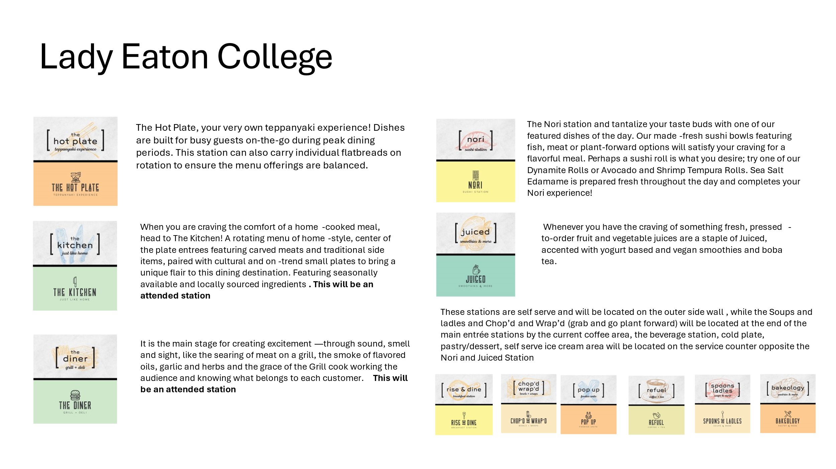
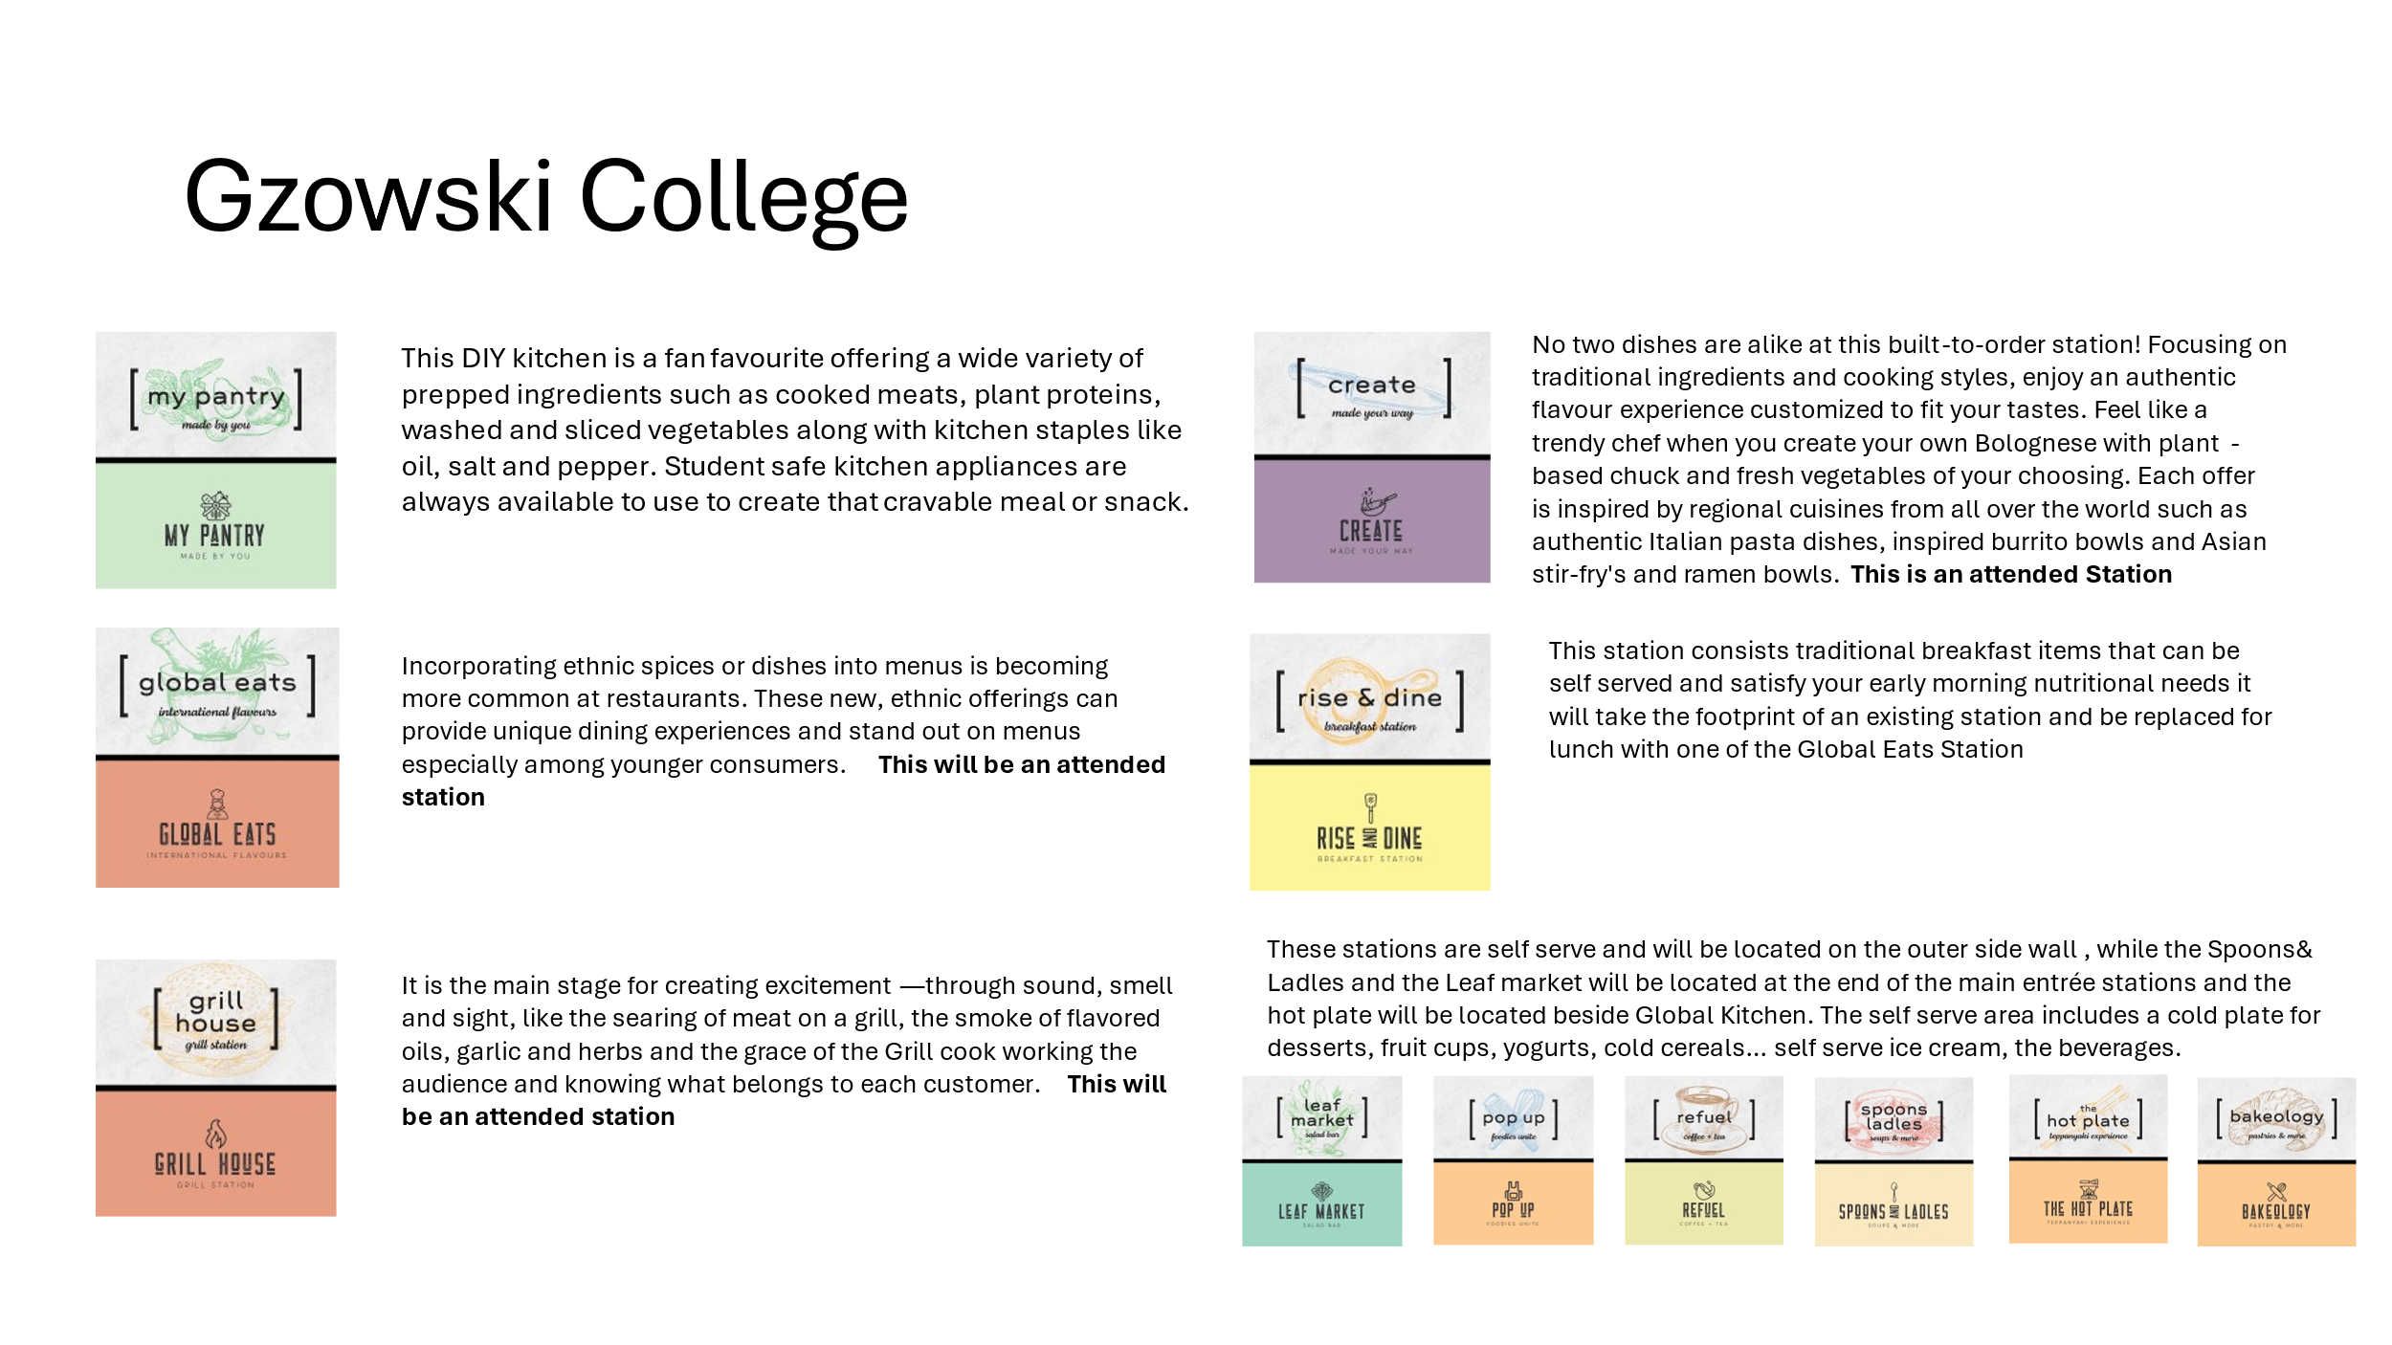

DRAFT – For discussion only


Food Services Advisory Committee
Winter 2025
Working Group and Committee Meeting Schedule

- Working Groups
  - Tuesday January 21
  - Tuesday February 25
  - Tuesday March 25

    - Operations and Marketing Working Group 9:00 – 10:30

    - Sustainability and Fair-Trade Working Group 10:30 – 12:00

    - All-You-Care-To-Eat Conversion Working Group 3:00 – 4:30

- Food Services Advisory Committee 9:00 – 10:30
- Thursday January 23
- Thursday February 27
- Thursday March 27

