

Foodservice Advisory Committee
March 26, 2026,

MEETING NOTES

Attendance: Mark Murdoch, Food Services; Aimee Blyth, Seasoned Spoon; Chef Joseph, Chartwells; Kiara McKinley, Otonabee College Cabinet; Shelley Strain, Sustainability Office.

- Review of Meeting Notes of February 26
- No items for follow up
- Sub-committee reports
- Operations and Marketing
  - See Meeting Notes of March 24
    - Gzowski construction update
    - Upcoming schedule changes - attached
- Sustainability and Fair Trade
  - See meeting notes of March 24
- Catering
  - No report
- All-You-Care-To-Eat Working Group
  - See meeting notes of March 24
- General Discussion and Q & A
- Next meeting – July (ish)



Trent University Foodservices
Food Services Advisory Committee
Operations and Marketing Working Group
MARCH 24, 2026

MEETING NOTES

Attendance: Mark Murdoch, Food Services; Aimee Blyth, Seasoned Spoon; Christine Thomas, Chartwells; Kim Stevens, Corine Bolton, CUPE 3205; Kassandra Glasbergen, The Ceilie; Shauna Carlow, Student Housing; Sophie Dorais, Gzowski College Cabinet.

- Review of Meeting Notes of February 24
  - No items for follow up.
- Gzowski Dining Hall update –phase one is complete, pending submission of final reports and documents. Phase two begins in late April.
- Operating hours: Adjusted schedules attached.
  - Easter weekend
  - Exams
  - Late April
  - Summer 2026 until mid June
- Other business
- Future meetings: July (ish)



Foodservice Advisory Committee
Sustainability and Fair-Trade Working Group
Tuesday March 24, 2026

MEETING NOTES

Attendance: Mark Murdoch, Food Services; Christine Thomas, Chartwells; Shelley Strain, Sustainability Office

- Review of the Meeting Notes from February 24
  - No items for follow up
- Updates from the Sustainability Office
  - Earth Day – April 22. Food Services has several programs in place for Earth Day, focusing on utility reduction and waste reduction.
  - Sustainability Office will work with Housing to try and capture more of the higher value items (clothing, electronics, fans, etc.) that residents typically throw away when they move out.
  - The Sustainability Office will have a display in the Library display case. Food Services will provide some props for the display.
  - Shelley is looking for a per customer estimate of compost from AYCTE dining.
- Eco-tray and travel mug use – the Gzowski dishwasher was down for a period of time resulting in increased use of disposable items. The use of paper cups declined, possibly the result of Roll-Up-The-Rim contest.

Reusable Data Feb 23 to March 23, 2026
$1 Disposable | 21140 | 36.5%
China Plate | 28226 | 48.7% | 63.5%
Eco Tray | 8578 | 14.8% | 63.5%
Total | 57944
China Mug | 1131 | 47.8% | 95.5%
Travel Mug | 1130 | 47.7% | 95.5%
Paper Cup | 107 | 4.5%
Total | 2368

- Other business
- Future meetings: July (ish) by TEAMS



FOOD SERVICES ADVISORY COMMITTEE
ALL-YOU-CARE-TO-EAT DINING PLAN
EXPLORATION WORKING GROUP
MARCH 24, 2026

MEETING NOTES

Attendance: Mark Murdoch, Food Services; James Onusko, Champlain College; Melanie Buddle, Gzowski College; Stephanie Muehlethaler, Otonabee College.

- Review of Meeting Notes of January 27
  - No items for follow up.
- Email between Melanie Buddle and Mark Murdoch – attached
  - In the fall of 2026 the new AYCTE menus will be in place, with all purchases on a fully retail model. No restrictions on use of the dining room.
- Gzowski Phase 1 update – complete.
- Updated plan for Gzowski – we had a walk through of the space and a discussion about the various stations.
- Next meetings; July (ish)

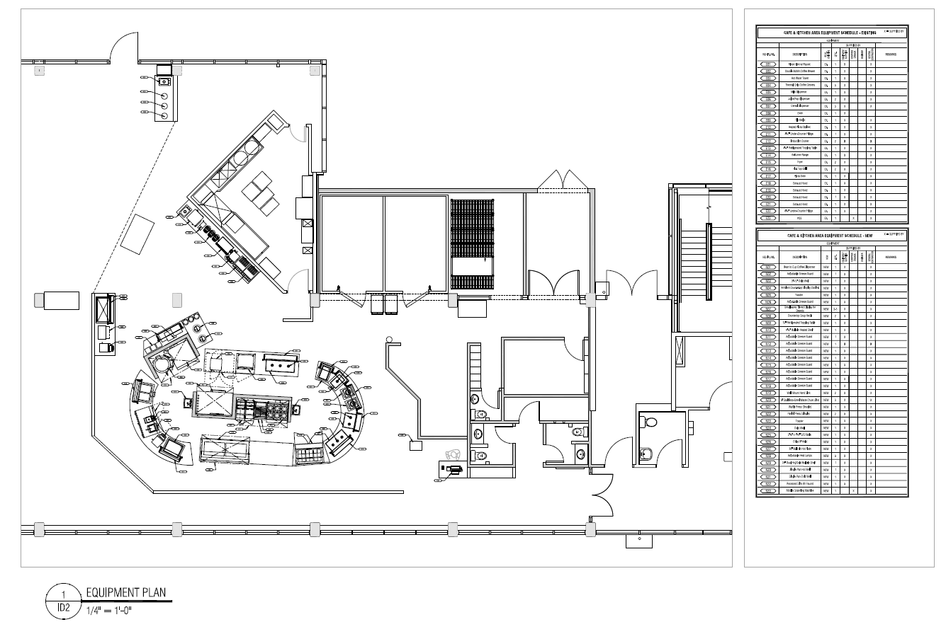

Text of an e-mail exchange between Melanie Buddle and Mark Murdoch regarding the plans for the Gzowski College Dining Room.

Melanie, thanks for reaching out.

We are not moving to AYCTE dining this fall. We are moving to a “door rate”. A guest will pay one price for one trip through the servery. This is a transitional step as we get GC and LEC ready for 2028 (a date of which I am suspicious). This subtle difference allows the dining room to remain open for all campus members to visit and use for purposes other than eating. This approach will morph when we fully transition to AYCTE. The dining room will have two areas. For part of the day, for example 8 am to 11 am, people who are eating will stay on one side of the dining room and the other side will remain open. At 11 am we need to switch the entire dining room to “dining only” because we need the seats. At, for example, 1:30 we switch back to the dining room being multi use. Then back to dining only at 4:30.

I haven’t thought enough about grab and go. It is very expensive to support. Will it have sufficient demand? Guests have other options for grab and go items. If the opening of GMC is going to be delayed ( for clarity I have no specific insight, but I have spidey senses) it may make more sense to offer grab and go. We will not be offering any packaged products at GC beginning this fall. No chips, bars, bottled beverages, etc. This will dampen demand for grab and go.

The hours for the dining hall will look fairly similar next year and until GMC is fully operational. The dining room will be available for booking on weekends and for special College events mid week.

The schedule post GMC is not known. Depending on the number of residents in the various buildings, and on the operating agreement with Knightstone, we may chose to keep GC open on weekends. I don’t know when we will finalize the operating agreement with Knightstone. It is not in my court.

Mark

Mark Murdoch
Executive Director
Food, Conferences and Campus Payment Services
Trent University
P: 705-748-1011 ext. 7791
C: 705-740-6906
Food@trentu.ca

On Feb 9, 2026, at 3:51 PM, Melanie Buddle <melaniebuddle@trentu.ca> wrote:
﻿
Hi Mark, I apologize that I could not attend the Dining hall meeting about AYCTE, and renovations, last week. I did read the minutes and the other principals filled me in. I see that the Peter Robinson hall is switching to this 'all you care to eat' model in Sept 2026 - a little earlier than planned, perhaps?

Two questions/follow-ups:
- Can you confirm that non-meal-eaters will be able to go in and out freely without purchasing any food, as we discussed in previous meetings? I really want to confirm that we continue to have this space open for all students to use for purposes other than eating meals.
- Will there be grab-and-go options for those who are not on a dining hall plan and do not want to pay for a full meal? - ex. items such as what are in the White Buffalo cafe? How about tea/coffee/drinks, separate from AYCTE?
- I lied: three questions. Will hours change? Just wondering about weekends and friday nights - which is when we sometimes use that space.

Thanks.
Melanie

__________________

