

Foodservice Advisory Committee
January 23, 2025

MEETING NOTES

Attendance: Mark Murdoch, Food Services; Matthew Porter, Experimental Farm; Sarah Laurie, Conferences; Christine Thomas, Chartwells; Heather Klyn-Hesselink, Prodip Mandal, TGSA; Shelley Strain, Sustainability Office; Aimee Blyth, Seasoned Spoon; Kim Stevens, Corine Bolton, CUPE 3205.

- Review of Meeting Notes of November 28
  - No items
- Sub-committee reports
- Operations and Marketing
  - See Meeting Notes of January 21
    - Family Day and Reading Week schedule
    - Hot Wing Challenge
    - Bell Let’s Talk Day - $6,400 was raised.
    - Mac and Cheese Throw Down
- Sustainability and Fair Trade
  - See meeting notes of January 21
- Catering
  - No meeting
- AYCTE WG
  - See meeting notes of January 21
- Next meeting – February 27, March 27, 9:00 – 10:30, by TEAMS

Trent University Foodservices
Food Services Advisory Committee
Operations and Marketing Working Group
January 21, 2025

MEETING NOTES

Attendance: Mark Murdoch, Food Services; Aimee Blyth, Seasoned Spoon; Anabelle Craig, Traill College; Heather Klyn-Hesselink, TGSA; Kassandra Glasbergen, The Ceilie; Maggie Allen, Traill; Sarah Gallen, Durham; Shauna Carlow, Student Housing; Corine Bolton, CUPE 3205; Taylor Tomasevic, LEC, Kyra Myderwyk, TCSA

- Review meeting notes from November 26
  - Update re Bata Bean JWO
- 10% of sales are not being processed
- Our system is too complicated – three payment methods
- Still going to have a staff member there
- Does not save video of customers
- Continuing to work on bugs
- HST reduction Dec 14 to Feb 15
  - On-going until Feb 15
  - Any issues or updates – applied only to beer and wine at the Ceilie
- Hot Wing Challenge – two photos attached
- Meal Steal 10 – discount package, savings of 28%
- 10 per paid meals with 15% discount and 13% HST savings
- Buy now and lasts until end of term
- Students get a punch card
- Promo flyer attached
- Bell Let’s Talk Day
  - Items marked as “Bell Lets Talk” and all proceeds go to mental health resources on campus
  - Promo flyer attached
- Mac and Cheese Throwdown
- Annual event
- Teams compete with different Mac and Cheese (regular, buffalo, lobster, etc)
- Students try and vote
- CC Great Hall on January 29 11am until 2pm
- Free for students to try
- Promo flyer attached
- Family Day and Reading Week operating hours - attached
- Other business
- Next meeting February 25 and March 25, 2025, TBD by TEAMS
Pictures from the Hot Wing Challenge

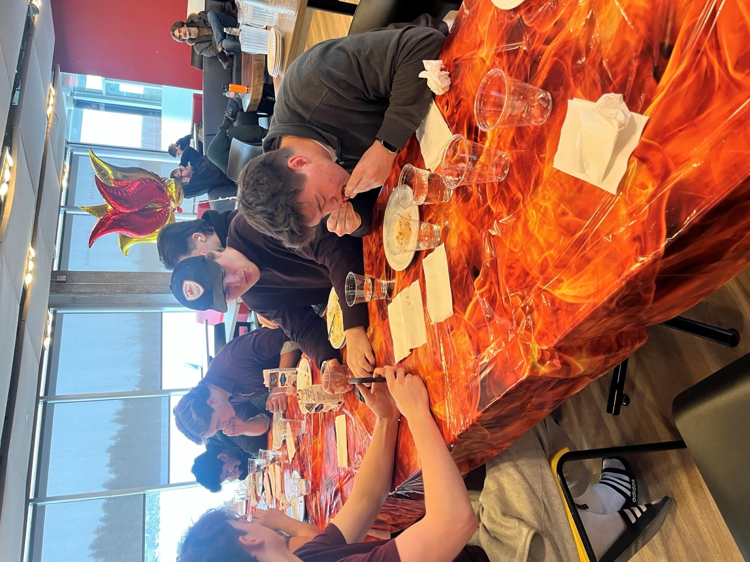

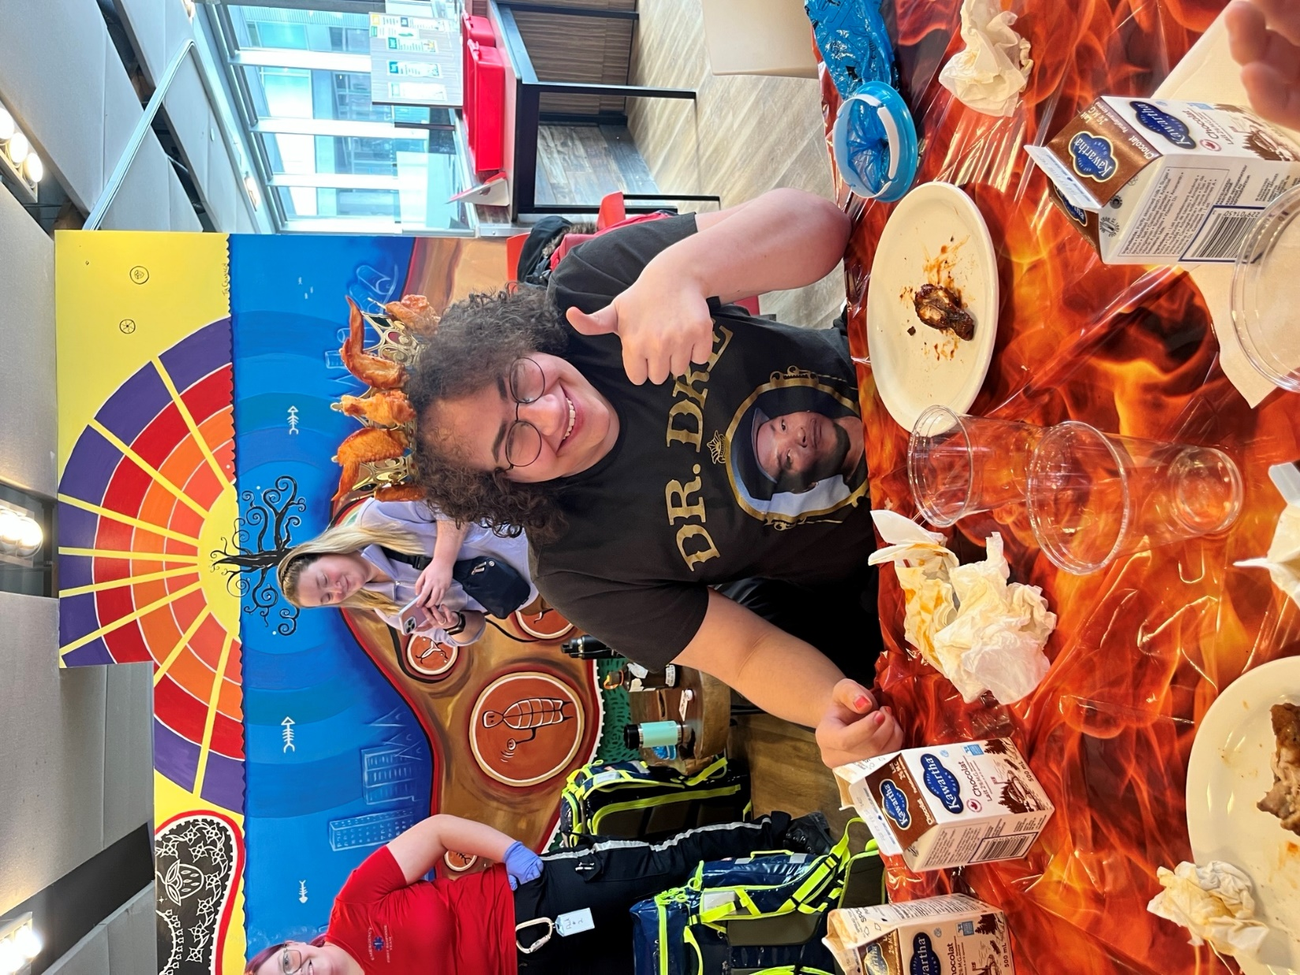

Sample of one of the Bell Let’s Talk Day promos





Foodservice Advisory Committee
Sustainability and Fair-Trade Working Group
Tuesday January 21, 2025

MEETING NOTES

Attendance: Mark Murdoch, Food Services; Christine Thomas, Cassandra Kun, Chartwells; Heather Klyn-Hesselink, TGSA; Marlee Lunshof, Student Housing; Shelley Strain, Jillian Fitzgerald, Sustainability Office; Caroline Priddle, Gzowski; Corine Bolton, CUPE 3205.

- Review of Meeting Notes of November 26, 2024
  - Waste audit update – no results yet
  - Oscar sort update – seeking deployment of two stations for fall 2025
  - Participation in eco-tray program – data not available
    - Chartwells will start a social media campaign is early February to encourage customers to return their eco-trays.
- Participation in travel mug usage- data not available
- The primary goal of each of our sustainability initiatives is to support the Zero Waste goal for 2028.
- Sustainability Snap Shots – web pages that highlight sustainability in action across campus https://www.trentu.ca/sustainabilityoffice/campus-sustainability/sustainability-action
- Waste Not 2.0 – a sample of the data we see from the system is attached
- Canadian Fair Trade Campus Network Conference – Feb 14/15 York University
- General discussion and Q and A
  - Too Good To Go - food recovery from waste to being sold at a discount. Started at Tim Hortons last week. Participation is picking up slowly.
  - Tim Hortons is considering a reusable cup program with the Friendlier system. https://www.friendlier.com/
- Next meetings– February 25 and March 25, 2025 by TEAMS

Sample data from the Waste Not 2.0 system

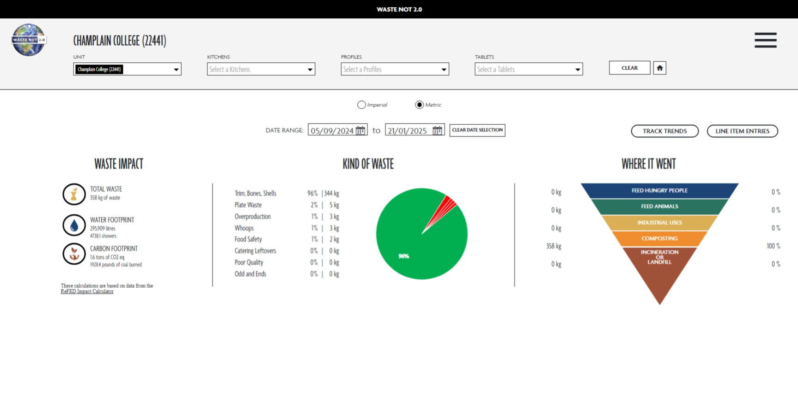



FOOD SERVICES ADVISORY COMMITTEE
ALL-YOU-CARE-TO-EAT DINING PLAN
EXPLORATION WORKING GROUP
January 21, 2025

MEETING NOTES

Attendance: Mark Murdoch, Food Services; Aimee Blyth, Seasoned Spoon; Michael Eamon, Traill; Kiara McKinley, Otonabee; Stevie-Dee Carter, LEC; Stephanie Muehlethaler, Otonabee

- Review Meeting Notes of November 26
- Revised servery layout for GC
  - Remove MyPantry – to be located in Gidigaa Migizi and LEC Dining Rooms
  - Add NORI – a sushi bowl and sushi roll concept and BOBA – a bubble tea concept.
- AYCTE Canadian Dining Plan Rates
  - The current average is $6,374.
  - Assume a 4% increase for 2025/2025 would take the average to $6,630
  - Our rate for next year will be $6,050
  - Future rates will be developed in consultation with the building owner.
- General discussion and Q&A
- Next meetings February 25 and March 25

