

Foodservice Advisory Committee
January 25, 2024

MEETING NOTES

Attendance: Mark Murdoch, Food Services; Aimee Blyth, Seasoned Spoon; Christine Thomas, Jesica Brooks, Chef Joseph Pirie, Chartwells; Kim Stevens, CUPE 3205; Jilliene Simone-Burns, Housing; Heather Klyn-Hesselink TGSA; Michael Eamon, Traill College; Lori Johnston, Conferences; Bri Policicchio, TCSA; Rushk Choudry, LEC; Shelley Strain, Sustainability Office.
- Review of Meeting Notes of November 30
  - The dining plan rates that were approved at the November meeting were included in the Food Service budget for 2024/2025. That budget has been submitted to PVP and will be approved by the Board in March.
- Sub-committee reports
- Operations and Marketing
  - See Meeting Notes of January 22
    - Food insecurity support efforts
    - Food Guide Friendly program
    - Reading Week Operating Hours
    - Retail Price Increase
    - Update on Bell Let’s Talk Day
      - There was good participation on the activities and lots of positive messages shared on the caring wall.
      - $4,065 was raised in support of the Wellness Centre
      - Images and details attached.
- Sustainability and Fair Trade
  - See meeting notes of January 22
    - Winter waste diversion contest in the works
      - The pre-audit is complete
      - Currently volunteers are supporting an education phase, showing people what to put where
      - The audit will measure which College had the greatest improvement in their diversion rate
  - The Sustainability Office will reach out to members of this committee and members of the Sustainability and Fair-Trade working group with dates and times of the post audits, looking for volunteers.
- Additional Working Groups:
  - Dining Room Redevelopment Group – see meeting notes of January 22
    - Working on a strategy to use volunteer alumnae to refinish the tables and having it as a project where students can participate and learn how the repair and refinish.
  - Food Service RFP Group
    - A recommendation has been sent to the Finance and Property Committee. This will be present to the Board on February 2. Information will not be available until an agreement is finalized which could take several days or weeks to complete.
- General Discussion and Q&A
  - Through “Giving Tuesday” a donor has provide support for food insecurity for graduate students. Traill College will lead a program unique for graduate students.
- Next meetings: February 29 and March 28, 9:00 – 10:30, by TEAMS

Bell Let’s Talk Day: All dining halls, Wednesday Jan 24
• Lady Eaton: 45 twister wraps, 18 cake pops & 8 cupcakes = $590.29
• Champlain: 73 love me tenders, 20 cake pops, 31 cupcakes = $874.46
• Otonabee: 234 classic pizza slices, 19 cake pops, 22 cupcakes = $1,070.69
• Gzowski: 97 build your own pasta, 19 cake pops, 19 cupcakes = $1,218.45
• Trent Durham: 23 love me tenders, 29 cupcakes = $311.19
• Create your own essential oil bracelets in Champlain & Gzowski, positive colouring pages in Lady Eaton & Otonabee + dedicated BLTD pages in each dining hall that students could write kind messages or quotes on to support others
• 656 total items sold, $4,065.08 to be donated to the Trent Wellness Department to support mental health education & promotion
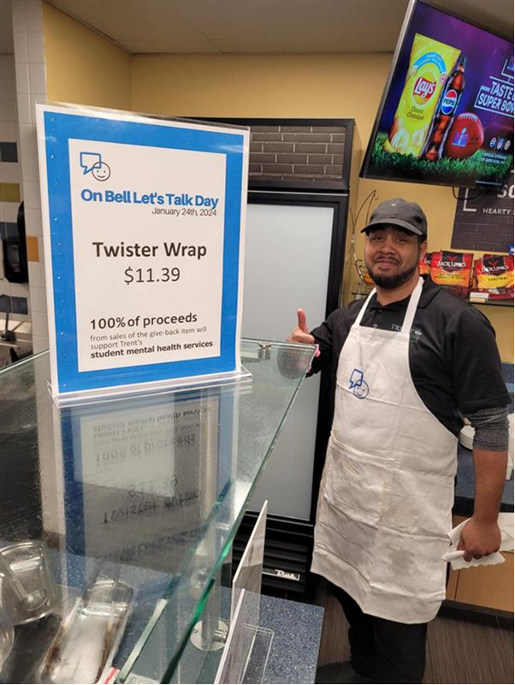

Trent University Foodservices
Food Services Advisory Committee
Operations and Marketing Working Group
Monday January 22

MEETING NOTES

Attendance: Mark Murdoch, Food Services; Kassandra Glasbergen, The Ceilie; Shauna Carlow, Student Housing; Aimee Blyth, Seasoned Spoon; Bri Policicchio, TCSA; Christine Thomas, Jessica Brooks, Chartwells; Kim Stevens, CUPE 3205; Mia Richardson, Lady Eaton.

- Review meeting notes from November 28
  - Still working on the Food Guide Friendly program at Traill
    - Looking at the Seasoned Spoon as an additional location
  - Update of Bata Bean:
    - Is it working? The system had an outage in November but since then has worked continuously. Sales are soft, about $1,200 since inception, about 2% of sales.
    - How many people are using it? Sales are soft, about $1,200 since inception, about 2% of sales. After reading week Chartwells will undertake another round of developing awareness of the frictionless market.
    - Tax issue? Not resolved. Chartwells is manually tracking any HST that was under-collected and remitting it to the CRA.
  - New Food Insecurity Program
    - Slow start in December. Sold 80 last week. Looking to get to 1,000 meals per week.
    - Monitoring use and will tweak the program as required.
    - The concern was raised that the connection of the $6.49 value menu to food insecurity was problematic. It may stigmatize users. The $6.49 value menu had its impetus earlier in the year when students asked for half portions at a lower price. We need to make sure that we keep the two items separate. The value meals are an appropriate portion size under Canada’s Food Guide. Dietary options are available, for example vegetarian.
- Food Services RFP process and timeline
  - A recommendation has been sent to the Finance and Property Committee of the Board. If approved at that level it will be sent to the Board for approval in February
- Reading Week operating hours – attached.
- Other business
  - Bell Let’s Talk Day
Trent Food Services (Chartwells), will be participating in Bell Let’s Talk Day again this year, on January 24th.

With this partnership, on January 24th (BLTD), 100% of the proceeds from the below give-back items + some additional snacks within our dining halls will be donated to the Trent Wellness Department to support student mental health services on campus.

Give-back items include:
- Lady Eaton dining hall –twister wrap
  - Champlain dining hall – love me tenders chicken fingers
  - Otonabee dining hall – classic Pizza Pizza slice
  - Gzowski dining hall – build-your-own pasta bar
  - Trent Durham dining hall – Love me tenders chicken fingers

We will also have the following activities in the dining halls on Wednesday:
- Lady Eaton & Otonabee dining halls: positive colouring pages & materials will be available all day
- Gzowski & Champlain dining halls: Create your own essential oils bracelet from 2-4pm or while quantities last

b) Retail Price Increases

Chartwells took a retail price increase on a number of menu items, of about 3%, at the start of the winter term. Retail price increases are delayed and minimized as much as possible. The impetus for this increase is tied back to the rate of inflation for food and the retail price increase that was implemented last fall, about 5%. During the summer of 2023 inflation on food items was running around 9%, much higher than the general rate of inflation. When retail prices were set in the middle of the summer it was expected that food inflation would soften to closer to 6%. It was this expected inflation rate that was used to set the retail price increase for the fall. Throughout the fall term the rate of inflation on food did not decrease. Throughout September, October and November we were monitoring food costs and came to realize that our price increase over the summer was not sufficient to cover the very high inflationary pressure. It reality, we likely should have increased prices more than the 5% we did over the summer. This recent price adjustment gets retail pricing back in line with where it needs to be. Food Services will continue to focus on ways to reduce cost, for example the recently introduced $6.49 lunches and the $5 discount cards.

- Next meeting February 26, March 25 by TEAMS



Foodservice Advisory Committee
Sustainability and Fair-Trade Working Group
Monday January 22, 2024

MEETING NOTES

Attendance: Mark Murdoch, Food Services; Christine Thomas, Jesica Brooks, Chartwells; Jillian Fitzgerald, Sustainability Office; Kim Stevens, CUPE 3205; Alyssa Scanga, TCSA; Ainsley MacPherson, Gzowski College; Heather Klyn-Hesselink, TGSA.

- Review of Meeting Notes of November 28, 2023
  - Winnow review with Sustainability Office? – Pending.
  - Waste Audit metrics update. - Pending
  - Sales of $5 eco-trays? 77 units were sold in January. Concurrently, the use of eco-trays declined. ☹ The sale of the $5 eco-trays was not well communicated as there are few avenues to undertake broad based advertising. In the fullness of time, about 60% of the campus population will have lived in residence. However, as the eco-tray program was suspended during COVID, the percentage of the total population that has had experience with the eco-tray program is lower. It should improve over the next two years.
  - Winter Waste Audit Challenge update.
    - The plan is to measure waste diversion February 1 – 16. In advance of the audit, 22 student volunteers are stationed at waste sorting stations to educate students on the proper way to sort waste.
    - Apre-audit was done to establish a baseline for waste sorting.
    - At the end of the program an audit will be done to measure the improvement of our waste sorting.
    - More data at the next meeting.
- Participation in eco-tray program – see attached.
- Travel mug usage – very strong. See attached.

- Food Guide Friendly program at The Trend – on-going
  - Seasoned Spoon seeking recognition by the end of the term.
- New project or initiative this year? Winter semester waste audit challenge.
- General discussion and Q and A
  - The Sustainability Office and the TCSA will share materials to support the upcoming environmental program at Gzowski.
- Next meeting February 26 and March 25, by TEAMS

Dining Room Redevelopment Group Meeting
January 22, 2024.
Great Hall
MEETING NOTES

Attendance: Mark Murdoch, Food Services; Lori Johnston, Conferences; Jen Tuters, Facilities Management; Christine Freeman-Roth, Lady Eaton; Chloe Deshevy, Champlain College; Michael Eamon, Traill College and Heritage Committee; Jillene Simone-Burns, Housing.
- Talking points from previous meeting
- Budget update – the remaining balance is $366,381.20 which will provide for expenditures of $354k, plus net HST.
- Status of the red furniture?
- Review of Priorities for Champlain Dining Hall:
  - Items that are the responsibility of Facilities Management:
    - Roof
    - Cleaning, including fabric panels
    - Painting
    - Wood refinishing
    - Replace exterior doors
    - Windows
    - Refinish floor
    - Area between exterior and new path/shoreline
  - Items that are the responsibility of the Group:
    - Tables
    - Chairs
    - Audio/video equipment
    - What are we trying to achieve, who will use the system, when, for what purpose?
- A few items that were captured at the last meeting:
- 28 tables in the Great Hall, with 6 chairs per table, which holds 168 people
- 3 chairs on both sides of tables is very tight
- Looking at renovating the CL-LLC and will having dining hall seats that can be brought down for weddings
- Who will be responsible for storing the furniture, moving, and maintaining it? Tina is going to make an MOU with Chris and Lori about moving furniture in the future.
  - Look at building out more cost.
  - Currently the red couches are being cleaned.
- Where will additional furniture be stored?
- Jen is going to pull together a PDF re 4 20 inch round tops with 3 chairs each.
- Jen Tuters updates:
  - Recreated tables, availability and cost
  - High top table and chair options
  - Chairs – with wood seats, fabric seats
  - Cork on the walls
- Progressive scheduling: Jen suggested that Chris D’Innocenzo may be assigned this project as most of the elements fall in his area.
  - There a quite a few moving pieces that we need to coordinate.
  - Requires a project coordinator to ensure all the parts work in a convenient and cost-effective order. Schedule around other commitments, such as Conferences.
  - For example, we have a skyjack being brought in to look at the ceiling. At the same time clean the light fixtures fabric panels in situ. What other high cleaning can be completed?
  - Schedule for work on the shoreline?
  - Plan to replace doors? Windows?
Items from this meeting:
- Lori will work with Chris and the new Principal of Champlain College to better define the guidelines and cost for the removal and repositioning of furniture.
- Lori will enquire about the status of the red couches. It is possible that snow has been piled against the door of the storage area.

- There was a robust discussion about the correct chair. It was suggested that we look at a chair similar in design to the original “Church chair” or a ladder back
- Michael Eamon will connect with Alumni Affairs regarding philanthropic opportunities to provide additional funding.
- We can look at building storage in the two or three recesses the waste stations currently are, and under the cabinets that are in two corners at the south end of the Great Hall. This would allow for the storage of one set of tables within the exiting footprint.
- Jen Tuters will order four black high top tables as soon as practical. Mark will get 12 black chairs to use while we search for a new chair.
- The phone charging station can be removed.
- Chloe confirmed that there is a second set of fabric panels in storage in the Champlain store room.
- During the meeting we counted 25 tables in the room. Of those, 14 require refinishing. It is believed that there are two Great Hall tables at Traill. Michael will arrange to have those sent to Champlain. It is also believed that there may be some in storage in the se cans near Blackburn Hall and that there could be some in the woodworking shop. Jen Tuters will try to complete an inventory of tables.
- Text of an e-mail from Jen Tuters:
Hi Mark,

Apologies for the delay, yes that’s correct. In addition, I am talking to Michael Eamon about what options he thinks we can pursue for the replacement of the cork from a heritage perspective.
  - Recreated tables, availability and cost
Woodarts can replicate the tables for $3,500ea plus tax and install, refinishing any exiting tables can be done for $1500ea.
  - High top table and chair options
See the attached(delivery & install extra)
  - Chairs – with wood seats, fabric seats
See the attached (delivery & install extra)
To get the same chairs that we purchased for LEC would be $597ea plus delivery and installation.
I can seek out other alternatives for chairs but it would be helpful to have a ballpark # for how much we want to spend on ea. chair.
Best,
Jen Tuters

- Info regarding samples of tables and chairs provided below.
- Next meeting in late February.

