

Foodservice Advisory Committee
February 27, 2025,

MEETING NOTES

Attendance: Mark Murdoch, Food Services; Aimee Blyth, Seasoned Spoon; Christine Thomas, Chartwells; Lori Johnston, Conferences

- Review of Meeting Notes of January 23

- Sub-committee reports
- Operations and Marketing
  - See meeting notes of February 25
- Sustainability and Fair Trade
  - See meeting notes of February 25
- Catering
  - No meeting
- AYCTE WG
  - No meeting
- General Discussion and Q & A
- Next meeting – March 27, 9:00 – 10:30, by TEAMS

Trent University Foodservices
Food Services Advisory Committee
Operations and Marketing Working Group
February 25, 2025

MEETING NOTES

Attendance: Mark Murdoch, Food Services; Aimee Blyth, Seasoned Spoon; Cassandra Kin, Christine Thomas, Chef Joseph Pirie, Chartwells; Shauna Carlow, Housing; Kim Stevens. Corrine Bolton, CUPE 3205; Kassandra Glasbergen, The Ceilie.

- Review meeting notes from January 21
  - Update re Bata Bean JWO
- GST reduction Dec 14 to Feb 15
  - Ended Feb 15
- Meal Steal 10 – discount package, savings of 28%
  - Sold 18 packages
- Mac and Cheese Throwdown update
  - 15 Mac and Cheese samples
  - Very well attended
  - Gzowski’s Smokey Bison Mac and Cheese was the winner, by a large a margin. It will be offered daily at Gzowski during the last week of February.
- Spiritual Affairs meeting:
  - Ramadan Feb 28 – Mar 29 – special meal program available at OC, LEC and Durham.
  - Lent Mar 5 – Apr 17 – simpler meals and more fish, especially Wednesdays and Fridays
  - Passover Apr 12 - 20
- Other business
- Next meeting March 25, 2025, by TEAMS

Ramadan Meal Program 2025

How It Works:
- Students must order meals in advance.
- Order Deadlines:
  - Orders for Feb 28 – Mar 8 must be placed by Feb 26.
  - Going forward, orders are due each Wednesday for meals in the following week (e.g., order by March 5 for meals from March 9 – 15).
Meal Pickup Schedule:
- Breakfast: Prepared the day before for next-morning consumption.
- Dinner: Prepared the same day for pickup after sunset.
- Ramadan Reminder: Meals are only to be eaten before sunrise and after sunset.
Manager Responsibilities:
- Ensure students fill out the meal selection sheets, circle their required meals, and print their name and student email clearly.
- Collect payment in advance to confirm the order.
- Submit completed order sheets to the Chef at LEC to ensure meal preparation aligns with student needs.
Students can sign up and order at LEC and OC Cash, with pickup available at Boost pickup areas or by requesting from the cashier.
I have attached the order form here for you to easily print for your reference and for students to fill out. I will send out the following week's menu by Wednesday of this week.
For the managers who are not at LEC or OC, I have included you here so that you have all of the information needed to direct students to OC and LEC, along with the process of ordering.
Please ensure all team members are familiar with this process. Let me know if you have any questions.



Foodservice Advisory Committee
Sustainability and Fair-Trade Working Group
Tuesday February 25, 2025

MEETING NOTES

Attendance: Mark Murdoch; Food Services; Cassandra Kun, Christine Thomas, Chartwells; Jenifer Richardson, Durham; Shelley Starin, Jillian Fitzgerald, Sustainability Office, Heather Klyn-Hesselink, TGSA; Kim Stevens, Corrine Bolton, CUPE 3205;

- Review of Meeting Notes of January 21, 2025
  - Waste audit update – not yet
  - Oscar sort update – still working on it.
- Participation in eco-tray program – participation has dropped from the prior period. There were two days that only single use containers were used on campus, to address staffing due to inclement weather, and this will have sent the eco-tray and china rates lower for the month. Let’s look through another period and see if things return to a higher participation rate.
- Participation in travel mug usage – participation remains very high
- Report on recent Fair-Trade conference – a report is attached.
- General discussion and Q and A
  - Is there an opportunity to create a Fair-Trade focused Experiential Leaning placement for a student? Mark and Shelley will explore.
- Next meetings– March 25, 2025 by TEAMS

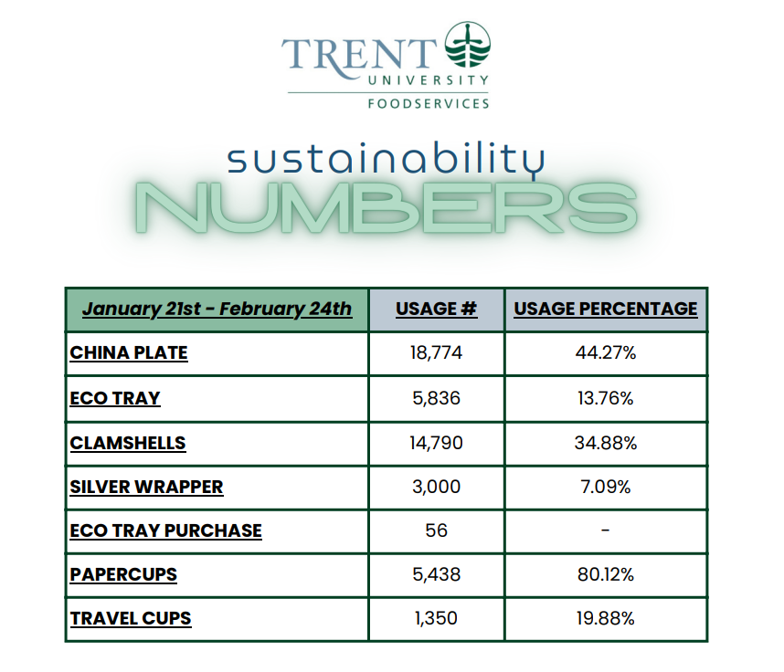

Canada’s 10th National Fair Trade Conference
February 14th-15th
York University
Notes – Jillian Fitzgerald

Conference Schedule: https://sites.grenadine.co/sites/fairtradecanada/en/canadas-10th-national-fair-trade-conference/schedule?date=2025-02-14

Action Items:
  - Create funny messaging that sneaks in sustainable messaging (ex: use travel mugs, dine with an eco-tray, our coffee & tea is fairtrade) Promote messaging everywhere we can (ex: bulletin board, college newsletters, mytrent homepage, bookstore, website)

  - Create fairtrade map of Trent campus (ex: where fairtrade coffee, tea, and chocolate are) Make fairtrade map of Peterborough (ex: fairtrade business)

  - Bob LeDrew at 10 Thousand Villages Cobourg interested in collaborating on pop-up event with us (ex: selling products, speaking at event, or as part of sustainable business fair)
  - Try to purchase fairtrade cloths and fabric to use at events (ex: convocation, dinners, conference, speaking events)
  - Offer fairtrade products in the bookstore! Or promote fairtrade stores in Peterborough at the checkout line or near the front entrance.
  - Table once a week on campus to educate about fairtrade (ex: hand out fairtrade coffee and tea to grab people’s attention and quickly tell them about fairtrade)
  - Raffle tickets to go to fairtrade conference or event using sales from fairtrade products sold at Trent (ex: 2 tickets to learn about fairtrade at annual Fair Trade conference)
  - Establish group of fairtrade student volunteers to host weekly fairtrade events on campus (ex: hand out fairtrade coffee and tea on Mondays, run events during fairtrade campus week, promote Fairtrade products sold in Canada)

February 14th

1st Panel: Embedding Sustainability in Businesses Core Mission
- Fairtrade embodies community autonomy (community members must have voice in community projects)
- How to use business as a force for good? Focus on trade, not aid.
- Important to have strong messaging and values for your business and constantly bring it up everywhere you can.
  - Change the conversation from the price of a product to how the product solves an issue. For example, farmers are supported fairly through buying fair trade bananas.

  - Bold, funny messaging is good. It grabs the reader's attention so you can sneak in your important message.
  - Connect consumer to the producer. Meet them where they are. For example, video messaging about travel mugs in the Starbucks lineup.

2nd Panel: Youth Round Table
- Be inclusive to young people surrounding all conversations when creating policies and implementing change.
  - Give young people more than a seat at the table For example, ask how they see the topic of farming changing in the future.

3rd Panel: Social Impact Through Coffee
  - It is important to ensure we have enough supplies to replenish the next generations. Reinforce an Indigenous perspective by applying the seven grandfather teachings to practice and business.

  - Black medicine was the term indigenous peoples used to refer to coffee during their first encounters with Europeans.
  - Few indigenous vendors in Canada, so they know each other very well and are well connected.

4th Panel: Making Textile Industry More Sustainable

Everyone must be treated fairly, from planting the first seed to selling the lost product for it to be fair trade.
  - - Make sure farmers are positively impacted. For instance, fair trade cotton uses less pesticides and less water in the process.

  - - If companies excess their carbon emissions, they should have to pay a premium to encourage them to reduce emissions and follow fair trade procedures to be a sustainable business.
  - - Unfortunately, Canada doesn't have the best infrastructure to produce garments. Easier + cheaper to import raw materials from other countries since there is no duty on them.
  - - Fair trade products ultimately equal better quality. Though their prices are still slightly cheaper than mainstream products.

  - - Fair trade textiles are monitored at every point of the process to ensure quality and sustainable production.
  - - It's important to set science-based targets when making fairtrade products, which can be complex for large supply chains since they will need to be aware of every aspect of the process.
  - - Important to have a very trade steering committee at your institution or business to oversee that these sustainable targets are being met
  - - UN – 2025 is the year of the cooperative

February 15th
1st Panel: How to Achieve Silver & Gold Status?
- Universities such as Concordia established a fairtrade corner every Tuesday where they offered coffee, tea and chocolate that was fairtrade.
- Changing supply chains impacts your carbon footprint positively if they are sustainable and a fairtrade business.
  - To achieve gold status: Offering a second fruit to sell, Starbucks offering fairtrade products, offering fairtrade materials in the bookstore.
  - To achieve silver status: Incorporate a steering committee at your institution or business.
  - Offer a fair trade caps and gowns at grad.
  - Offer fair trade flowers at events or graduation. (blueboxing could hand these out)
  - Host a Fairtrade Campus week at the beginning of the school year for incoming students. Or during an open house for potential students to see.
- Important to keep the next generations of Students involved in fair trade.
- The smallest things that you use at events can be fair trade, such as the tablecloths, the food, the plates you serve the food on, the utensils that you eat on, and the writing tools that you use.
- Some schools, such as York, sold pink T-shirts that were fair trade during Anti bullying week.
- Other universities during their Fairtrade Campus Activity week bought fair trade bananas to spread the message of Fair trade and bring them in with funny messaging.
- Some schools hosted a fairtrade cooking workshop. You can cook and learn how you can use fairtrade ingredients in your meals.

2nd Panel: Ana De Laura – Honey Cooperative in Argentina
- Honey farms at her cooperative needed at least three kilometers of the surrounding area to be completely untouched by chemicals to ensure no pesticides encounter the honey.
- Label needs to tell a story and catch your eye
- Young person surrounded by older people and she finally stood up for herself and continued to fight for her voice to be heard and finally she was.

3rd Panel: Humanizing Business Through Relationships

Businesses are deemed sustainable by their social, economic and environmental benefits.
- It is important to spread your message to the broader community through fairs, workshops and other events.

4th Panel: Cooperatives Create Democratic & Empowering Society Cooperative groups were the first to bring fair trade to Canada.
- Empowering producers motivates them to continue to grow and build stronger relationships with them and thus, trust.
- Fair trade can reduce social inequalities.
- Cooperatives work by gaining members. Then those members elect a board of members (small like 5-10) to then make decisions for the cooperative. Instead of getting say 800 members to come together and find common solution.

5th Panel: Future of Trade & Cooperation
- Future of fair trade involves young voices leading the fight
- Be involved with the larger community (ptbo)
- Fairtrade products becoming mainstream would be a huge success

