

Foodservice Advisory Committee
February 26, 2026

MEETING NOTES

Attendance: Mark Murdoch, Food Services; Maddison Winkworth, Champlain College Cabinet; Christine Thomas, Chef Joseph, Chartwell; Lori Johnston, Conference Services; Shelley Strain, Sustainability Office; Aimee Blyth, The Seasoned Spoon; Ainsley McPherson, Gzowski College Cabinet; Kim Stevens, Corine Bolton, CUPE 3205

- Review of Meeting Notes of January 29
  - N items for follow up
- Sub-committee reports
- Operations and Marketing
  - See Meeting Notes of February 25
    - Gzowski construction update
    - Upcoming schedule changes
- Sustainability and Fair Trade
  - See meeting notes of February 24

- Catering
  - No report
- All-You-Care-To-Eat Working Group
  - No meeting
- General Discussion and Q & A
  - Committee members are encouraged to participate in the Sustainability and Active Transportation survey:
https://trentu.qualtrics.com/jfe/form/SV_egkdkhWakEC9RUq

- Next meeting – March 26, 9:00 – 10:30, by TEAMS

Trent University Foodservices
Food Services Advisory Committee
Operations and Marketing Working Group
February 24, 2026

MEETING NOTES

Attendance: Mark Murdoch, Food Services; Christine Thomas, Chartwells; Corine Bolton, Kim Stevens, CUPE 3205; Shauna Carlow, Student Housing; Sophie Dorais, Gzowski College Cabinet; Sarah Gallen, Durham; Sarah Adjei, TGSA

- Review of Meeting Notes of January 27

- Extension of dining hours in late April to align with new Housing term
  - A plan will be presented at the next meeting that covers; Easter Weekend, Exams, the period until the end of April.
- Gzowski Dining Hall update – getting close.
- Other business
  - Will Gzowski be All-You-Care-To-Eat this fall? No. We will renovate and adopt the new AYCTE menu, for example, no packaged beverages, but on a retail/declining balance basis.
  - Will everyone have access to the dining room. Yes. Sort of. The dining rooms in Gzowski, Lady Eaton and Gidigaa Migizi will have an area that, during off-peak periods, will be open to the public to use. During peak times, for example 11:30 until 1:30, the entire dining area will be reserved for residents on a dining plan or guests who have paid a door rate. This is required a) to ensure we have enough seats for residents and b) so that a resident can’t provide meals for free to non residents. The attached drawing for GMC shows the separation point.
  - Will there be specific meal periods, for example, Breakfast, Lunch and Dinner. Yes, and no. The intention is that a dining hall will open at a certain time and then close at a certain time, remaining continuously open throughout. Guests can enter and select food items as many times as they want. However, for example, breakfast may be served until 10:30 and lunch will start at 11:00. There will be a period of time, during the switchover, that a hot meal is not available, but the remainder of the servery can be accessed and food items selected. It is unlikely that all three AYCTE dining halls will be open for three meals per day or seven days per week.
- Future meetings: March 24
DRAFT Gidigaa Migizi Kitchen and Servery
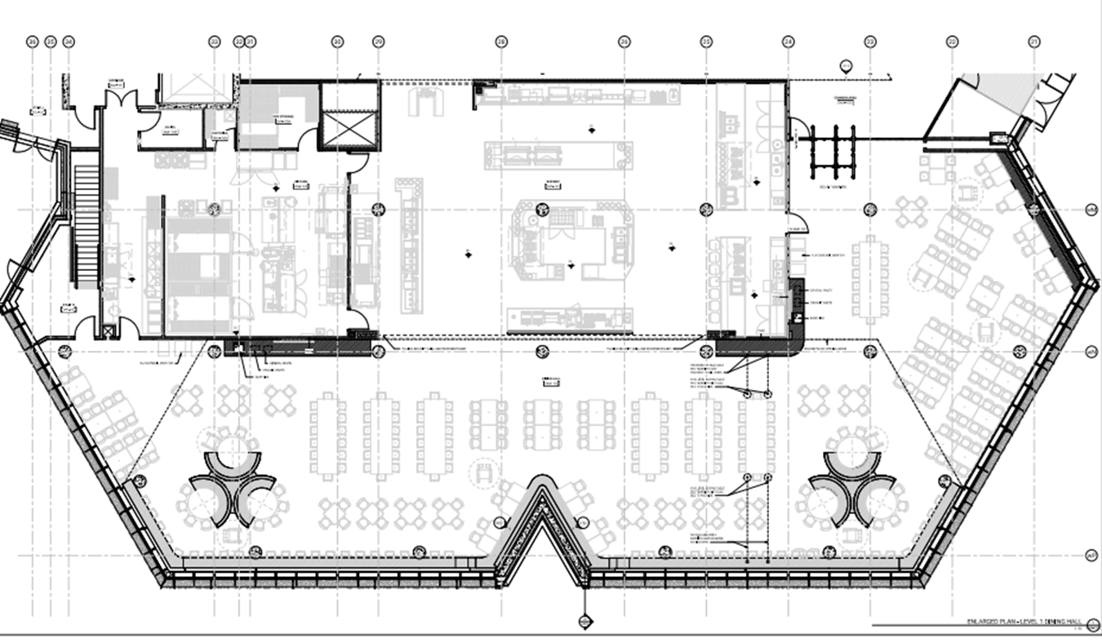



Foodservice Advisory Committee
Sustainability and Fair-Trade Working Group
Tuesday February 24, 2026

MEETING NOTES

Attendance: Mark Murdoch, Food Services; Christine Thomas, Chartwells; Corine Bolton, CUPE 3205; Katherine Plante, Student Housing; Kristin Jones, TGSA;

- Review of the Meeting Notes from January 27
  - See item 2 below.
- Updates from the Sustainability Office
  - These updates may not be completely accurate as Shelley was not able to provide the most accurate info.
    - To date there has been almost no liquid dumped in the “Dump Liquid Here” buckets at the clearing stations. Some enhanced signage and/or tabling may be required.
    - No action yet on labels/stickers for take out containers.
- Eco-tray and travel mug use – see below.
  - The use of $1 disposables increase by about 3%. This is not unexpected as during reading week only OC was open and the menu leads to a greater utilization of single use items.
  - Colder weather tends to increase the use of single use items.
  - BOOST is only delivered on single use, and as this delivery method increases, our use of china or eco-tray declines. Christine is going to investigate, again, the use eco-trays through the BOOST system.
- Other business - none
- Future meetings: March 24, 10:30 – 12:00, by TEAMS

