

Foodservice Advisory Committee
December 4, 2025

MEETING NOTES

Attendance: Mark Murdoch, Food Services; Christine Thomas, Chef Joseph, Chartwells; Aimee Blyth, Seasoned Spoon; Shelley Strain, Sustainability Office; Lori Johnston, Conferences; Ainsley McPherson, Gzowski College Cabinet; Kim Stevens, CUPE 3205.

- Review of Meeting Notes of November 6

- Sub-committee reports
- Operations and Marketing
  - See Meeting Notes of December 2
    - Gzowski construction update
    - Change to Tim Hortons hours
    - Exam and holiday season hours
    - Winter operating hours
- Sustainability and Fair Trade
  - See meeting notes of December 2
    - Updates from Sustainability Office
    - Great info re reusable dishes and eco-trays
- Catering
  - No report
  - Chartwells is offering two new catering packages that align with Provincial spending guidelines. The packages offer pick up or drop off with no follow up, set up or clean up. These are similar to the service provided by off-campus caterers who service the campus. Chartwells will continue to provide only single use materials that align with our recyclable and compostable guidelines.
  - In the new year, the Sustainability Office will prepare a cheat sheet that can be included in pick up or drop off only scattering events, helping the event organizer to appropriately sort any waste from the event.
- All-You-Care-To-Eat Working Group
  - See Meeting Notes of December 2
    - Can Chartwells reach out to the locations that were visited as part of the AYCTE field trip to see how much waste is generated by customers at the AYCTE dining halls.
- Other working groups
  - See meeting notes of Campus Card Steering Committee December 2
- General Discussion and Q & A
- Next meeting – January 29, February 26, March 26, 9:00 – 10:30, by TEAMS

Trent University Foodservices
Food Services Advisory Committee
Operations and Marketing Working Group
December 2, 2025

MEETING NOTES

Attendance: Mark Murdoch, Food Services; Aimee Blyth, Seasoned Spoon; Christine Thomas, Chartwells; Kassandra Glasbergen, The Ceilie; Rylin Wormington, Otonabee Cabinet; Sophie Dorias, Gzowski Cabinet; Kim Stevens, Corine Bolton, CUPE 3205

- Review of Meeting Notes of November 4
  - Punch a lunch cards are being distributed but not used. It is possible that students have been collecting the cards early in the term and saving them to use later in the term as other funds run low. We just want to make sure that no funds get left on the table while students are in need.
- Gzowski Dining Hall update – the latest project schedule has the project wrapping up on January 28. The University does not want the contractor making any noise during the exam period, so work may be paused until the new year, possibly pushing the completion back to late February.
- Change to Tim Hortons hours – hours being adjust to a 7:00 pm closure Monday to Thursday and 5:00 pm on Friday.
- Exam and Holiday Season Hours – attached
- Winter 2026 Hours - attached
- Other business
- Future meetings: January 27, February 24, March 24

Winter 2025 Operating Hours



Foodservice Advisory Committee
Sustainability and Fair-Trade Working Group
Tuesday December 2, 2025

MEETING NOTES

Attendance: Mark Murdoch, Food Services; Christine Thomas, Chartwells; Kristin Jones, TGSA; Corine Bolton, CUPE 3205; Katherine Plante, Student Housing.

- Review of the Meeting Notes from September 30

- Updates from the Sustainability Office were provided in writing in advance of the meeting:
  - Waste Audit: We still have outstanding data for the completion of our waste audit, we are waiting on shredded paper, electronics and ecotray/travel mug reuse. We hope to share results for the February meeting.
  - New Ontario Recycling Program: As discussed, the recycling program in Ontario is changing (Jan1, 2026) to now include all packaging and packaging-like materials. The local recycling facility confirmed that Peterborough will remain in a 2-stream recycling format (one for paper materials and one for the container mix). We are waiting on confirmation from our hauler that they will support us adopting this expended list or materials. Once we have that the Zero Waste Working Group will meet to discuss implementation. There will be a few changes that we need to figure out such as flexible plastics. More to come!
  - New Reporting: The federal government is requiring reporting on all plastics that flow through our campus. The guidance document on this reporting was set to be released this Fall but is delayed. My hope is that our waste audit data is sufficient for our reporting requirements as a generator. We will also have requirements as a producer and all plastic items that are branded to Trent (travel mugs, lanyards, shirts, stuffed toys, etc. etc. etc.) This reporting starts in September of 2026 but will be for the 2025 year. More to come.

- Eco-tray and travel mug use
  - Reusable coffee cups at 98%! Hooray! This likely translates to about 10% of ALL coffee cups used on campus, including Tim Horotns and Starbucks, about 5 times the national average.
  - Reusable dinner ware at 72%. Fantastic! We are seeing the trend we have predicted.

- Other business
- Future meetings: January 27, February 24, March 24, 10:30 – 12:00, by TEAMS



FOOD SERVICES ADVISORY COMMITTEE
ALL-YOU-CARE-TO-EAT DINING PLAN
EXPLORATION WORKING GROUP
DECEMBER 2, 2025

MEETING NOTES

Attendance: Mark Murdoch, Food Services; Aimee Blyth, Seasoned Spoon; James Onusko, Champlain College; Ananaya Gupta, Dana Paisley Gzowski College Cabinet; Kiara McKinley, Otonabee College Cabinets

- Review of Meeting Notes of September 30
  - No items for follow up
- Update from the AYCTE Filed Trip
  - Memo attached
  - Student feedback attached
- Most recent DRAFT layout for Gzowski attached.
- Next meetings; January 27, February 24, March 24, 3:00 – 4:30, by TEAMS

Proposed layout of Gidigaa Migizi College Dining Room, Servery and Kitchen
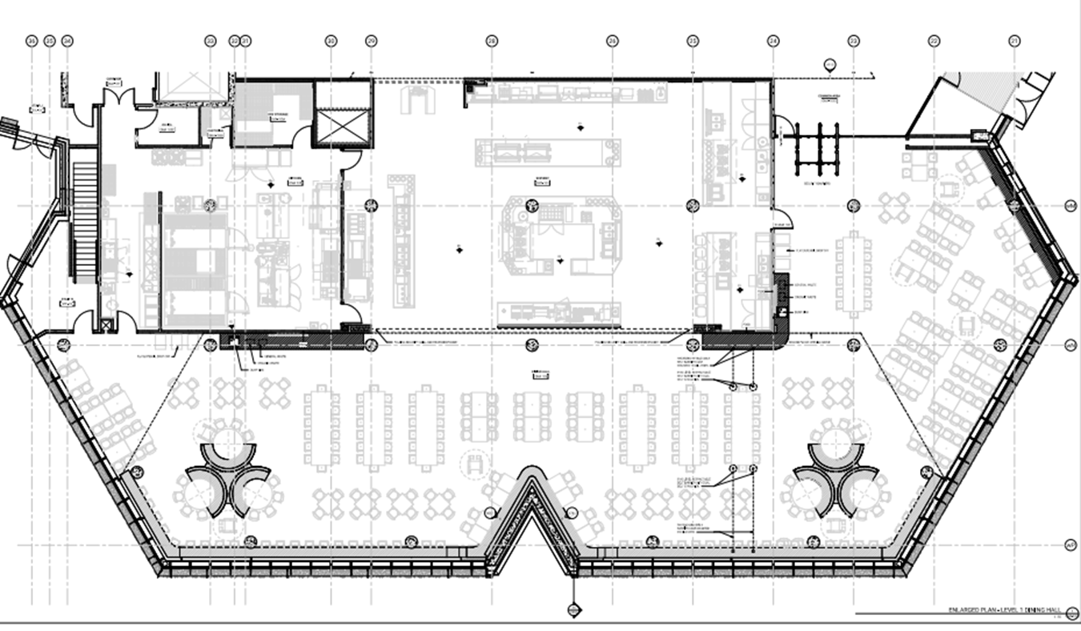



MEMORANDUM
TO: Members of the AYCTE Working Group
COPY: AYCTE Working Group Meeting Notes, December 2, 2025
FROM: Mark Murdoch
DATE: November 24, 2025
SUBJECT: AYCTE Working Group Field Trip Report

On Tuesday November 18 a group consisting of myself, Chef Joseph Pirie, Sarah Ovens, (LEC Cabinet) and Ananaya Gupta (Gzowski Cabinet) had the opportunity to tour four AYCTE dining facilities. All four facilities were managed by Chartwells, three were operated on a “management fee” model similar tour financial relationship with Chartwells, and one was managed in partnership with Knightstone, the developers of Gidigaa Migizi College.

- Pittman Hall, Toronto Metropolitan University. The facility was a fairly traditional in-line servery that offered a wide range of meal options. The layout is most similar to Lady Eaton. The servery offered a station that focused specifically on allergen awareness. A Chef’s Table offered breakfast throughout the morning and homestyle meals throughout the lunch and dinner period. A grill station offered burgers, chicken fingers and other grill foods on a static basis. A salad bar, deli bar, morning yogurt and smoothie bar, fresh fruit pastries, and a range of hot and cold beverages were always available. Most stations were self-serve. The seating area was interspersed throughout the servery. Management fee model. The cost for dining plans were: 5 days @ $5,400, 7 days @ $7,200 both with $450 flex cash included.
- ILC Dining Hall, Toronto Metropolitan University. The facility was similar to Pittman Hall, with the addition of stone oven pizza and a “My Pantry” location where students could prepare their own meals from a pantry and fridges stocked with proteins, vegetables spices and related supplies. The make your own waffle station was a big hit. The servery was about the same size and a similar layout as Gzowski College, proving proof of concept for the plans to redevelop Gzowski. Mostly self-serve. The seating area was adjacent to the servery. Students in any residence building could dine in either location. Open Monday to Friday only. Management fee model. Dining plan rates were the same as Pittman Hall.
- Parkside Residence. The Parkside Residence is a stand alone building operated by Knightstone and is home to students from any of the surrounding colleges and universities. The food service program, while similar to the program at TMU, was a bit more upscale in its menu offering. Most stations were staff served. The dining room was adjacent to the servery and offered seating for about 25% of the building population. Management fee model. The dining plan for a seven-day program is: $7,540, 7 day only, plus HST, prorated from 12 months.
- Durham College. The dining room at Durham College was very large with a scatter system. Food stations were mixed among the tables. It was the largest of the four locations and had the most expansive menu. It had a large and well equipped My Pantry section. The stations were a combination of self-serve and staff served. The servery was the most similar to the future Gidigaa Migizi servery. Several seating and table configurations were available. The dining plan rates were: 5 days @ $6,921 including $325 flex cash, 7 days @ $7,557 including $250 flex cash.

The two students who attended will provide a separate commentary on their observations, likes and dislikes.

From Ananaya Gupta, Gzowski College Cabinet

Hi Mark,
I hope you are doing well; I would like to thankyou for taking me on that trip. It was a great experience and a lot of learning for sure, below is the short summary of the things I like and my observation for the same:
1. TMU (Toronto Metropolitan University)
TMU offered the strongest overall experience. The first station, which was entirely vegan and allergy-safe, stood out for its thoughtful approach to students’ dietary needs. The wide range of healthy options reflects genuine concern for student well-being. Additionally, the availability of lactose-free drink options was appreciated.
The salad bar and yogurt bar which was also seen at a few other locations is an excellent breakfast choice. These stations increase variety and allow students to build their own meals. This is especially helpful for those who may feel hesitant to request customizations, and it naturally promotes healthier eating.

2. Parkside
Parkside impressed with its commitment to meeting student needs. The option to write down items that are unavailable so staff can arrange them later helps students feel seen and supported. Parkside offered the widest variety among the locations visited, including multiple salads, dressings, an avocado grill station, a fruit bar, sandwiches, and full hot meal options.

3. Durham College
Durham College offered the greatest variety of desserts. While many of their meal options were like the other institutions, their pancake station stood out. The concept of an open teaching outlet where students can watch food preparation and socialize with friends while cooking was thoughtful and engaging.
However, streaming live kitchen footage on television may pose some risks if access is not carefully controlled, as it could be misused.

Overall Observations
The salad bar, yogurt bar, and customizable stations were consistently the strongest features across campuses. These options empower students to personalize their meals and encourage healthier choices.
Compared with the other institutions, Trent currently offers fewer healthy options, which ideally should be a top priority. Introducing an allergy-free station would be a meaningful initiative that promotes safe, healthy eating for all students and reduces concerns related to dietary restrictions.

Thankyou again for the experience. If you need any other surveys or questions to answer, I would love to do that!

From Sarah Ovens, Lady Eaton College Cabinet

I really like the station at TMU called “SANS” where they offered foods that were appropriate for food allergies, insensitivities and religious observances. The station should be open for all three meal periods.

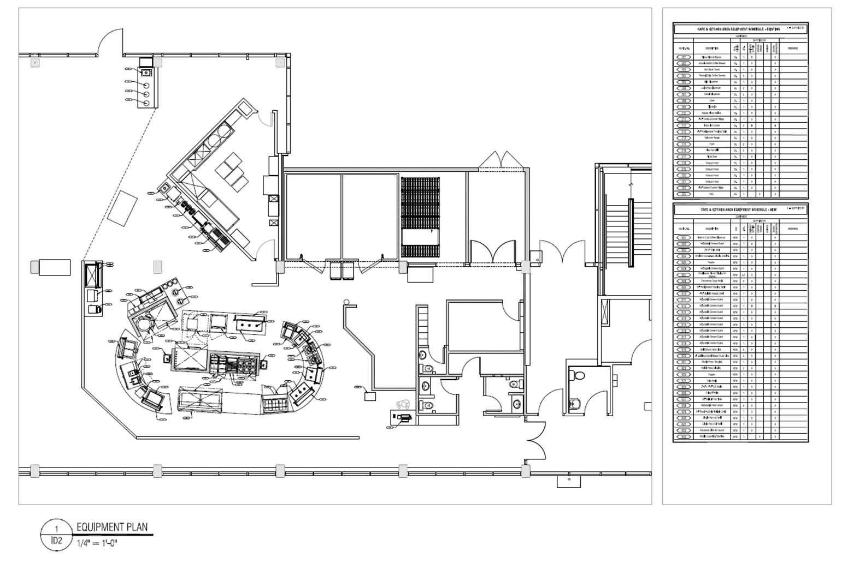



Campus Card Steering Committee
December 2, 2025
11:00 am.
meeting notes

Present
Brendan Humphrey- Card Office, Patti Kidd- Campus Payment, Robyn Gundy – Housing, Jonathan Nayler- TGSA, Adam Myers - Finance, Tracy Milne- TCSA, Ananaya Gupta – Gzowski College, Diamond Akinbaleye – Champlain College

Absent
Sarah Ovens- TCSA, Anthony Coulter – TDSA, Claire Strome Teasdale – Otonabee College, Keith Pua – Campus Security, Andrew Bell- IT, LEC Cabinet- LEC, Traill Cabinet,

Introductions

Budget
We are budgeting for a loss of ~$10,500 for the 2026-2027 Fiscal Year. This loss is due to the purchasing of Door readers for the campus to upgrade the existing hardware to be able to accept Mobile credentials. We have enough in our reserves to cover this loss.
We are not asking for an increase of any fees this year as we secured a $1.50 increase to the Campus Card fee for the next three years to help support the increase of costs of the Mobile Credential.

Mobile Credentials
We’ve updated the software of all door readers on campus, both Peterborough and Durham, that already support Bluetooth and NFC, that will accept Mobile Credentials.
Any Card readers on campus that are not compatible, we will have replaced early in the new year.
We are planning to have a pilot group of Students on Mobile Credentials for September 2026. This will most likely be students living in Residence.
We will still have the option for a physical card, but our goal is to have mobile credentials being the primary option moving forward.

Questions?
Tracy – Does this app function like ID123 where it has a live time on it and can it be used for Transit?
Yes, the app works the exact same as ID123 where it has the live timer to verify it’s not a screen shot. We can merge Transit onto the app in the future and will circle back with Tracy to work on this moving forward.

