

Foodservice Advisory Committee
October 8, 2026

MEETING NOTES

Attendance; Mark Murdoch, Food Services; Andrew Root, Starbucks; Alex Burnett, Seasoned Spoon; Dani Daoust, LEC Cabinet; Christine Thomas, Chartwells; Kim Stevens, CUPE 3205; Jordan Webb, TGSA; Shelley Strain, Sustainability Office; James Onusko, Colleges; Klara Hennig, Champlain Cabinet; Ainsley MacPherson, Gzowski Cabinet.

- Terms of Reference
  - Review and edits - attached
  - Role of the Committee and Participants – attached
  - Meeting Schedule - attached
- Role of Working Groups - attached
  - Membership
  - Meetings
- Review of Meeting Notes of July 23
  - Chartwells to begin tracking eco-tray use by College.
- Working Group Reports:
  - Operations and Marketing
    - See Meeting Notes of October 6
    - Proposed hours for Thanksgiving and Reading Week
    - Harvest Lunch – estimated that 150 – 160 guests participated. The event raised $897.64. An additional donation from Chartwells of $2,500, will bring the total donation to the TCSA One Stop Chop to $3,397.64.
b. Sustainability and Fair Trade
    - See meeting notes of October 6
- Budget
  - See meeting notes of October 6
    - We are anticipating larger the normal increases in the dining plan fees for next year.
- Catering
  - No report
- All-You-Care-To-Eat Working Group
  - See meeting notes of October 6
- Related Committees:
  - Dining Room Redevelopment Group – no report.
  - Campus Card Committee – no report.

- Future structure of Food Services
- General Discussion and Q & A
- Next meeting – November 5 and 26, 10:30 – 12:00, by TEAMS


Trent Food Services Advisory Committee
Terms of Reference – September 2026

Membership:
Executive Director, Food, Conferences and Campus Payment Services (Chair)
A designate of: TCSA, TDSA, TGSA, TUFA
Student Representative from each College Cabinet (5 total)
Student Representative from Durham GTA College Residence Council
Student Representative from Trent International
Trent Market Garden
Trent Vegetable Garden
Trent International Staff member
First People House of Learning representative
Sustainability Committee representative
Trent Director of Student Housing or Designate
Trent Director of Conference Services
Chartwells General Manager
Chartwells CUPE staff member
Ceilie Pub Manager
Seasoned Spoon Manager
Starbucks Manager
A College Principal
A staff representative from Durham GTA

Meetings:
Monthly during the fall and winter semesters, summer as required. Meetings are open to the entire community. Minutes will be posted online.

Mandate:
- To provide feedback and recommendations regarding the Trent Food Services operations
- To identify specific food needs of individuals and the community, and to ensure they are being met
- To review financial, sustainability, wellness, education and community outreach key performance indicators
- To review dining plan structures and cost for the following year
- To determine short-term and long-term food service goals and advise on planning and future directions
- To communicate with the broader Trent community about food services issues and operations
- To identify partnerships and initiatives to educate and support the Trent and Kawartha region communities, including educating students about food issues
- To assist all campus foodservice providers in developing a top-tier food service operation that is a national model for quality and sustainability

Decision Making
The committee is advisory in nature and will normally make decisions on a consensus basis. Typically, the only item that will be voted on will be the approval of the annual budget for Trent University Food Services and the related fees for Dining Plans for the following year. Only the representative from each of the College Cabinets and a student elected or appointed to represent residents from the Durham GTA Campus will participate in this vote. If there is a tie, the representative from the TCSA will cast the deciding vote.

Sub Committees
Sub committees and working groups, both regular and ad hoc may be established to address specific matters, for example:
- Operations and Marketing
- Sustainability and Fair Trade
- Budget
- Catering
- All-You-Care-To-Eat
- Ad hoc and Special Working Groups

Role of Sub Committees

Operations and Marketing

The role of this sub-committee is to identify the operational elements of the foodservice program that can be changed or corrected in very short time frames to create an immediate impact for customers, with a specific focus on residents. For example, the committee may recommend improvements to signage as an immediate item. The renovation of a foodservice facility would not be considered by this sub-committee

Sustainability and Fair Trade

The role of this group is to plan and execute small and targeted activities, in the two week to one month time frame, that create immediate changes in sustainable behavior, with a goal of establishing longer term habits in on-campus consumers.

Budget

The committee will advise the Executive Director, Food, Conferences and Campus Payment Services in the development of the annual operating budget for the University department. This budget is limited to Trent Foodservice and does not consider the budget of Chartwells or other on-campus foodservice providers. The group will make a recommendation to the Food Services Advisory Committee regarding the budget and related dining plan fess for Trent University Foodservice for the next fiscal year (May – April). The recommendation to FSAC, if approved, is forwarded to CASSC for information and then the Board of Governors for final approval.

Catering

The Catering Working Group is a subcommittee of the Food Services Advisory Committee that meets to discuss items that are unique to the users of catering services.

All-You-Care-To-Eat Working Group

Working with campus stakeholders, the working group will explore how to best execute the transition to AYCTE ding for the fall of 2028.

Ad hoc and Special Working Group

Ad hoc and special working groups may be established from time to time.

FOOD SERVICES ADVISORY COMMITTEE
MEETING SCHEDULE
SEPTEMBER 2026 THROUGH APRIL 2027

Tuesday October 6, November 3, November 24, January 26, February 23, March 23
9:00 – 10:30 Operations and Marketing
10:30 – 12:00 Sustainability and Fair Trade
1:30 – 3:00 Budget Working Group (extra meeting November 17 if required)
3:00 – 4:30 All-You-Care-To-Eat Working Group

Thursday October 8, November 5, November 26, January 28, February 25, March 25
10:30 – 12:00 Food Services Advisory Committee

Foodservice Advisory Committee
July 23, 2026

MEETING NOTES

Attendance: Mark Murdoch, Food Services; Sabina Kapoor, TDSA; Shauna Carlow, Student Housing; Shelley Strain, Sustainability Office; Kassandra Glasbergen, The Ceilie; Alex Burnett, The Seasoned Spoon; Corine Bolton, Laurie Hachey, CUPE 3205; Christine Thomas, Chartwells.

- Review of Meeting Notes of March 26
- Sub-committee reports
- Operations and Marketing
  - See meeting notes of March 24
  - Gzowski construction update
    - Progressing very well, just a few minor items to finish before the start of the fall term.
  - Lady Eaton construction update
  - Design of the future servery is progressing well. Work to complete to walls in the later part of this summer will help speed up construction in the summer of 2027. We believe that we can complete the entire renovation in the summer of 2027.
- Sustainability and Fair Trade
  - See meeting notes of March 24
  - Eco-trays have been ordered for fall 2026
    - Can eco-tray use be tracked by location? Possibly. Christine can (possibly) add the eco-tray data collection by College.
    - We really need to think about the eco-tray program after 2028, when most meals on campus will be served on reusable dishware in the all-you-care-to-eat facilities.
- Catering
  - No meeting
    - Meeting of catering users upcoming – last week of August.
      - There will be a round table to focus on changing needs and interests
    - New internal catering rates for 2026 will be developed and posted on-line in the catering system.
- AYCTE WG
  - See meeting notes of March 24
    - .
- Budget Working Group
  - No meeting
    - With declining enrolment and more empty rooms, our budget is becoming VERY precarious
      - Likely that increases close to the increase in the prior year (12%) will be required by the University. We need to find every opportunity to reduce costs.
    - Anticipating a multi-year budget and a change to policies related to refunds.
      - We will be able to de-couple the Peterborough and Durham dining plans in 2028, but this may require the operation in Durham to be fully self supporting, which could result in higher costs. In 2023 the capital repayment from Durham to Peterborough will end, equal to $400 per year per bed, so this will help close the gap.
- Dining Room Redevelopment Group
  - No meetings
- Fall Operating Hours – attached with important changes highlighted.
- General Discussion and Q & A
  - None
- Fall Meeting Schedule - attached



Trent University Foodservices
Food Services Advisory Committee
Operations and Marketing Working Group
OCTOBER 6, 2026

MEETING NOTES

Attendance: Mark Murdoch, Food Services; Christine Thomas, Chef Joseph Pirie, Chartwells; Kim Stevens, CUPE 3205; Kassandra Glasbergen, The Ceilie; Montana Scott, Wyatt Rawlings, Housing; Sophie Dorias, Gzowski Cabinet.

- Purpose of the Working Group
  - The role of this sub-committee is to identify the operational elements of the foodservice program that can be changed or corrected in very short time frames to create an immediate impact for customers, with a specific focus on residents. For example, the committee may recommend improvements to signage as an immediate item. The renovation of a foodservice facility would not be considered by this sub-committee.
- Review of the meeting notes of March 24
- Harvest Lunch – October 7, The Great Hall, Pay What You Can, 11:30 – 2:00
- Construction updates:
  - Gzowski phase 2 complete
  - Lady Eaton phase 1 complete
  - Lady Eaton phase 2 planning is underway, with construction planned for the summer of 2027.
- Changes to the elements of the Dining Program are being confirmed at the All-You-Care-To-Eat Working Group
  - Refund policy
  - Plan structure
  - Flex cash practices
  - Dining plan conversion procedure
  - Grandfathering prior residents
  - Dining room access during off peak hours

- Changes to Bata Bean
  - The Amazon Just Walk Out program at Bata Bean will be discontinued. The program has not been operational since the space re-opened in September. We are not realizing the promised benefits of the program, and this is having a negative impact on the student experience.
- Thanksgiving and Reading Week Operating Hours – attached, with one correction. The website has also been updated.
- Future reporting structure for Food Services
  - Mark Murdoch will retire in April of 2027
  - In May Conference Services was removed from the portfolio to better align with the future direction of Housing Services.
  - The TrentU Card, Campus Payment Services and Marketplace, the University on-line store, has recently moved into Finance.
  - The remaining portfolio will be Food Services only: Chartwells, Starbucks, The Ceilie, The Seasoned Spoon, Vending.
  - A Director level position will be advertised shortly, with an expected start date in January 2027 to provide some overlap between Mrk and the new Director.
- Meeting schedule - attached
- Other business
  - Can students visit the dining hall 15 times a day? If they want to. The model encourages healthier eating as students know thay can come back and just get a snack, beverage of fruit later, and don’t gorge themselves during each visit.
  - We could use some improved communication around sorting garbage and compost, specifically in Durham. Mark will connect the Sustainability Office with the right people.
  - Better communications and marketing of dining specials, promotions and events like theme dinners would be useful. Chartwells will connect with Housing staff to explore the best opportunities to do this.
- Next meetings – November 3 and 24, by TEAMS

Thanksgiving Operating Hours 2026

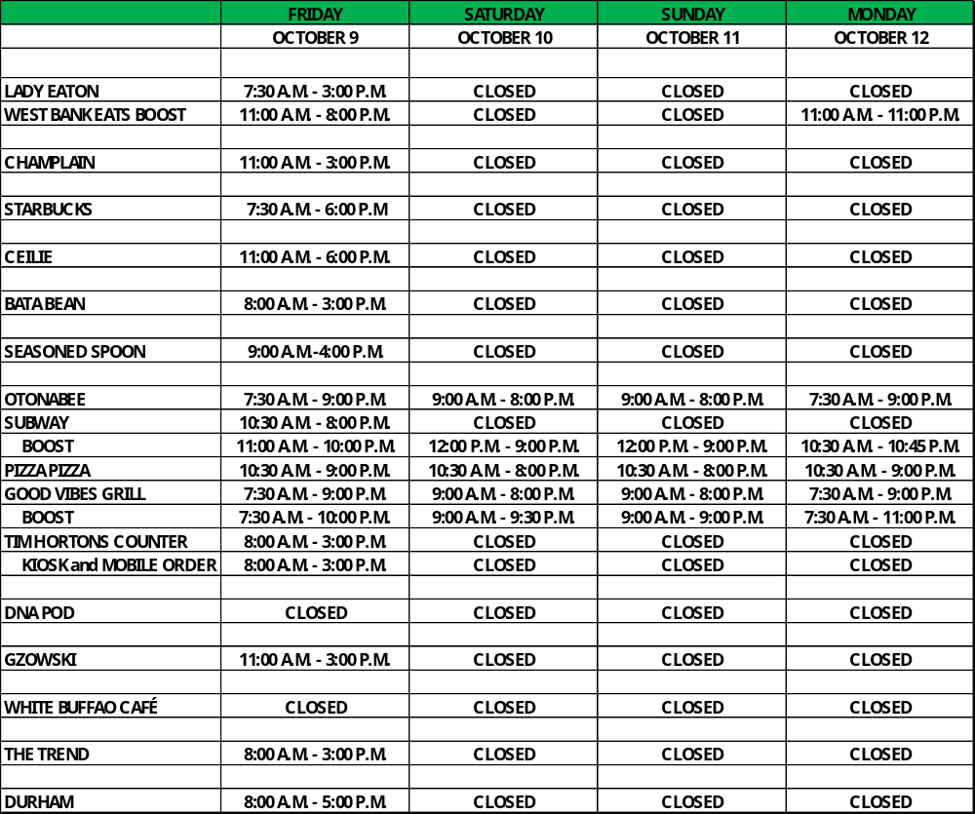

Fall 2026 Reading Week Operating Hours
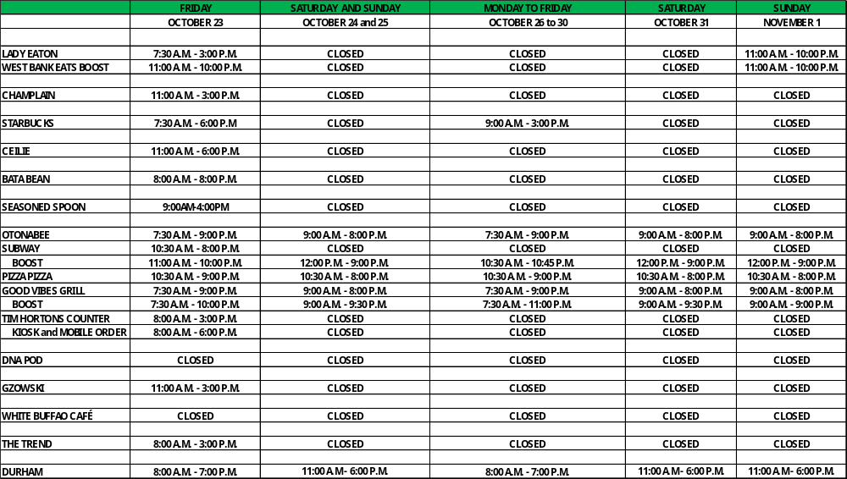



Foodservice Advisory Committee
Sustainability and Fair-Trade Working Group
Tuesday October 6, 2026

MEETING NOTES

Attendance: Mark Murdoch, Food Services; Shelley Strain, Sustainability Office; Abby Maguire, Sustainable Trent and Otonabee College; Christine Thomas, Chartwells; Kim Stevens, CUPE 3205; Elisha MacMillan, Durham GTA; Katherine Plants, Housing Services; Jamie Burnett, TGSA.

- Role of the working group

The role of this group is to plan and execute small and targeted activities, in the two weeks to one month time frame, that create immediate changes in sustainable behavior, with a goal of establishing longer term habits in on campus consumers.

- Participation in eco-tray program and travel mug utilization
  - Collection of accurate data – see attached below
  - These are programs that will see considerable decline as we transition to AYCTE dining
- Renewal of Fair-Trade certification - completed
- Renewal of Lady Eaton and Durham Green Restaurant 3-star certification is complete. Working on re-certifying Gzowski at the 3-star level. Chartwells is pursing 4-star certification, with a focus on education.
- Green Restaurant environmental impact report – attached
  - There is some suspicion that the waste diversion number for Gzowski and Durham may be incorrect. Chartwells will look to confirm.
- What does our goal of being a “Waste Free” campus by 2028 look like and how might it impact food service operations?
  - Trent has a goal to be a zero waste campus by 2028. In practical terms, this means a 90% diversion of all waste that can be diverted from landfill being successfully diverted. The focus in first on reduce the amount of waste being generated and then on reuse, think china plates and then eco-trays. We are currently at about +/- 80% diversion and think the 90% is achievable.
- Carbon neutral strategies and timetable
  - The University supports the Provincial target of achieving 37% carbon reduction by 20230 and being carbon neutral by 2050. There is considerable work to be done in phasing our approach(es) and in investing in the programs need to get there.
- Deployment of Green Ambassadors
  - The Sustainability Office has 12 students and 3 TWSP students who are providing peer coaching to improve diversion rates and focus on other sustainability programs.
- General discussion and Q and A
  - There is a dish rental program available in Peterborough. Can a similar program be implemented in Durham? The Green Plates program allows recognized student groups to “rent” up to 144 settings of plates, bowls, glasses, cups and cutlery for use at student run events. The dishes are picked up and returned to Lady Eaton College. The fee for the program, $25 per rental event, is paid by the TCSA. Staff from Durham will collect info about the frequency a program of this nature would be used, if user groups/departments would pay the fee, and the typical number of attendees for events. A similar program is available just for cups/glasses for events.
  - Chartwells provided info about a program called Frylow which promises to deliver lower energy costs, less food waste, less oil waste and improved food quality. We will put a trial program in place in two dining halls as soon as the equipment can be obtained. A copy of the slide show is attached.
  - Is Chartwells still using the waste tracking system? Yes. It is called Waste Not 2.0. The system using AI enabled technology and user input to track the type, source and disposal of back of house waste to help users identify where/how food waste can be reduced. An exemplar report is attached.
  - Does Chartwells has a program for tracking and identifying the carbon footprint of menu items? Chartwells will have to investigate.
- Meeting schedule – attached
- Next meetings– November 3 and 24, 10:30 – 12:00 by TEAMS

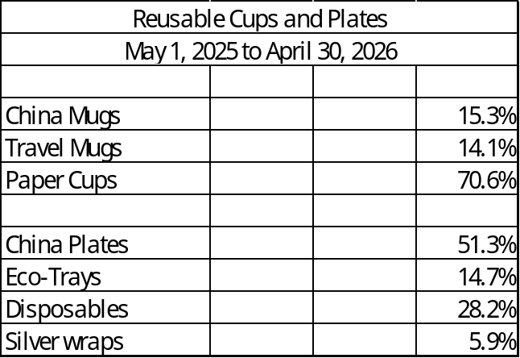

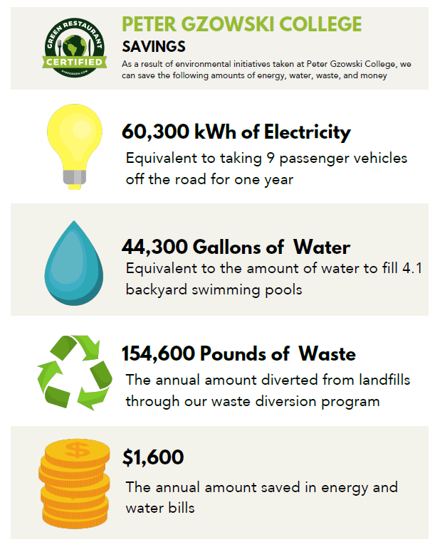
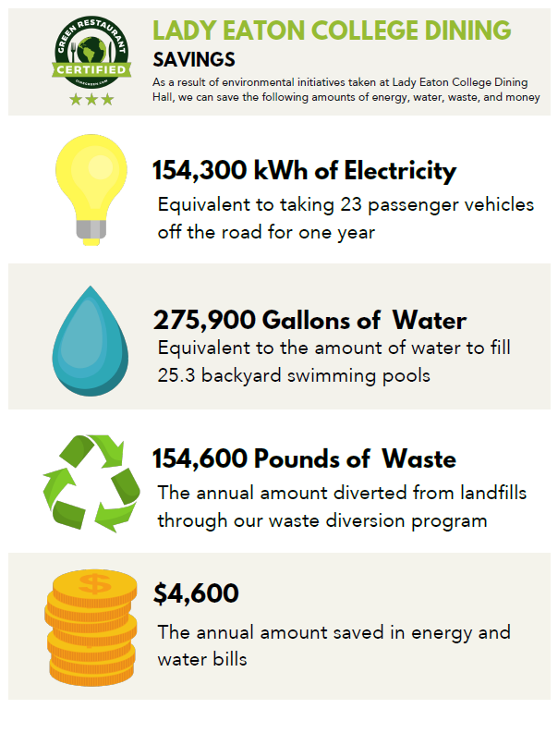

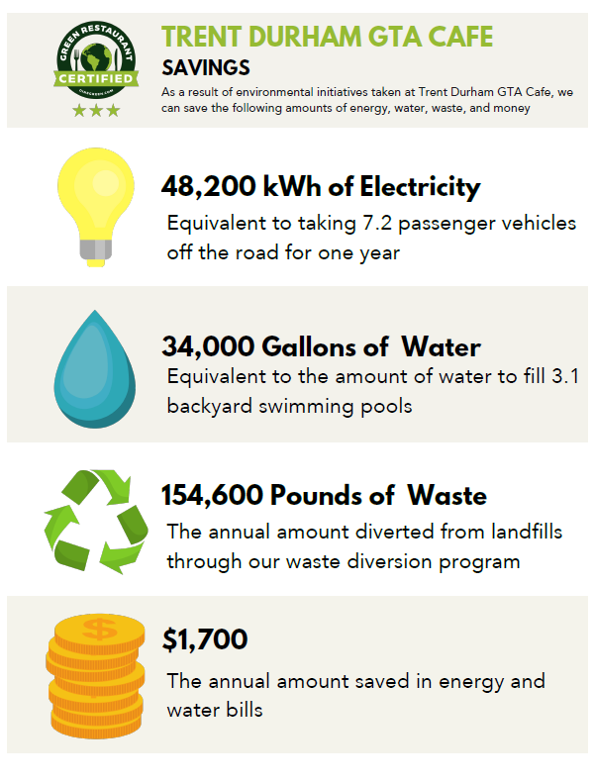

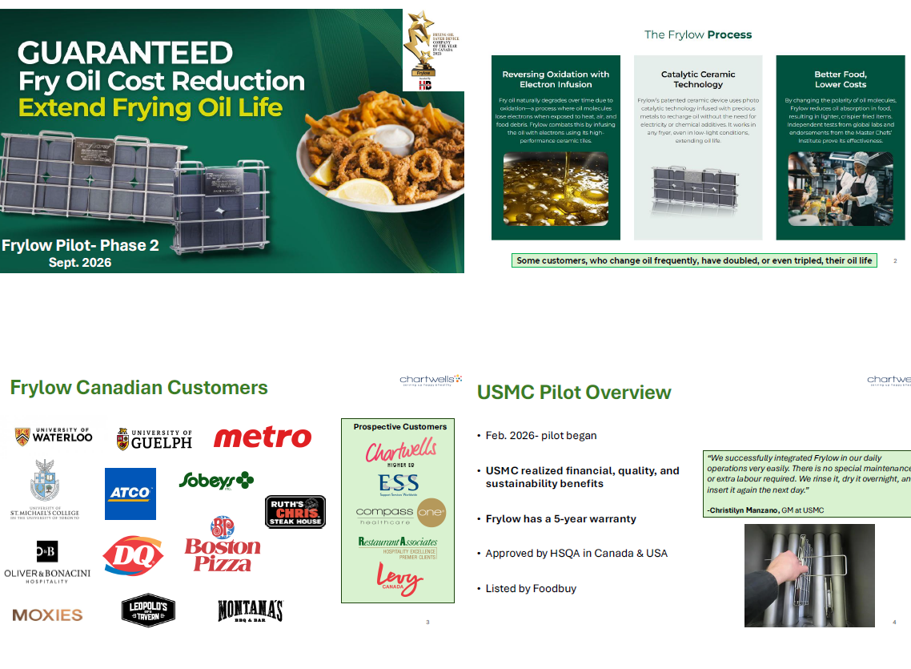
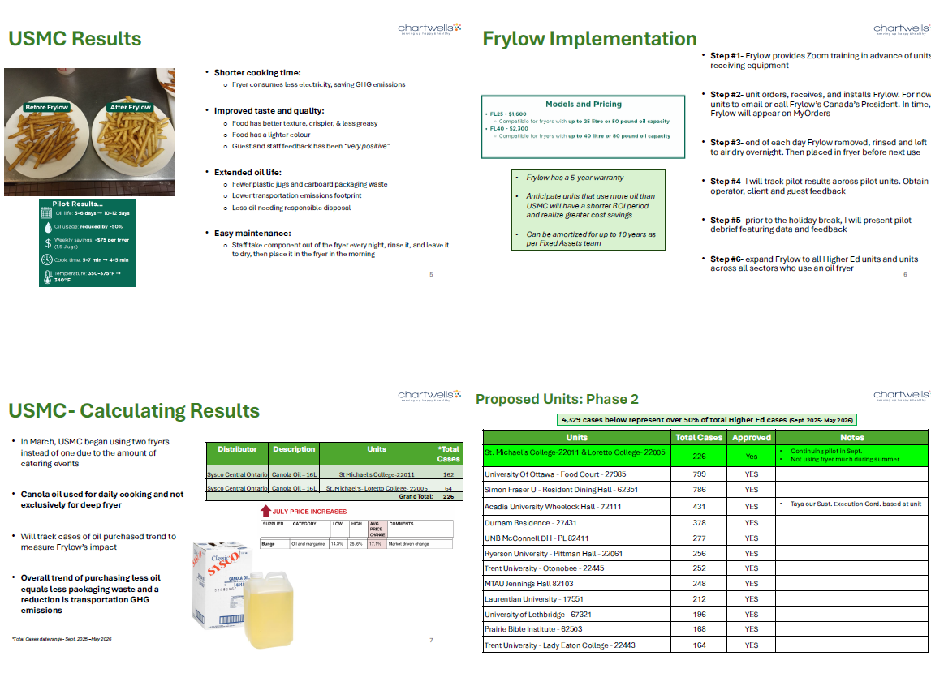
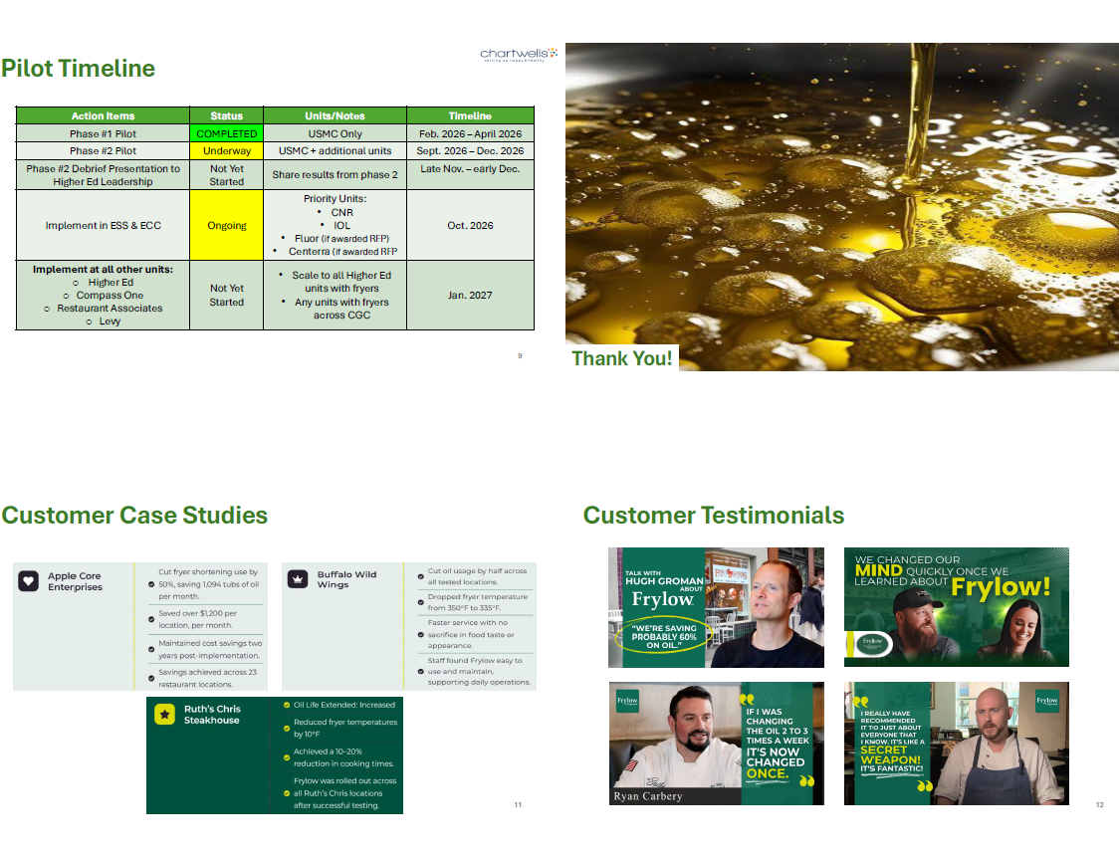
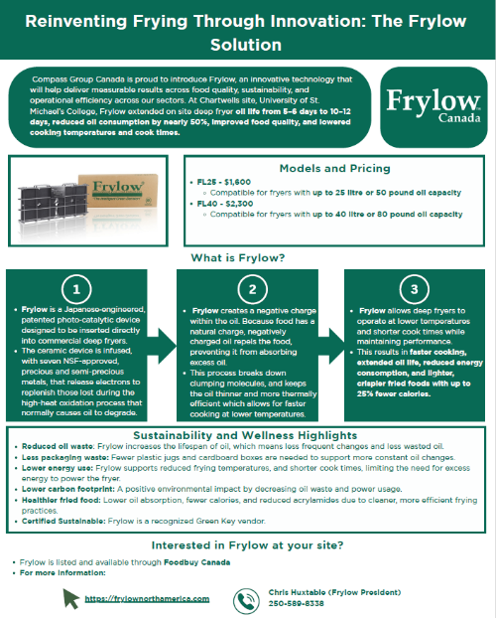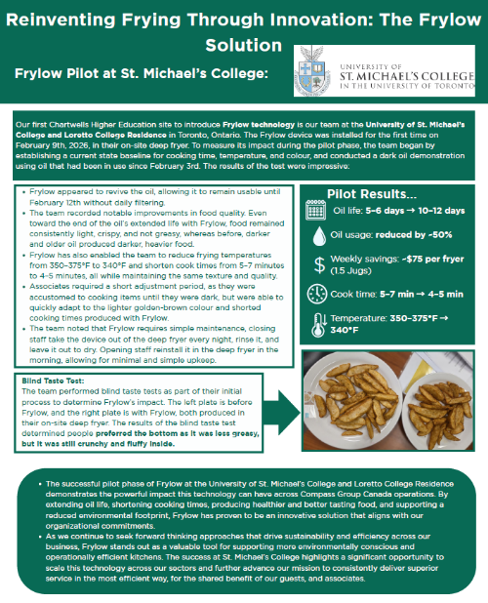

This is an exemplar report of the kind of data the Waste Not 2.0 system can provide.
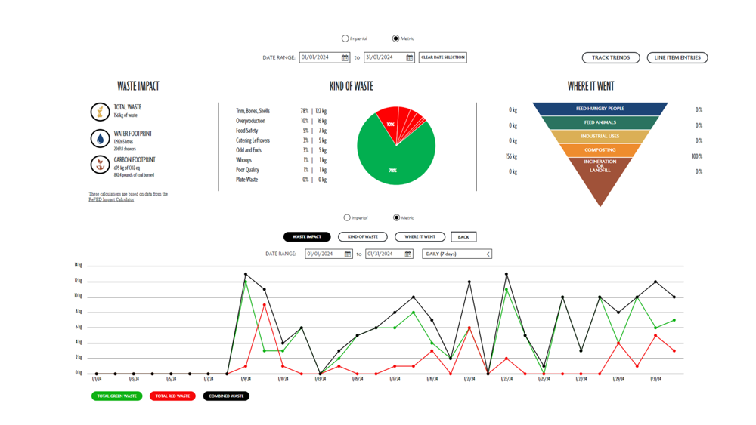



Foodservice Advisory Committee
Budget Working Group
October 6, 2026

MEETING NOTES

Attendance: Mark Murdoch, Food Services; Chris Nelan, Durham; Jack Chesson, Housing;

- Roll of this working group:

The committee will advise the Executive Director, Food, Conferences and Campus Payment Services in the development of the annual operating budget for the University department. This budget is limited to Trent Foodservice and does not consider the budget of Chartwells or other on-campus foodservice providers. The group will make a recommendation to the Food Services Advisory Committee regarding the budget and related dining plan fees for Trent University Foodservice for the next fiscal year (May – April). The recommendation to FSAC, if approved, is forwarded to CASSC for information and then the Board of Governors for final approval.

- This year, we intend to develop a framework for the redevelopment of the Food Service budget and the establishment of dining plan rates for the 2027 – 2028 year, while we continue to operate on a declining balance model, but looking forward to:
  - Transition to All-You-Care-To-Eat dining and the operation of the new dining facility under a relationship with the building owner/partner.
  - Contemplate adding two weeks to the dining schedule, over the winter holiday period
  - Decouple the AYCTE dining plan from the declining balance dining plan that will remain in place for Durham, Traill, Suite Style plans and grandfathered residents.
  - Develop a budget model that accounts for fewer beds in Durham and has the location be self supporting, likely resulting in a higher admin fee

- Budget drivers:
  - Escalating food cost – inflation has slowed; however food inflation is running at a rate much higher than general inflation, running around 4%
  - High fuel costs will continue to put pressure on food inflation as input costs and transportation costs increase.
  - Wage costs- the wages that were established through the latest collective bargaining process were not fully captured in the budget over the past two years. Additional increases related to holidays and pay equity have further impacted wage costs. The wage increase, over three years, totals about 22%. Only 12% of this amount has been captured to date.
  - Projects
    - Total redevelopment of LEC in the summer of 2027, estimated at $3,500,000
    - The cost to finance this project is estimated at about $425,000 per year.
  - Preliminary 2027-2028 Budget
  - Priorities
    - Keeping costs as low as possible while maintaining the viability of the program
    - Maintain tax exempt status
  - Discuss Dining Plan rates for 2027 – 2028,
- General Discussion and Q & A
- Next meetings:
  - November 3, 1:30 by TEAMS.
  - A special meeting may be held November 17 if new budget info is available
  - A meeting may be held November 24 if required prior to final approval of the dining plan rates at the main committee meeting on November 26

Budget Development 2027-2028

- The key messages related to the development of the Trent University Foodservices Budget:
  - There is considerable uncertainty in the budget development process as increases for space, utilities and University Admin Overhead have not yet been communicated to budget developers. Any new information that is available prior to the finalization of the 2027-2028 Dining Plan Rates will be reflected in the final budget and may result in a change to the proposed rates, with the new rates being no higher than the rates outlined below.
  - Trent Foodservices is a not for profit ancillary operation of the University. Over time, the department should “breakeven” once it has covered the costs of all operations, overhead, capital investments and an appropriate level of accrual for future investments or projects.
  - We attempt to keep retail prices at or below the national average, based on an annual survey conducted by the Canadian College and University Food Service Association.
  - Trent students greatly value the ability to “carry forward” any unused dining plan balances at the end of the year. This attribute will become less important as we transition to all-you-care-to-eat dining in 2028.
  - Student value the tax exempt status of the dining plans.
  - The design of dining plans should be simple and easy to understand.
  - A comparison of several AYCTE dining plans at Canadian schools has been provided below.
  - Additional operating hours costs residents. For example, adding Gzowski on weekends would cost each resident about $120.

- Major budget drivers in future years
  - Capital replacement. Within the budget we need to begin to set aside capital reserves for known future projects. For example, the redevelopment of LEC about $3.5 million, to be financed through an internal interest bearing loan.
  - A lower-than-normal recruitment level and the conversion of some beds to upper year/grad rooms, without an assigned dining plan, has resulted in about 400 empty beds system wide. Durham GTA has been reduced to 100 beds,
  - Inflation. While inflation has cooled to about 2%, wage and food cost increases have run much higher and will continue to put pressure on the total costs of operation.
  - US dollar and tariffs. Most food commodities are traded in US dollars. If the Canadian dollar weakens the effective cost of food increases, compounding any inflationary effect.

- Current Dining Plan Rates:

:

Plan | Traditional | Suite
Cost | $6,570 | $4,600
Overhead | $ 1,263 | $ 963
O-Week Meals | $ 287 | $ 287
Value | $5,020 | $3,350

- Tax Exemption.

To be tax exempt a Dining Plan must meet a number of criteria established by the Canadian Revenue Agency. One of these requires that the plan provides for meals over the duration of the plan (30 weeks for two semesters) and a minimum of 10 meals per week at the “average” cost of a meal on campus.

For Trent the math is; 30 weeks X 10 meals X $11.04 = $3,312

Given inflationary pressures the average cost of a meal will need to increase next year, likely close to $11.54, moving the suite style declining balance plan value to about $3,462, plus overhead and O-week meals.

Preliminary Unadjusted Budget Food Services 2026-2027
The budget is broken down into several bundles:
- Revenue
- Wage and Benefits
- Transfers to vendors for services
- Operating expenses
- Principal and Interest Repayment
- University Overhead
- Utilities
The original budget did not anticipate the operation of Traill, which ill have a negative impact of about $35,000 on the net operating result.
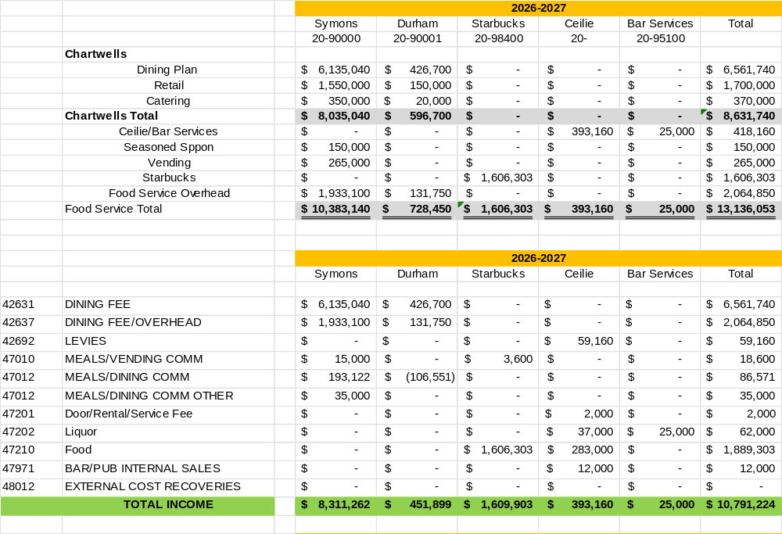

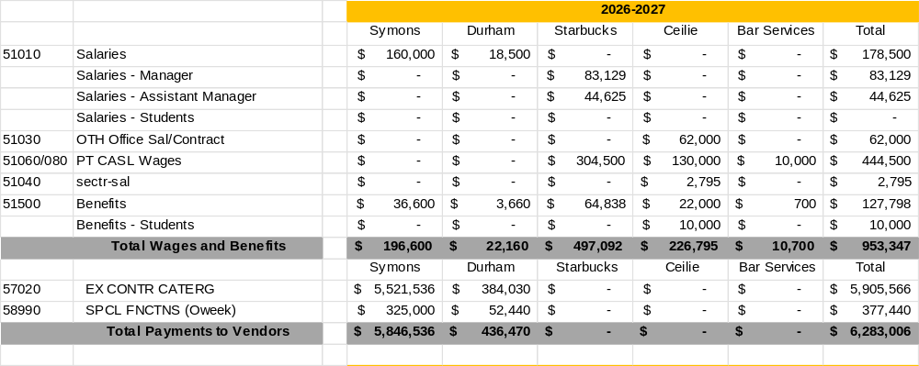

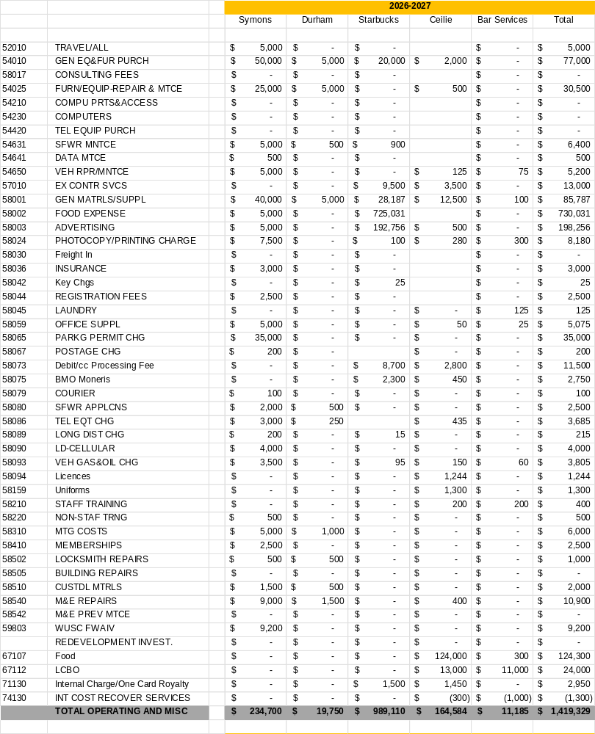

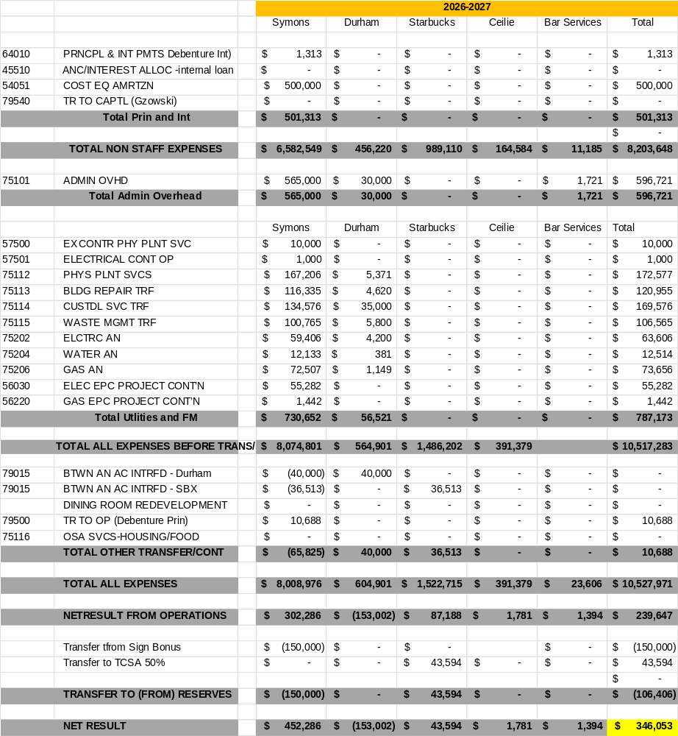

Dining Plan Components

The total Dining Plan Fee is made up of two components, the overhead and the declining balance portion.
- The cost for O-week “free” meals will increase 4.7% for 2027-2028.
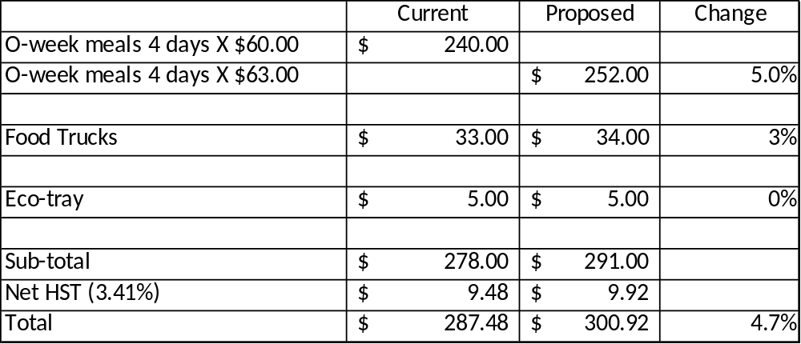
- Overhead for a Traditional Dining Plan:
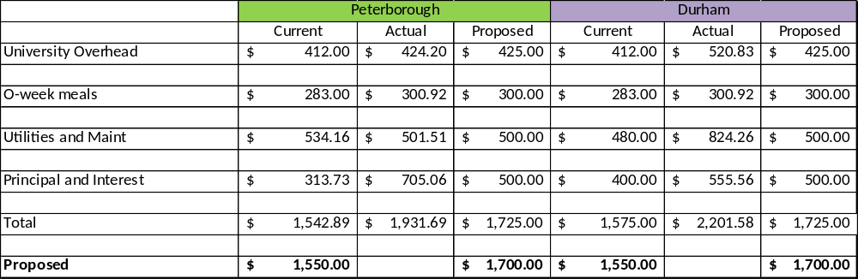

- Total Food Services Revenue and Admin Overhead
The Admin Overhead portion is intended to proportionally share the cost of operating the food service program among all residents.
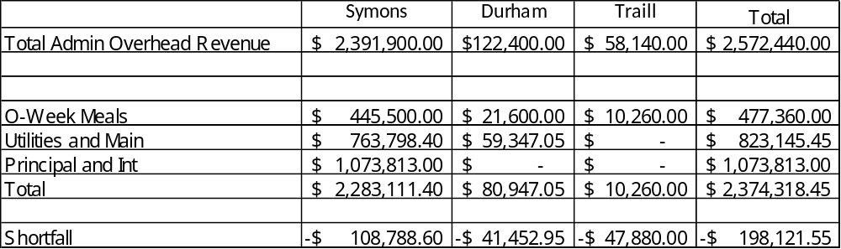
The recovery of Admin Overhead will result in a shortfall of approximately $200,000. The shortfall is covered by retail customers and other income sources.
- Declining Balance Portion
The declining balance portion of the dining plan needs to increase by an amount sufficient to cover inflation in the three broad categories of expenses:
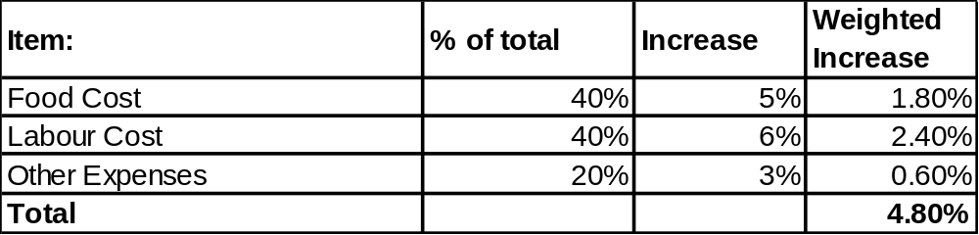
The value of the Declining Balance portion of a dining plan will need to increase by 4.8% to maintain the same purchasing power. The minimum amount for traditional rooms will be $5,260 and suite style rooms $3,510.
We have a lot of work to do on the costs included in the Overhead fee (where will utilities land for example) and on the declining balance value, given inflation.
It is important to note that because Trent offers an automatic carry forward of any unused dining plan value students who do not spend their entire dining plan never lose the purchasing power of the plan.

- Proposed dining plan fees for 2027/2028.
Traditional Style Plans
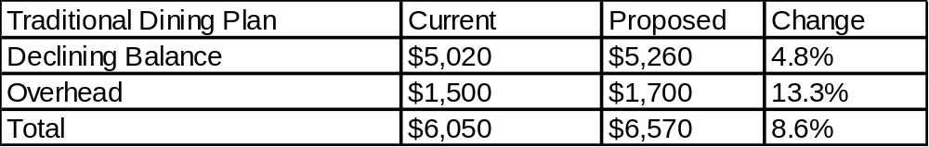
Suite Style Plans
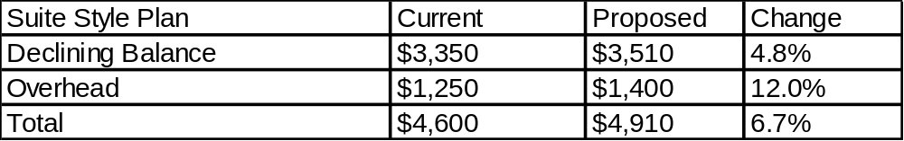

Preliminary Food Service Budget for 2027-2028
Amounts for Starbucks, The Ceilie and Bar Services are not updated, but have little material affect

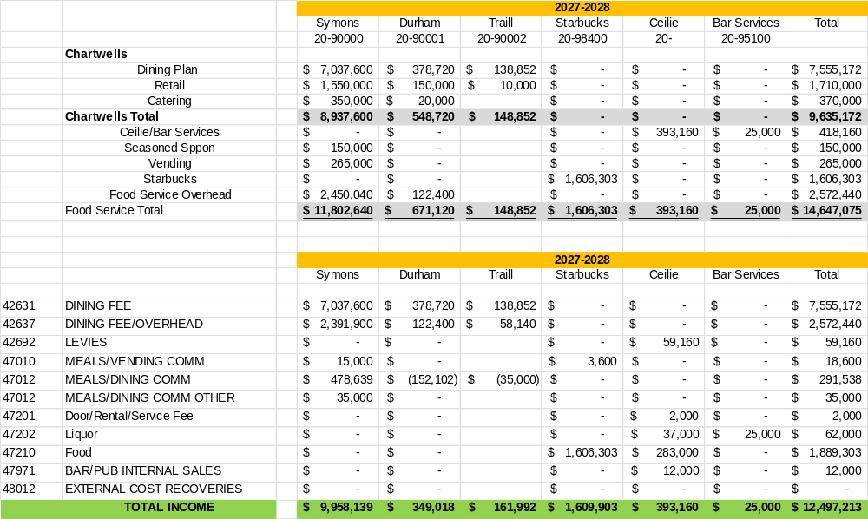

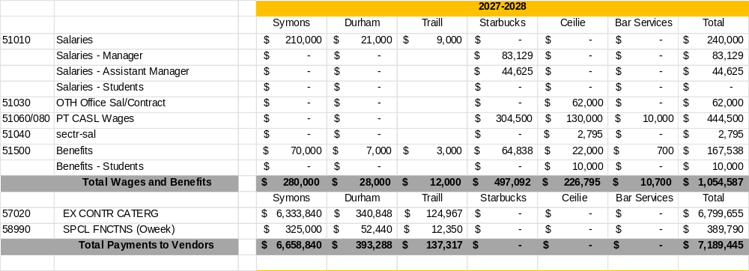

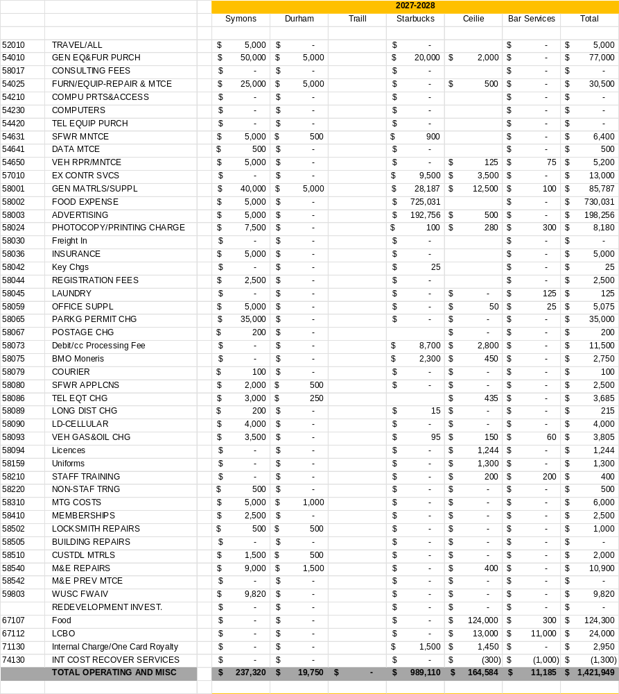

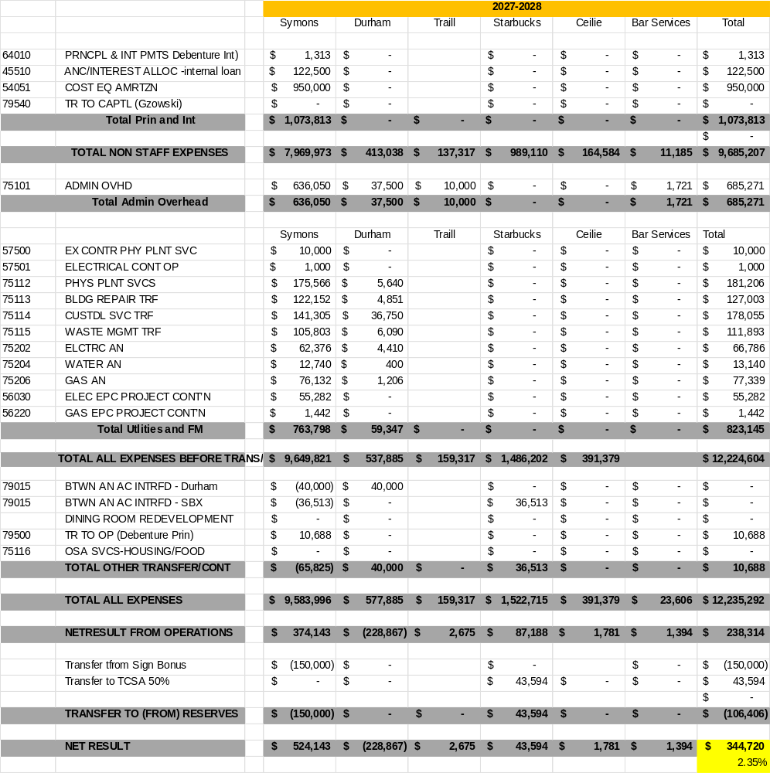


FOOD SERVICES ADVISORY COMMITTEE
ALL-YOU-CARE-TO-EAT DINING PLAN
TRANSITION WORKING GROUP
OCTOBER 6, 2026

MEETING NOTES

Attendance: Mark Murdoch, Food Services; Christine Freeman-Roth, Colleges; Robert King, Housing; Shelley Strain, Sustainability Office; Melanie Buddle, Gzowski College; Christine Thomas, Chartwells.

- Role of this working group:
  - Working with campus stakeholders, the working group will explore how to best execute the transition to AYCTE dining for the fall of 2028.

- Review of Meeting Notes of March 24
  - No items for follow up.
- Gzowski Phase 2 update and facility tour
  - Phase 2 is complete and Chartwells is working through the operational kinks of a new unit, preparing for AYCTE operations in 2028.
- Preliminary plan for LEC – see attached. No major changes anticipated.
- Policies that require consideration: The consideration of the policies will be delayed until a new Director for the Food Service program is hired, likely in early 2027.
  - Refund policy
  - Flex cash practices, auto load with option to remove
  - Dining plan conversion policy
  - Grandfathering of prior residents
  - Dining room access during off-peak hours and specific bookings
  - BOOST deployment

- Schedule of changes:
  - Fall 2027, LEC and GC operating on a declining balance model with an AYCTE menu and a door rate. OC and CC unchanged.
  - Fall 2028, AYCTE dining for all Symons Campus traditional rooms
  - Fall 2028, suite style rooms and grandfather residents will be assigned a declining balance plan, but can opt to change to AYCTE if they want
- Sample AYCTE dining plan rates - attached
- Next meetings; TBD, pending new structure for Food Services, possibly early 2027

Sample dining plan rates:
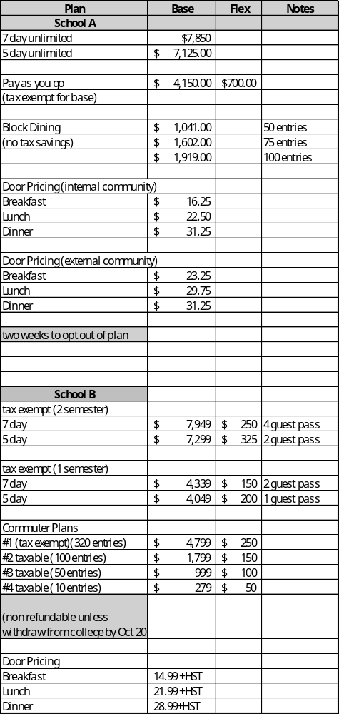

AYCTE Dining Plan Rates

