 The Turtle Mathematics Contest 2021

Contest B



First Name: _______________________________ Grade: ______

Last Name: ________________________________ School: _____________________________

**(Circle the answer. Only one answer is correct.)**

Part A (3 points each)

1. Jamie made equal sized triangles, using the fewest toothpicks possible. Below shows how he made 1 triangle, then 2 triangles, then 3 triangles.

What is the fewest number of toothpicks he needs to make 5 equal sized triangles?

|  |  |  |  |  |  |
| --- | --- | --- | --- | --- | --- |
| 1. 9 | 1. 10 | 1. 11 | 1. 12 | 1. 14 |  |

2.

2 3 4 7 5 3 2 6

6 11 14 10

1 0 6

To complete the pattern, what number goes in ?

|  |  |  |  |  |
| --- | --- | --- | --- | --- |
| 1. 1 | 1. 2 | 1. 3 | 1. 4 | 1. None of these |

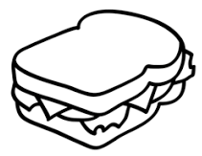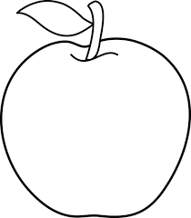

1. Robert bought 2 apples and 1 sandwich for $6.

Samuel bought 3 apples for $3. Kayla buys 1 sandwich.

How much does she pay?

|  |  |  |  |  |  |
| --- | --- | --- | --- | --- | --- |
| (A) $1 | (B) $2 | (C) $3 | (D) $4 | (E) $5 |  |

1. The number in a hexagon is formed by adding the numbers in the two touching hexagons below it. When the missing numbers are filled in, what number goes in ?

7 4

2 5 1 3

|  |  |  |  |  |
| --- | --- | --- | --- | --- |
| 1. 6 | 1. 10 | 1. 13 | 1. 23 | 1. 25 |

1. The rectangles are the same size in each picture. Which picture has the largest white area?

1. (B) (C) (D)

(E) All are the same

1. Audrianna folded a piece of paper and drilled one hole through the folded paper.

After she unfolded it, the paper looked like

How had Audrianna folded the paper?

1. (B) (C) (D) (E)

1. The digits 5, 2, and 8 are written on cards as shown: 5 2 8   
     
   Six different 3-digit numbers can be made using these cards. The number 285 would be the

|  |  |  |  |  |
| --- | --- | --- | --- | --- |
| 1. smallest | 1. 2nd | 1. 3rd | 1. 4th | 1. 5th |

smallest smallest smallest smallest

Part B (4 points each)

8.

Combining with gives

1. (B) (C)

(D) (E)

9. Alex has a secret code that assigns a different number to each letter of the alphabet. If he has encoded the name of an animal with the numbers:

3 11 13 9 21 5,

what animal could it be?

|  |  |  |  |  |
| --- | --- | --- | --- | --- |
| 1. turtle | 1. beetle | 1. kitten | 1. piglet | 1. baboon |

1. Alysia is rotating a shape 4 times. The first 3 rotations are shown.

If she keeps rotating the same way, what does the next rotation look like?

|  |  |  |  |  |
| --- | --- | --- | --- | --- |
|  |  |  |  |  |

1. Fiona has 4 pieces of this shape: . If she can use some or all of them, which shape can she ***not*** make if pieces can’t overlap?
2. (B) (C)

(D) (E)

1. 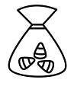Four bags contain either 1 or 2 or 3 or 4 candies, with no repetitions. Connor, Daniel and Evan divide up the bags so that Connor gets 4 candies and Daniel gets 5. How many candies remain for Evan?

|  |  |  |  |  |  |  |
| --- | --- | --- | --- | --- | --- | --- |
| 1. None | 1. 1 | 1. 2 | 1. 3 | 1. 4 |  |  |

13. If the pattern continues, what number goes in **X**?

17 16 15 14 13

18 5 4 3 12

19 6 1 2 11

20 7 8 9 10

etc. **X**

|  |  |  |  |  |
| --- | --- | --- | --- | --- |
| 1. 18 | 1. 23 | 1. 33 | 1. 37 | 1. 45 |

1. 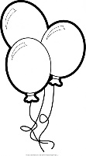If 2 students can blow up 4 balloons in 2 minutes, how many balloons can 1 student blow up in 2 minutes?

|  |  |  |  |  |
| --- | --- | --- | --- | --- |
| 1. 1 | 1. 2 | 1. 3 | 1. 4 | 1. 5 |

Part C (5 points each)

1. At a school banquet hall, the guest tables seat 8 people each. At each of the tables there are 2 parents. The rest of all the seats are occupied by students. If there are 14 parents at the event, how many students are there?

|  |  |  |  |  |
| --- | --- | --- | --- | --- |
| 1. 6 | 1. 22 | 1. 28 | 1. 42 | 1. 56 |

16.

A

B

D

C

When Train 1 travels from A to B and then to C, it travels 15 km.

When Train 2 travels from C to B and then to D, it travels 21 km.

When Train 3 travels from D to B and then to A, it travels 12 km.

If Train 1 goes from B to A, Train 2 goes from B to C and Train 3 goes from B to D, how many km do the 3 trains travel in total?

|  |  |  |  |  |
| --- | --- | --- | --- | --- |
| 1. 48 | 1. 21 | 1. 24 | 1. 15 | 1. 12 |

1. Grannie's watch is consistently faster than normal, and Grandpa's watch is consistently slower than normal. When one hour has passed, 65 minutes have passed according to Grannie's watch and 55 minutes have passed according to Grandpa's watch.

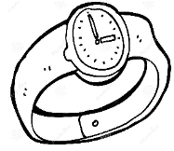At 12:00 noon, they both set their watches to the correct time. Later that

afternoon when Grandpa’s watch says 4:35, what time will Grannie’s

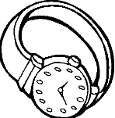watch say?

|  |  |  |  |  |
| --- | --- | --- | --- | --- |
| 1. 4:25 | 1. 4:35 | 1. 5:00 | 1. 5:25 | 1. 5:35 |

1. 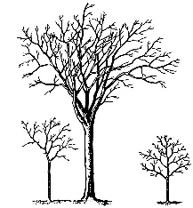Mr. Green has 2 sons, Marcus who was born in June and Anthony who was born in August in a different year. Every year, Mr. Green plants trees on his sons' birthdays. The number of trees he plants on each birthday is twice the number of the son's age. If Marcus turned 3 years old in June of 2020 and by the end of 2020, the total number of trees Mr. Green has planted from that year plus all previous years is 32, how old was Anthony on his birthday in 2020?
2. 4 (B) 5 (C) 6 (D) 7 (E) 8
3. The streets in Jason’s town form blocks that are perfectly square. He lives at the corner of two streets. He starts walking for 3 blocks. He stops and turns to his right and walks 1 block. He stops and turns to his left and walks 2 blocks. Then he stops again and turns to his left and walks 3 blocks, then turns left again and walks for 1 block. Which one of the following ways is the fastest back to his home?

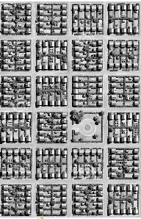

1. Left for 1 block and then Right for 3 blocks
2. Left for 3 blocks and then Right of 4 blocks
3. Left of 1 block and then Left for 2 blocks
4. Left for 2 blocks and then Right for 4 blocks
5. Right for 1 block and then Left for 2 blocks
6. You have a chocolate bar that is divided into squares as shown.

What is the fewest number of steps required to break it into 1 × 1 pieces? You can break the entire section of an existing piece of chocolate horizontally or vertically. You cannot break two or more pieces at once (so no cutting through stacks).

|  |  |  |  |  |
| --- | --- | --- | --- | --- |
| 1. 12 | 1. 14 | 1. 16 | 1. 18 | 1. 20 |

1. The octagon below has equal sides and angles. It is folded so that point A coincides with point C and point B coincides with point D.

A B

C D

The resulting shape will be a

|  |  |  |  |  |
| --- | --- | --- | --- | --- |
| 1. rectangle | 1. triangle | 1. hexagon | 1. trapezoid | 1. parallelogram |

**The Turtle Math Contest**



**Response Form**

**Contest B**

**Student’s Name: _____________________________________________________________________**

**First Name Last Name**

**School: _____________________________________________ Grade: _______________**

**Circle the correct answer. Only one answer is correct.**

|  |  |  |  |  |  |
| --- | --- | --- | --- | --- | --- |
| **1** | A B C D E | **8** | A B C D E | **15** | A B C D E |
| **2** | A B C D E | **9** | A B C D E | **16** | A B C D E |
| **3** | A B C D E | **10** | A B C D E | **17** | A B C D E |
| **4** | A B C D E | **11** | A B C D E | **18** | A B C D E |
| **5** | A B C D E | **12** | A B C D E | **19** | A B C D E |
| **6** | A B C D E | **13** | A B C D E | **20** | A B C D E |
| **7** | A B C D E | **14** | A B C D E | **21** | A B C D E |

For Marker’s Use:

|  |  |  |  |
| --- | --- | --- | --- |
|  | Part A (3 points) | Part B (4 points) | Part C (5 points) |
| Number Correct |  |  |  |
| Points |  |  |  |