 The Turtle Mathematics Contest 2021

Contest A



First Name: _______________________________ Grade: ______

Last Name: ________________________________ School: _____________________________

**(Circle the answer. Only one answer is correct.)**

Part A (3 points each)

1. How many *right* feet do you see?

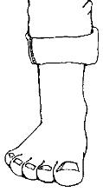 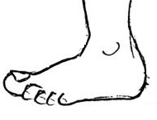 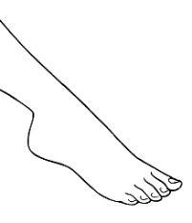 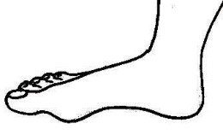 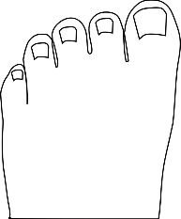

|  |  |  |  |  |
| --- | --- | --- | --- | --- |
| 1. 1 | 1. 2 | 1. 3 | 1. 4 | 1. 5 |

1. How many triangles are there in this picture?

|  |  |  |  |  |
| --- | --- | --- | --- | --- |
| 1. 6 | 1. 9 | 1. 10 | 1. 11 | 1. 12 |

1. This puzzle is made of many different shapes:

.

Which shape is *not* used in the puzzle?

1. (B) (C)

(D) (E)



If the pattern continues, which of these could come next?

|  |  |  |  |  |
| --- | --- | --- | --- | --- |
|  |  |  |  |  |

1. If the pattern continues, what is the next shape?

|  |  |  |  |  |
| --- | --- | --- | --- | --- |
|  |  |  |  | 1. 14 |

1. Audrianna folded a piece of paper and drilled one hole through the folded paper. After she unfolded it, the paper looked like this:

How had Audrianna folded the paper?

1. (B) (C) (D) (E)

Part B (4 points each)

1. The digits 5, 2, and 8 are written on cards as shown: 5 2 8   
     
   Six different 3-digit numbers can be made using these cards. The number 285 would be the

|  |  |  |  |  |
| --- | --- | --- | --- | --- |
| 1. smallest | 1. 2nd | 1. 3rd | 1. 4th | 1. 5th |

smallest smallest smallest smallest

8.

2 3 4 7 5 3 2 6

6 11 14 10

1 0 6

To complete the pattern, what number goes in ?

|  |  |  |  |  |
| --- | --- | --- | --- | --- |
| 1. 1 | 1. 2 | 1. 3 | 1. 4 | 1. None of these |

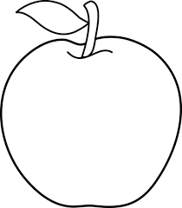

1. Robert bought 2 apples and 1 sandwich for $6.

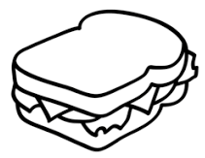Samuel bought 3 apples for $3. Kayla buys 1 sandwich.

How much does she pay?

|  |  |  |  |  |
| --- | --- | --- | --- | --- |
| 1. $1 | 1. $2 | 1. $3 | 1. $4 | 1. $5 |

1. The number in a hexagon is formed by adding the numbers in the two touching hexagons below it. When the missing numbers are filled in, what number goes in ?

7 4

2 5 1 3

|  |  |  |  |  |
| --- | --- | --- | --- | --- |
| 1. 6 | 1. 10 | 1. 13 | 1. 23 | 1. 25 |

1. 1, 1, 2, 3, 5, 8, 13, … what is the next number?

|  |  |  |  |  |
| --- | --- | --- | --- | --- |
| 1. 19 | 1. 21 | 1. 23 | 1. 25 | 1. 27 |

1. James made equal sized triangles using toothpicks. See how he made 1 triangle with 3 toothpicks, then how he made 2 triangles with only 5 toothpicks, and how he made 3 triangles with only 7 toothpicks.

What is the smallest number of toothpicks he needs to make 4 equal sized triangles?

|  |  |  |  |  |
| --- | --- | --- | --- | --- |
| 1. 12 | 1. 11 | 1. 10 | 1. 9 | 1. 8 |

Part C (5 points each)

13.

Combining with gives

1. (B) (C)

(D) (E)

14. Alex has a secret code that gives a different number to each letter of the

alphabet. If he has encoded the name of an animal with the numbers:

3 11 13 9 21 5, what animal could it be?

|  |  |  |  |  |
| --- | --- | --- | --- | --- |
| 1. turtle | 1. beetle | 1. kitten | 1. piglet | 1. baboon |

1. Alysia is rotating a shape 4 times. The first 3 rotations are shown.

If she keeps rotating the same way, what does the next rotation look like?

|  |  |  |  |  |
| --- | --- | --- | --- | --- |
|  |  |  |  |  |

1. Four bags contain either 1 or 2 or 3 or 4 candies, all bags being different. Connor, Danielle and Evan divide up the bags so that Connor gets 4 candies and Danielle gets 5. How many candies remain for Evan?

|  |  |  |  |  |  |
| --- | --- | --- | --- | --- | --- |
| 1. None | 1. 1 | 1. 2 | 1. 3 | 1. 4 |  |

17. If the pattern continues, what number goes in **X**?

17 16 15 14 13

18 5 4 3 12

19 6 1 2 11

20 7 8 9 10

etc. **X**

|  |  |  |  |  |
| --- | --- | --- | --- | --- |
| 1. 18 | 1. 23 | 1. 33 | 1. 37 | 1. 45 |

1. Fiona has 4 pieces of this shape: If she can use all of them or just some of them, which shape can she ***not*** make if pieces can’t overlap?
2. (B) (C)

(D) (E)

**The Turtle Math Contest**



**Response Form**

**Contest A**

**Student’s Name: _____________________________________________________________________**

**First Name Last Name**

**School: ___________________________________________ Grade: ____________**

**Circle the correct answer. Only one answer is correct.**

|  |  |  |  |  |  |
| --- | --- | --- | --- | --- | --- |
| **1** | A B C D E | **7** | A B C D E | **13** | A B C D E |
| **2** | A B C D E | **8** | A B C D E | **14** | A B C D E |
| **3** | A B C D E | **9** | A B C D E | **15** | A B C D E |
| **4** | A B C D E | **10** | A B C D E | **16** | A B C D E |
| **5** | A B C D E | **11** | A B C D E | **17** | A B C D E |
| **6** | A B C D E | **12** | A B C D E | **18** | A B C D E |

For Marker’s Use:

|  |  |  |  |
| --- | --- | --- | --- |
|  | Part A (3 points) | Part B (4 points) | Part C (5 points) |
| Number Correct |  |  |  |
| Points |  |  |  |