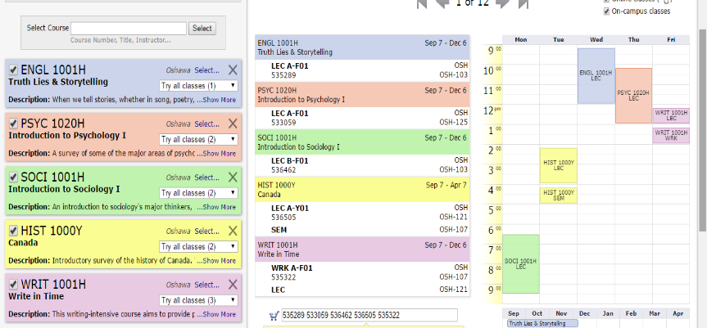

After building your schedule using Trent’s Visual Schedule Builder, locate the 6-digit codes corresponding to each of your chosen courses. These can be found inside the red circles above. For example, the code for ENGL 1001H is 535289. Document these codes.



Once you are prepared to officially register in those courses, begin on your myTrent homepage. Then, click on the “academics” tab in the upper right-hand corner.

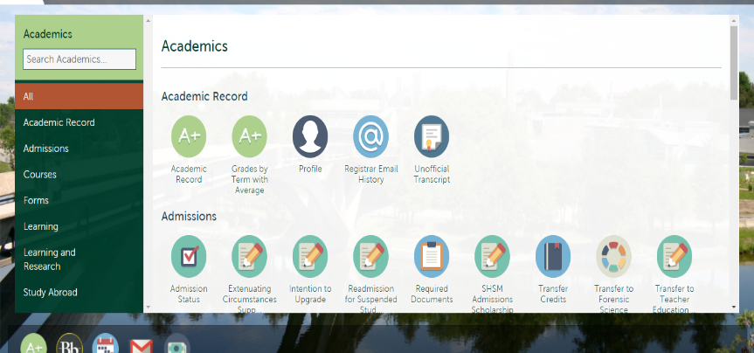

You will then be taken to this screen.

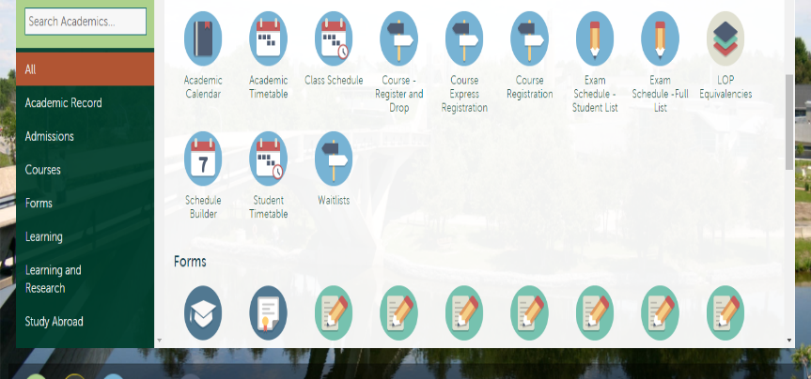

Once you are within the “academics” tab, scroll down until you find the “course express registration” icon and click on it.

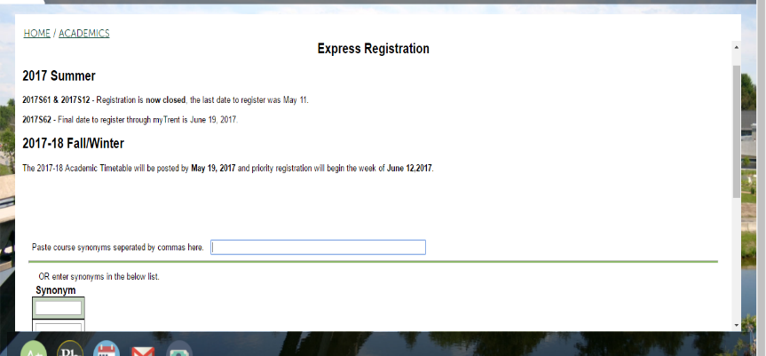

You will then be taken to this screen.

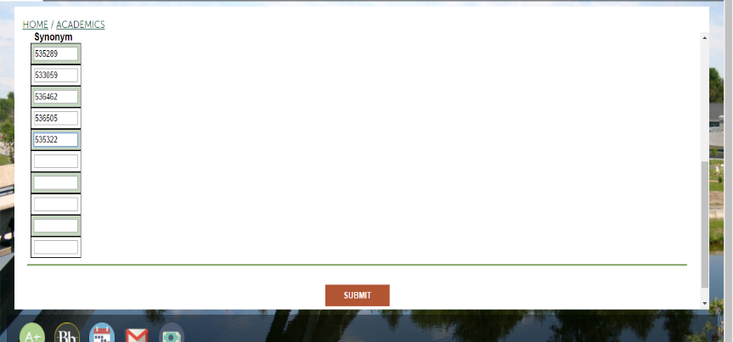

Scroll down and input each of the codes that you documented from the visual schedule builder into the synonym boxes. One code should be input into each box, as shown above. Once you have done this, click submit.

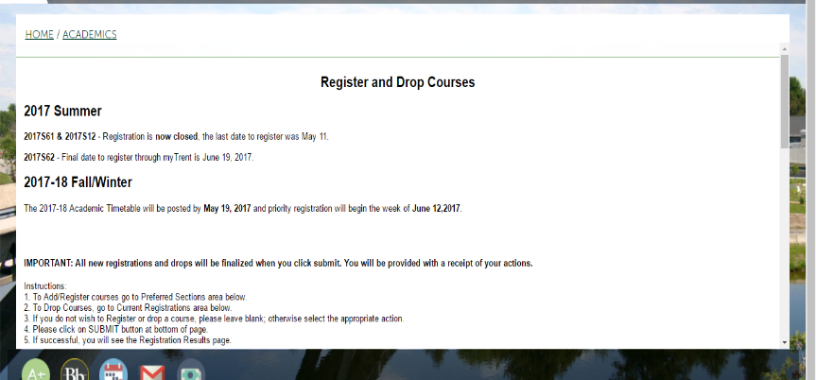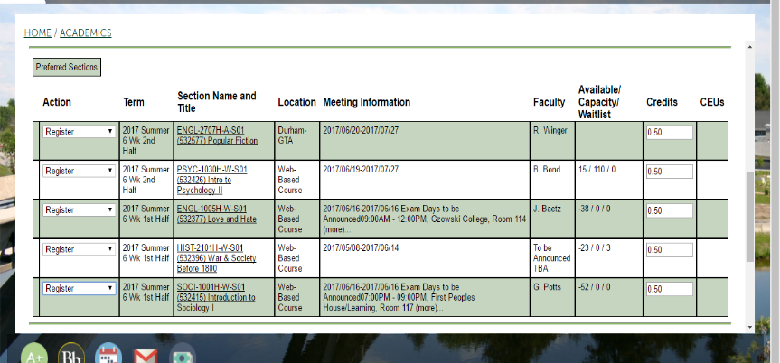

You will then be taken to this screen. If you are not taken to this screen, it means that there was an error with one or more of the courses you have chosen. Read the error messages to determine which courses received an error and what that error was (ex. you do not have the prerequisite), so that you can adjust accordingly.

Scroll down and ensure that the courses shown correspond to those that you selected earlier using the visual schedule builder. Once you have done this select the drop down menu to the left of each of the courses and click register. You must do this for each course individually.

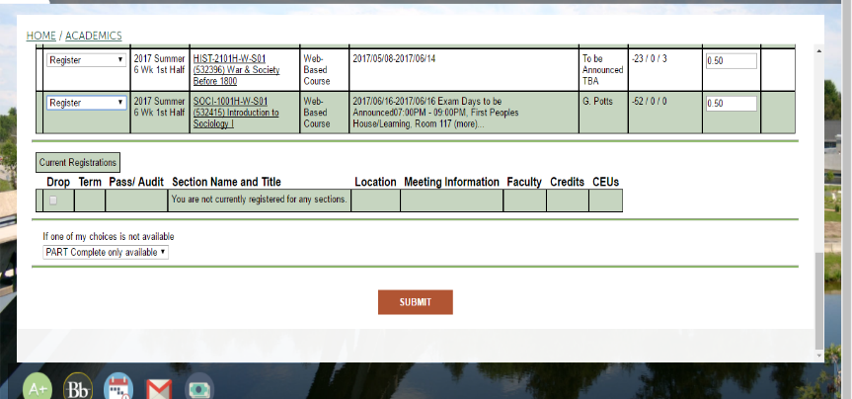

Once you have done this, scroll down to the bottom of this screen and click submit. Clicking submit will officially register you in those courses. You will receive a confirmation email with this information to your Trent email. Be sure to check this email and read its contents to double check that the details are correct.

Congratulations – you have officially registered for courses!