Community-Based Research Project Proposal Form
Visit our website for frequently asked questions and other helpful tips. You can also talk with one of our projects coordinators if you would like assistance developing your proposal. If there are sections you’re not sure of, our staff can help.

Lead organization/group/employer:
Organization/group/employer name:
Contact person:
Mailing address:
Phone:
Email:
Website:
Can we post your logo on our website? Yes No

Please answer the following questions:
- Briefly state your organization/group’s purpose and the products or services offered.
- Year your organization/group was established:
- How many staff members (including contract workers) work for your organization/group?
- Has your immediate supervisor or board approved this application? If necessary, please provide a name and contact information.

Indicate the Sustainable Development Goals(s) for your project (indicate #’s that apply) ex. 9, 16, 17:
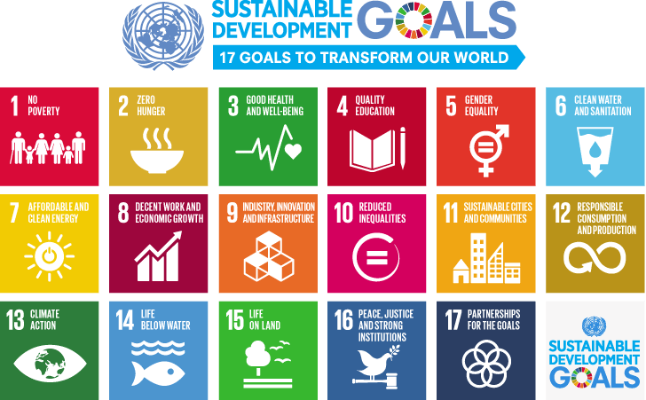

Tell us about the potential scale of your project
We understand that it can be difficult to determine the scale of your research project, however it helps us if you can provide some details about project scope, including how many students might be involved and the potential time frame. Use the check boxes below to guide your thinking – check all that apply.
It’s a single/discreet project
It contains multiple community-based research projects
It’s a single year project
It’s a multi-year project
This project is a great opportunity for undergraduate students
This project is a great opportunity for graduate students
There may be external funding opportunities and a role for Trent Centre staff beyond student project coordination (e.g. overall project management, mentoring, research design and facilitation, etc.)
Other (please state):

Tentative project title:

Tell us your project idea
- What is the purpose of the project and how it will benefit your clients and the social, cultural, environmental and/or economic health of the community?
- Will there be more than one research project for this initiative? If so, please list and describe each sub-project briefly:
- What are the proposed research questions to be answered?
- Can you describe what methods might be used to answer the above question(s)?
- Briefly describe what the student(s) would do (e.g. creating a manual, evaluating a program, conducting a survey, etc.):

Please outline the major tasks involved in completing the project.
For example: Important information to be gathered, key stakeholders who should be involved, relevant dates for your organization, and critical meetings for the student to attend.
Note: Please fill out only the number of tasks which applies for your project – 5 spaces have been provided.
Task 1:
Objective 1:
Task 2:
Objective 2:
Task 3:
Objective 3:
Task 4:
Objective 4:
Task 5:
Objective 5:

Please explain any important start and end dates for the project

Please explain how you would like project results to be disseminated and made useful to the broader community. (check all that apply)
Conference/forum paper or presentation
Manual
Report
Workshop
Presentation
Academic article
Other:
NOTE: Please note the researcher(s) will own the copyright for all work completed as part of his/her involvement, but the lead organization/group/employer may use all project outputs in whole or in part, as it sees fit as long as the researcher(s) is duly credited as the author. If work is completed collaboratively, copyright will be decided by all project participants.

Research ethics

Does the research involve human subjects? (e.g. surveys, interviews)
Yes No
NOTE: If yes, the project may be required to submit an application for ethical review of the research. This process may take up to 4-6 weeks and will need to be taken into consideration when creating project timelines.

If your project involves collecting human subject data (e.g. interview transcripts), would you like access to that “raw” data at the end of the project?
Yes No
If yes, please specify:

Does the lead organization/group/employer have policies about research ethics approval?
Yes No
If yes, please explain:

Screening and/or training
- Do the students require any specific screening or training? (e.g. police checks, confidentiality agreements, CPR, WHMIS):
- Will the student(s) be conducting research on site, or working with valuable equipment?
Yes No
If yes, please attach proof of insurance.

Adequate resourcing
- What resources are needed and in place to support the research – financial or otherwise?
- Do you anticipate needing funding or other types of resources? If so, please explain (including any ideas on where resourcing may be obtained):
NOTE: All known and needed resources should be listed here (e.g. for project coordination, data collection and analysis, software, hardware, photocopying, office supplies, workspace, computer, phone, travel expenses, food and refreshments, training, etc.).

Please explain when project results will be disseminated and made useful to the broader community. If there are special circumstances where results might not be made public, please explain:

Please attach a photo to help promote your project

What Happens Next?
- Review and preliminary matching: Email your proposal to rsisson@trentu.ca Proposals are reviewed according to the community-based research expected outcomes criteria*(please see below). We will strive to explore any preliminary matches with academic courses, faculty research and students across the university.
- Student application review and first meeting (if applicable): If a student expresses interest in your project, or a faculty is interested in connecting your project to a course, TCRC staff will contact you to discuss the best way to initiate the project and set up a first meeting.
NOTE: Your organization has the option to accept or decline students who express interest in your project if you do not feel they have the necessary background or skills.
- Doing the research: Once everyone is on board, all parties will work together to complete a project agreement, insurance forms, budget, etc. so the research can begin!
Community-based research expected outcomes criteria:
- Thorough research is conducted.
- Positive benefits to the social, cultural, environmental and/or economic health of the community are demonstrated.
- Local partnerships are strengthened.
- Students experience is transformative learning that is purposeful.
We Appreciate Your Support!
To raise awareness of the work we do, we ask project partners to publicly acknowledge
our support in print or in-person wherever possible.

