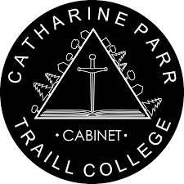
Traill College Cabinet
Clubs and Groups Funding Request Form
(Winter 2023)
Application Period: Opens- January 9th, 2023
Closes- January 30th 2023 at 12pm (noon)
Please submit this form completed, along with the required documentation as listed below. The form and documents can be submitted to the Traill College Cabinet email traillcabinet@gmail.com. Please only submit completed applications.
Please note: Late applications will NOT be accepted. Incomplete applications will NOT be approved for funding. If your group is newly established this year and a recent bank statement and previous budget are not available, then a projected budget, short letter, and proof of an established bank account are all that is required for the documentation.
Please direct any questions or concerns to our President, Krista Kartick, via email at traillcabinet@gmail.com or kristakartick@trentu.ca.
Required Information Checklist (Please fill out):
Club/Group Name
Club/Group Email
Contact Person Name
Contact Person Position
Contact Person Email
Funding Amount Requested
# of Student in Club/Group
# of Traill College Affiliated Students in Club/Group
Please Circle:
Does the Club/Group receive a levy from the University? | Yes | No
Has the Club/Group sought out alternative funding sources? | Yes | No
If the answer is yes to the final question, please indicate the funding source(s) in your letter.
Require Documentation Checklist (Please Attach in Email)
___Final Budget for the previous Academic Year (2021-2022)
___Projected Budget (up-to-date) for the current academic year (2022-2023)
___The most recent bank statement for the Club/Group
___A short letter indicating how the requested funding will be used

