On-Campus Job Search

On-Campus jobs are part-time or summer opportunities designed for students which take place both on the Peterborough and Durham campuses as well as a few locations off-campus. These jobs usually receive funding from student work study programs. However, some departments at Trent may fund their own student staff positions.

Eligibility:
Many jobs on campus have eligibility requirements, but some are open to all students. Many student positions are funded by subsidy programs that require students to meet certain criteria. The two main programs at Trent are the Trent Work Study Program and the Trent International Program. Most jobs that do require eligibility will have TWSP or TI/TIP written in the job title. Some offices like the college offices and housing often don’t require TWSP eligibility. If you are unsure about eligibility, you can go to the job posting and read the opportunity requirements listed at the bottom.

TWSP:
The Trent work study program or TWSP is a program designed to offer employment to students in financial need with the hope of helping offset the costs of education by working 10 hours a week. To be eligible for this program students must a Canadian resident, be enrolled in full-time studies and receive assistance through OSAP, or funding from another province/ territory. All students who are eligible for TWSP positions will receive a confirmation email from office of the register at the start of each fall and winter term.

TI/TIP:
The Trent international job study program or TI/TIP offers job opportunities to international students to work 10 hours a week. To be eligible for these positions, you must be an international student enrolled in full-time studies and have a valid study permit as well as a social insurance number (which is required to work in Canada).
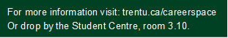

Where to search:
Many on-campus jobs will be found on the job board on the Student Experience Portal which can be found at trentu.ca/sep. Sometimes departments or groups will post on their websites or social media. For example, housing and athletics will often post on their websites. Additionally, some TA, AA and lab demonstrator positions will be posted on Trent’s Human Resources web page.
When to search:
Some departments such as Athletics may hire in June or July. Most TWSP/TI positions will be posted in July, August and September as that is normally when funding gets approved. Some departments such as housing services and orientation programs will start to post jobs in December. The colleges often post jobs as early as February or March. Additionally, most summer jobs will start to appear from January into April. Keep in mind these timelines are subject to change, so it is recommended you check the job board regularly.

Non-Trent Employers:
Some employers on-campus post on-campus positions on their company websites. Examples of these employers include Compass for dining services and Follett for the bookstore. For Compass see compass-canada.com and for Follett see follett.com.
Other experience:
Volunteer or extracurricular positions don't require eligibility and can help you build your skills and your resume which will give you more experience. Some of the opportunities include student government such as the TCSA or the college cabinets as well as clubs and groups like TUEFRT, the Trent Student Emergency First Response Team. These are often posted in August and September.

How to do an Advanced Search on the Job Board

Doing an advanced search on Trent’s job board will allow you to limit your search to on-campus jobs. Start by logging into your student account on the Student Experience Portal at trentu.ca/sep.

Start by clicking the Student and Alumni Job Board and then clicking Advanced Search. This will bring you to a page that will allow you to filter your search. You will see a variety of options to filter your search results, but they are two main ways to effectively find on-campus jobs. You can also search for specific jobs using their job ID in the search posting section.

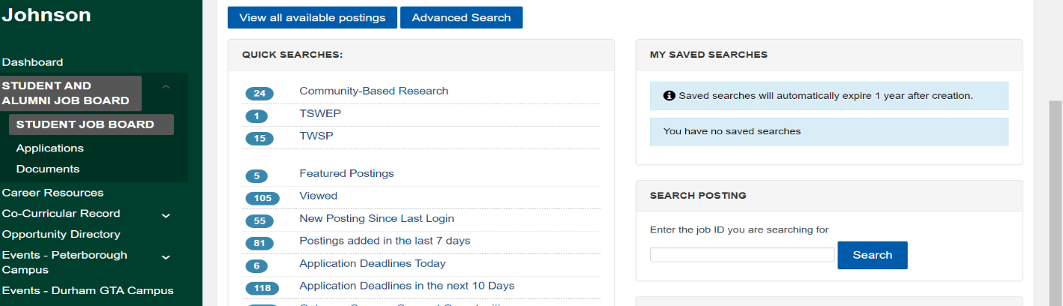

To limit your search to on-campus opportunities, filter the opportunity location to either Trent- Peterborough or Durham campus. Sometimes on-campus jobs may be listed under Peterborough and area which can also be selected in your search.

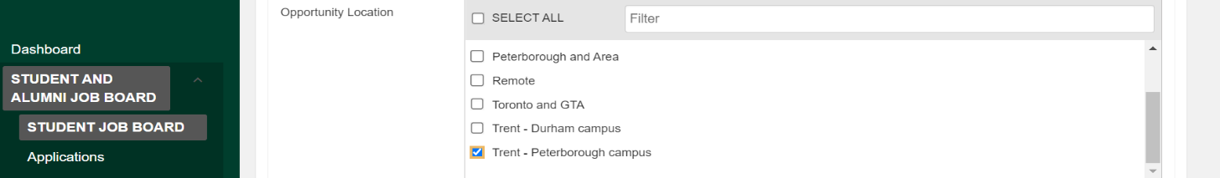

You can also limit your search to opportunity type or student eligibility. Most on-campus jobs will be listed under part time and will fall under TWSP/TIP eligibility.

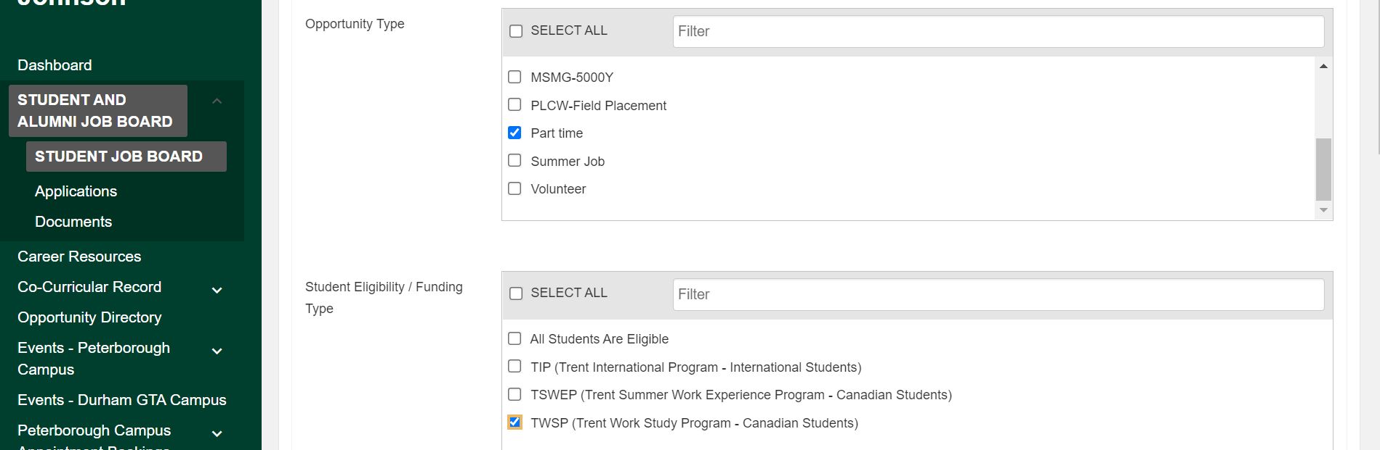

Careerspace Resources
Visit trentu.ca/sep to access the job board and book appointments with Careerspace.
Careerspace Appointments:
- 1:1 review of résumés, CVs, and LinkedIn profiles.
- 1:1 career counselling appointments.

