How OSAP works with Micro-credentials
Thank you for your interest in our micro-credential Program.
OSAP is administered by the government of Ontario, which means the application process is not controlled by our institution. While the process may seem complicated, students have successfully secured OSAP funding for this program.
Click if you would like instructions on how to find out what OSAP will cover before you register (you can find it at the end of the document).
Please make sure that you review the pricing and course description before continuing with your application. Micro-credentials - Careerspace - Trent University
If you are applying as part of the Emotional Health Practitioner Program please follow the detailed OSAP instructions on the website. (At the bottom of the website page)

Instructions on how to complete OSAP application
- Register your account
OSAP: Ontario Student Assistance Program | ontario.ca

- Start an application
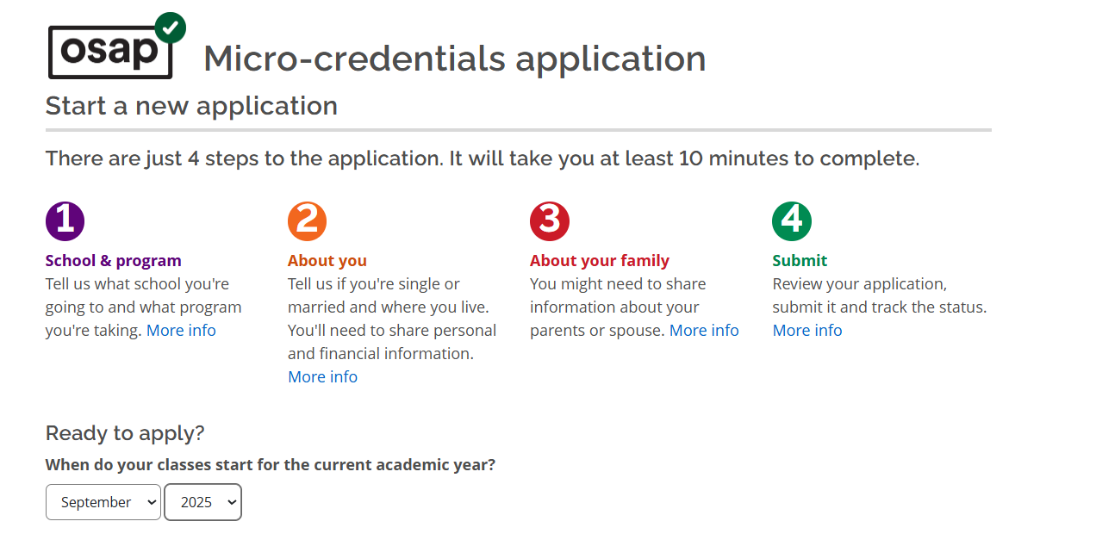

- Select study year that you will be taking the course. Eg. 2025-2026. The year runs from August to July and opens in August each year.

- Select micro-credential program
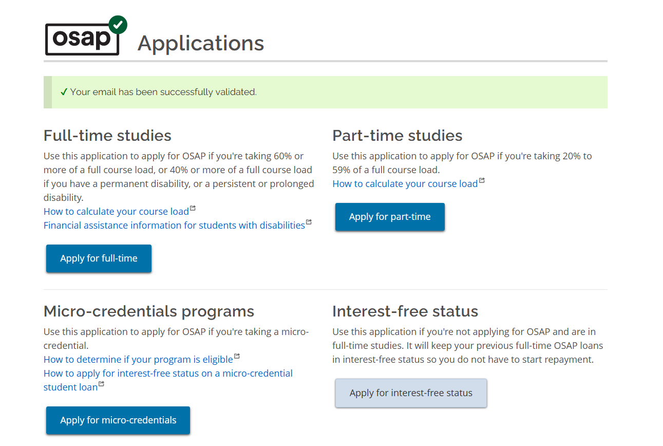
- Click on what programs are eligible and type in the name of the program.
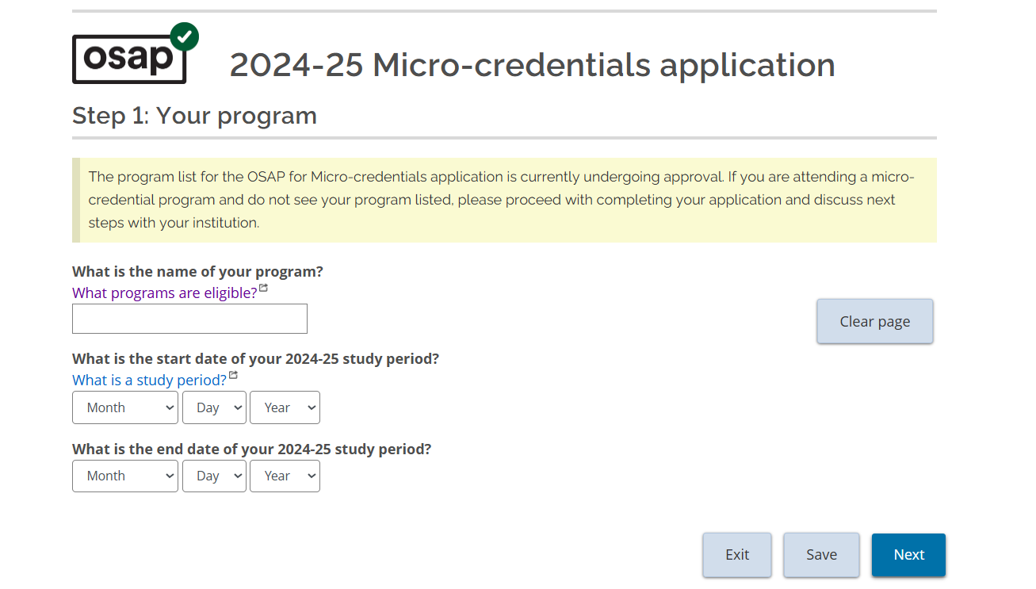
Select your option: This will be the name of your program. Type in a key word such as Nonprofit or neurobiology for our helping professional series.
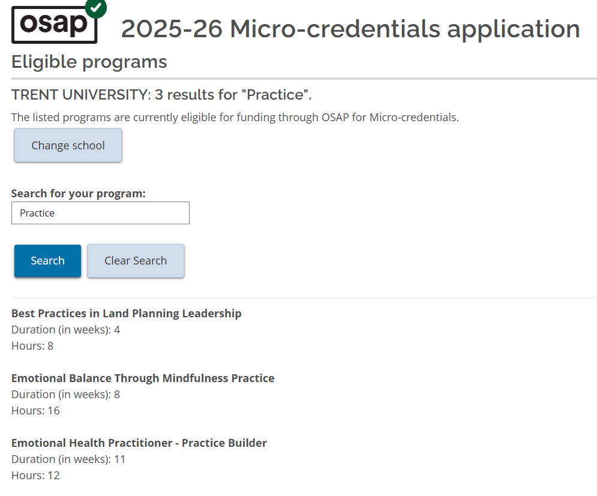
You can then select the appropriate title.
Start Date: You confirmed in your registration
End Date: Add the duration onto your start date.
Example: If you start on 1 June and have a duration of 4 weeks your end date will be 28 June.
If you have any questions you can visit the OSAP webpage
OSAP for Micro-credentials - Tuition, Scholarships and Financial Aid - Trent University
Or email them at financialaid@trentu.ca.

How to confirm what you are eligible for
The way the process works is that to get approved for OSAP you need to have paid and be registered into a program.
However, if you want to find out what you would receive without registering you will need to:
- Apply for OSAP
- Enter the program details (Follow the details to register)
- You will be sent a message to confirm what you are eligible for
- When you register for the program check the status of your application.
    - If it is still in progress, you do not need to do anything.
    - If it has been denied (as you were not registered into a program) you will need to reapply.
Return to top of document

