How OSAP works with the EHP Practice Builder
Micro-credentials
Thank you for your interest in the Emotional Health Practitioner Practice Builder Program.
OSAP is administered by the government of Ontario, which means the application process is not controlled by our institution. While the process may seem complicated, students have successfully secured OSAP funding for this program.

Click if you would like instructions on how to find out what OSAP will cover before you register

Which method of signing up to the Program Builder will you use?
- Sign up for the Asynchronous program and Practice Builder in one go (This is the cheapest option)
- I signed up for the Asynchronous program and included a deposit for the Practice Builder program. I will pay the remaining amount before the course starts.
- I signed up to reserve a spot in the Practice Builder program as a separate order from the Asynchronous course and will pay the remaining amount before the course starts
- Sign up for the Practice Builder program after you have completed the Asychronous program

To review the pricing and course descriptions please visit our website Emotional Health Practitioner - Careerspace - Trent University

Click on the option you would like to take to go to the instructions.

Sign up for the asynchronous program and practice builder in one go.
When you sign up for this program you can claim OSAP for 3 courses:
- EHP Asynchronous course
- EHP Practice Builder – Foundations
- EHP Practice Builder - Client Care
Course | OSAP Details
EHP Asynchronous | OSAP Program: Emotional Health Practitioner Program  Start Date: Same as your application start date  End Date: See table below  Amount to Claim: $1597 minus eligible discounts (Visit website to see if you qualify)  Application Date: Once registered in program  OSAP paid: Typically paid within 3 weeks of course start date

START DATE FROM APPLICATION | END DATE
Jan 6, 2026 | Mar 23, 2026
Feb 1, 2026 | Apr 18, 2026
Mar 1, 2026 | May 16, 2026
Apr 1, 2026 | Jun 16, 2026
May 1, 2026 | Jul 16, 2026
Jun 1, 2026 | Aug 16, 2026
Jul 1, 2026 | Sep 15, 2026
Aug 1, 2026 | Sept 16, 2026 (OSAP applications cannot overlap)
Sep 1, 2026 | Sept 16, 2026 (OSAP applications cannot overlap)
Oct 1, 2026 | Dec 16, 2026
Nov 1, 2026 | Jan 16, 2026
Dec 1, 2026 | Feb 15, 2026

Course | OSAP Details
EHP Practice Builder – Foundations | OSAP Program: EHP Practice Essentials - Foundations  Start Date: 22 Sept 2026  End Date: 6 Dec 2026  Amount to Claim: $2000  Application Date: When applications for year open in August 2026  OSAP paid: Typically paid within 3 weeks of course start date
EHP Practice Builder - Client Care | OSAP Program: EHP Practice Essentials - Client Care  Start Date: 4 Jan 2027  End Date: 26 Mar 2027  Amount to Claim: $400  Application Date: After the applications for the year open in August 2026  OSAP paid: Typically paid within 3 weeks of course start date

Click for instructions on how to enter details into the OSAP system.

Pay for practice builder program after claiming the deposit as part of the EHP asynchronous course
You can claim OSAP for 2 courses:
- EHP Practice Builder – Foundations
- EHP Practice Builder - Client Care
The total you can claim is the price you paid for the Practice Builder program.
(You will already have claimed the deposit as part of your claim for the Asynchronous program).
Course | OSAP Details
EHP Practice Builder – Foundations | OSAP Program: EHP Practice Essentials - Foundations  Start Date: 22 Sept 2026  End Date: 6 Dec 2026  Amount to Claim: $1500  Application Date: When applications for year open in August 2026  OSAP paid: Typically paid within 3 weeks of course start date
EHP Practice Builder - Client Care | OSAP Program: EHP Practice Essentials - Client Care  Start Date: 4 Jan 2027  End Date: 26 Mar 2027  Amount to Claim: Total price paid - $1500  (Normally $497)  Application Date: After the applications for the year open in August 2026  OSAP paid: Typically paid within 3 weeks of course start date

Click for instructions on how to enter details into the OSAP system
Return to top of document

Pay for practice builder program separately from the EHP asynchronous course
You can claim OSAP for 2 courses:
- EHP Practice Builder – Foundations
- EHP Practice Builder - Client Care
The total you can claim is the price you paid for the Practice Builder program plus any deposit you have paid.
Course | OSAP Details
EHP Practice Builder – Foundations | OSAP Program: EHP Practice Essentials - Foundations  Start Date: 22 Sept 2026  End Date: 6 Dec 2026  Amount to Claim: $2000  Application Date: When applications for the year open in August 2026  OSAP paid: Typically paid within 3 weeks of course start date
EHP Practice Builder - Client Care | OSAP Program: EHP Practice Essentials - Client Care  Start Date: 4 Jan 2027  End Date: 26 Mar 2027  Amount to Claim: Total price paid - $2000  ( Normally $997)  Application Date: After the applications for the year open in August 2026  OSAP paid: Typically paid within 3 weeks of course start date

Click for instructions on how to enter details into the OSAP system
Return to top of document

Instruction on how to complete OSAP application
- Register your account
OSAP: Ontario Student Assistance Program | ontario.ca

- Start an application
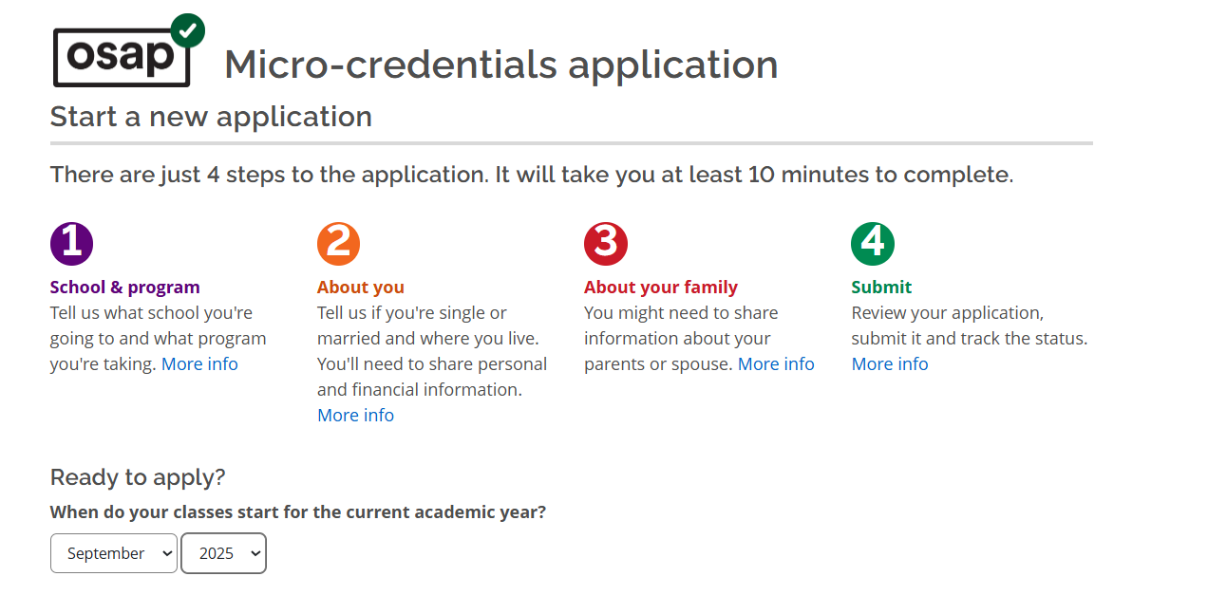

- Select study year that you will be taking the course. Eg. 2026-2026. The year runs from August to July and opens in August each year.

- Select micro-credential program
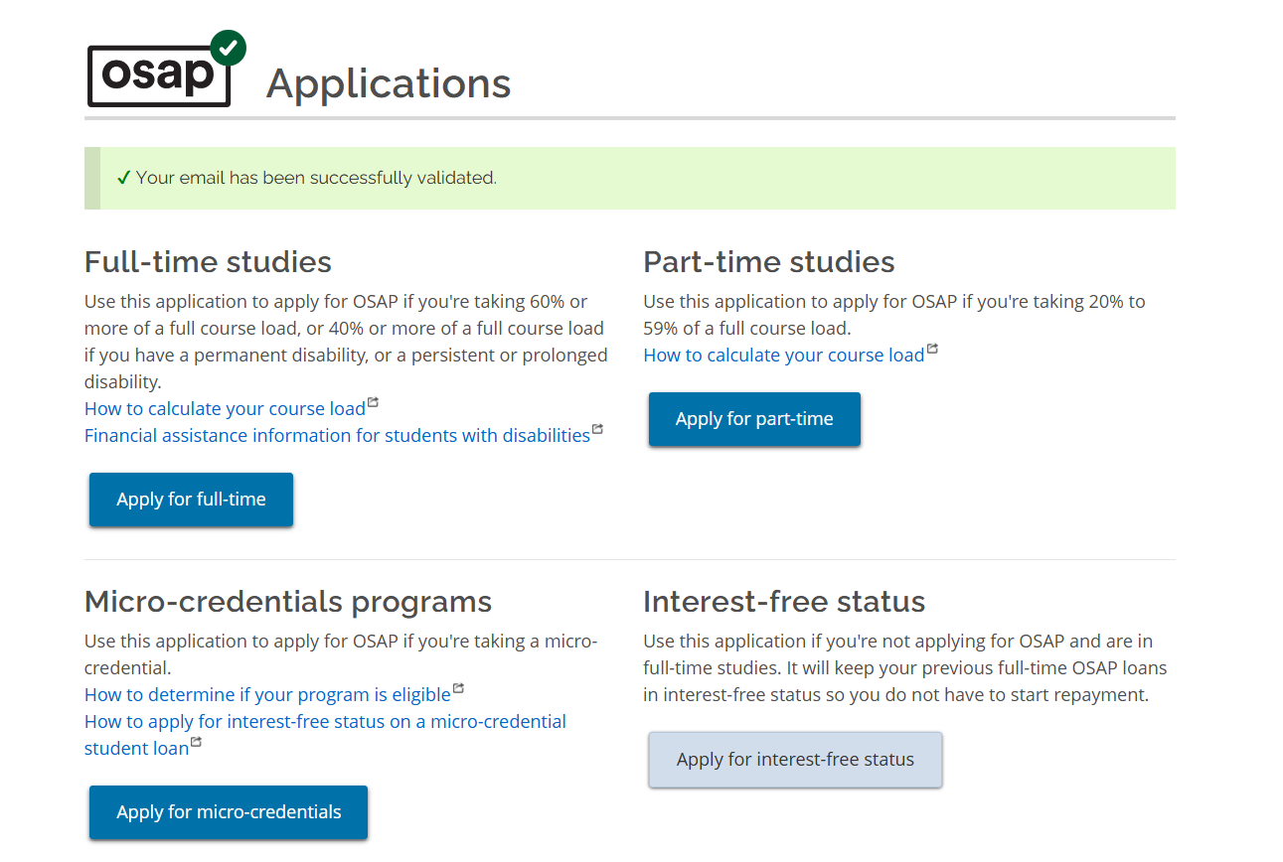
- Click on what programs are eligible and type in the name of the program.
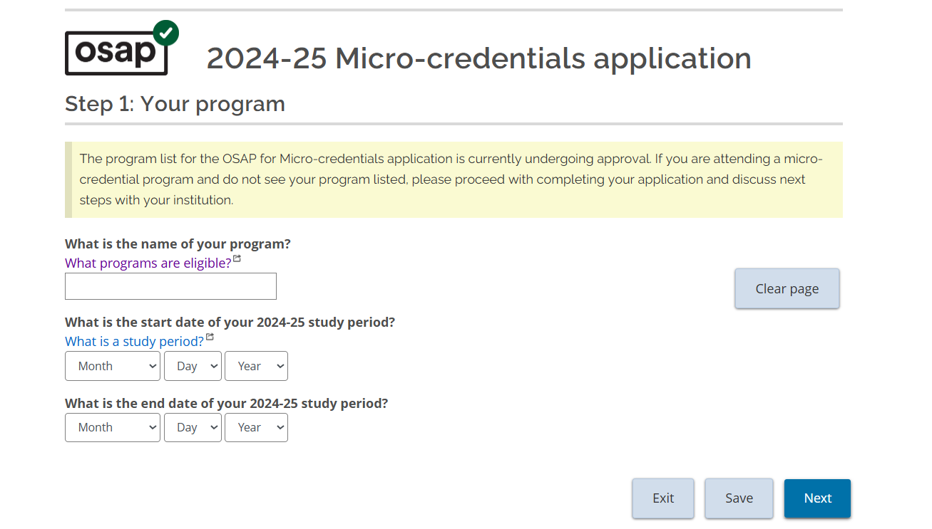
Select your option
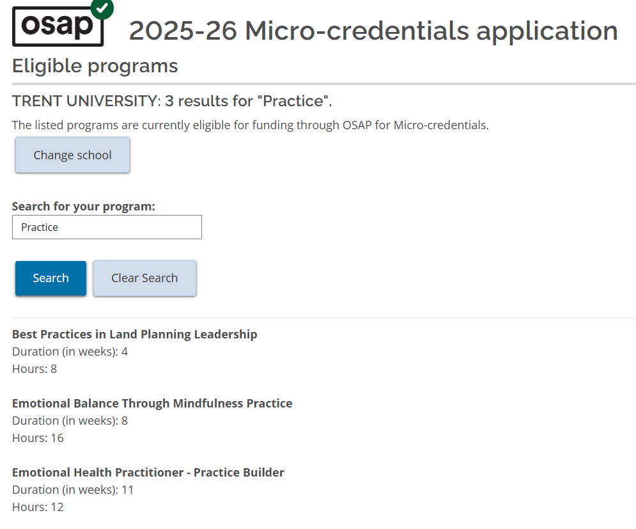
You can then type in the study period. (Start and end dates)
Return to top of document

How to confirm what you are eligible for
The way the process works is that to get approved for OSAP you need to have paid and be registered into a program.
However, if you want to find out what you would receive without registering you will need to:
- Apply for OSAP
- Enter the program details (Follow the details to register)
- You will be sent a message to confirm what you are eligible for
- When you register for the program check the status of your application.
    - If it is still in progress, you do not need to do anything.
    - If it has been denied (as you were not registered into a program) you will need to reapply.
Return to top of document

