How OSAP works with the EHP Asynchronous Program
Micro-credentials
Thank you for your interest in the Emotional Health Practitioner Asynchronous Program.
OSAP is administered by the government of Ontario, which means the application process is not controlled by our institution. While the process may seem complicated, students have successfully secured OSAP funding for this program.
Click if you would like instructions on how to find out what OSAP will cover before you register

Which method of signing up to the EHP asynchronous program will you use?
- I am signing up to the EHP asynchronous program only
- I am signing up to the EHP asynchronous plus program (this includes a deposit for the practice builder program)
- I am signing up for the asynchronous program and practice builder in one go. (This is the cheapest option if you want to take the practice builder)
To review the pricing and course descriptions please visit our website Emotional Health Practitioner - Careerspace - Trent University
Click on the option you would like to take to go to the instructions

I am signing up to the EHP asynchronous program only
You can claim OSAP for EHP ASYNCH Course
Course | OSAP Details
EHP Asynchronous | OSAP Program: Emotional Health Practitioner Program  Start Date: Same as your application start date  End Date: See table below  Amount to Claim: $1597 minus eligible discounts (Visit website to see if you qualify)  Application Date: Once registered in program  OSAP paid: Typically paid within 3 weeks of course start date

START DATE FROM APPLICATION | END DATE
Jan 6, 2026 | Mar 23, 2026
Feb 1, 2026 | Apr 18, 2026
Mar 1, 2026 | May 16, 2026
Apr 1, 2026 | Jun 16, 2026
May 1, 2026 | Jul 16, 2026
Jun 1, 2026 | Aug 16, 2026
Jul 1, 2026 | Sep 15, 2026
Aug 1, 2026 | Oct16, 2026
Sep 1, 2026 | Nov 16, 2026
Oct 1, 2026 | Dec 16, 2026
Nov 1, 2026 | Jan 16, 2026
Dec 1, 2026 | Feb 15, 2026
Click for instructions on how to enter details into the OSAP system
Click if you would like instructions on how to find out what OSAP will cover before you register
Return to top of document

I am signing up to the EHP asynchronous plus program
You can claim OSAP for EHP ASYNCH Course including the deposit you have paid
Course | OSAP Details
EHP Asynchronous | OSAP Program: Emotional Health Practitioner Program  Start Date: Same as your application start date  End Date: See table below  Amount to Claim: $2597 minus eligible discounts (Visit website to see if you qualify)  Application Date: Once registered in program  OSAP paid: Typically paid within 3 weeks of course start date

START DATE FROM APPLICATION | END DATE
Jan 6, 2026 | Mar 23, 2026
Feb 1, 2026 | Apr 18, 2026
Mar 1, 2026 | May 16, 2026
Apr 1, 2026 | Jun 16, 2026
May 1, 2026 | Jul 16, 2026
Jun 1, 2026 | Aug 16, 2026
Jul 1, 2026 | Sep 15, 2026
Aug 1, 2026 | Sept 16, 2026 (OSAP applications cannot overlap)
Sep 1, 2026 | Sept 16, 2026 (OSAP applications cannot overlap)
Oct 1, 2026 | Dec 16, 2026
Nov 1, 2026 | Jan 16, 2026
Dec 1, 2026 | Feb 15, 2026

You will be able to claim OSAP for the practice builder course too. See the practice builder OSAP document for details.
Click for instructions on how to enter details into the OSAP system
Click if you would like instructions on how to find out what OSAP will cover before you register
Return to top of document

Sign up for the asynchronous program and practice builder in one go.
When you sign up for this program you can claim OSAP for 3 courses:
- EHP ASYNCH Course
- EHP Practice Builder – Foundations
- EHP Practice Builder - Client Care
Course | OSAP Details
EHP Asynchronous | OSAP Program: Emotional Health Practitioner Program  Start Date: Same as your application start date  End Date: See table below  Amount to Claim: $1597 minus eligible discounts (Visit website to see if you qualify)  Application Date: Once registered in program  OSAP paid: Typically paid within 3 weeks of course start date

START DATE FROM APPLICATION | END DATE
Jan 6, 2026 | Mar 23, 2026
Feb 1, 2026 | Apr 18, 2026
Mar 1, 2026 | May 16, 2026
Apr 1, 2026 | Jun 16, 2026
May 1, 2026 | Jul 16, 2026
Jun 1, 2026 | Aug 16, 2026
Jul 1, 2026 | Sep 15, 2026
Aug 1, 2026 | Sept 16, 2026 (OSAP applications cannot overlap)
Sep 1, 2026 | Sept 16, 2026 (OSAP applications cannot overlap)
Oct 1, 2026 | Dec 16, 2026
Nov 1, 2026 | Jan 16, 2026
Dec 1, 2026 | Feb 15, 2026

Course | OSAP Details
EHP Practice Builder – Foundations | OSAP Program: EHP Practice Essentials - Foundations  Start Date: 22 Sept 26  End Date: 6 Dec 26  Amount to Claim: $2000  Application Date: When applications for year open in August 2026  OSAP paid: Typically paid within 3 weeks of course start date
EHP Practice Builder - Client Care | OSAP Program: EHP Practice Essentials - Client Care  Start Date: 4 Jan 27  End Date: 26 Mar 27  Amount to Claim: $400  Application Date: After the applications for the year open in August 2026  OSAP paid: Typically paid within 3 weeks of course start date

Click for instructions on how to enter details into the OSAP system
Click if you would like instructions on how to find out what OSAP will cover before you register
Return to top of document

Instruction on how to complete OSAP application
- Register your account
OSAP: Ontario Student Assistance Program | ontario.ca

- Start an application
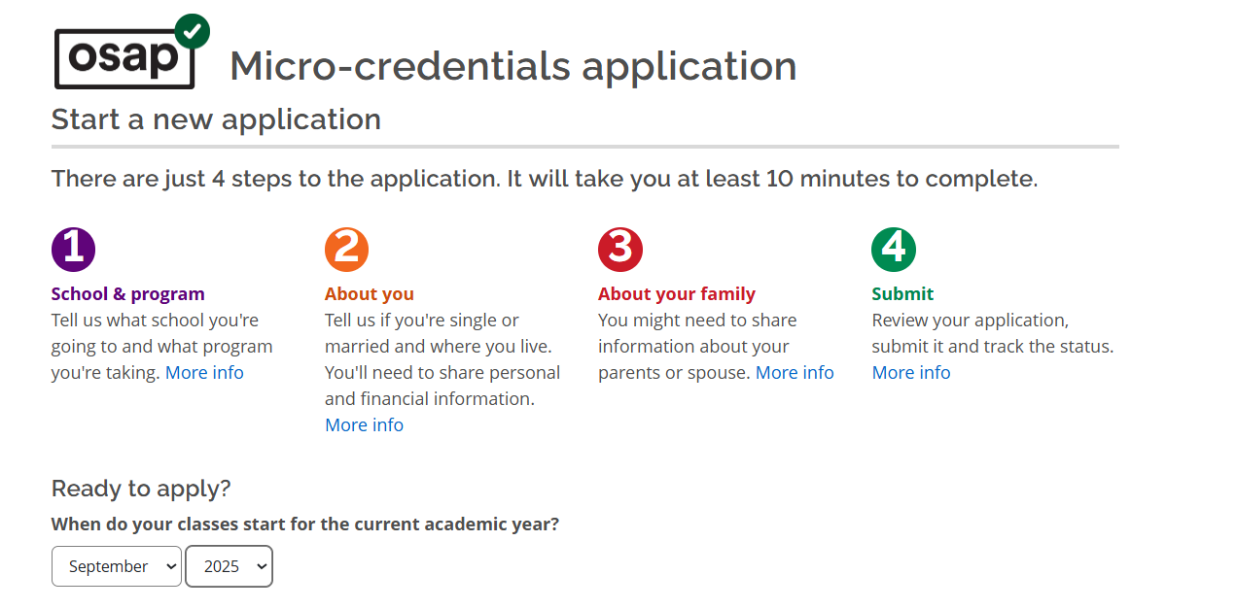

- Select study year that you will be taking the course. Eg. 2026-26
The year runs from August to July and opens in August each year.

- Select micro-credential program
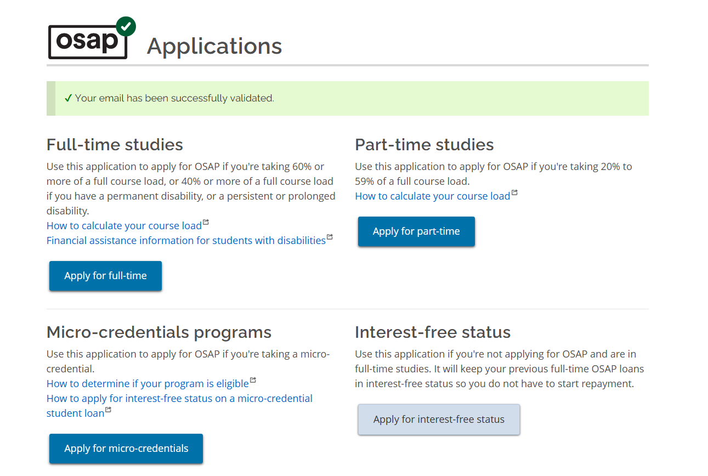
- Click on what programs are eligible and type in the name of the program.
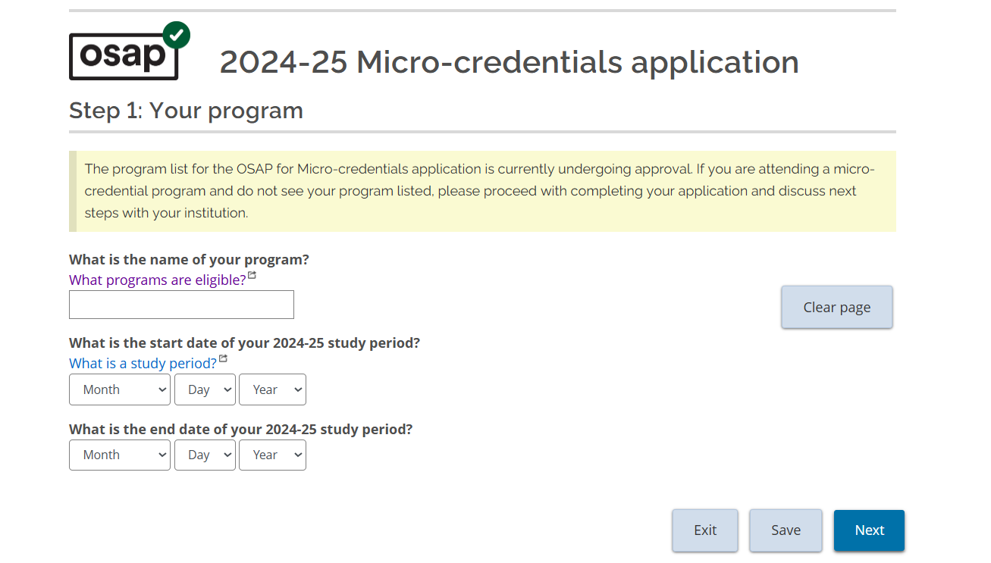
Select your option
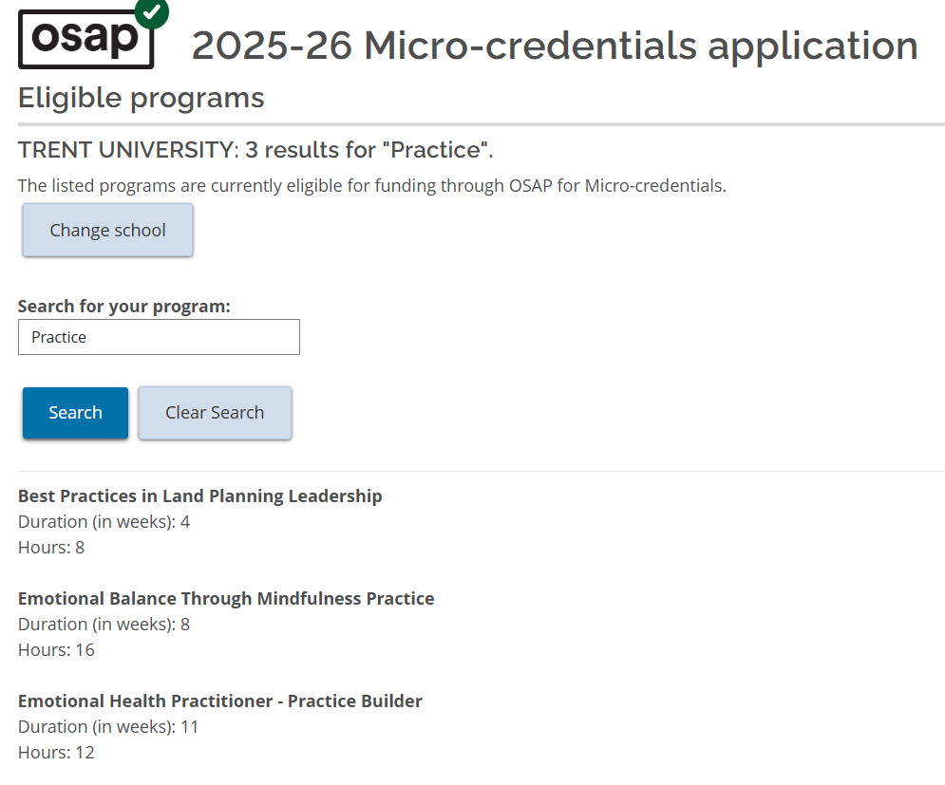
You can then type in the study period. (Start and end dates)
Return to top of document

How to confirm what you are eligible for
The way the process works is that to get approved for OSAP you need to have paid and be registered into a program.
However, if you want to find out what you would receive without registering you will need to:
- Apply for OSAP
- Enter the program details (Follow the details to register)
- You will be sent a message to confirm what you are eligible for
- When you register for the program check the status of your application.
    - If it is still in progress you do not need to do anything.
    - If it has been denied (as you were not registered into a program) you will need to reapply.
- If you do not register into the program your application will be denied. (You will be able to reapply if you change your mind)

Return to top of document

