Before you are able to register in or drop courses, you need to accept the required agreements.
- Log in to self-service. Click on your username at the top of the page.
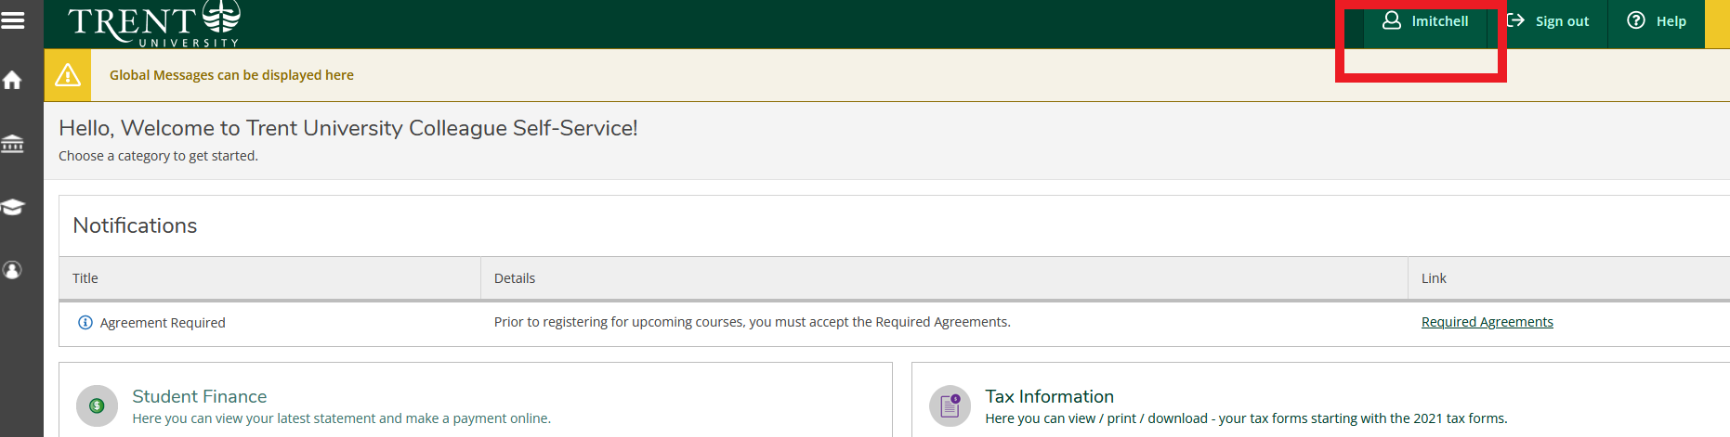
- Click on required agreements from the drop down menu.
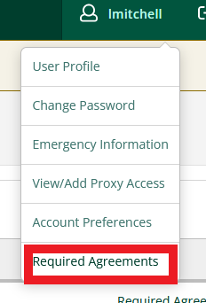
- You need to “view” then “accept” the two required agreements so the status changes to accepted.
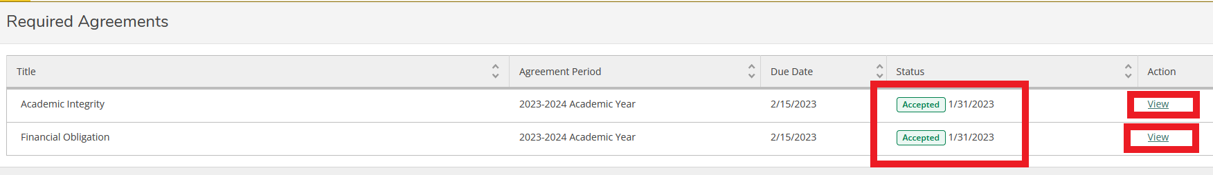
- You can now try to register/drop

