ChemWatch: Trent User instructions
Chemwatch is a user friendly, universal library of Chemical Safety Data Sheets (SDS, formerly known as MSDS) for a large number of laboratory and industrial chemicals and products. Chemwatch is available for all members of the Trent University community and is accessible from any computer on the Trent University Network.
Section A: Accessing Safety Data Sheets
Within ChemWatch there are two types of SDS available. ‘Gold SDS’, which are ChemWatch created SDS’s that combine information from each vendor’s SDS and put it together into one. They are very detailed and contain the “best” information available on a specified chemical or product. The second option is the ‘Vendor SDS’. Under the Hazardous Products Regulations, Vendor’s are required to supply SDS for the material they sell. However, sometimes the SDS from Vendors is very generic and not always as detailed as they could be. All chemicals must have Vendor SDS, but not all chemicals have a “Gold” version of this in Chemwatch.
To Access the SDS in Chemwatch follow the instructions below. If you have any questions please don’t hesitate to contact Science Facilities.
- Log into ChemWatch by copying and pasting the link below into the address bar in your browser or by clicking on the Chemwatch icon on a web page. https://jr.chemwatch.net/chemwatch.web/account/autologinbyip

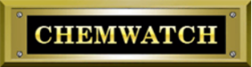

- On the left side of the window there is a menu broken down into three sections:
  - Search
  - SDS and Labels
  - Folder Search
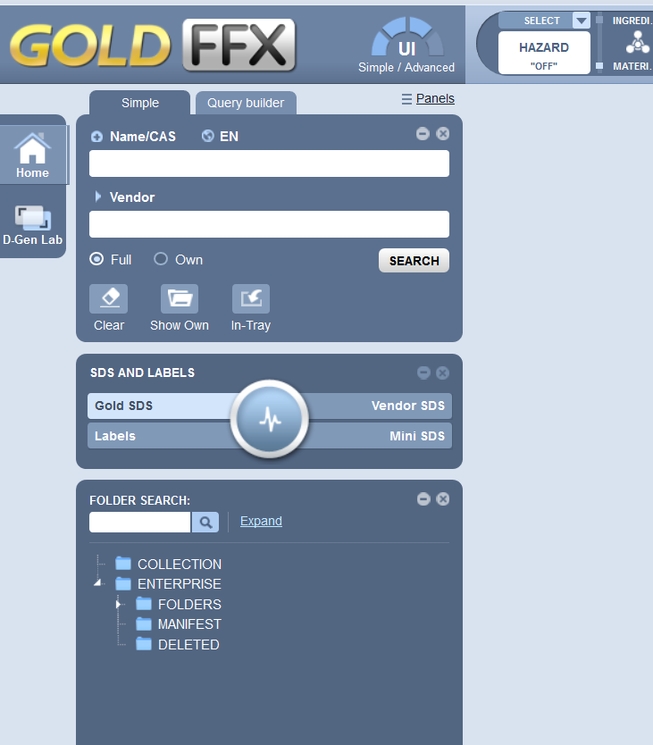

- On the ‘SDS and Labels’ section select the ‘Gold SDS or Vendor’ option.
- In the search section ensure under the ‘Vendor’ field the ‘Full’ option is selected.
- Type the chemical name or CAS number in to the ‘Name/CAS field’.

  - Click on the ‘Search button’ or press ‘enter’ on the keyboard

- On the right side of the screen a list of options will appear, select and double click on the option you believe to be the most accurate for the chemical.
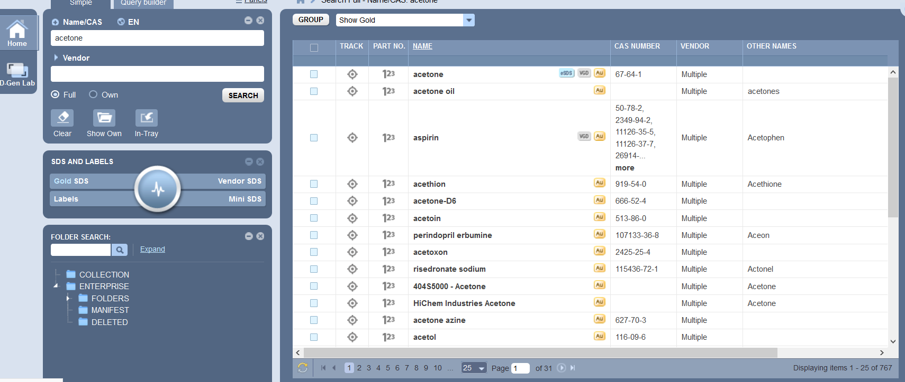

- A Gold SDS will load on the screen. You may print or save as a .pdf .
- Should you wish a vendor SDS select the “Vendor SDS” button in the SDS and Labels menu.
- Type the name of the chemical or CAS # into the Search menu, if you know the vendor you can also type the vendor name into the ‘Vendor’ field or leave it blank. Click on the ‘Search’ button.
  - If you complete the ‘Vendor’ field, a SDS for that chemical from that vendor should appear, if available, in the right side of the screen. If the Vendor has multiple “countries” associated with it then all of the vendor specific addresses will appear in that list. Search the list for the appropriate vendor address and select. The SDS for that chemical and that vendor should appear on the right side of the screen.
  - If you have not entered information into the ‘vendor’ field, a list of all vendors of that chemical should appear in the right side of the screen. You will need to scroll through the list and select the appropriate vendor. You may need to use the filter function for country (Canada) to limit the list as all vendors are listed and the list can be quite long and is not necessarily in alphabetic order.
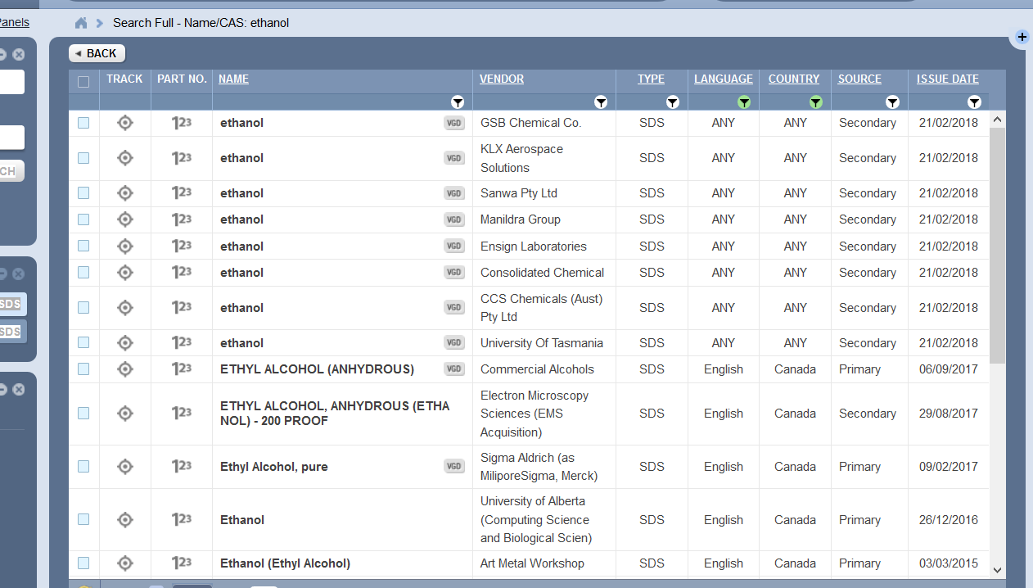

  - To filter out “non-Canadian” vendors if required click on the “down arrow” under the column heading “Country” in the list of Vendors, a pop-up box with countries listed will appear. Ensure the checkbox beside Canada is highlighted and click on “Apply”. The list should then update to reflect only Canadian Vendors.
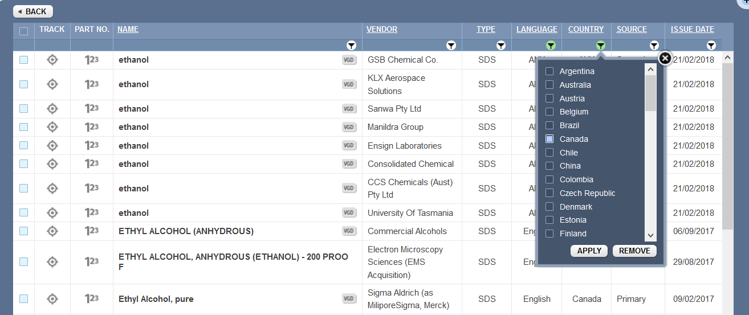
  - The list for all the Vendors of that product in Canada should appear Select the appropriate choice from the list.

  - The SDS should appear for the chemical and selected vendor on the right side of screen.

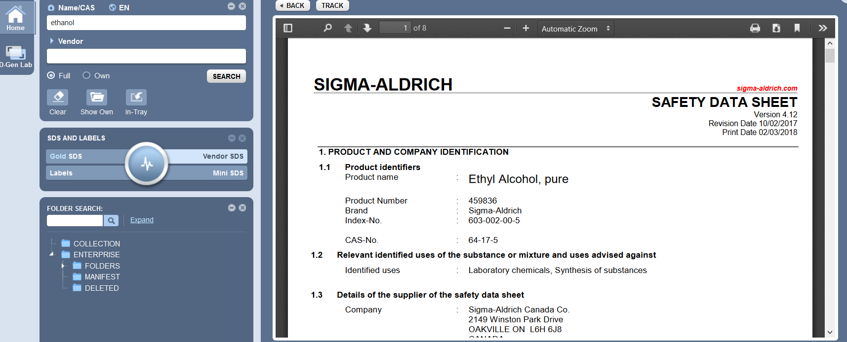

- The user can then print or save as a .pdf the SDS

Section B. Workplace Label Templates:

The new WHMIS 2015 regulations have new requirements for the labelling of Workplace dilutions or working aliquots from original containers of chemicals. For example, ethanol, decanted from a 4 L original container into a “wash bottle” (or any other secondary container) requires a ‘Workplace Label’. There are specific information requirements for ‘Workplace’ labels and therefore we have created 2 label templates (one for containers greater than 100 mL and one for containers less than 100 mL) Small containers have different information requirements. This applies to dilutions as well, but does not apply to “working solutions” provided they are used immediately by the worker, used by only one person, and are used up at the end of the day. Working solutions only require the name of the material(s) and Signal Word (Danger, Caution or Warning).
To access and use the templates follow the instructions below.
- Log into ChemWatch https://jr.chemwatch.net/chemwatch.web/account/autologinbyip
- On the left side there is a menu broken down in three sections:
  - Search
  - SDS and Labels
  - Folder Search
- On the ‘SDS and Labels’ section select the ‘Labels’ option
- Go up to the search section and ensure the ‘Full’ button is highlighted (this can be found under the ‘Vendor’ field)
- Type chemical name or CAS number into the ‘Name/CAS’ field.
  - Press enter on the keyboard or select the ‘Search’ button
  - A list of chemicals matching the name or CAS# will come up on the right screen. Select the appropriate one. NOTE: You can only create labels for chemicals that have a Gold SDS associated with them. If no ‘Gold SDS’ is available for a specific chemical there will not be any options to select from.
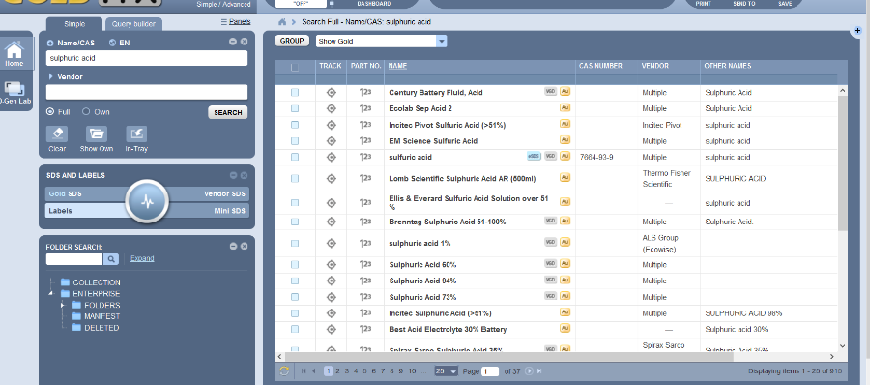

- The ‘Gallery’ of workplace label templates will come up
  - Select the ‘User Defined’ tab
  - Select the appropriate template
    - To select and view the template click on the triangle in the bottom right corner
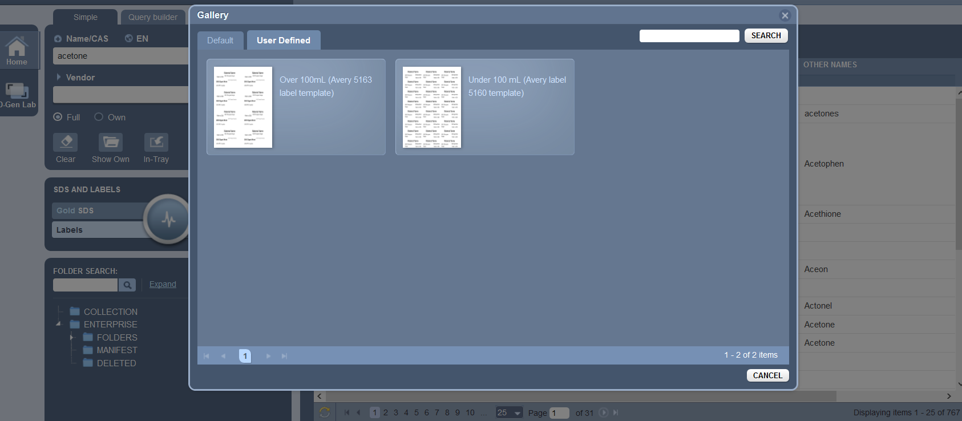
- A template sheet will load with the Chemical filled.
- At this point you can select Print or Send to (by email) or Save. We are not sure how the email option will work so it is not recommended at this time. The Save option allows you to save as a .pdf and can be printed at a later data using any .pdf program. The templates were designed for Avery Labels paper. Avery 5163 for the larger labels and Avery 5160 for the smaller labels.
- To Print Select the print option in the top right corner of the screen

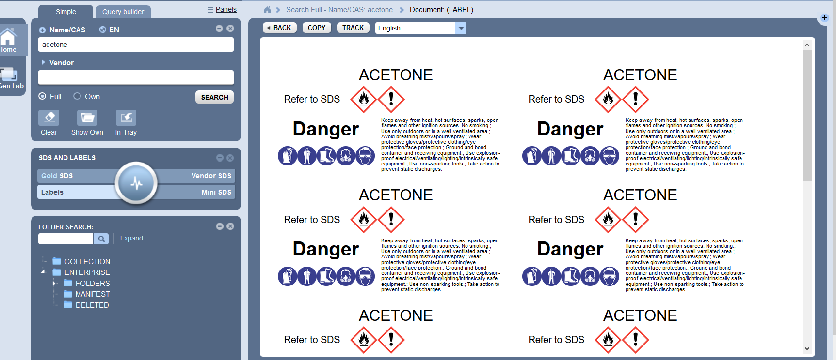

- Select the print option on the new screen
- A print options will come up, do not select ‘Print’ right away (Note: Printing instructions may be printer specific)
  - Select ‘Print using system dialog…’
  - Select ‘Preferences’
  - Select ‘Paper/Quality’
  - Select the drop down menu for ‘Paper Source’
  - Select ‘Manual Feed’
  - Select ‘ Okay’
  - Select ‘Apply’ then ‘Print’
- Manually feed the Avery Label template that goes with the size templates being printed
- This method will produce 10 labels (of the large labels) all the same. If you wish to create multiple chemicals on the same sheet follow the directions below.
Section C: Printing Multiple Materials on one Label Sheet:
Log into Chemwatch as above
- On the left side of the menus and screen there are two options ‘Home’ and ‘D-Gen Lab’
- Select ‘D-Gen Lab’ this will automatically put you into the Search section of this module.
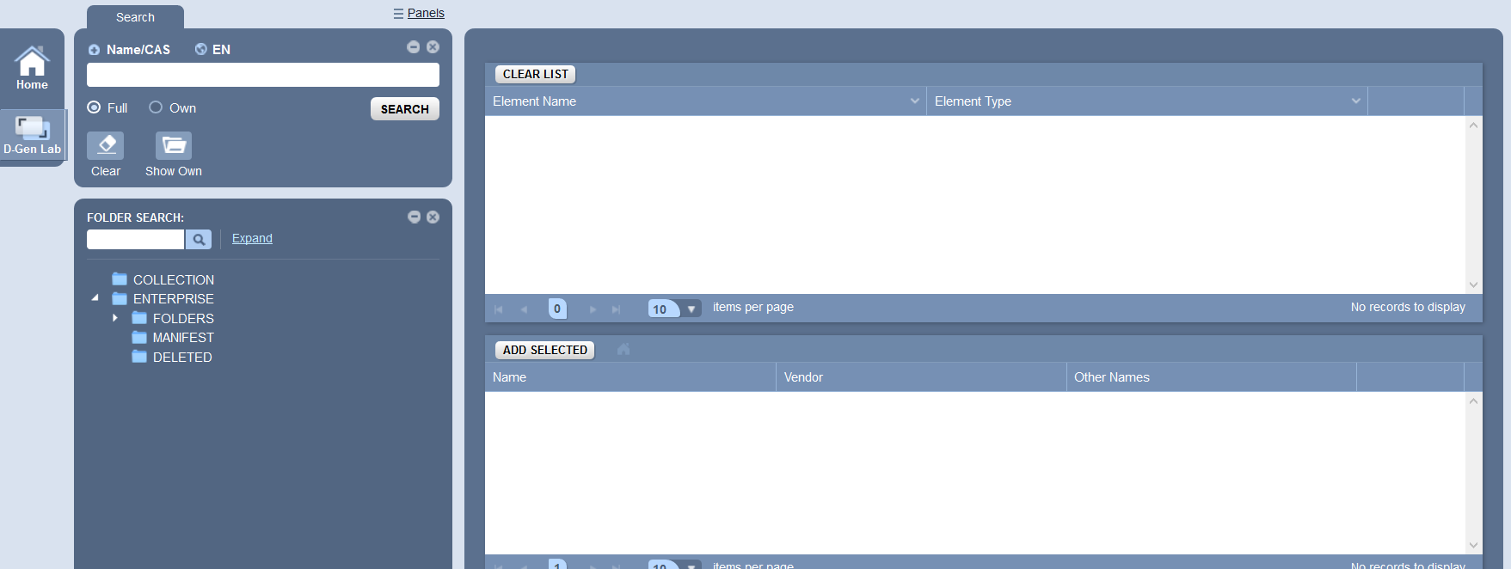
- Ensure the ‘Full’ button under the Name/CAS field is highlighted
- Type in a chemical name
- Select ‘Search’ or press enter on your keyboard
- In the bottom table all the chemicals they have that include that name will come up, select the ‘Add to List’ button next to the appropriate chemical
For wh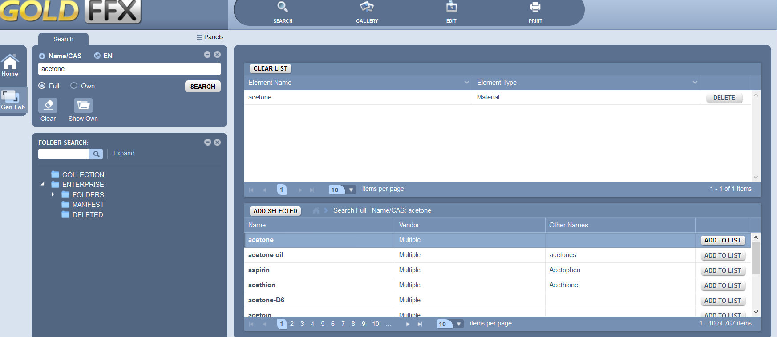
- Repeat step five (5) until you have selected all the chemicals for which you need labels.
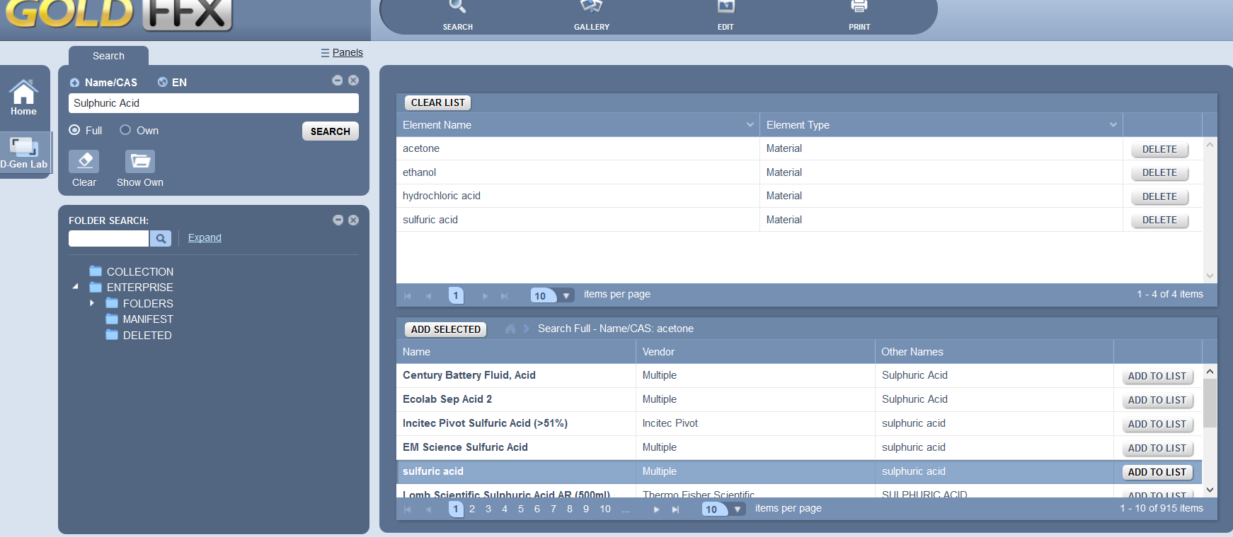
- Select the ‘Gallery’ option
- Select the ‘User Defined’ tab
- Pick the template you want to fill in
  - Click on the triangle in the bottom right corner of the template.
  - If you want to edit or change the template in anyway go to the ‘Edit’ option and make those changes, it will not allow you to save the template, but you can make changes to “your label”.
  - You do not have access to create a new template so you must use an existing template, you will be able to edit, delete, and adjust the size if need be
- Select the ‘Print’ option
- In the ‘Filling’ section on the left side there is a box next to the words ‘Multiple material print’, select the box
- Under that there is a field that says ‘Select Some Options’. Select the materials you just searched and add them to your list in that field. (to see the options click on the field)
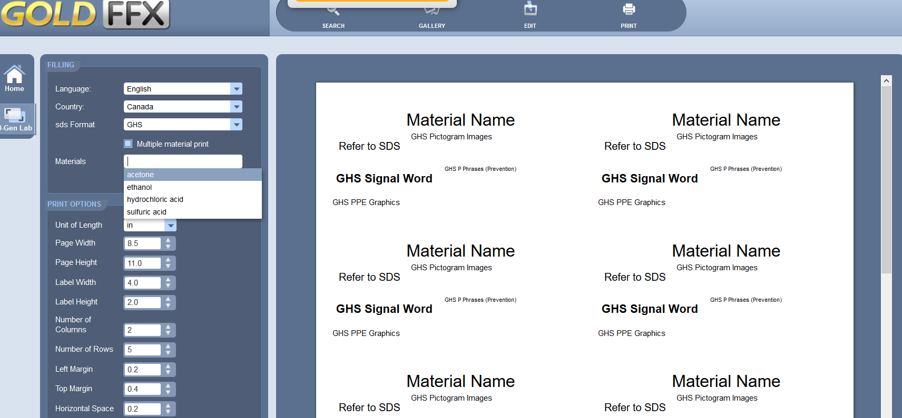
- Select ‘Fill’
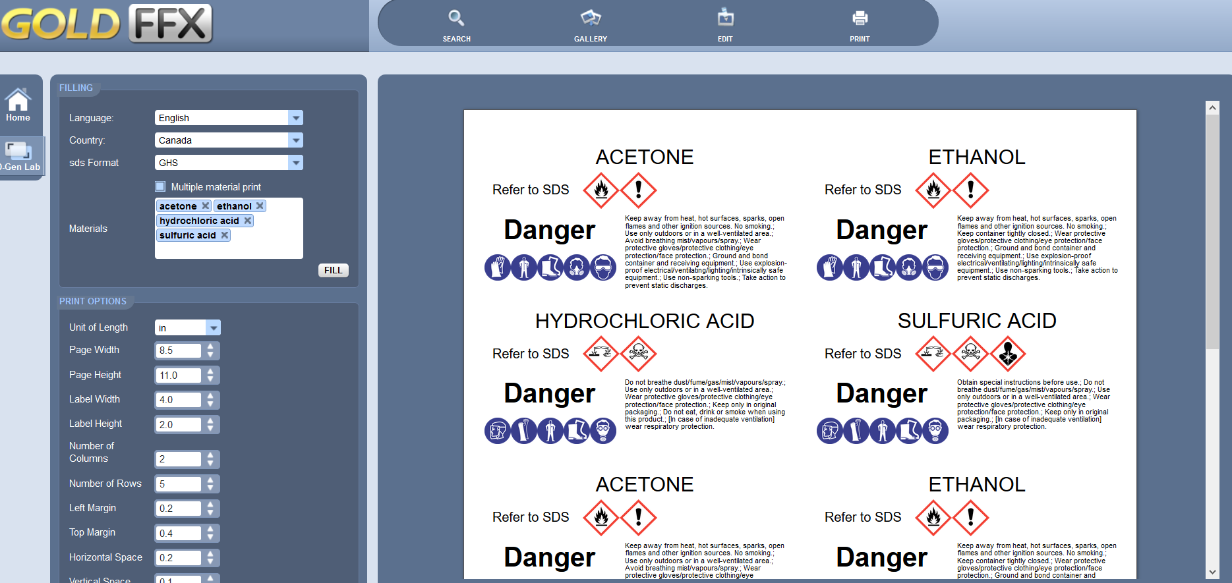
- You can then either select the ‘Print’ button or the ‘Save pdf’ button at the bottom of the page on the left side. If you wish to Print, another screen will come up with the template, select the print button on the new screen
- (Note: the following instructions may vary from Printer to Printer these are just a guide as to the process for printing on pre-set Avery Label paper) A print options menu will come up, do not select ‘Print’ right away
16.1 Select ‘Print using system dialog’
16.2 Select ‘Preferences’
16.3 Select ‘Paper/Quantity’
16.4 Select the drop down menu for ‘Paper Source’
16.5 Select ‘Manual Feed’ (for use with Avery label paper)
16.6 Select ‘Okay’
16.7 Select ‘Apply’ then ‘Print’
17. To return to the main screen select the ‘Home” button.
Section D: Program Help
For more information on ChemWatch and how to use the program:
- On the very top of the screen there are six (6) symbols in the right corner

{ here }
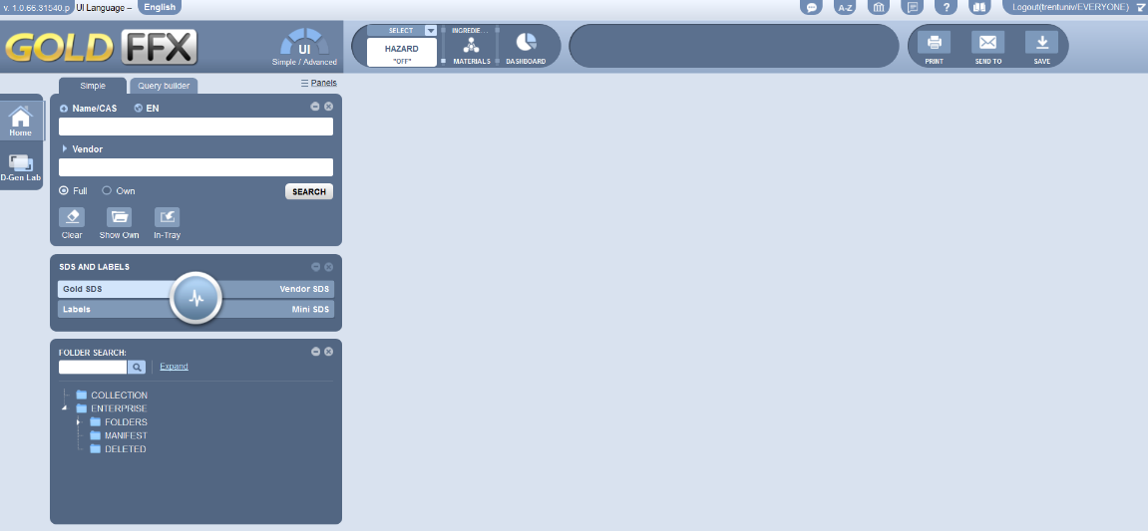
- Go to the building symbol, an eLearning ‘pop-up’ will come up
- select the ‘Modules’ tab
- You can watch videos on different modules about how to use ChemWatch, At present only the SDS and D Gen modules are available to everyone. Requests for additional access to other modules can be made through Science Facilities or the Risk Management Office.

