HECHMET Chemical Inventory System
Starting February 1, 2020
Effective for all Trent University Teaching & Research labs
HECHMET involves applying a barcode to every existing and newly purchased chemical in our teaching and research labs.
- The barcodes will assist in cataloging details specific to each chemical including its location on campus.
- Your cooperation is essential in helping the inventory work.
 | When you order a chemical for your lab, you must include the following information in the “Attention” line of the order:
 | “CH” to denote shipment contains a chemical
Building & wing where chemical will be stored
●Science Complex = SC ● Environmental Science Building =ESB A, B, C
●Chemical Science Building = CSB D, E, F ● DNA A,B or Life & Health Science =LHS C,D
 | Lab number: where chemical will be stored i.e. this is the 3 or 4 digit room number where your lab is located
Researcher/Principal Investigator’s (PI) name
!! Do not deliver to a student’s attention !!
e.g. if your lab is in the “Einstein lab—DNA A118.2” you will enter
“CHDNAA118.2 Einstein” in the attention line of the order
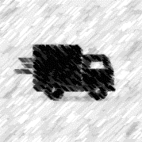 | The Shipping & Receiving Center (SRC) will receive all incoming deliveries in their new facilities in the Environmental Science Building (ESB).  - The new delivery address for all shipments is:  Trent University  Shipping and Receiving Center  Environmental Sciences Building  2089 East Bank Dr. Peterborough, ON K9L 1Z8
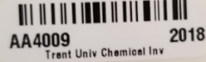 |  | The “attention” line of the shipping label will specify the contents are a chemical, final lab location and the researcher/PI.  - SRC will catalogue your purchased chemical and add information into the chemical inventory system called “HECHMET”  - They will attach a barcode directly onto each container  - This barcode will be uniquely coded and identify the chemical as belonging to your lab  - SRC will deliver the chemical(s) to your lab.
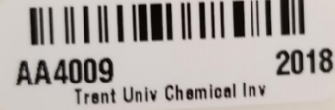 |  | If your chemical arrives sealed within additional packing, SRC will attach the barcode to the outer package e.g. poly bag, foil package or tin.  - When you open the packing to use the chemical for the first time, attach the barcode directly to the chemical bottle.  - Ensure you do not cover any of the label information.
When you have used all the chemical or need to dispose of a chemical through chemical waste, you will need to;
- Remove the Trent University chemical barcode
- Attach it to the “Barcode Disposal” poster
- Follow directions as listed for returning barcodes to Science Facilities
More information is available at Science Services URL https://www.trentu.ca/scienceservices/

