

Foodservice Advisory Committee

November 4, 2021

MEETING NOTES

Attendance: Mark Murdoch, Food Services; Jessica Brooks, Neil Dolman, Patti Gowing, Chartwells; Corine Bolton, CUPE 3205; Aimee Blyth, Seasoned Spoon; Marisa Scigliano, TUFA; Sebastian Johnston-Lindsay, TGSA; Shelley Strain, Sustainability Office; Stephanie Muehlethaler, Colleges; Riley Ambrose, TDSA;

1. Review of Meeting Notes of September 30
   1. No items to follow up
2. Sub-committee reports
3. Operations and Marketing
   1. See Meeting Notes of November 2
      1. The scanning of QR codes is going well. Most people on campus are aware of the protocol and are ready to have the documents and ID checked if required.
4. Sustainability and Fair Trade
   1. See meeting notes of November 2
      1. Eco-tray roll out is trending up. Since Monday 65 trays have been purchased. Residence Life Dons are distributing the green cards to residents so we should see increased use of eco-trays in the coming days.
      2. Chartwells will launch digital and table top marketing to increase awareness of the program.
5. Budget
   1. See meeting notes of November 2
      1. Thing that will be tough is the inflation, going up.  CPI will be figured out for the university by next week
      2. Food has gone up considerably
      3. Durham and Traill do not make money in terms of food so we need to cover those costs
      4. Looking at significant increase on dining hall plans (at least 4% which is about two hundred dollars for the largest meal plan)
6. Catering
   1. No report
7. Additional Working Group Reports
   1. Dining room redevelopment group – waiting for the new chairs for LEC
   2. Durham Food Services re weekend operating hours – see attached memo
8. New Business
   1. Winter meeting schedule - attached
9. General Discussion and Q & A
   1. When will we see reusable dishes back on campus? Right now staff from Chartwells can’t go into the residential spaces to collect dishes. It is unlikely we will see the use of reusable dishes before January.
10. Next meeting – November 30, 9:00 – 10:30, location TBD



Trent University Foodservices

Food Services Advisory Committee

Operations and Marketing Working Group

November 2, 2021

MEETING NOTES

Attendance: Mark Murdoch, Food Services; Aimee Blyth, Seasoned Spoon; Corine Bolton, CUPE 3205; Jessica Brooks, Neil Dolman, Chartwells; Kassandra Glasbergen, The Ceilie; Aislinn Defries, LEC

1. Review meeting notes from FSAC September 28
   1. Reopening of locations
      1. Chartwells continues to struggle with recruiting new staff, an issue that is challenging the entire service industry.
      2. Reopening Tim Horton’s is a priority for both a customer service solution and a fiscal one.
   2. Update on BOOST
      1. The new format for Gzowski is operational. Additional units are being updated.
   3. Dining room capacity with colder weather
      1. Provincial capacity limits have been lifted so dining rooms are able to seat as many customers as we have chairs.
2. Vaccine passport update
   1. The new system of scanning QR codes is actually worse than the old system as now staff have three steps; scan QR code, review document, confirm identiy, one more than without the QR code scanner. We will look at the impact of scanning the code and may drop this process.
3. Update re Durham GTA Operations – see attached memo
4. Q and A
   1. The plexi glass is missing in the Great Hall.
      1. Under the latest stage of the re-opening plan it is not required. Plexi will be maintained at service counters.
   2. The first premium dinner of the year will be offered at Gzowski on November 9.
5. Next meeting November 30, 9:00 – 10:30



MEMORANDUM

TO: All Durham GTA Residents

COPY: Scott Henderson, Jen Richardson, Jen Coulter, Lawrence Lam, Nona Robinson,

Phuong Nguyen, Neil Dolman, Michael Wood

FROM: Mark Murdoch

DATE: October 1, 2021

SUBJECT: Durham GTA Dining Room Operating Hours

Thank you everyone who attended our meeting last Tuesday. The dialogue was very beneficial for me and we were able to affect some changes very quickly.

The Qualtrics survey had 50 respondents, 54% of the residence population. The breakdown of responses was:

17 Yes

31 No

2 Abstained

The dining room will continue to be closed on weekends, with a few changes to operations:

* Effective Friday October 15 the dining room will remain open until 8 pm,
  + with the exception of October 8 (3pm) and October 22(6 pm)
* The dining room will increase the number of items and options available for take-out on Friday afternoons
* Full take-out meals will be available on Friday afternoons, first come first served
* Residents will be able to convert up to $150 of Trent Cash to Walmart gift cards by completing the spreadsheet that was also attached to this e-mail message and returning it by noon on Friday October 8
* The amount requested will be deducted from Trent Cash and the Walmart e-gift cards will be delivered to you, no later than October 15



Foodservice Advisory Committee

Sustainability and Fair Trade Working Group

Tuesday November 2, 2021

MEETING NOTES

Attendance: Mark Murdoch, Food Services; Jessica Brooks, Neil Dolman, Chartwells; Marisa Scigliano, TUFA; Shelley Strain, Sustainability Office; Zoe Litow-Daye, TCSA; Noah Edwards, LEC.

1. Review of FSAC Meeting Notes of September 28, 2021
   1. Local fill station directions
      1. Shelley and Jessica will work to develop a location specific message for the four dining halls.
2. Current commitment:
3. Bottled water – on-going
4. Disposable dishes only – no news at this time
5. Local food vendors – ne change
6. Updates:
   1. Winnow waste management – hope to have operational by November 15
   2. Tim Hortons AI system – delayed pending re-opening of Tim Hortons. We may have missed our opportunity on this as only a few systems were available and may have been redeployed.
7. Eco-tray program reintroduction – eco-tray cards are being distributed to residents this week. It will require some education of how and why to use the system. Trays are available at all food service locations.
8. Waste Reduction Week news – focus on the eco-tray program. Digital media only.
9. Fair Trade Week news – fell during Reading Week so the outcome was muted. An info table with swag operated during Reading Week.
10. General discussion and Q and A
    1. There is a waste audit coming up.
    2. Food Services and Sustainability will work to jointly fund a student, possibly through TWSP, for next year.
11. Next meetings– November 30 19, 2020, 10:30 – 12:00



Foodservice Advisory Committee

Budget Working Group

November 02, 2021

MEETING NOTES

Attendance: Mark Murdoch, Food Services; Zoe Litow-Daye, TCSA; Deondrae Thompson, LEC, Campbell Deck, Champlain.

1. Roll of this working group:

The working group will advise the Director, Trent Foodservices, in the development of the annual operating budget for the University department. This budget is limited to Trent Foodservice and does not consider the budget of Chartwells or other on-campus foodservice providers. The group will make a recommendation to the Food Services Advisory Committee regarding the budget for Trent University Foodservice for the next fiscal year (May – April). The recommendation to FSAC, is approved, is forwarded to CASSC and then the Board of Governors for final approval.

1. Budget drivers:
   1. Escalating food cost – estimated at greater than 5%
   2. Wage costs
   3. Projects
   4. Current and potentially on-going operating losses
   5. Preliminary 2022-2023 Budget
   6. Priorities
   7. Discuss Dining Plan rates for 2022 - 2023
2. Other business
   1. Durham Operating Hours – 2022-2023
3. General Discussion and Q & A
   1. Will BOOST be upgraded to allow for Debit/Credit? Not at this time. The TrentU Card (tax exempt, taxable and Trent Cash) works for a very large percentage of the campus population, with a focus on students. An upgrade would be very expensive (think $500k). It is an item we will consider in 2024 when we renegotiate our Food Service Management Contract.
   2. How mush will the fee increase be for next year and when would it begin? The fee increase will closely mirror CPI, around 4%, about $200 on a traditional plan. The new fees would be effective for September of 2022.
4. Next meeting – November 30, 1:30
5. The key messages related to the development of the Trent University Foodservices Budget:
   1. Trent Foodservices is a not for profit ancillary operation of the University. Over time, the department should “breakeven” once it has covered the costs of all operations, overhead and an appropriately level of accrual for future investments or projects.
   2. We attempt to keep retail prices at or below the national average, based on an annual survey conducted by the Canadian College and University Food Service Association.
   3. Trent students greatly value the ability to “carry forward” any unused dining plan balances at the end of the year.
   4. Student value the tax exempt status of the dining plans.
   5. The design of dining plans should be simple and easy to understand.
   6. A comparison of several dining plans at Canadian schools has been provided below.
   7. Additional operating hours costs residents. For example, adding Gzowski on weekends would cost each resident about $100.
6. Major budget drivers in future years
   1. Capital replacement. Within the budget we need to begin to set aside capital reserves for known future projects. For example, the redevelopment of Tim Hortons in 2024 will cost about $400,000. We should be setting aside $70,000 per year over the next seven years to fund this redevelopment.
   2. Dining hall refurbishment. There is a plan underway to refurbish the dining halls, possibly Gzowski (2018), LEC (2019) and Champlain (2020 or 2021). Foodservices is looking to other campus partners to support these projects, which are likely to cost about $750,000 over five years, of which $50,000 per year ($250,000 over fie years) would be funded by Food Services.
   3. Inflation, US dollar. Most food commodities are traded in US dollars. If the Canadian dollar weakens the effective cost of food increases, compounding any inflationary affect. Chinese trade talks will further cloud this issue and exacerbate this problem.
7. Current Dining Plan Models:

a. Basic plans:

|  |  |  |
| --- | --- | --- |
| Plan | Traditional | Suite |
| Cost | $4,700 | $2,875 |
| Overhead | $   630 | $   320 |
| O-Week Meals | $   195 | $   195 |
| Value | $3,875 | $2,360 |

1. Special Plans:

|  |  |
| --- | --- |
| Plan: | Durham GTA, Traill |
| Cost | $4,700 |
| Overhead | $   630 |
| O-Week Meals | $   195 |
| Value (see above) | $3,875 |
| Trent Cash | $1,000 |
| Declining Balance | $2,875 |

1. Tax Exemption. To be tax exempt a Dining Plan must meet a number of criteria established by the Canadian Revenue Agency. One of these requires that the plan provides for meals over the duration f the plan (30 weeks for two semesters) and a minimum of 10 meals per week at the “average” cost of a meal on campus.

For Trent the math is; 30 weeks X 10 meals X $7.98 = $2,394.

Sample of Canadian Dining Plan Rates:

|  |  |  |  |
| --- | --- | --- | --- |
| **School** | **Minimum Plan Value** | **Type** | **Number of Dining Plans** |
| Brock | $4,800 | AYCTE | 3 |
| Carleton | $5,150 | AYCTE | 2 |
| Durham College | $5,471 | AYCTE | 4 |
| Laurier | $5,610 | AYCTE | 3 |
| McGill | $4,500 | DB | 1 |
| McMaster | $4,260 | DB | 8 |
| Queens | $6,940 | AYCTE | 9 |
| Trent | $2,825/$4,700 | DB | 2 |
| University of Calgary | $4,111 | AYCTE | 4 |
| University of Guelph | $4,250 | DB | 5 |
| U of Toronto Miss. | $2,400 | DB | 8 |
| U of Waterloo | $5,050 | DB | 3 |
| U of Western | $5,620 | DB | 1 |
| U of Windsor | $4,950 | DB | 4 |
| UBC | $5,542 | DB | 1 |
| University of Victoria | $5,100 | DB | 2 |
| York | $3,750 | AYCTE | 4 |
|  |  |  |  |

*Discreet dining plan rates are not available for all Canadian schools as

many schools include the cost of the dining plan within a total cost for

room and board.

Preliminary Unadjusted Budget Food Services 2022-2023







Dining Plan Components and Likely Increases for 2021-2022

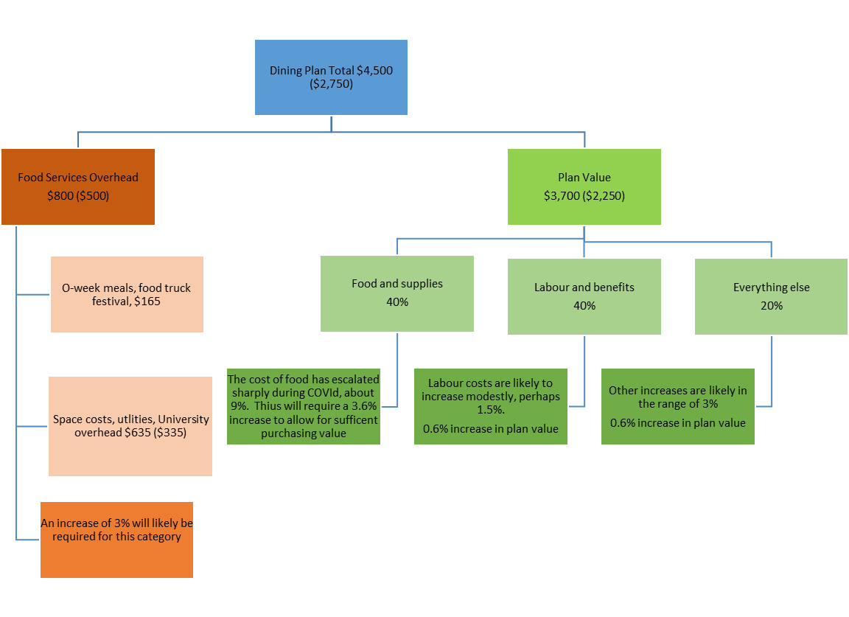





**FOOD SERVICES ADVISORY COMMITTEE**

**MEETING SCHEDULE**

**WINTER 2022**

**Operations and Marketing Working Group**

9:00 – 10:30, January 11, February 15, March 15

**Sustainability and Fair Trade Working Group**

10:30 – 12:00, January 11, February 15, March 15

**Budget Working Group**

1:30 – 3:00, January 11,

**Food Services Advisory Committee**

9:00 – 10:30, January 13, February 17, March 17